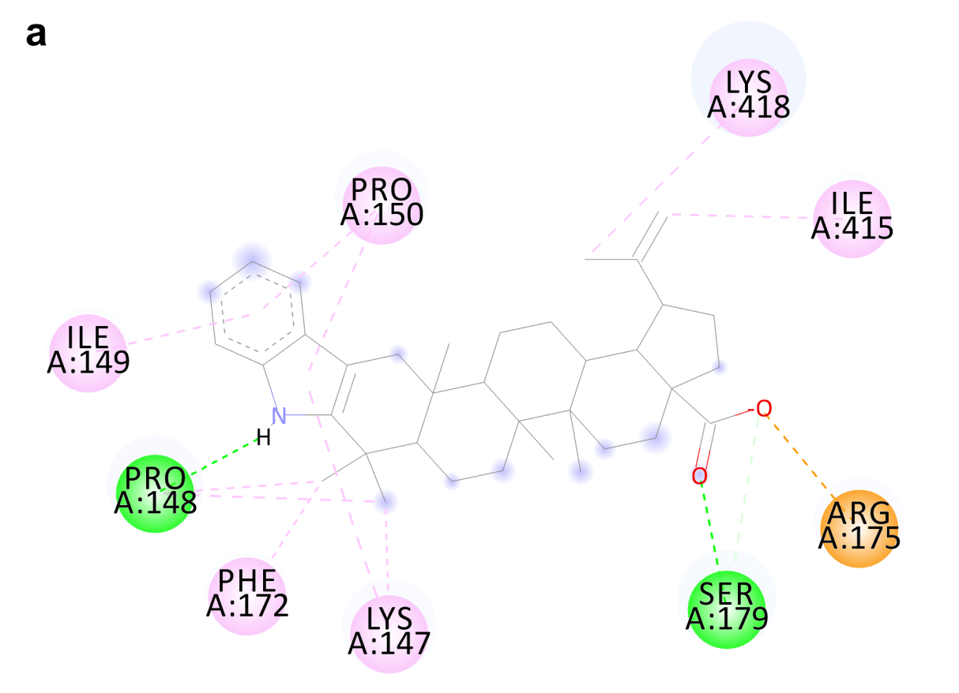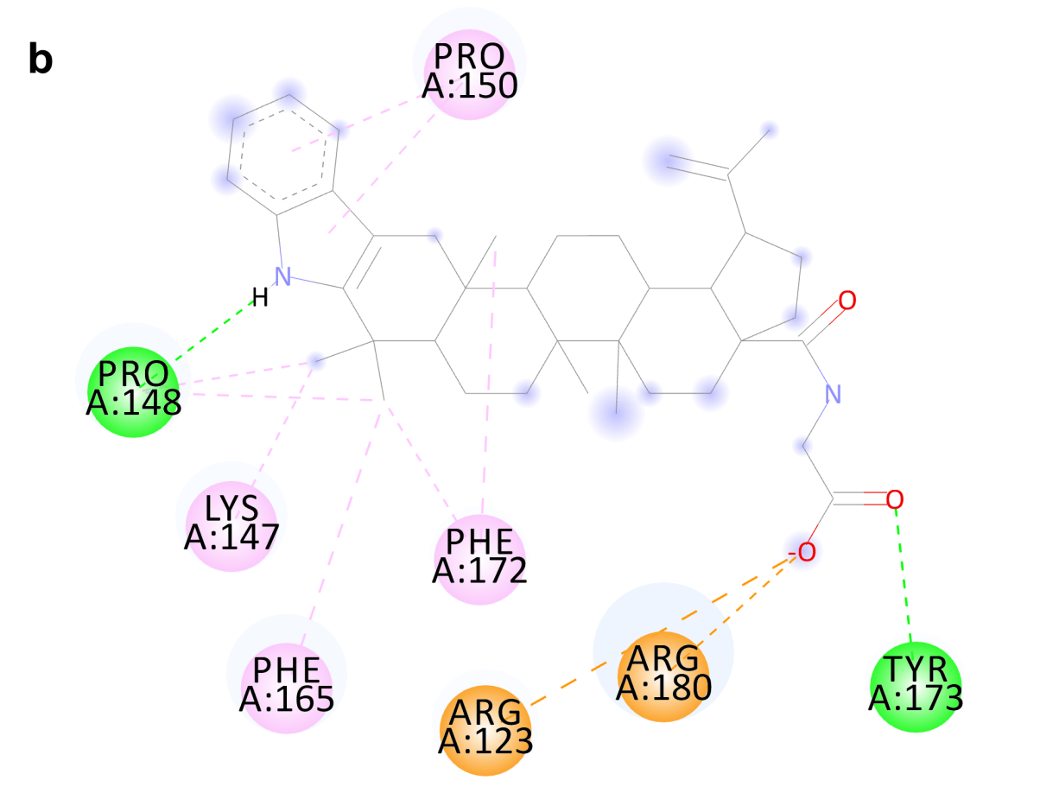
Fig. 5. Schematic 2D diagram of intermolecular interactions of compound 1 (a) and compound 3 (b) with the allosteric site of S. cerevisiae α-glucosidase. Key amino acids are shown. Interactions are indicated with dashed lines (purple for hydrophobic contacts, green for H-bonds, orange for charge attraction).

