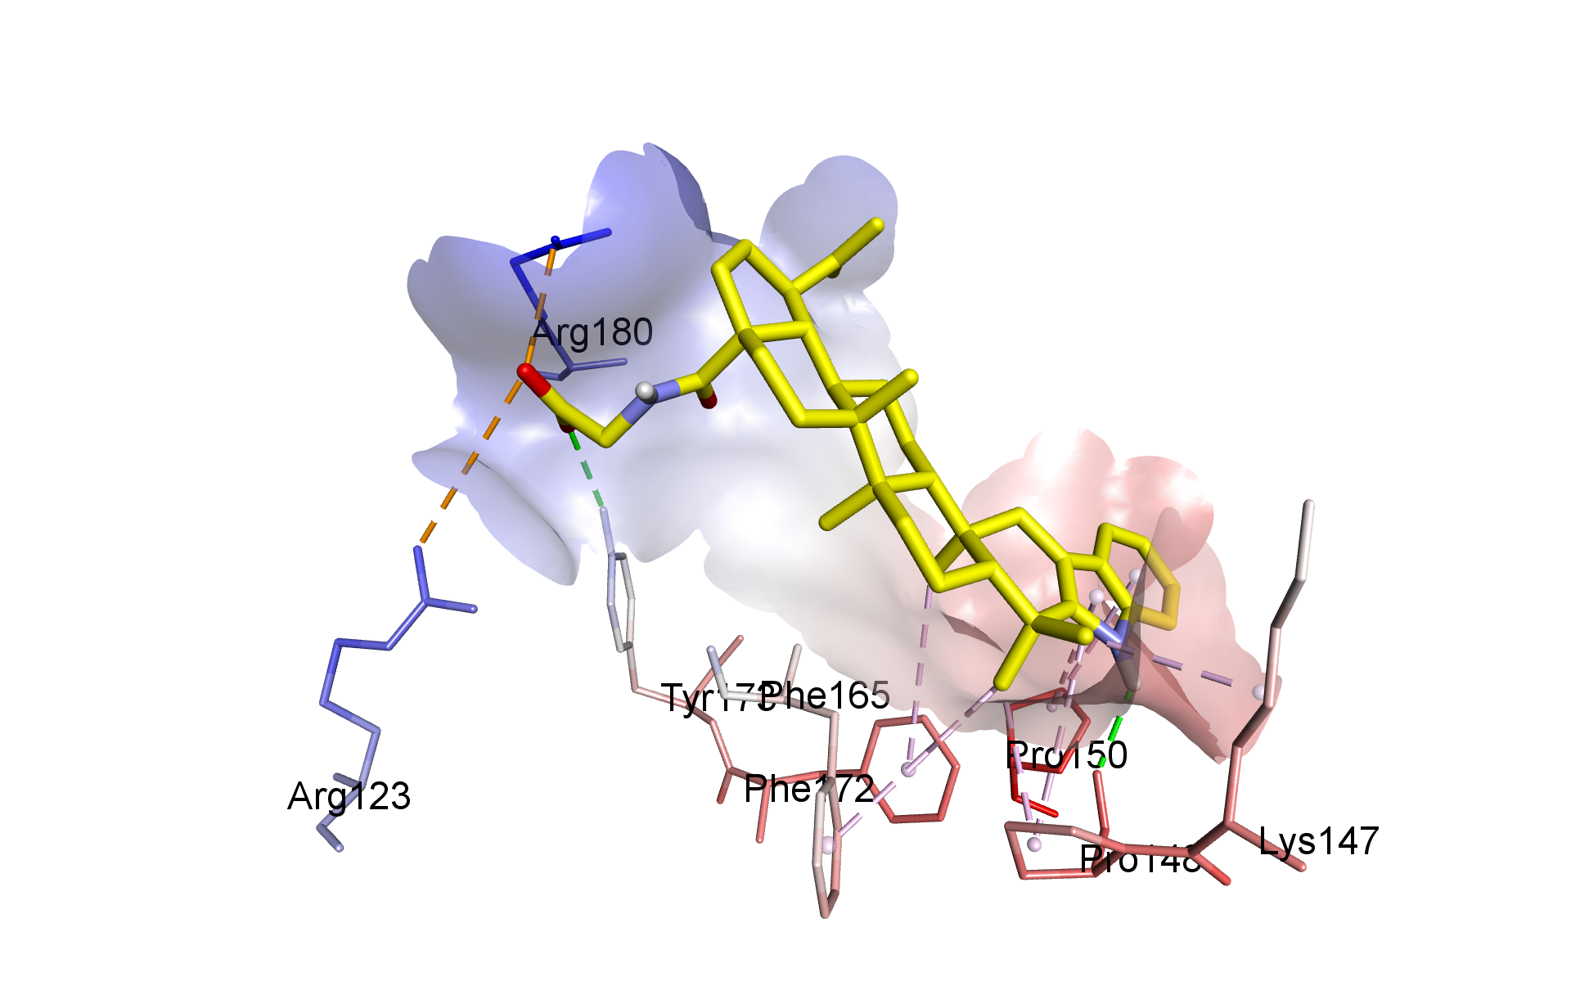
Fig. 4. Proposed binding mode and interaction of compound 3 with the allosteric site of S. cerevisiae α-glucosidase. Key amino acids are shown. Protein-ligand interactions are indicated with dashed lines.

