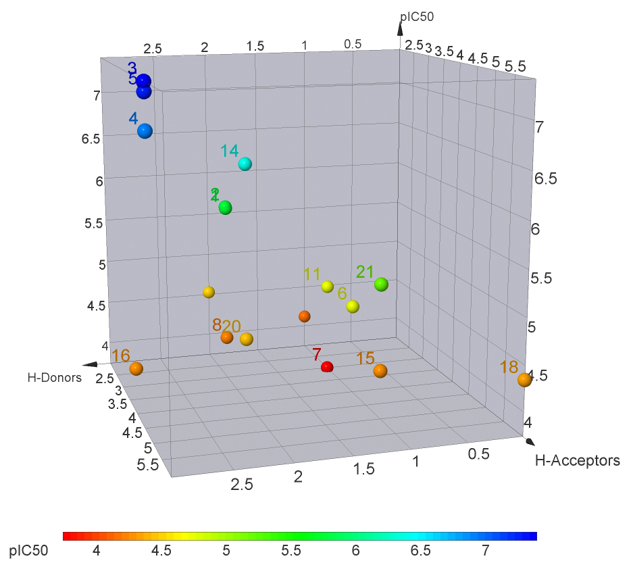
Fig. 3. The contribution of H-bond donors and acceptors to the α-glucosidase inhibitory activity of active 2,3-indolo-betulinic acid derivatives.

