GRL: 2014GL061665
Auxiliary material for
Dynamic morphology of gas hydrate on a methane bubble in water:
Observations and new insights for hydrate film models
Robert P. Warzinski
1
, Ronald Lynn
2
, Igor Haljasmaa
2
, Ira Leifer
3,4
, Frank Shaffer
1
, Brian J.
Anderson
5
, Jonathan S. Levine
1
(
1
U.S. Department of Energy, National Energy Technology Laboratory, Pittsburgh,
Pennsylvania, USA.
2
URS, South Park, Pennsylvania, USA.
3
Bubbleology Research
International, Solvang, California, USA.
4
Marine Sciences Institute, University of California,
Santa Barbara, California, USA.
5
West Virginia University, Department of Chemical
Engineering, Morgantown, West Virginia, USA)
Geophysical Research Letters
Introduction
The auxiliary material consists of four types of supporting information (SI), which are:
Manuscript Number ICARUS_2019_168

Icarus

Supporting information for:

Quantitative Assessment of Uncertainties in Modeled Crater Retention Ages on Mars
M.C. Palucis¹, J.T. Jasper², B. Garczynski¹ and W.E. Dietrich³

¹Department of Earth Sciences, Dartmouth College, Hanover, NH, USA
²California Institute of Technology, Pasadena, CA, USA
³Department of Earth and Planetary Science, University of California Berkeley, Berkeley, CA, USA

Introduction:

The supporting information consists of:

1. Seven supporting figures with captions – referred to as S1-S7 in the paper

2. Text (and Figures S8 – S10) that gives additional detail on the Monte Carlo model used to assign ages to Martian landforms in the Gale Crater region.

3. Matlab scripts to generate Figures 2, 5, 7, and 8 in the main text, and an example crater counting file (.diam)

4. Crater count data for the features mapped in Figure 9 (and S7), as well as Table S1 and S2.

Contents of this file

Figures S1-S7
Text with Figures S8 – S10

Additional Supporting Information (Files uploaded separately)

Matlab scripts
Excel Files (also saved as .csv)

Supporting Figures

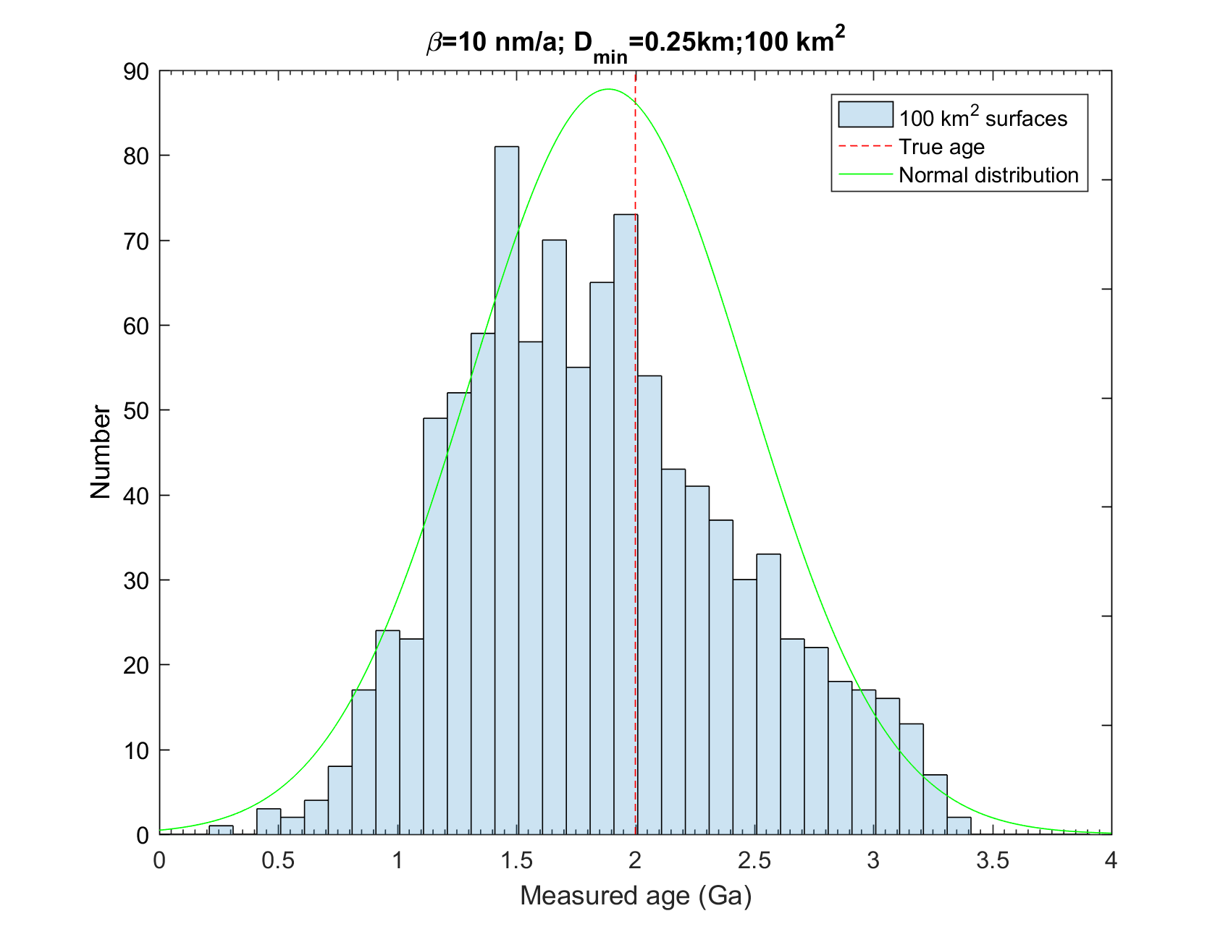
Figure S1. Example distribution of surface ages assigned to 100 km² subsamples from a 2 Ga parent surface with an area of 20,000 km² and β = 10 nm a⁻¹. The dotted red line shows the parent surface age (2 Ga) and the green line shows the normal distribution calculated for this data set (mean age = 1.9 Ga; standard deviation = 0.6 Ga). The minimum crater diameter was 0.25 km.

Figure S2. Median (symbol) and interquartile range (error bars) of ages calculated by cratering model with a β value of 100 nm a⁻¹ using a range of true parent surface ages (1, 2, and 3 Ga), sample areas (10, 100, 1,000, and 10,000 km²), and minimum crater diameters (for readability, data are slightly offset within all bins). Parent surfaces were 200,000 km², except for trials when the minimum crater diameter was 16 m and the parent surface was 20,000 km². Each set of conditions was tested 100 iterations. Modeled surfaces without craters were omitted.

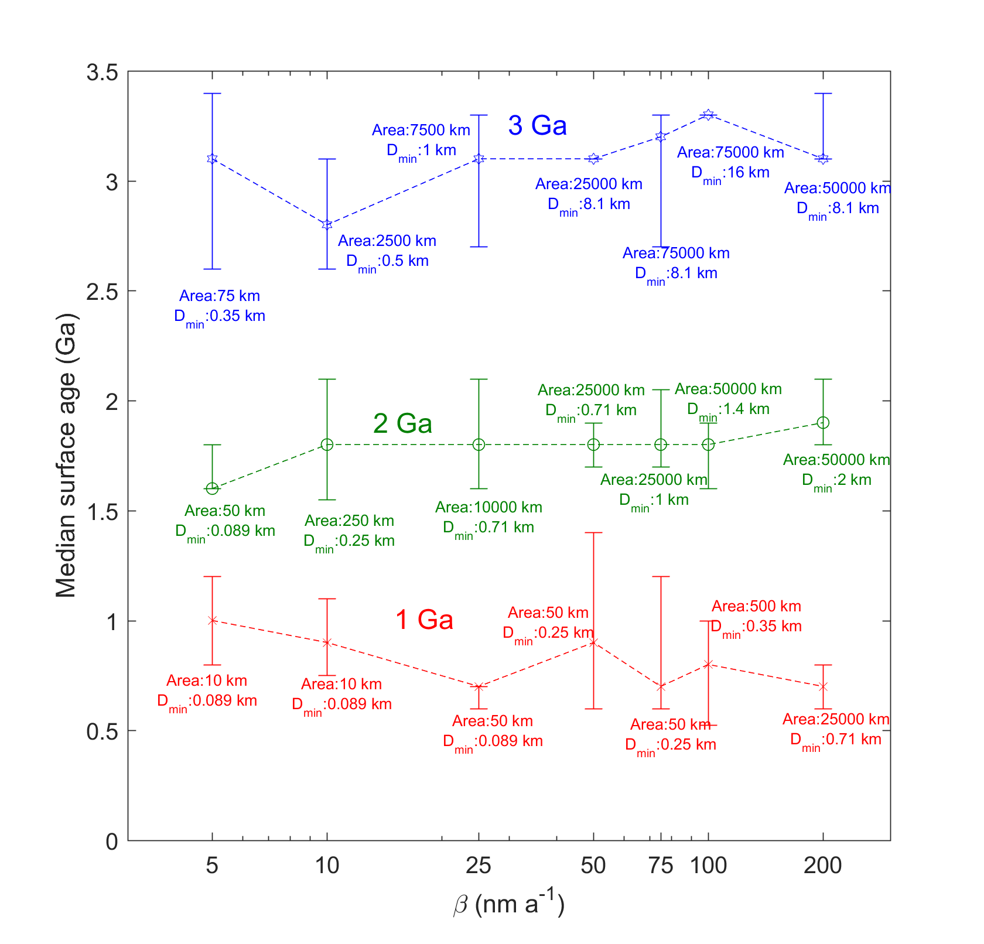
Figure S3. Median (symbol) and interquartile range (error bars) of ages calculated by cratering model over a range of β values and parent surface ages (1, 2, and 3 Ga) for the minimum sample area and crater size needed to produce accurate (75% of data within 0.5 Ga) results. The minimum crater diameter and surface area used is listed for each point (see also Figure 6 of main document). Parent surfaces were 200,000 km². Each set of conditions was tested 100 iterations. Modeled surfaces without craters were omitted.

Figure S4a. Example fit with β = 90 nm a⁻¹ and a model age of 0.6 Ga with model fit (black circles; 200 km²) compared to crater counting data (blue diamonds) of Coprates Chasma landslide on Vallis Marineris, from Quantin et al. (2004). Model simulations were considered fits if $\frac{\left|N_{observed}(i)-N_{modeled}(i)\right|}{(N_{modeled}\left(i\right)+N_{modeled}\left(i\right))/2}<0.25$ for all crater bins, i. Model parent surfaces used the secondaries model of Smith et al. (2008) and had surface areas of 10,000 km². See Figure S5 for a comparison of the isochrons on a single plot.

Figure S4b. Example fit with β = 114 nm a⁻¹ and a model age of 2.9 Ga with model fit (black circles; 200 km²) compared to crater counting data (blue diamonds) of Coprates Chasma landslide on Vallis Marineris, from Quantin et al. (2004). Model simulations were considered fits if $\frac{\left|N_{observed}(i)-N_{modeled}(i)\right|}{(N_{modeled}\left(i\right)+N_{modeled}\left(i\right))/2}<0.25$ for all crater bins, i. Model parent surfaces used the secondaries model of Smith et al. (2008) and had surface areas of 10,000 km². See Figure S5 for a comparison of the isochrons on a single plot.

Figure S4c. Example fit with β = 327 nm a⁻¹ and a model age of 3.7 Ga with model fit (black circles; 200 km²) compared to crater counting data (blue diamonds) of Coprates Chasma landslide on Vallis Marineris, from Quantin et al. (2004). Model simulations were considered fits if $\frac{\left|N_{observed}(i)-N_{modeled}(i)\right|}{(N_{modeled}\left(i\right)+N_{modeled}\left(i\right))/2}<0.25$ for all crater bins, i. Model parent surfaces used the secondaries model of Smith et al. (2008) and had surface areas of 10,000 km². See Figure S5 for a comparison of the isochrons on a single plot.

Figure S5. Example isochrons assigned to subsampled surfaces that fit crater counting data (black squares) of Coprates Chasma landslide on Vallis Marineris, from Quantin et al. (2004). See Figure 7 for histogram of age/β value combinations that fit crater counting data. See Figure S4 for comparisons of Quantin’s crater counting data and modeled crater counts determined to fit. Age and β values are denoted for each isochron.
Figure S6. Percent of modeled crater counts for the Peace Vallis fan (green) and Pancake delta (red) that closely matched observed crater counts, with both features restricted to β≤100 nm a⁻¹.

Figure S7. Model age distribution histograms showing the percent of modeled crater size-frequency data that closely matched observed crater size-frequency data (Supporting Information; Table S2) for alluvial fan (tan diamonds) and deltaic (blue triangles) features in the vicinity of Gale crater. Crater size-frequency data were fit in the probability model using diameters greater than 0.125 km. The dashed lines on each histogram represent the cumulative fit model surface age (with errors reported in Table S2) following Platz and Michael (2012). In all cases, the minimum crater diameter used for the CraterStatsII fits were >60 m. All crater diameter data are in Supporting Information.

Supporting Text

In order to apply our probabilistic model to actual Martian crater datasets, we use a Monto Carlo approach, as described in the main text. To evaluate the robustness of this approach, we generated synthetic crater data for three surface areas (10,000, 1000 and 100 km²), three obliteration rates (β = 0, 50, and 100 nm a⁻¹), and three ages (1, 2, and 3 Ga) using crater diameters between 0.125 km and 32 km. We then determined the most likely ages and β values of these test surfaces, where the Monte Carlo-generated crater counts were compared to the synthetic data using the criterion that the density of craters in all bins match the synthetic crater count data within a user-defined threshold. We varied this threshold from 10% to 50% (in increments of 5%) and determined that a threshold of 25% gave the highest percent of correct matches to the true surface age (within + 0.5 Ga) for 10,000 km² test surfaces with low to moderate erosion (β < 50 nm a⁻¹).

The results using test surfaces are shown in Figures S8 through S10. As expected, for 10,000 km² surfaces with no erosion (Figure S8), the Monte Carlo approach correctly identified the true age of the surface within + 0.5 Ga for all iterations. At higher obliteration rates (β = 50 and 100 nm a⁻¹), the model almost always identified the true age of the surface within + 0.5 Ga for 1 and 3 Ga surfaces. For 2 Ga surfaces, as obliteration rates increased, the model incorrectly identified the test surfaces as being older than they actually were (2.5 to 3.5 Ga versus 1.5 to 2.5 Ga) ~40% of the time. As surface area decreases (Figure S9 and S10) and obliteration rates increase, a higher percent of the test surfaces were dated to be younger or older than their true age. In all cases though, the age bin with the highest percent of matching surfaces matched the true age of the test surface within + 0.5 Ga.

Figure S8. Histograms showing the Monte Carlo results for 10,000 km² test surfaces with ages of 1 Ga (first column), 2 Ga (second column) and 3 Ga (third column) and obliteration rates of 0 nm a⁻¹ (first row), 50 nm a⁻¹ (second row), and 100 nm a⁻¹ (third row). The data were binned into age bins from 0 to <0.5 Ga (red), 0.5 to <1.5 Ga (orange), 1.5 to < 2.5 Ga (yellow), 2.5 to <3.5 Ga (blue) and 3.5 to 4 Ga (navy). Each surface age and β combination was tested with 1,000 model iterations.

Figure S9. Histograms showing the Monte Carlo results for 1,000 km² test surfaces with ages of 1 Ga (first column), 2 Ga (second column) and 3 Ga (third column) and obliteration rates of 0 nm a⁻¹ (first row), 50 nm a⁻¹ (second row), and 100 nm a⁻¹ (third row). The data were binned into age bins from 0 to <0.5 Ga (red), 0.5 to <1.5 Ga (orange), 1.5 to < 2.5 Ga (yellow), 2.5 to <3.5 Ga (blue) and 3.5 to 4 Ga (navy). Each surface age and β combination was tested with 1,000 model iterations.
Figure S10. Histograms showing the Monte Carlo results for 100 km² test surfaces with ages of 1 Ga (first column), 2 Ga (second column) and 3 Ga (third column) and obliteration rates of 0 nm a⁻¹ (first row), 50 nm a⁻¹ (second row), and 100 nm a⁻¹ (third row). The data were binned into age bins from 0 to <0.5 Ga (red), 0.5 to <1.5 Ga (orange), 1.5 to < 2.5 Ga (yellow), 2.5 to <3.5 Ga (blue) and 3.5 to 4 Ga (navy). Each surface age and β combination was tested with 1,000 model iterations.

