Material and Methods

Self-trustworthiness measure (Study 1). Separation lines indicate separate screens.
Task 1: Imagine...
On the following pages, we will ask you to imagine various situations and make some judgments about them. There are no right and wrong answers to this task. We are purely interested in your personal estimate.
Please imagine the following situation happens to you:
A person leaves the subway. The person notices that s/he left his/her backpack underneath the seat. When the person tries to re-enter the subway, the doors close and the subway leaves the station. The person knocks against the window and you, who sat next to the person get aware of the person. The person makes gestures to explain to you that s/he forgot the backpack underneath the seat next to you in the subway.
How likely will you try to return the backpack to the person (e.g. by trying to find out about your contact data or handing the backpack to a representative of the transportation system)?
(0-100%)
Please imagine the following situation happens to you:
A person has been grocery shopping with a car for a BBQ evening. The person has bought several bags of groceries and beverages. Upon unloading the groceries, the person notices that the car keys as well as the latchkeys are locked in the car. The person's partner, who is living a few minutes away, has a spare key for the car. You get aware of the situation and offer to watch the groceries while the person is fetching the spare keys. The person decides to leave the groceries with you and fetch the keys.
How likely will you wait next to your groceries until she has returned?
(0-100%)
Please imagine the following situation happens to you:
You are at an event where a lottery takes place. You buy a lot. At the end of the event, the winner is announced. The moderator announces the first numeral of the winning lot. It is identical to your first numeral. The second numeral is also identical. A person standing next to you reports that the first two numerals are also identical to his/her lot. While the moderator pauses for an instant, you suggest sharing the prize in case one of you wins.
How likely would you keep the entire prize for yourself in case you win?
(0-100%)
Please imagine the following situation happens to you:
A person wants to sell a bike. The person makes paper announcements and also advertise on web platforms as well as in a local newspaper. You like the bike. You ask to take the bike on a test drive around the block. You explain that you forgot your ID at home so that you cannot leave it as a deposit.
How likely will you return the bike after the test drive?
(0-100%)
Please imagine the following situation happens to you:
A person is in a park and plays football with friends. Upon ending the game, you and your friends ask to borrow the football. The person agrees to lend the ball to you and your group of friends. After a while the person decides to go home. You still play with the person's football. The person explains to you that s/he is about to leave and wants to take the football. You ask where the person lives and explain that the quarter the person lives in is on your way back home. You ask whether you can continue playing with the person's football. You yourself would afterwards return the football to the person's home.
How likely will you return the football to the person's home?
(0-100%)
Please imagine the following situation happens to you:
You are eating in a crowded restaurant. A stranger shares a table with you. After the stranger has finished the meal, the stranger leaves the restaurant. Upon returning home, the stranger notices that s/he has left his/her wallet on the table of the restaurant. As the wallet laid centered on the table, you, who sat with the person at the table, have found the wallet.
How likely will you have handed the wallet to the restaurant staff so that it can be returned to the person?
(0-100%)
Please imagine the following situation happens to you:
It is a warm summer day and you are lying at the shore of a lake. The person next to you would like to go swimming, but the person does not know whether the person can leave the bag unattended. You lie next to the person, reading a book. The person decides to ask you to watch the bag for a short period of time. In the water the person floats on an air mattress and closes the eyes. When opening them again, the person notices that the sun has moved quite a bit and the person has been in the water longer than expected.
How likely would you leave the bag unattended while the person was gone (e.g., to also go swimming)?
(0-100%)
Please imagine the following situation happens to you:
Your neighbor has just moved in next door. One week after the neighbor has moved into the new apartment, your neighbor needs to travel for two weeks. Your neighbor has to find someone who waters the plants while travelling, but your neighbor does not know anybody in the new city. You have only briefly greeted your new neighbor on the stairway. Your neighbor decides to ask you to water the plants while your neighbor is gone. You agree.
How likely will your neighbors plants wither while your neighbor is gone?
(0-100%)
Please imagine the following situation happens to you:
A person is working as a waiter at a restaurant. Upon returning change to you, the customer, the waiter notices that s/he has given too much change. You have just left the restaurant. The waiter tries to find you on the street and sees that you are just about to put the change into the wallet. While doing so, you seem to notice the waiter's mistake.
How likely will you return the change to the waiter?
(0-100%)

Focus manipulation (Study 1, 3, 4). This manipulation was adapted from Crusius & Mussweiler, 2012).
Task 2: Find Similarities
On the next three pages you will find two pictures in each case. Your task is to compare these two pictures and to search for similarities. Please write down the first three similarities that come to your mind.
Please compare the two halves of the picture and search for similarities.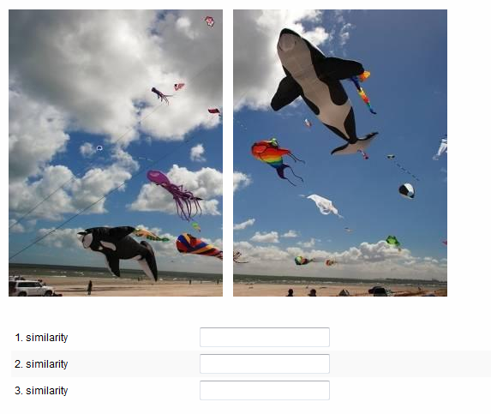
Please compare the two halves of the picture and search for similarities.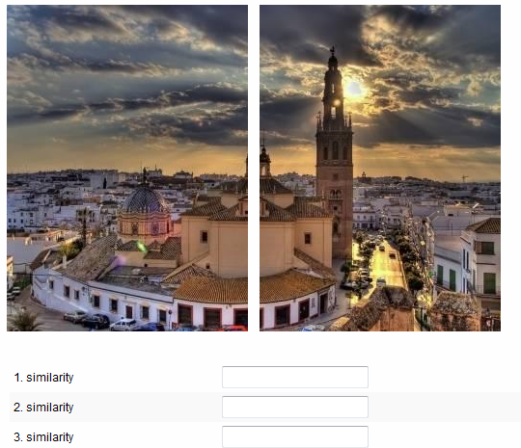

Please compare the two halves of the picture and search for similarities.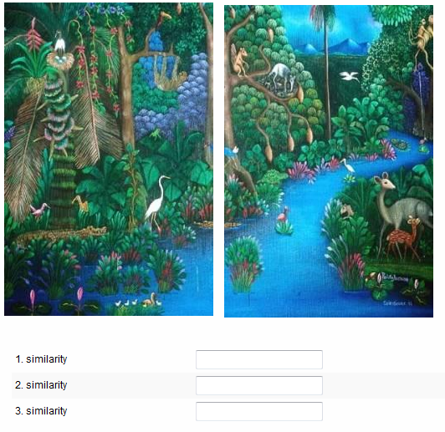

Trust measure (Study 1, 2, and 3). Original materials of Study 2 were direct German translations of these materials. We report the English wording of Study 3 here. In Study 1, the sentence “Please imagine the following situation“ was substituted by this sentence “Please imagine the following situation happens to you and the person portrayed on the picture”, accompanied by a picture of a trustworthy or untrustworthy looking person. Pictures were taken from Schul, Mayo, and Burnstein, 2008 (p. 1299).
Task: Imagine...
On the following pages, we will ask you to imagine various situations and make some judgments about them. There are no right and wrong answers to this task. We are purely interested in your personal estimate.
Please imagine the following situation:
You are leaving the subway. You notice that you left your backpack underneath your seat. When you try to re-enter the subway, the doors close and the subway leaves the station. You knock against the window and the person who sat next to you gets aware of you. You make gestures to explain the other person that you forgot the backpack underneath your seat in the subway.
What do you think: How likely will the other person try to return the backpack to you (e.g. by trying to find out about your contact data or handing the backpack to a representative of the transportation system)?
Please enter the likelihood in percent (0 - 100%).
Please imagine the following situation:
You have been grocery shopping with your car for a BBQ evening. You have bought several bags of groceries and beverages. Upon unloading the groceries, you notice that you locked your car keys as well as your latchkeys in the car. Your partner, who is living a few minutes away, has a spare key for the car. A passerby gets aware of your situation and offers to watch the groceries while you are fetching the spare keys. You decide to leave the groceries with the stranger and fetch the keys.
What do you think: How likely will the passerby wait next to your groceries until you have returned?
Please enter the likelihood in percent (0 - 100%).
Please imagine the following situation:
You are at an event where a lottery takes place. You buy a lot. At the end of the event, the winner is announced. The moderator announces the first numeral of the winning lot. It is identical to your first numeral. The second numeral is also identical. A person standing next to you reports that the first two numerals are also identical to his/her lot. While the moderator pauses for an instant, the person next to you suggests sharing the prize in case one of you wins.
What do you think: How likely will the other person keep the entire prize for him/herself in case the person wins?
Please enter the likelihood in percent (0 - 100%).
Please imagine the following situation:
You want to sell your bike. You make paper announcements and also advertise on web platforms as well as in a local newspaper. A person seems to like the bike. The potential buyer asks to take the bike on a test drive around the block. The person explains that he/she forgot her ID at home so that he/she cannot leave it as a deposit.
What do you think: How likely will the potential buyer return the bike after the test drive?
Please enter the likelihood in percent (0 - 100%).
Please imagine the following situation:
You are in a park and play football with your friends. Upon ending the game, a person from a different group of friends asks you to borrow the football. You agree to lend the ball to the other group. After a while you decide to go home. The other group still plays with your football. You explain to the group that you are about to leave and want to take the football with you. The person that had borrowed the football in the first place asks you where you live and explains that the quarter you live in is on their way back home. The person asks whether they can continue playing with your football. The person him/herself would afterwards return the football to your home.
What do you think: How likely will the person return the football to your home?
Please enter the likelihood in percent (0 - 100%).
Please imagine the following situation:
You are eating in a crowded restaurant. A stranger shares a table with you. After you have finished your meal you leave the restaurant. Upon returning home, you notice that you have left your wallet on the table of the restaurant. As your wallet lay centered on the table, you assume that the person, who sat with you at the table, has found your wallet.
What do you think: How likely will the person have handed the wallet to the restaurant staff so that it can be returned to you?
Please enter the likelihood in percent (0 - 100%).
Please imagine the following situation:
It is a warm summer day and you are lying at the shore of a lake. You would like to go swimming, but you do not know whether you can leave your bag unattended. A person lies next to you, reading a book. You decide to ask the person to watch your bag for a short period of time. In the water you are floating on an air mattress and close your eyes. When opening them again, you notice that the sun has moved quite a bit and you have been in the water longer than expected.
What do you think: How likely did the person leave your bag unattended while you were gone (e.g., to also go swimming)?
Please enter the likelihood in percent (0 - 100%).
Please imagine the following situation:
You have just moved to a new city. One week after you have moved into a new apartment, you need to travel for two weeks. You have to find someone who waters your plants while you are gone, but you do not know anybody in the new city. You have only briefly greeted your new neighbors on the stairway. You decide to ask your neighbors to water your plants while you are gone. Your neighbor agrees.
What do you think: How likely will your plants wither while you are gone?
Please enter the likelihood in percent (0 - 100%).
Please imagine the following situation:
You are working as a waiter at a restaurant. Upon returning change to a customer, you notice that you have given too much change. The customer has just left the restaurant. You try to find the customer on the street and see that the customer is just about to put the change into the wallet. While doing so, the customer seems to notice your mistake.
What do you think: How likely will the customer return the change to you?
Please enter the likelihood in percent (0 - 100%).
Self-trustworthiness manipulation (Study 2-4). Original materials of Study 2 were in German. Original materials of Study 3 and 4 were direct English translations. We report the English wording here.

Task 1: Think about past behavior
Please think about situations in which you interacted with another person and you behaved in your own interest, even though this may have been at the cost of the other person. Those situations may have been rather insignificant everyday actions (such as telling small lies, not sticking to a favor one had already promised to do, or to pass rather confidential information to a third party).
During the last month: How often did you put your own interests first? (Fill in the blank)
During the last month: How often did you put your own interest first?
Please sign in your value.
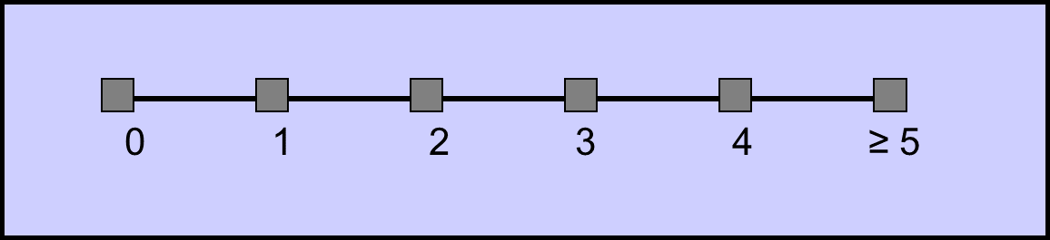
During the last month: How often did you put your own interest first?
Please sign in your value.
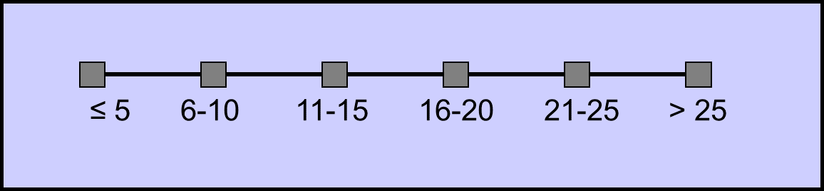

Focus manipulation (Study 1, 3 and 4).
Task 2: Find Similarities
On the next three pages you will find two pictures in each case. Your task is to compare these two pictures and to search for similarities. Please write down the first three similarities that come to your mind.
Please compare the two halves of the picture and search for similarities.
Please compare the two halves of the picture and search for similarities.

Please compare the two halves of the picture and search for similarities.

Focus manipulation (Study 2). For the focus manipulation, the materials of the similarity condition are displayed. In the difference manipulation, the word “similarities” was substituted by “differences” (Corcoran, Hundhammer, & Mussweiler, 2009; Mussweiler, 2001).

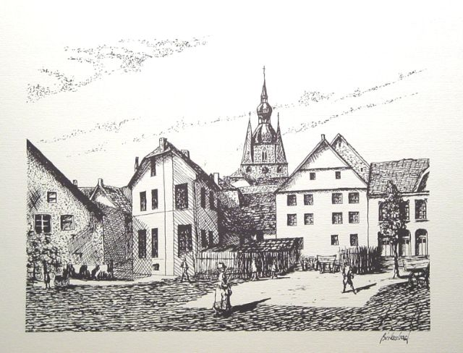

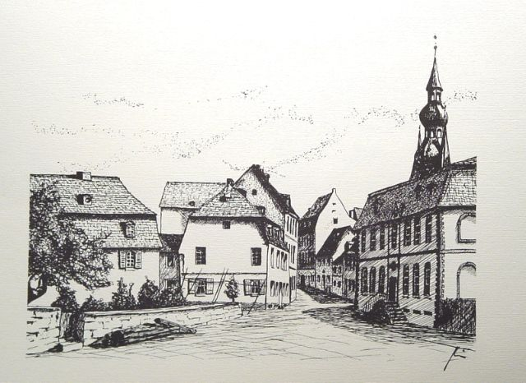

Please compare these two pictures and list similarities.
Please list all the similarities that you notice between the pictures. Please take some minutes to list as many similarities as possible.

Thank you!

Trust measure (Study 4). Instructions and forms were identical for participant trustor (Participant A) and trustee (Participant B). Here instructions for the trustor are displayed. Instructions for the trustee differed in the one sentence “You are Participant B.” instead of “You are Participant A.“

Task: Real Economic Decision
For the third task you will be allocated to some other participant. Please keep in mind that this is a real monetary decision that will affect your as well as the other participant's outcome.
One person is Participant A, the other is Participant B.
You are Participant A.
Every Participant A gets an initial endowment of 60 cent. Participant A can now send any amount of this initial endowment of 60 cent to Participant B in increments of 10 cent. Thus, Participant A may transfer 0, 10, 20, 30, 40, 50, or 60 cent to Participant B. Each amount sent by Participant A will be tripled by us. This means for each cent sent by Participant A, Participant B will receive 3 cent. Participant B does not get an initial endowment. Participant B on his part can afterwards send any amount of the received cents back to Participant A. This may thus be an amount between 0 and possibly 180 cents. Because Participant B does not yet know, which amount Participant A will send, Participant B can define the amount for every possible amount Participant A could have sent. Hence, Participant B can specify how much he or she will send to Participant A, if Participant A sends 0, 10, ... or 60 cent to Participant B.
Please keep in mind: The amount Participant A sends to Participant B will be tripled by us.
That means for payment:
payment of Participant A = 60 cent - transfer amount of Participant A + transfer amount of Participant B
payment of Participant B = 3* transfer amount of Participant A - transfer amount of Participant B
Please take your time and ensure that you understand this instruction. On the next page you will be asked to provide your decision. All decisions and payments are confidential. No other participant will get to know how much you will be payed and nobody will know which participant was allocated to him, not during the study and not afterwards.
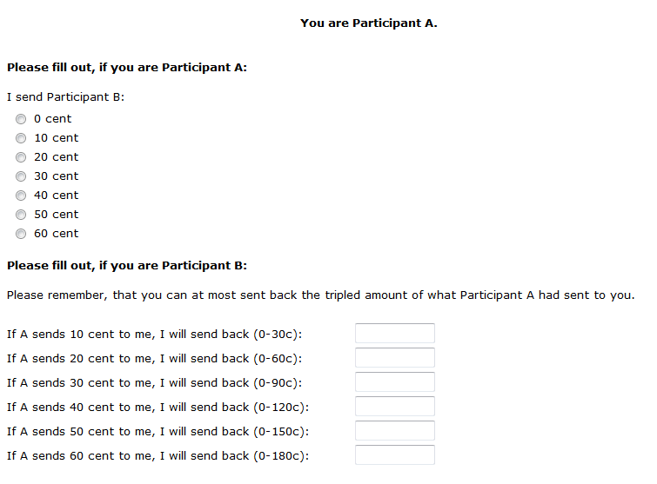

References
Corcoran, K., Hundhammer, T., & Mussweiler, T. (2009). A tool for thought! When comparative thinking reduces stereotyping effects. Journal of Experimental Social Psychology, 45, 1008–1011. doi:10.1016/j.jesp.2009.04.015
Crusius, J., & Mussweiler, T. (2012). To achieve or not to achieve? Comparative mindsets elicit assimilation and contrast in goal priming. European Journal of Social Psychology, 42, 780–788. doi:10.1002/ejsp.873
Mussweiler, T. (2001). “Seek and ye shall find”: Antecedents of assimilation and contrast in social comparison. European Journal of Social Psychology, 31, 499–509. doi:10.1002/ejsp.75
Schul, Y., Mayo, R., & Burnstein, E. (2008). The value of distrust. Journal of Experimental Social Psychology, 44, 1293–1302. doi:10.1016/j.jesp.2008.05.003

