Manuscript MTENER_2018_190:
Supporting data

The voltage profiles for KCl, NaCl and MgCl₂, during charge/discharge cycling, are shown below. This data was used to provide capacity values for each ion system presented in Table 1.

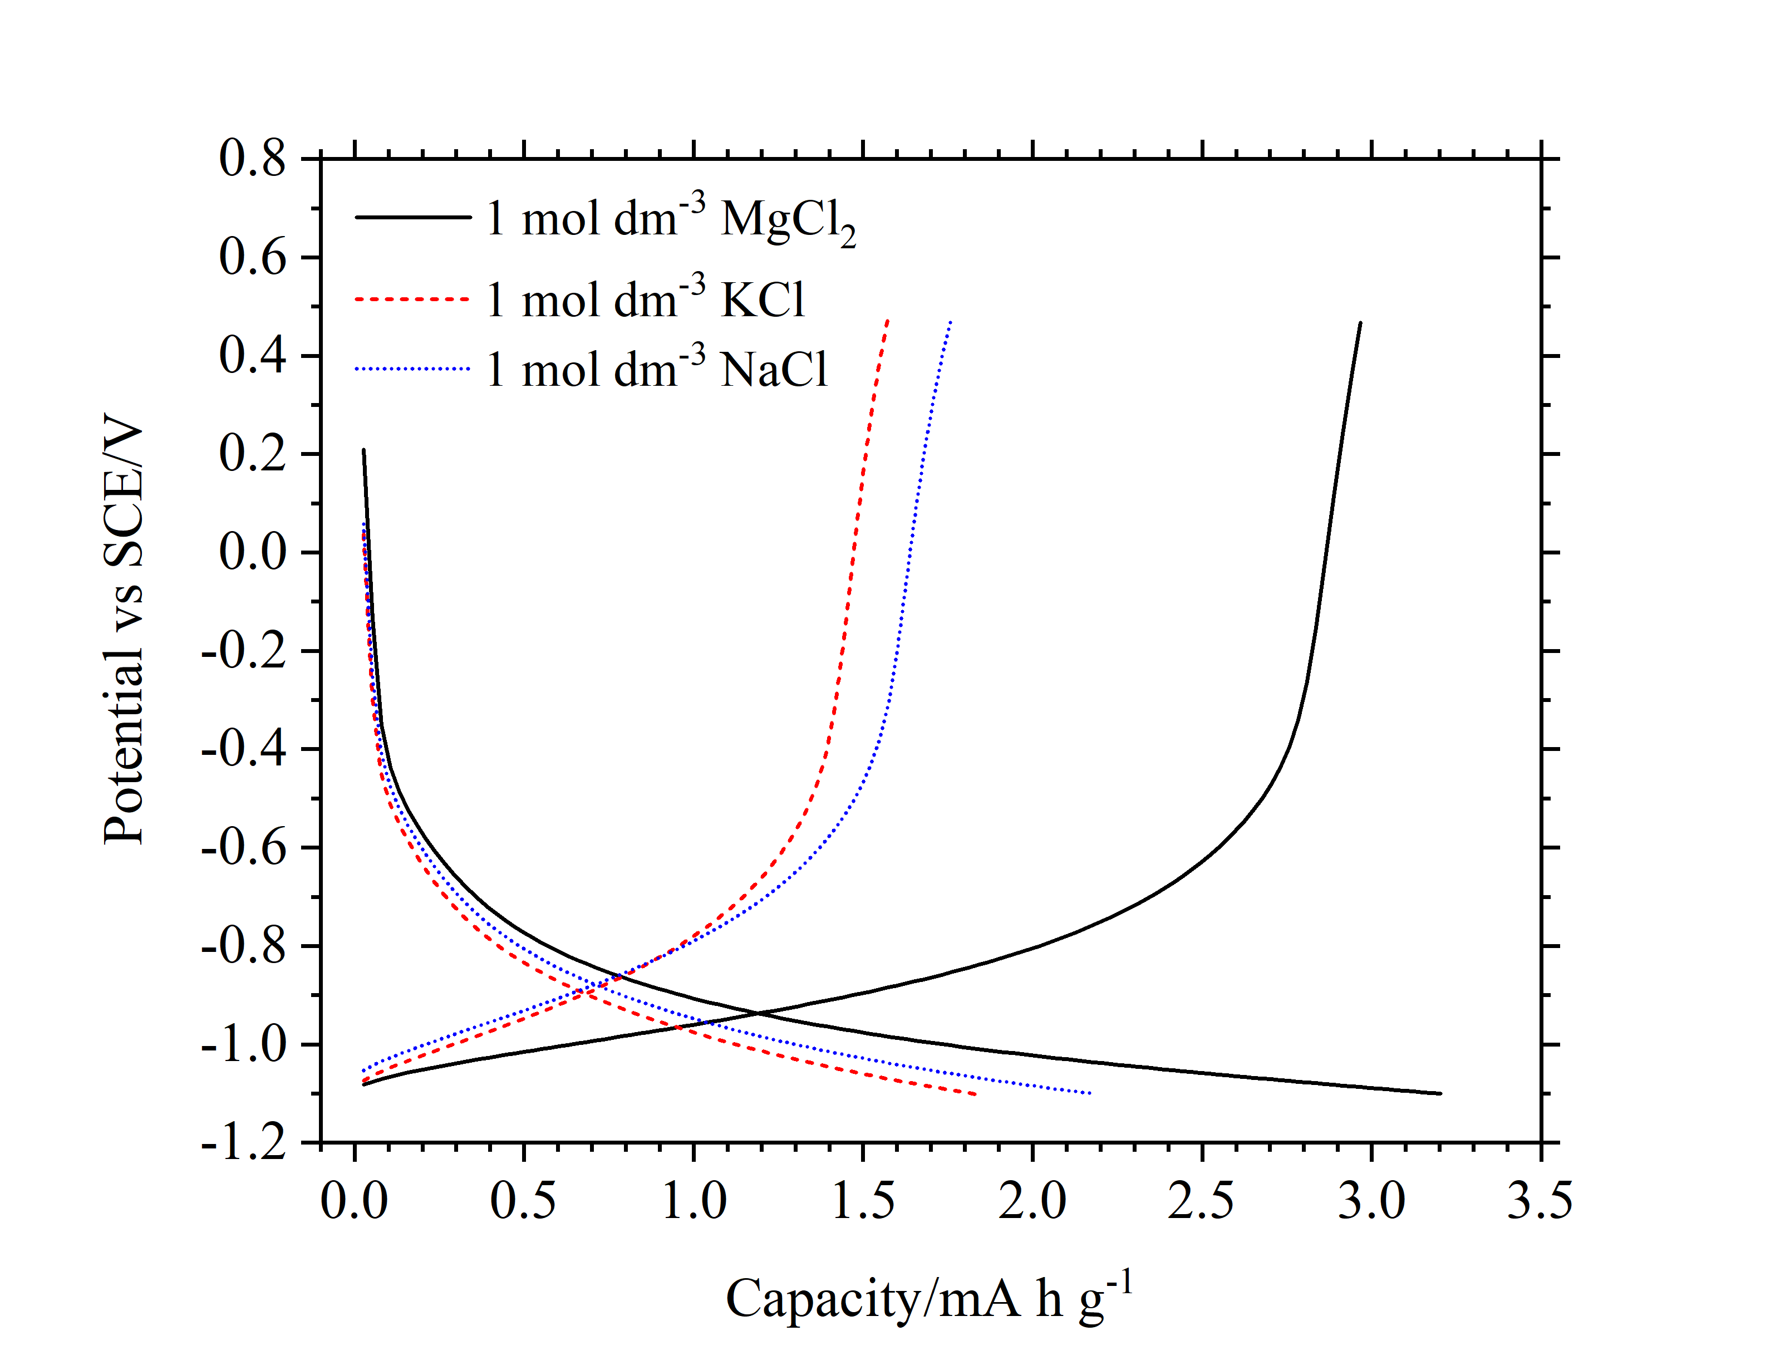
Figure S1. Charge/discharge profiles of TiO₂ in 1 mol dm⁻³ MgCl₂, NaCl and KCl at 1 A g⁻¹.

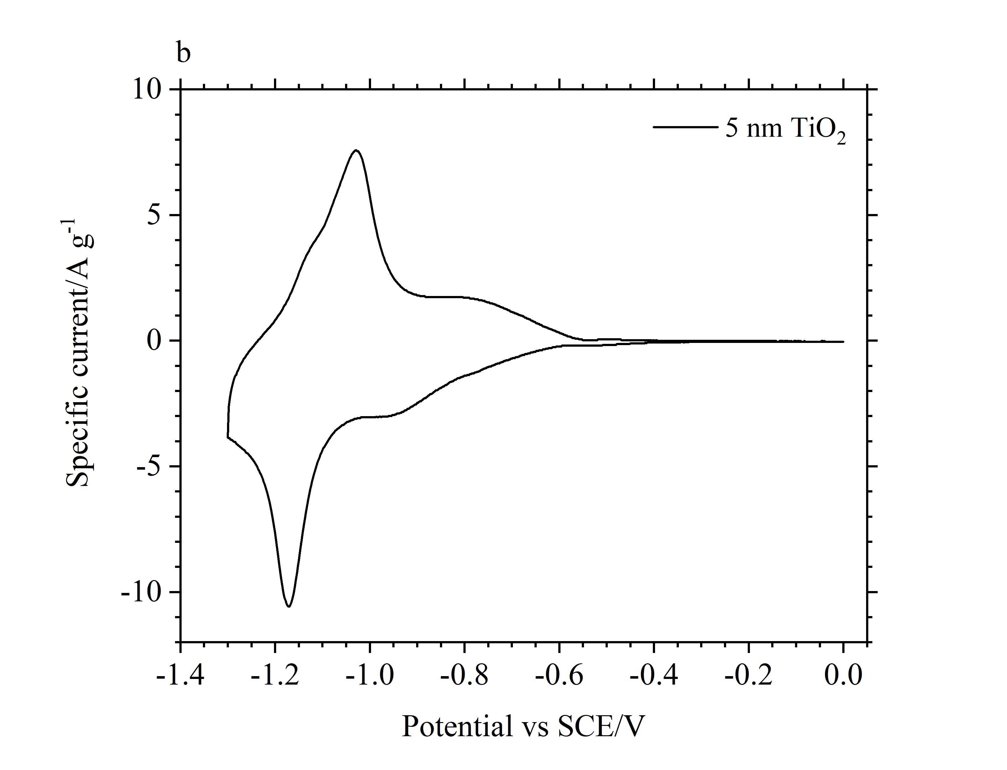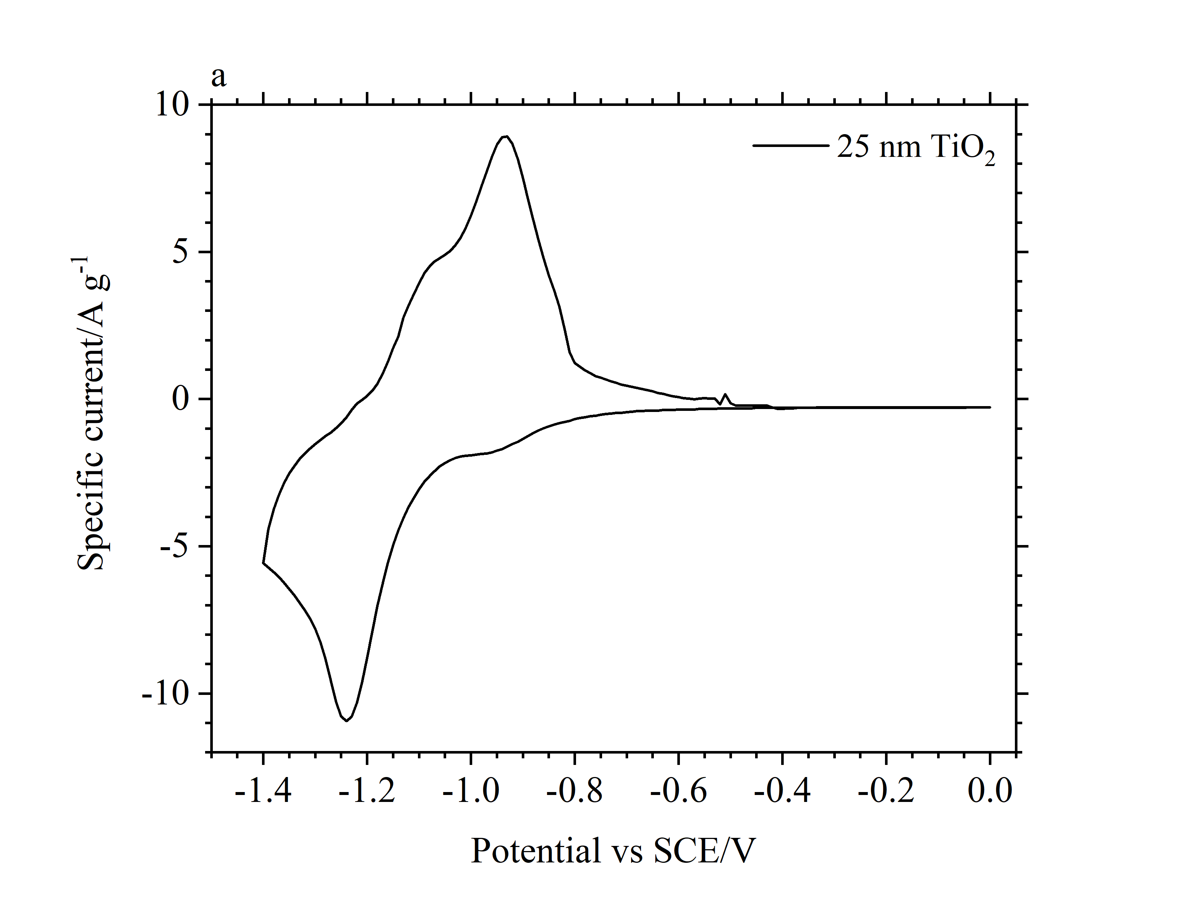

Figure S2. CV scans of TiO₂ electrodes at 10 mV s⁻¹, in 1 mol dm⁻³ AlCl₃, vs SCE using 25 nm (a) and 5 nm (b) powder.

CV scans at 10 mV s⁻¹ in 1 mol dm⁻³ AlCl₃ are shown above, figure S2. However, as seen in other publications, TiO₂ shows no obvious end of state-of-charge during galvanostatic cycling, making the potential range used open to some interpretation, see figure S3. We found that while higher capacities can be achieved by moving the minimum potential, to -1.1 V vs SCE, this negatively impacts on coulombic efficiency, especially at lower specific currents. The figure below demonstrates this, showing cycles at 1.0 A g⁻¹ to either -1.0 V or -1.1 V. As such, the capacity limits chosen (Figure 2, 4 and 5) were found to be near optimal in terms of maximising capacity without significantly reducing coulombic efficiency.
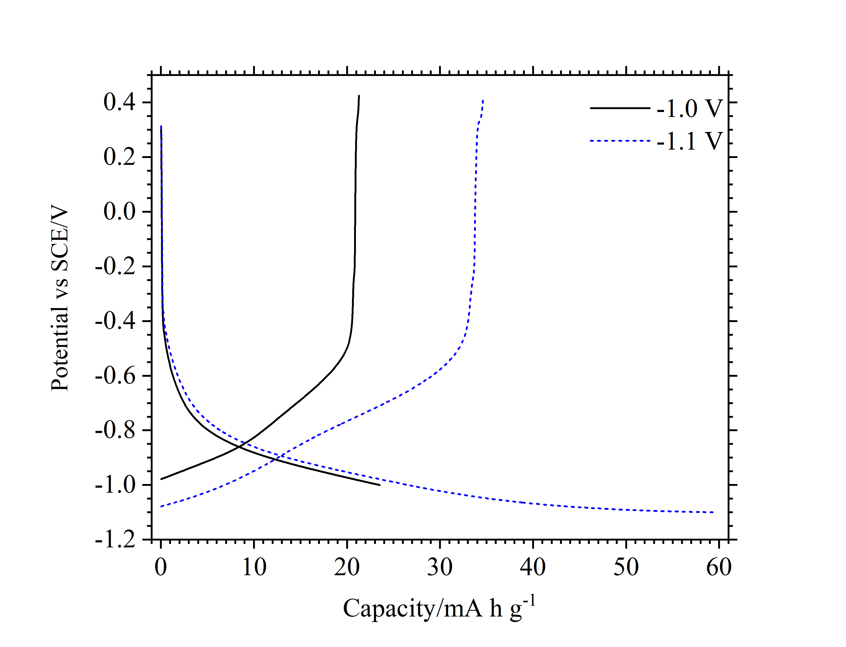
Figure S3. Charge/discharge profiles of TiO₂ in 1 mol dm⁻³ AlCl₃ charged to either -1.0 V (black) or -1.1 V (blue-dash) vs SCE at 1 A g⁻¹.

We suggest a time-dependent self-discharge is evidenced by the decreasing coulombic efficiency at decreasing C-rates (i.e. increasing cycle times). Figure S4 also shows the OCP becoming more positive after charging to -1.0 V. With a 30 minute OCP, discharge capacity was measured at 16.40 mA h g⁻¹, as opposed to 20.10 mA h g⁻¹ without a rest period between charge and discharge.
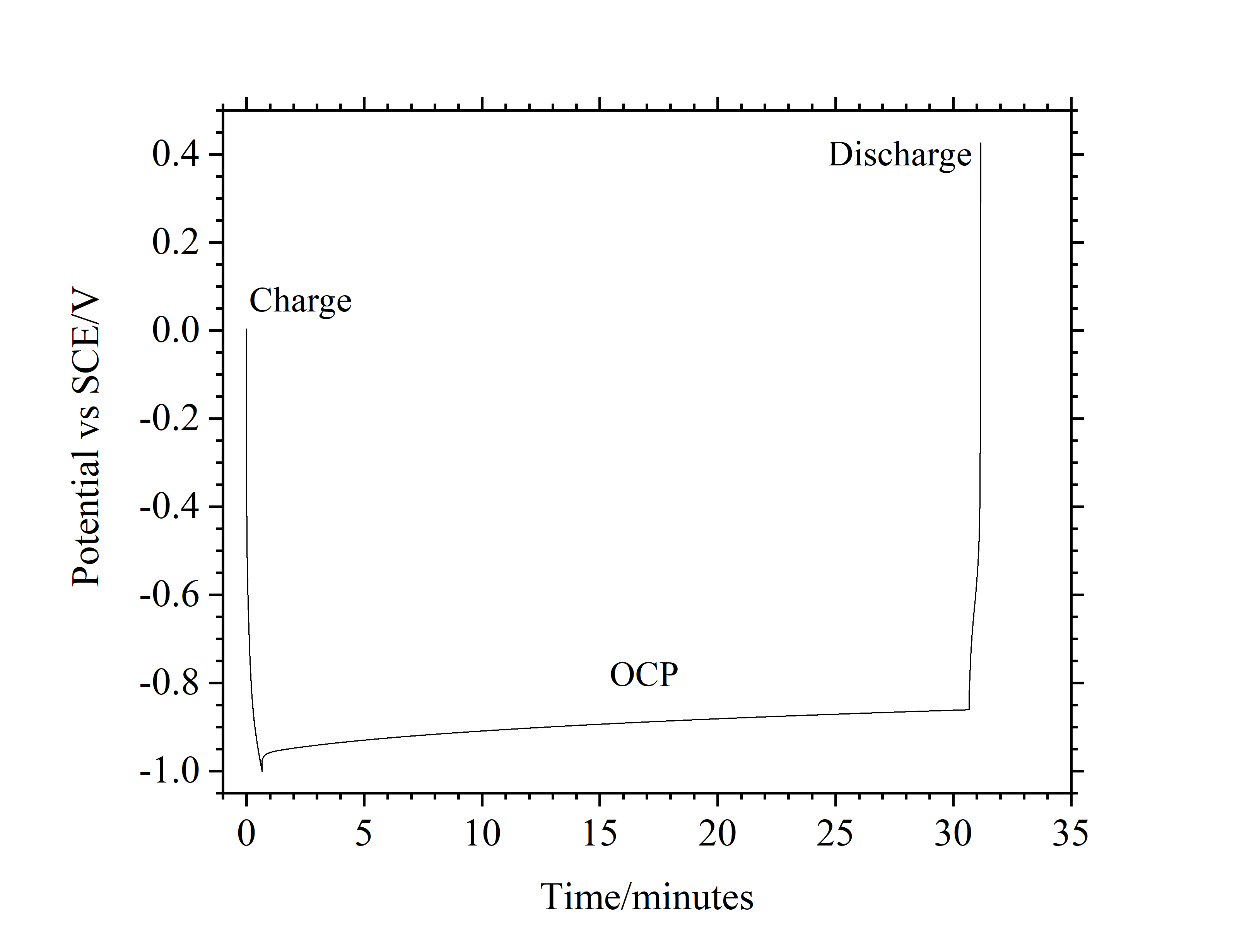
Figure S4. Voltage profiles of TiO₂ charged to -1.0 V, at 2.0 A g⁻¹, and left at open circuit for 30 minutes before discharging.

