**Electronic Supplementary Information**

**A metal-free and a volatile organic solvent-free ipso-nitration of carboxylic acids using a mixture of nitronium tetrafluoroborate, base and 1-hexyl-3,4,5-trimethyl-1H-imidazolium tetrafluoroborate**

Palani Natarajan,* Renu Chaudhary and Paloth Venugopalan

Department of Chemistry & Centre for Advanced Studies in Chemistry, Panjab University, Chandigarh - 160 014, India.

[*pnataraj@pu.ac.in*](mailto:pnataraj@pu.ac.in)

**Table of Contents:**

1. General aspects S2
2. General procedure for the synthesis S2
3. Experimental characterization data for selected products S2-S3
4. Copies of 1H and 13C NMR spectra of selected products S4-S9

**Experimental Section**

**General Aspects**

Unless otherwise noted, all the reactions were performed at 160-190 °C. All commercial chemicals, reagents and precursors were used as received. All reactions were carried out under nitrogen gas atmosphere. All solvents were dried over 4Å molecular sieves and distilled prior to use. Reactions were monitored by analytical thin layer chromatography on silica gel and visualization was accomplished by irradiation with short wave UV light at 254 nm and near UV 366 nm lights. Column chromatography was carried out on silica gel using 60-120 mesh powder. All NMR spectra were recorded on a Bruker Avance (300 MHz) spectrometer in deuterated solvents. Chemical shifts are expressed in parts per million (ppm) and were calibrated using the residual protonated solvent peak. High resolution mass spectra were collected on Waters-Q-TOF-Premier. IR spectra were recorded on a Perkin Elmer Spectrum 1000 FT-IR spectrometer.

**General procedure for the *ipso*-nitration of carboxylic acids**

To a suspension of carboxylic acid (1.0 mmol) and 4-chloropyridine (1.0 mmol) were added NO2BF4 (2.5 mmol) and 1-hexyl-3,4,5-trimethylimidazolium tetrafluoroborate (MIM3, 2.0 mL) under nitrogen gas atmosphere. Resultant mixture was stirred at 190 ± 5 °C for 26 h under nitrogen gas atmosphere. Subsequently, the reaction mixture was cooled down to room temperature, diluted with 50 mL of ethyl acetate and filtered through a short pad of silica-gel column. The filtrate was evaporated in a rotary evaporator under reduced pressure. The crude product was purified by either column chromatography on silica-gel using 5-20% ethyl acetate in hexane or recrystallization employing ethyl acetate-hexane mixture to afford the desired product. The purity of the compound was confirmed by melting point, 1H- and 13C NMR measurements, vide infra.

**4-Nitrobenzonitrile (1b).** *Rf* 0.57 in ethyl acetate–hexane (0.5:9.5); 1H NMR (CDCl3) *δ* (ppm): 7.87 (d, *J* = 8.4 Hz, 2H), 8.34 (d, *J* = 8.4 Hz, 2H); 13C NMR (CDCl3) *δ* (ppm): 116.8, 118.2, 124.3, 133.5, 149.9.

**Nitrobenzene (4b).** *Rf* 0.79 in ethyl acetate–hexane (0.5:9.5); 1H NMR (CDCl3) *δ* (ppm): 7.48-7.54 (m, 2H), 7.61-7.65 (m, 1H), 8.19 (d, *J* = 8.4 Hz, 2H); 13C NMR (CDCl3) *δ* (ppm): 123.4, 129.4, 134.7, 148.2.

**4-Hydroxynitrobenzene (5b)**. *Rf* 0.52 in ethyl acetate–hexane (0.5:9.5); 1H NMR (CDCl3) *δ* (ppm): 7.31 (d, *J* = 8.4 Hz, 2H), 8.02 (d, *J* = 8.4 Hz, 2H); 13C NMR (CDCl3) *δ* (ppm): 123.5, 129.8, 146.1, 146.5.

**4-Chloronitrobenzene (8b).** *Rf* 0.81 in ethyl acetate–hexane (0.5:9.5); 1H NMR (CDCl3) *δ* (ppm): 7.68 (d, *J* = 8.4 Hz, 2H), 8.12 (d, *J* = 8.4 Hz, 2H); 13C NMR (CDCl3) *δ* (ppm): 125.0, 129.9, 132.7, 147.2.

**3-Chloronitrobenzene (9b)**. *Rf* 0.80 in ethyl acetate–hexane (0.5:9.5); 1H NMR (CDCl3) *δ* (ppm): 7.50-7.53 (m, 1H), 7.67 (d, *J* = 8.4 Hz, 1H), 8.16 (d, *J* = 8.4 Hz, 1H), 8.23 (s, 1H); 13C NMR (CDCl3) *δ* (ppm): 121.7, 123.8, 130.5, 134.7, 135.5, 148.9.

**4-(Trifluoromethyl)nitrobenzene (10b)**. *Rf* 0.73 in ethyl acetate–hexane (0.5:9.5); 1H NMR (CDCl3) *δ* (ppm): 7.87 (d, *J* = 8.8 Hz, 2H), 8.49 (d, *J* = 8.8 Hz, 2H); 13C NMR (CDCl3) *δ* (ppm): 121.8, 124.4 (q, *J* = 32 Hz), 127.6, 137.2 (q, *J* = 3 Hz), 150.3 (q, *J* = 260 Hz).

**7-Nitro-1-tetralone (12b)**. *Rf* 0.54 in ethyl acetate–hexane (0.5:9.5); 1H NMR (CDCl3) *δ* (ppm): 2.03-2.09 (m, 2H), 2.72-2.81 (m, 4H), 7.64 (d, *J* = 8.8 Hz, 1H), 8.43 (d, *J* = 8.8 Hz, 1H), 8.49 (s, 1H); 13C NMR (CDCl3) *δ* (ppm): 22.2, 29.7, 38.6, 122.5, 126.99, 130.2, 133.3, 147.2, 150.9, 195.8.

**2-Nitroanthraquinone (17b)**. *Rf* 0.48 in ethyl acetate–hexane (2:8); 1H NMR (CDCl3) *δ* (ppm): 7.85-7.91 (m, 2H), 8.36-8.46 (m, 2H), 8.51 (d, *J* = 8.4 Hz, 1H), 8.59-8.63 (m, 1H), 9.15 (d, *J* = 8.4 Hz, 1H); 13C NMR (CDCl3) *δ* (ppm): 121.2, 126.3, 126.3, 126.6, 127.8, 131.7, 131.8, 133.2, 133.6, 135.5, 149.8, 179.6, 180.2.

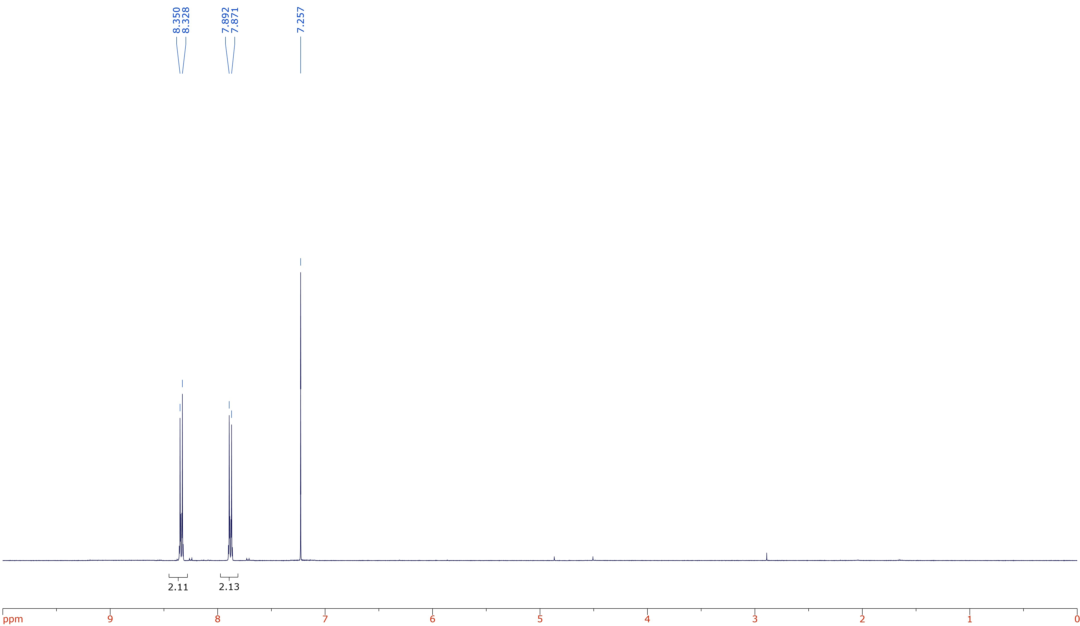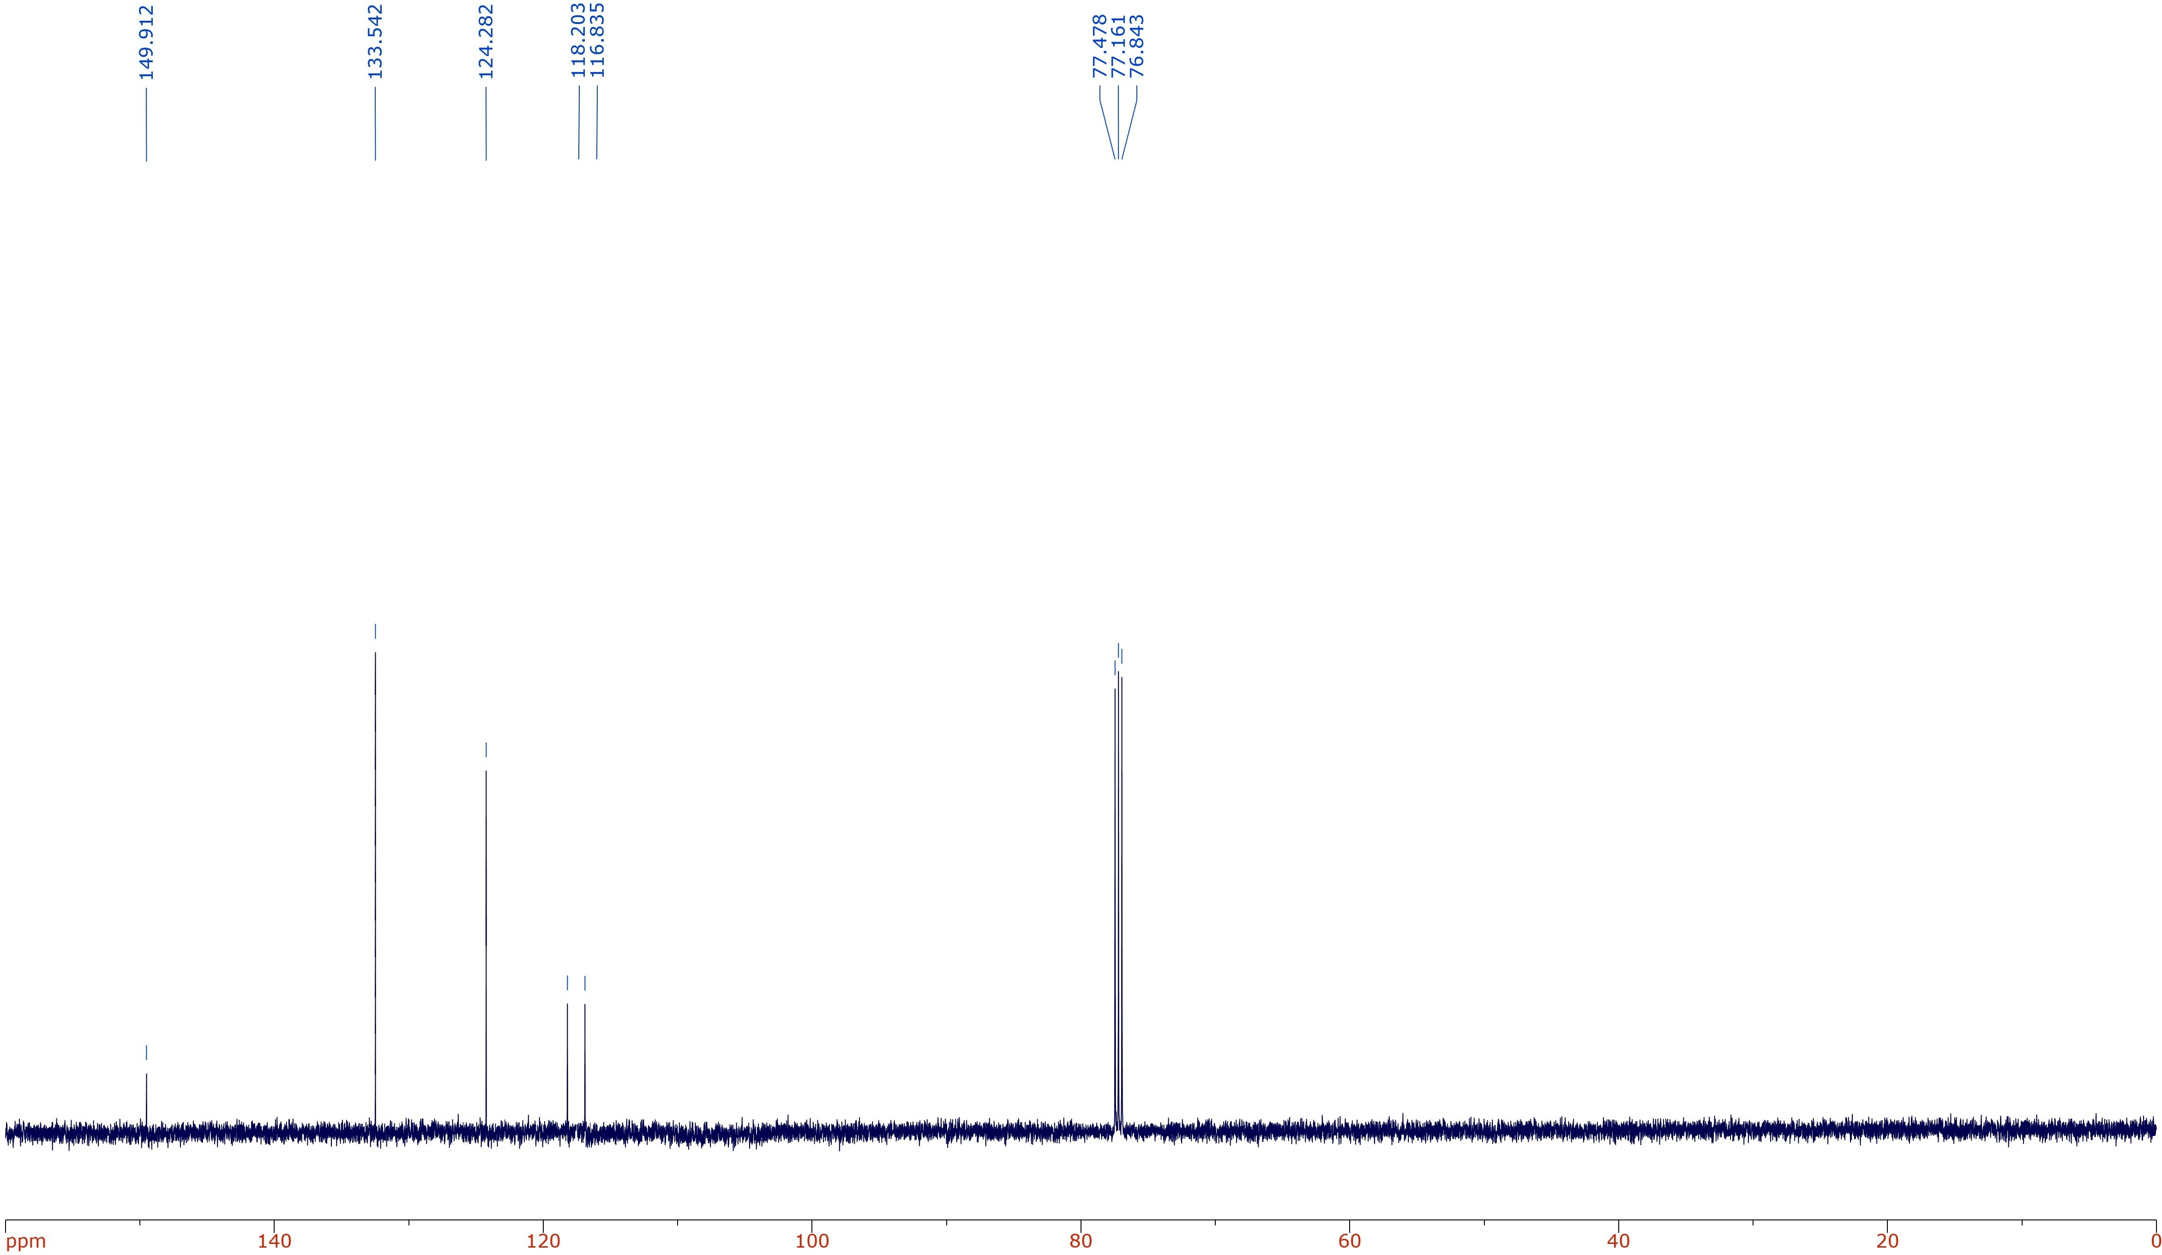

**Figure S1**. IH (top) and 13C (bottom) spectra of 4-nitrobenzonitrilein CDCl3.

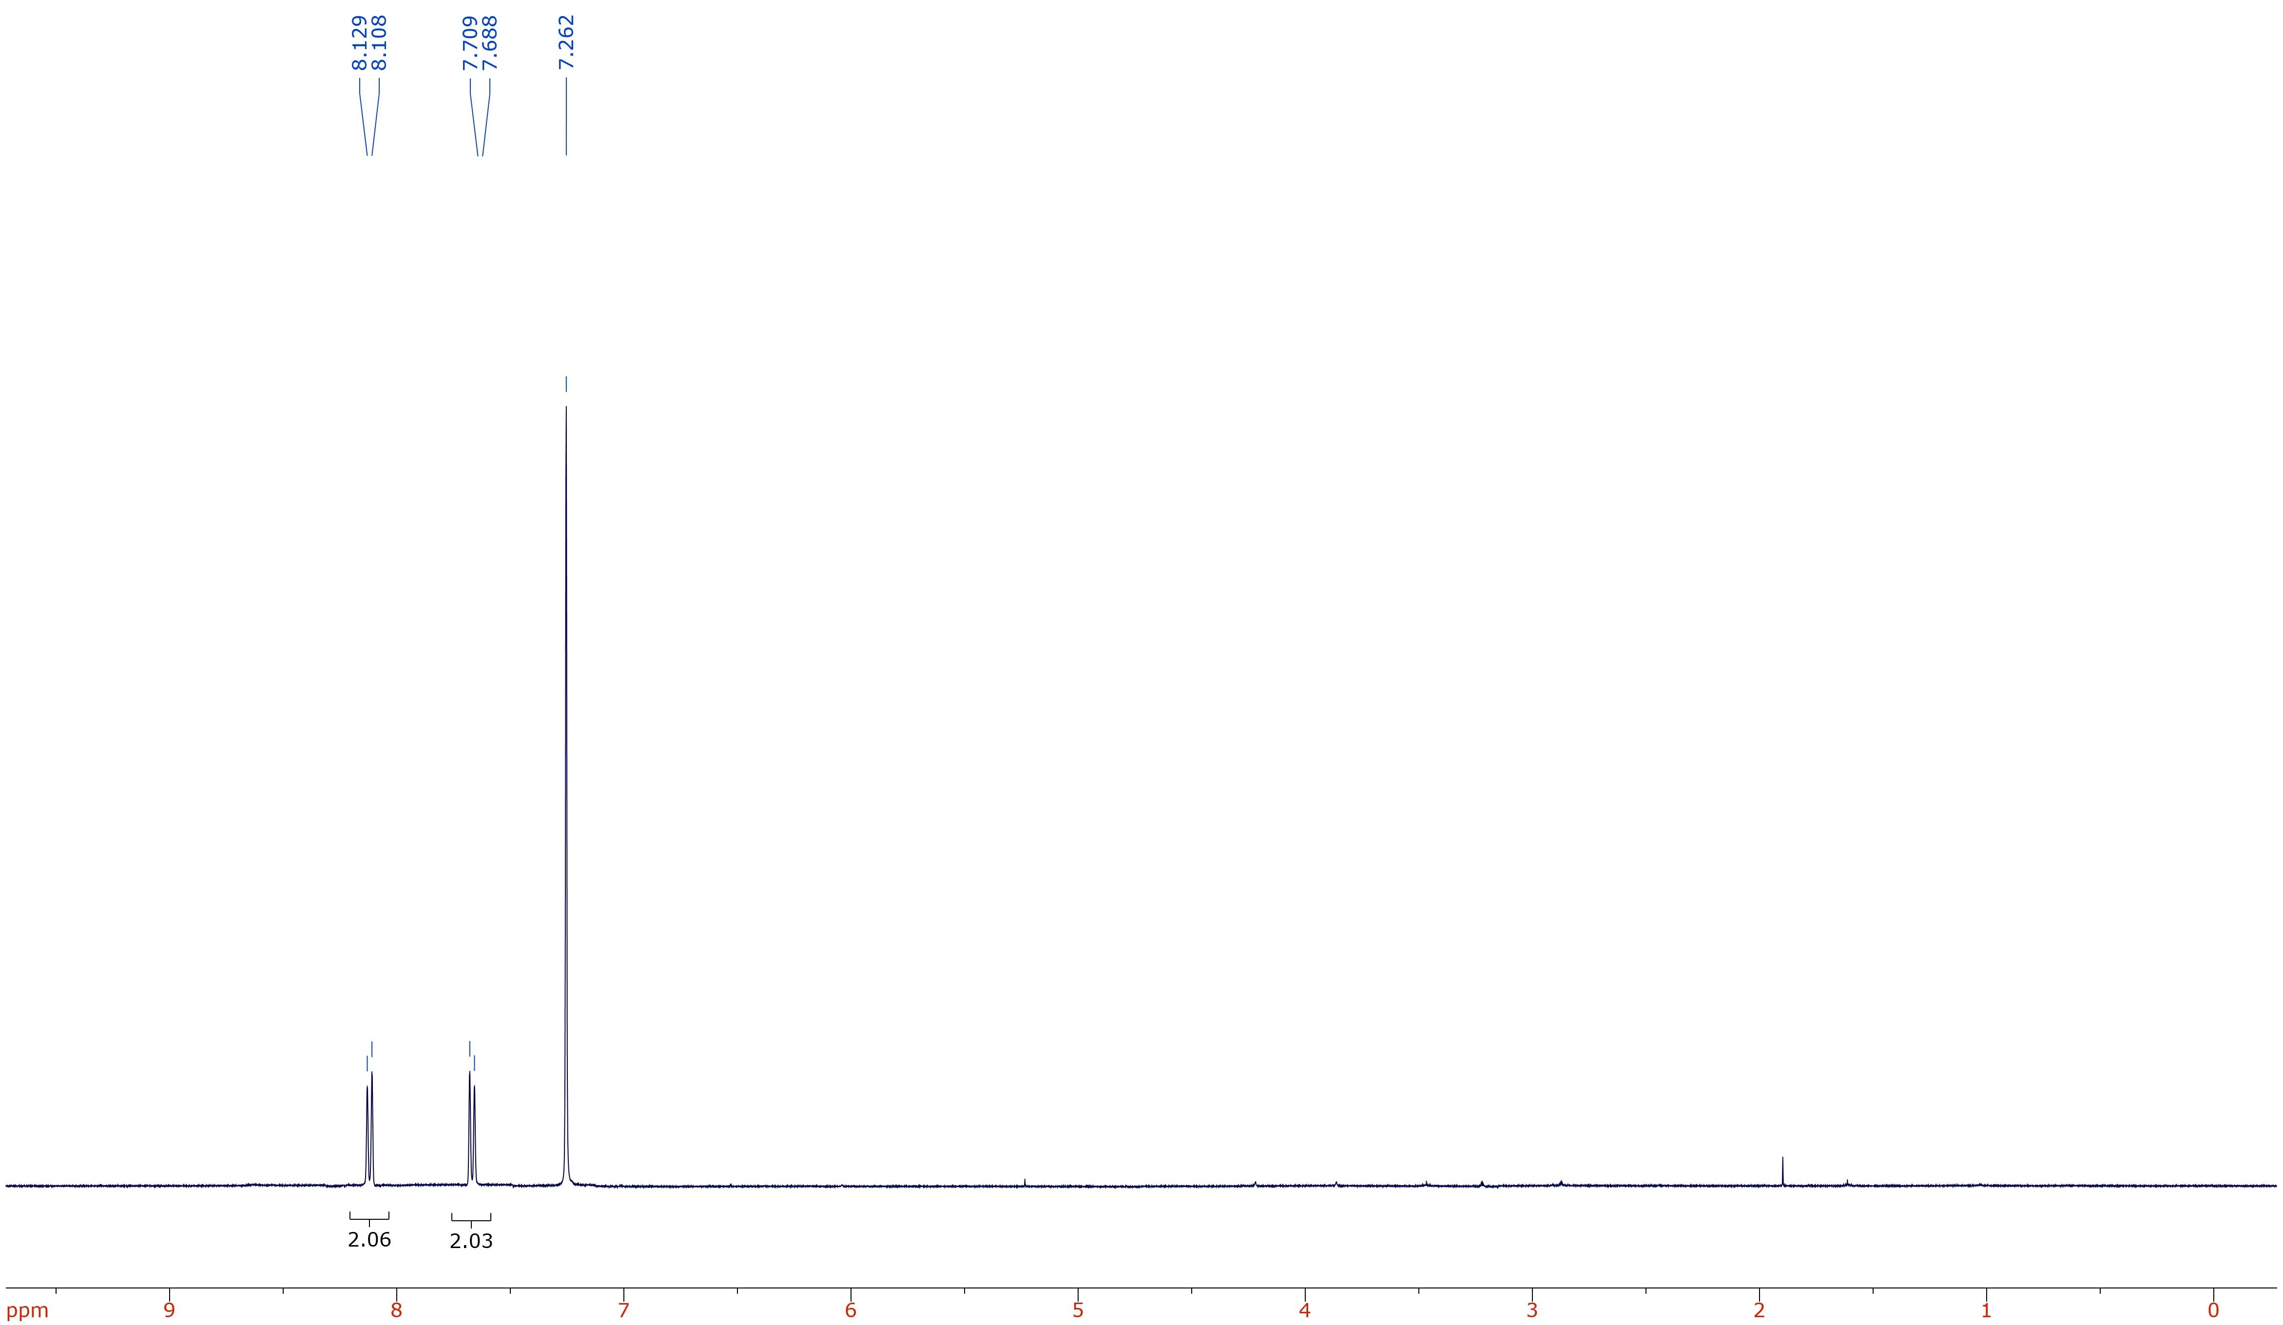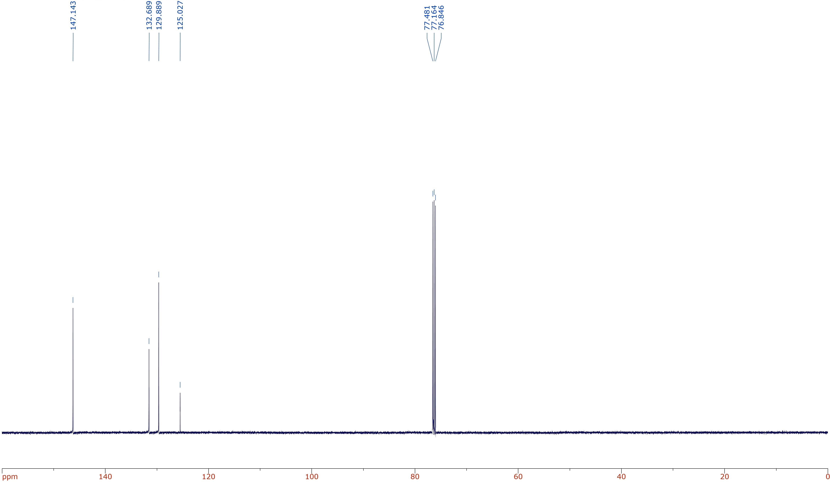

**Figure S2**. IH (top) and 13C (bottom) spectra of 4-chloronitrobenzenein CDCl3.

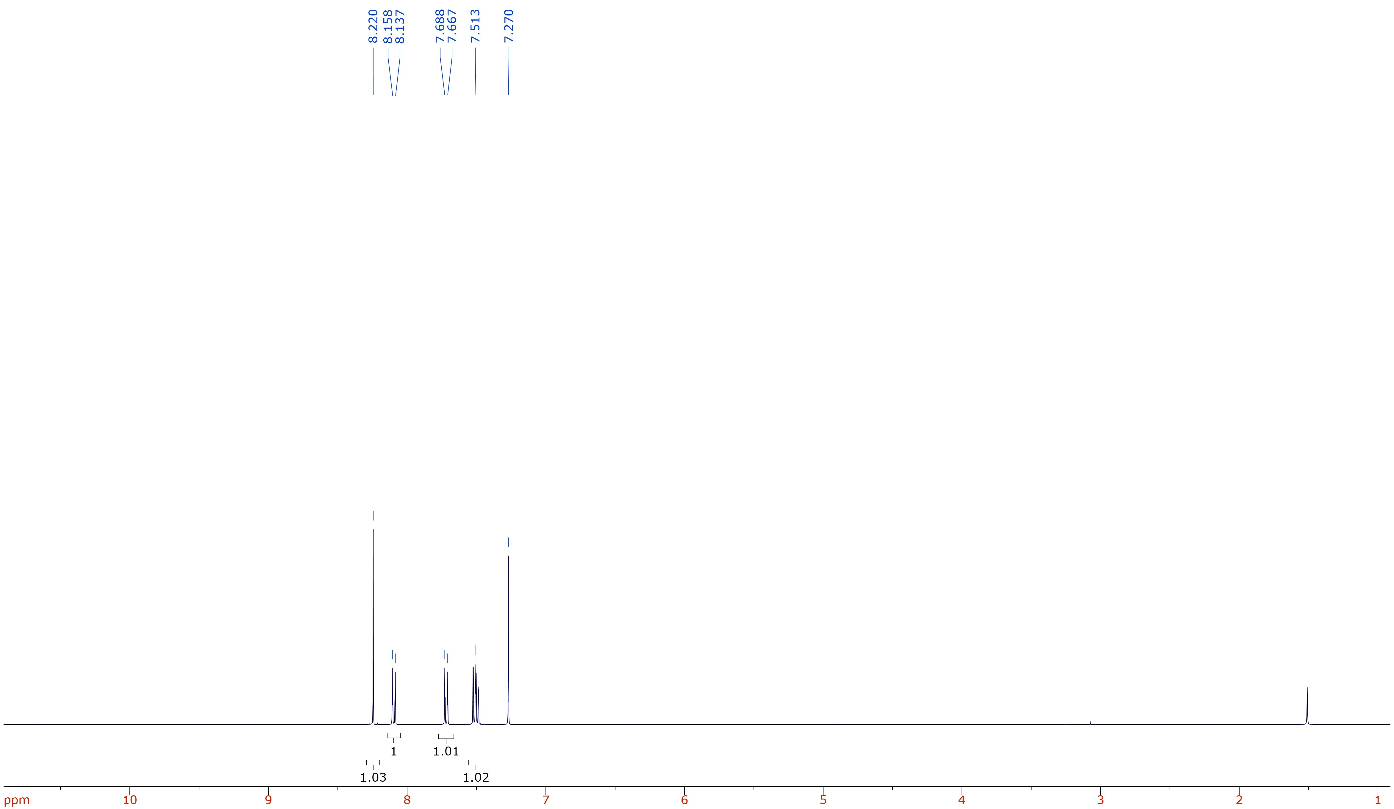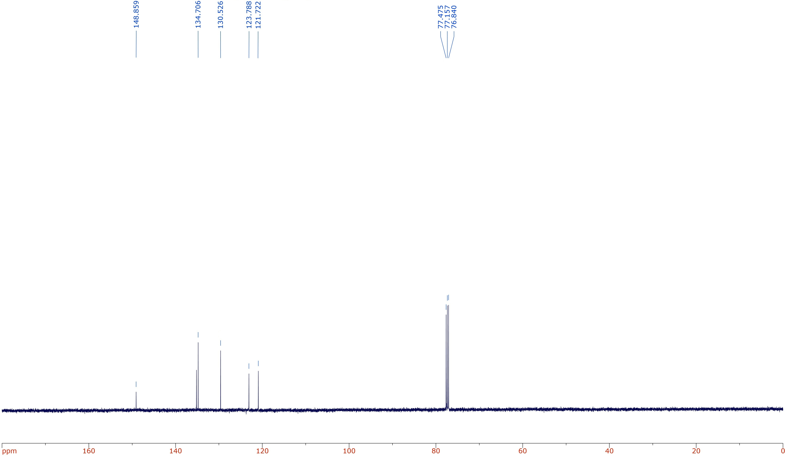

**Figure S3**. IH (top) and 13C (bottom) spectra of 3-chloronitrobenzenein CDCl3.

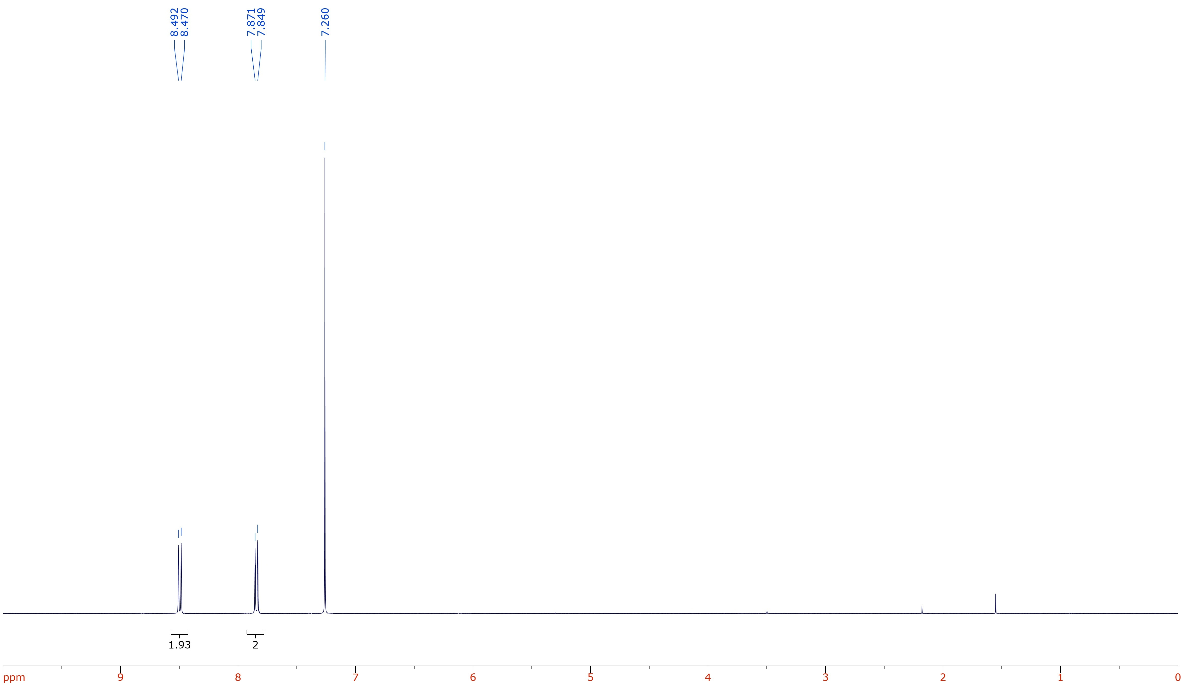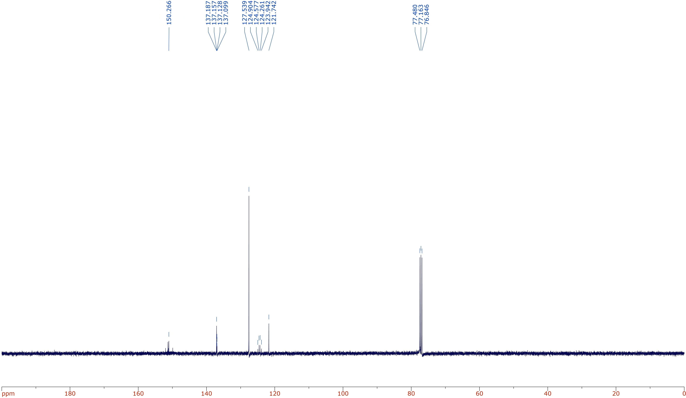

**Figure S4**. IH (top) and 13C (bottom) spectra of 4-(trifluoromethyl)nitrobenzenein CDCl3.

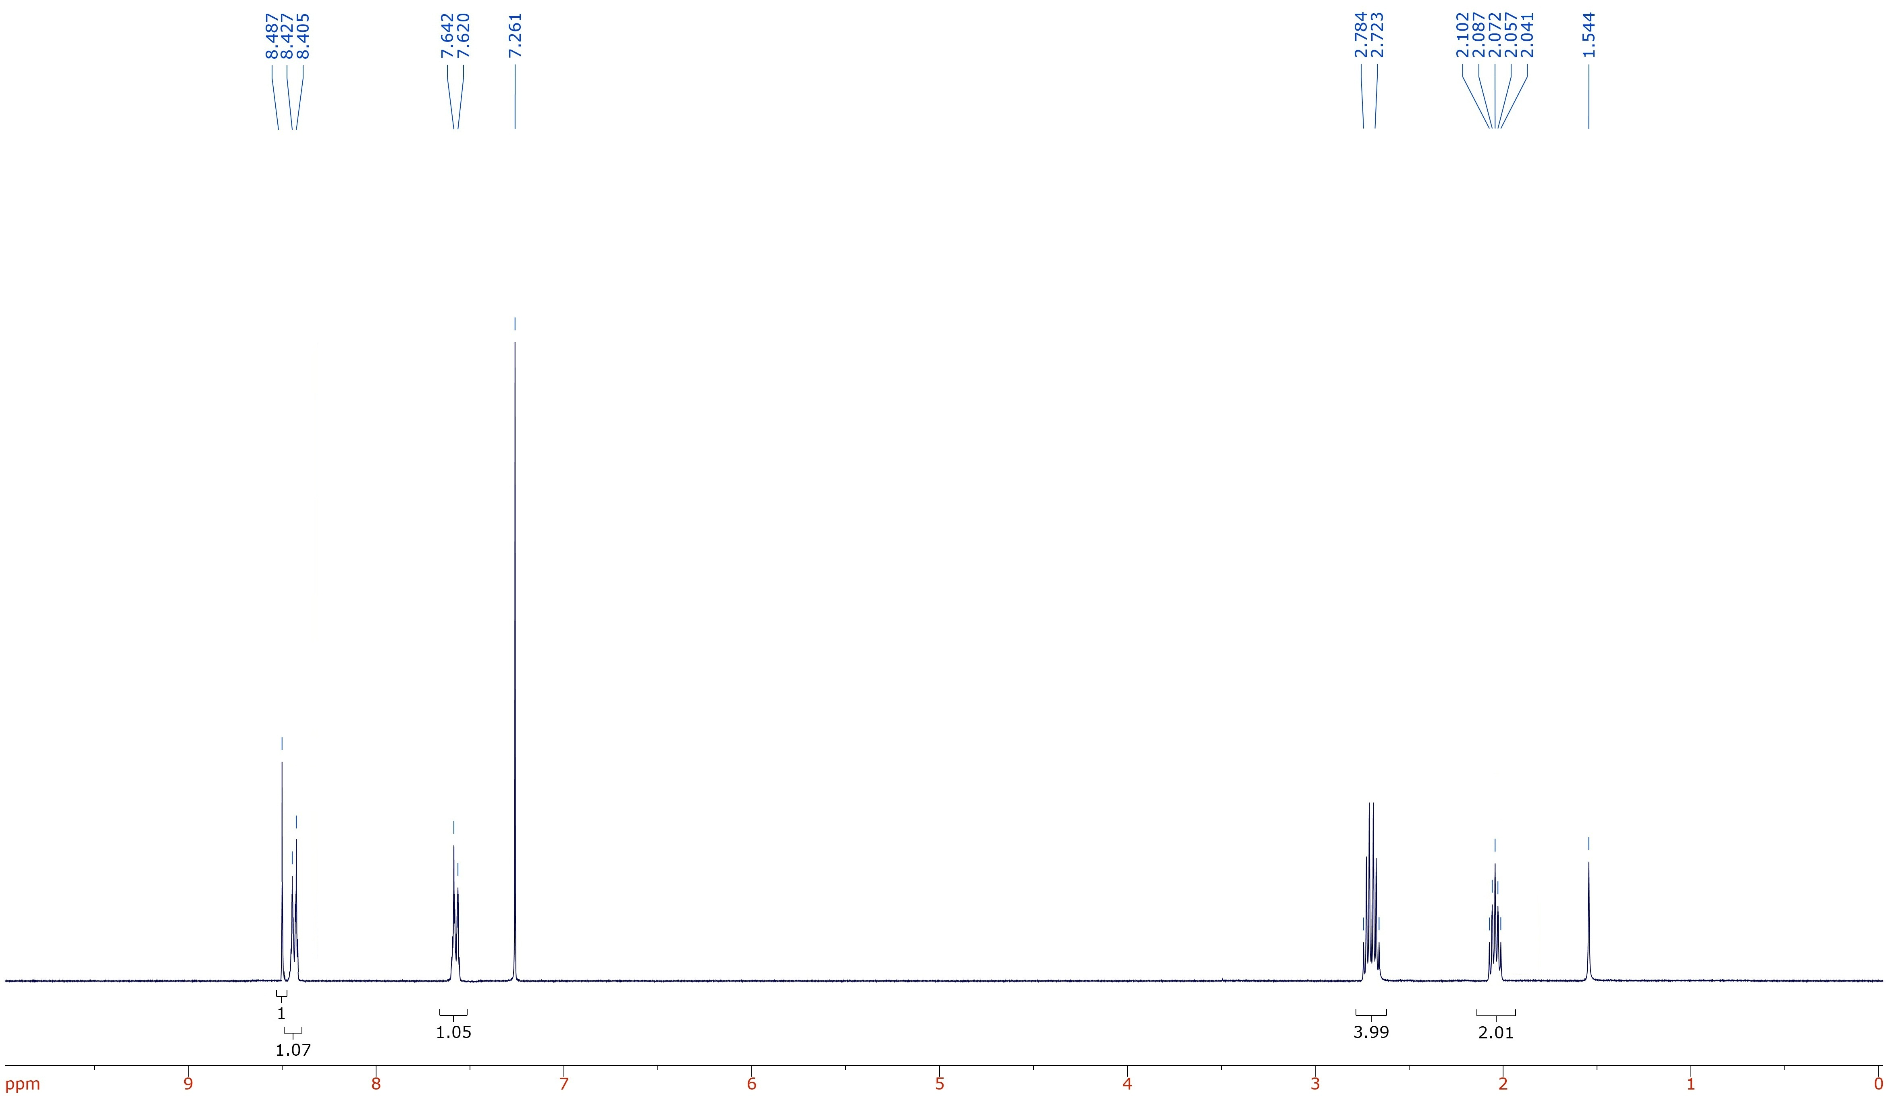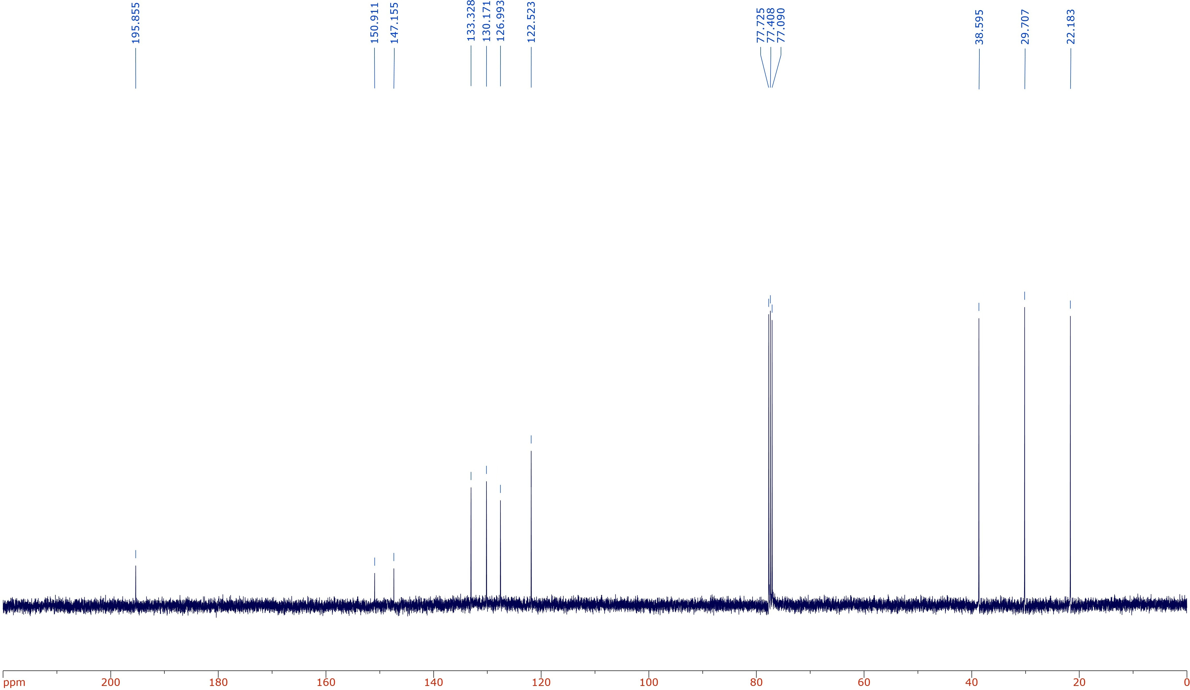

**Figure S5**. IH (top) and 13C (bottom) spectra of 7-nitro-1-tetralonein CDCl3.

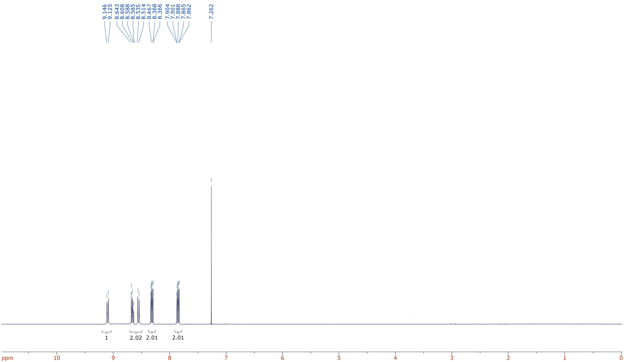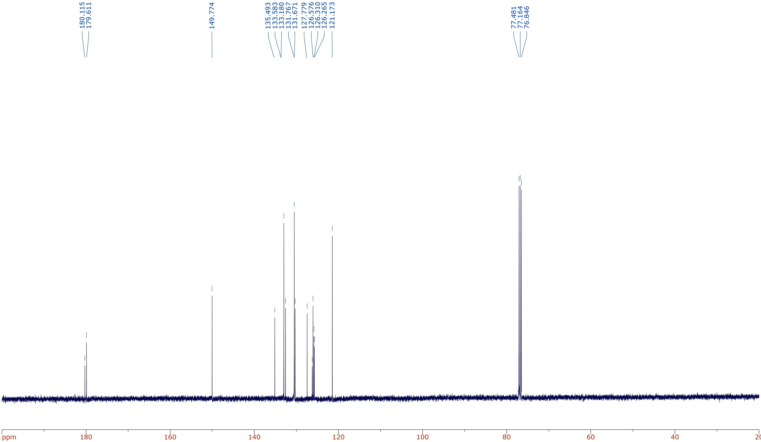

**Figure S6**. IH (top) and 13C (bottom) spectra of 2-nitroanthraquinonein CDCl3.