The second member of the bacterial UDP-N-acetyl-D-glucosamine:heparosan alpha-1, 4-N-acetyl-D-glucosaminyltransferase superfamily: GaKfiA from Gallibacterium anatis
Tian-Tian Wang ª, Jian-Qun Deng ª, Lu-Zhou Chenª, Liu Sun ª, Feng-Shan Wang ^{a, c}, Pei-Xue-Ling ^{a, b, *}, Ju-Zheng Sheng ^{a, c, *}
ª Key Laboratory of Chemical Biology of Natural Products (Ministry of Education), School of Pharmaceutical Sciences, Shandong University, Jinan 250012, China
^{b} Key Laboratory of Biopharmaceuticals, Shandong Academy of Pharmaceutical Sciences, Jinan 250101, China
^{c} National Glycoengineering Research Center, Shandong University, Jinan 250012, China

∗Corresponding authors. Key Laboratory of Chemical Biology of Natural Products (Ministry of Education), School of Pharmaceutical Sciences, Shandong University, Jinan 250012, China.
E-mail: lingpeixue@126.com (PX. Ling); shengjuzheng@sdu.edu.cn (JZ. Sheng)

Supplementary Fig.S1 SDS-PAGE and western blot analysis of GaKfiA expressed in Arctic Express(DE3) strain and BL21(DE3) strain. Lane M1: Protein marker. Lane M2: Western blot marker.
Lane PC1: BSA (1 μg). Lane PC2: BSA (2 μg). Lane NC: Cell lysate without induction. Lane 1: Cell lysate with induction for 16 h at 15℃. Lane 2: Cell lysate with induction for 4 h at 37 ℃. Lane NC1: Supernatant of cell lysate without induction. Lane 3: Supernatant of cell lysate with induction for 16 h at 15 ℃. Lane 4: Supernatant of cell lysate with induction for 4 h at 37 ℃. Lane NC2: Debris of cell lysate without induction. Lane 5: Debris of cell lysate with induction for 16h at 15℃. Lane 6: Debris of cell lysate with induction for 4 h at 37 ℃. The primary antibody for western blot is anti-His antibody.

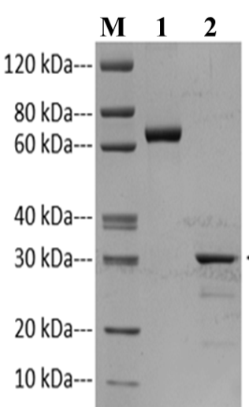
Supplementary Fig.S2 SDS-PAGE analysis of purified GaKfiA. M: Marker; 1: BSA; 2: recombinant GaKfiA protein.

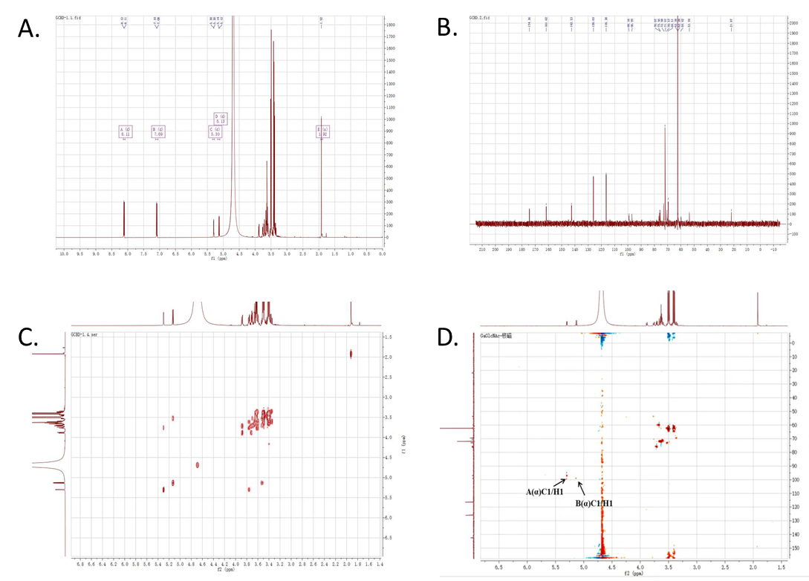
Supplementary Fig.S3 1D and 2D correlation spectra of drisaccharide. Calculated the coupling constant of GaKfiA (~3.45 Hz), indicated that the glycosidic bone of GlcA and GlcNAc residues were the α-(1, 4) linkage, which coupling constant of anomeric proton was near to 4 Hz. (a) 1H N (600 MHz, D₂O) δ 5.3 (d, J = 3.45 Hz, 1H). (b)13C NMR (600 MHz, D₂O). (C)HHCOSY spectra (600 MHz, D₂O). (d)HSQC spectra (600 MHz, D₂O).

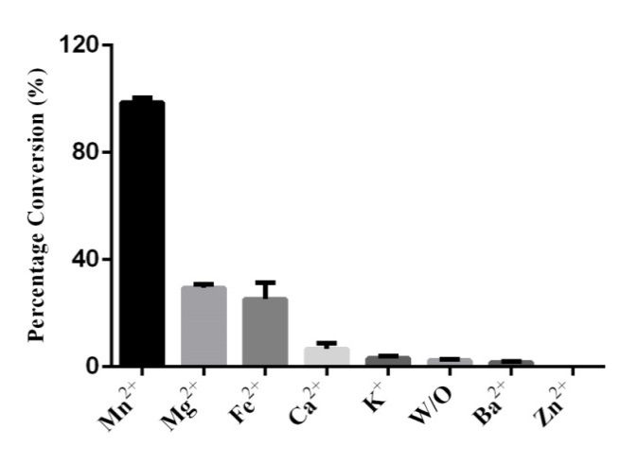
Supplementary Fig.S4 The optimum mental ion of GaKfiA. The activity of GaKfiA was conducted in diverse metal ions (Mn²⁺, Mg2+, Fe2+, Ca2+, K⁺, Ba²⁺, Zn²⁺ and no metal ion) with Tris-Hcl buffer (50 mM, pH 6.5), pNP-GlcA (0.2 mM), UDP-GlcNAc (0.3 mM). The bars indicated the range of assay results from three different batches.

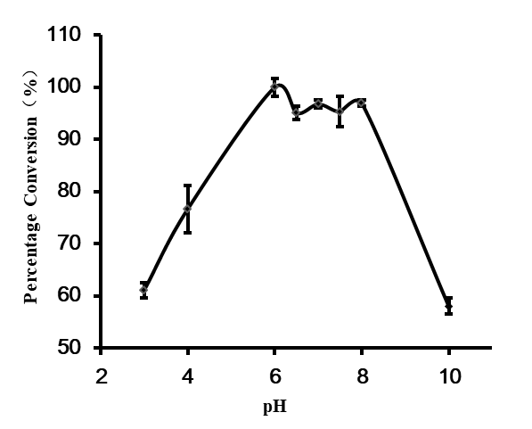
Supplementary Fig.S5 The effect of pH profile on GlcNAc-T activity. The reaction was performed at gradient pH in different buffer (Na₂HPO₄, pH 3.0, 4.0; MES, pH 6.0, 6.5; Tris-HCl，pH 7.0, 7.5, 8.0 and 10.0). Each group of the reaction was performed using three paralleled assays.

Supplementary Fig.S6 The temperature preference of GaKfiA. The enzymatic reaction was carried out at a range of temperature (4 ℃, 10 ℃, 20 ℃, 30 ℃, 37 ℃, and 45 ℃) to detection the optimum temperature conditions, other conditions were performed as described above. All date represented the average of three independent determinations.

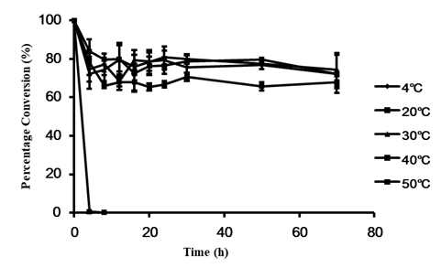
Supplementary Fig.S7 The effect of temperature on GlcNAc-T stability of recombinant GaKfiA. Enzymatic stability was experimented by incubating enzyme in different temperature (4 ℃, 10 ℃, 20 ℃, 30 ℃, 40 ℃, and 50 ℃) and times for 4 h, 8 h, 12 h, 16 h, 20 h, 24 h, 30 h, 50 h, and 70 h respectively. The reaction were incubated at 37 ℃ for 4 hours and analyzed by PAMN-HPLC. There were three parallels for each temperature and time reaction.

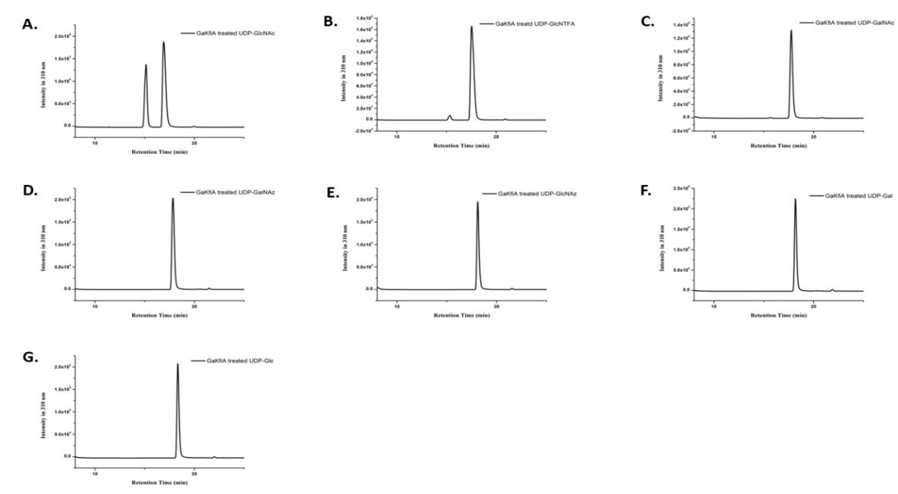
Supplementary Fig.S8 The PAMN-HPLC assays of GlcA-pNP treated with GaKfiA using various donors. Reactions contained GlcA-pNP(0.2 mM) as the acceptor substrate in a reaction mixture containing Tris-HCl (50 mM, pH 7.0), MnCl2 (20 mM), expect UDP-GlcNAc (A) as natural donor substrate, the other nucleic acid sugar derivatives were also analyzed specificity as donor substrate, including UDP-GlcNTFA (B), UDP-GalNAc (C), UDP-GalNAz (D), UDP-GlcNAz (E), UDP-Gal (F), and UDP-Glc (G).
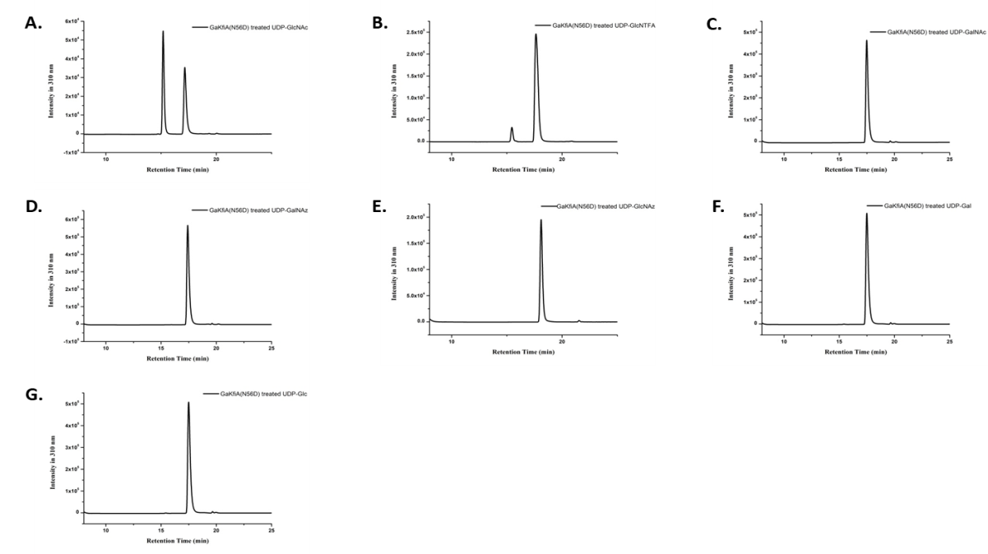
Supplementary Fig.S9 The PAMN-HPLC assays of GlcA-pNP treated with GaKfiA(N56D) using various donors. The PAMN-HPLC analysis of reaction mixture using (A) UDP-GlcNAc; (B) UDP-GlcNTFA; (C) UDP-GalNAc; (D) UDP-GalNAz; (E) UDP-GlcNAz; (F) UDP-Gal; (G) UDP-Glc as the donor substrate.
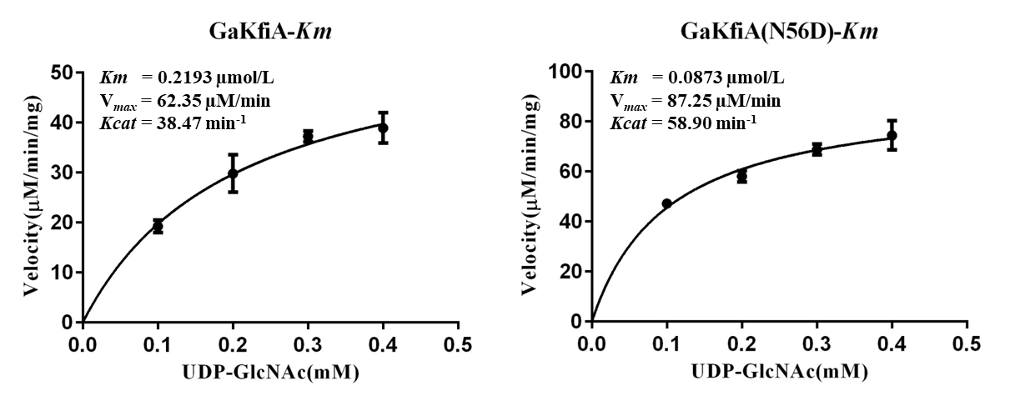
Supplementary Fig.S10 Kinetic parameters of GaKfiA and GaKfiA(N56D). The reaction was contained constant GlcA-pNP of 0.6mM as acceptor substrate concentration and UDP-GlcNAc, which concentration range of 0.1 mM to 0.5 mM. After analyzed by (PAMN)-HPLC, the Vmax and Km can be calculated by Michaelis-Menten kinetics equation.

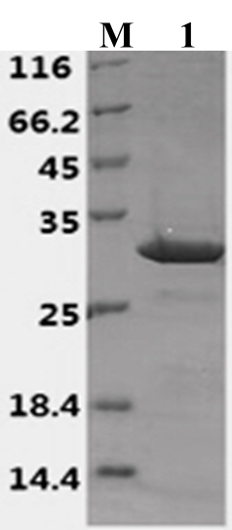
Supplementary Fig.S11 SDS-PAGE analysis of purified GaKfiA(N56D).

