**Supporting information**

**Fig. S1.** FT-IR spectrum of compound **3**.

**Fig. S2.** 1H-NMR spectrum of compound **3**.

**Fig. S3. 13C**-NMR spectrum of compound **3**.

**Fig. S4.** FT-IR spectrum of compound **5**.

**Fig. S5.** 1H-NMR spectrum of compound **5**.

**Fig. S6.** FT-IR spectrum of compound **6**.

**Fig. S7.** 1H-NMR spectrum of compound **6**.

**Fig. S8. 13C**-NMR spectrum of compound **6**.

**Fig. S1.** FT-IR spectrum of compound **3**.

**Fig. S2.** 1H-NMR spectrum of compound **3**.

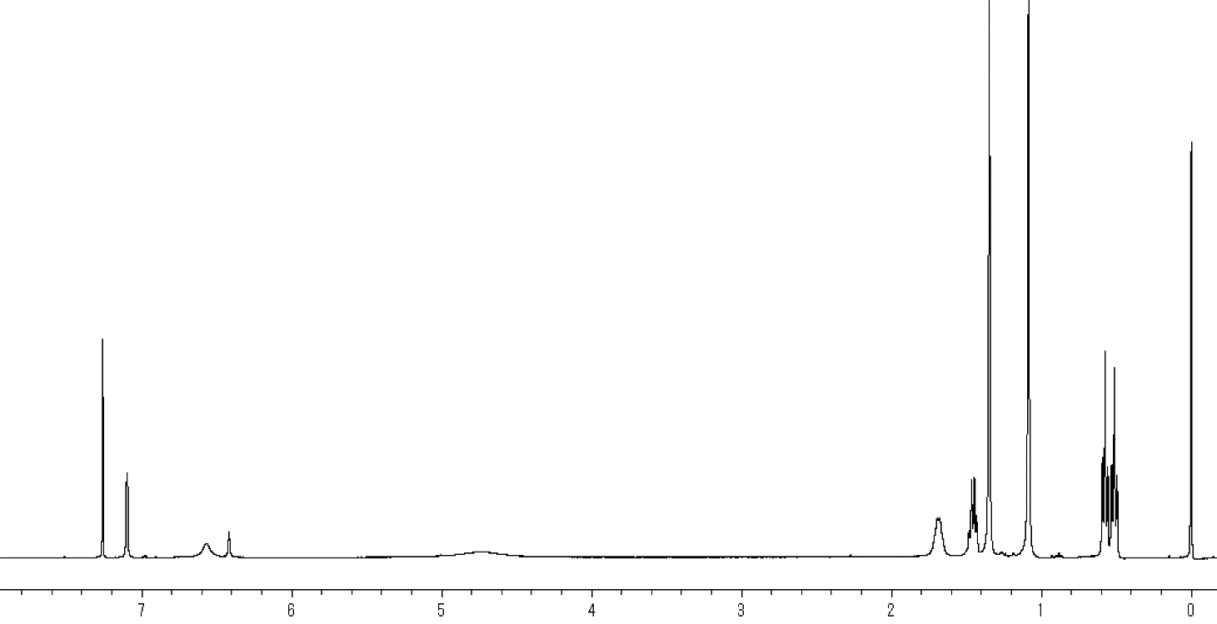

**Fig. S3. 13C**-NMR spectrum of compound **3**.

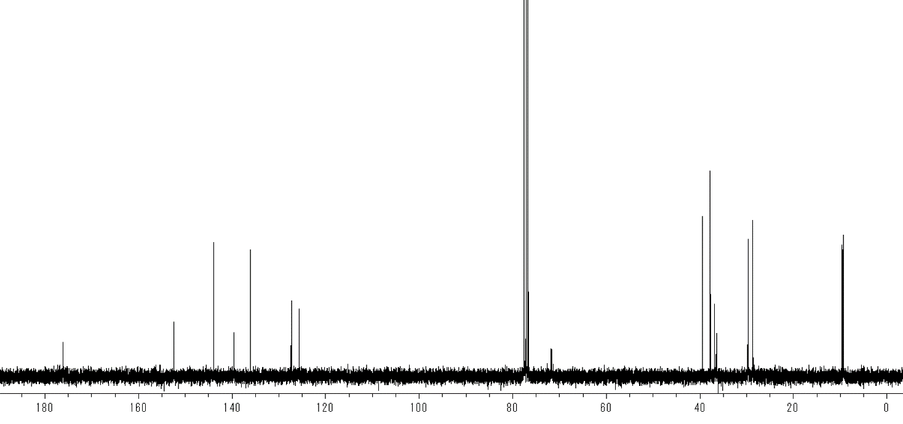



**Fig. S4.** FT-IR spectrum of compound **5**.

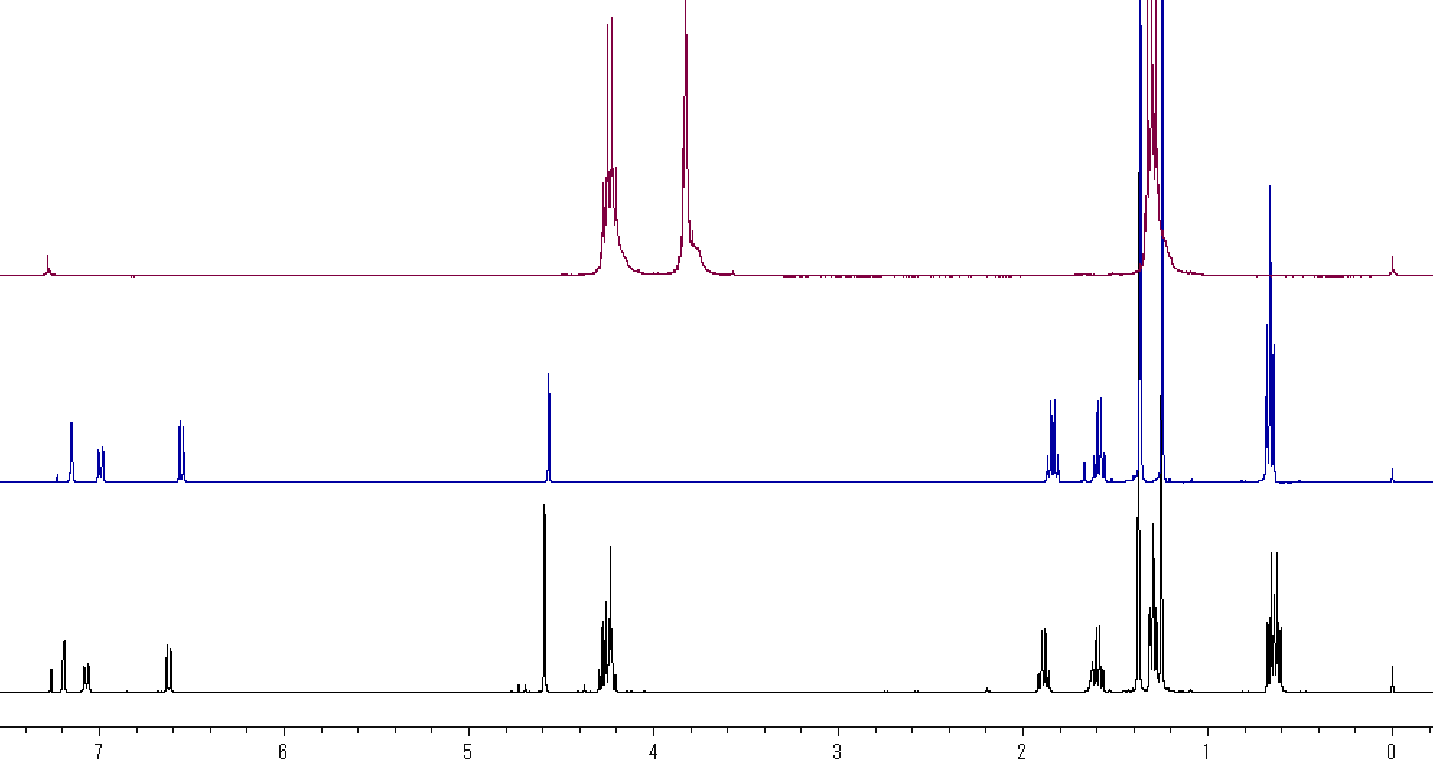

Ethyl bromoacetate

2,4-Di-*tert*-amylphenol

Crude product

**Fig. S5.** 1H-NMR spectrum of compound **5**.

**Fig. S6.** FT-IR spectrum of compound **6**.



**Fig. S7.** 1H-NMR spectrum of compound **6**.

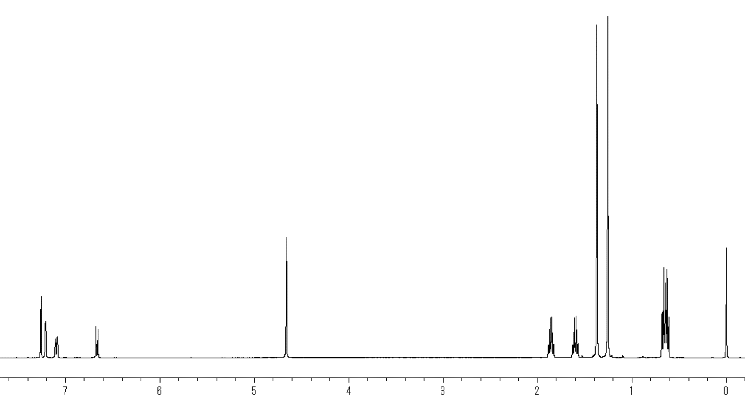

**Fig. S8. 13C**-NMR spectrum of compound **6**.

