Supplementary Material

Comparison of Different Chemical Cleaning Reagents on Fouling Recovery in a Self-Forming Dynamic Membrane Bioreactor (SFDMBR)

Dao Guanª, Ji Dai^{a,}*, Muhammad Ahmar Siddiquiª, and Guanghao Chenª
ª Department of Civil and Environmental Engineering, Water Technology Center, Hong Kong Branch of Chinese National Engineering Research Center for Control & Treatment of Heavy Metal Pollution, The Hong Kong University of Science & Technology, Clear Water Bay, Kowloon, Hong Kong, China.
*Corresponding author phone: (852) 2358 8761; e-mail: cedj@ust.hk

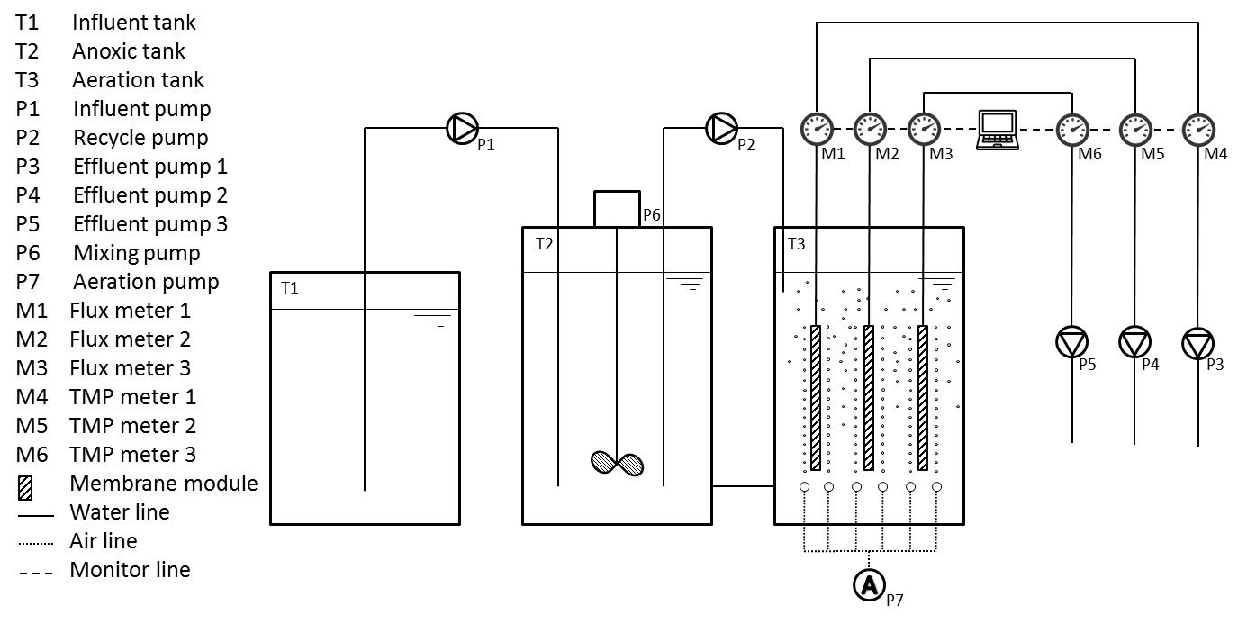
Fig. S1. The scheme of lab-scale reactor.

Table S1
Influent contents.
Contents | Influent Concentration | Contents | Influent Concentration
COD (C₆H₁₂O₆) | 400 mg/L | FeCl₃•6H₂O | 0.45 mg/L
NH₄⁺-N (NH₄Cl) | 31.24 mg/L | H₃BO₃ | 0.045 mg/L
TN | 31.24 mg/L | CuSO₄•5H₂O | 0.009 mg/L
KH₂PO₄ | 13.2 mg/L | KI | 0.054 mg/L
Na₂HPO₄ | 2.7 mg/L | MnCl₂•4H₂O | 0.036 mg/L
Na₂CO₃ | 224.46 mg/L | Na₂MoO₄•2H₂O | 0.018 mg/L
NaHCO₃ | 175.62 mg/L | SnSO₄•7H₂O | 0.036 mg/L
CaCl₂ | 11 mg/L | CoCl₂•6H₂O | 0.045 mg/L
MgCl₂•6H₂O | 71.4 mg/L | pH | 8.2 - 8.9
Na₂EDTA | 3 mg/L | TSS | 0 mg/L

