Size Control of Cross-Linked Carboxy-Functionalized Polystyrene Particles: Four Orders of Magnitude of Dimensional Versatility

*Nina M. Sekerak,† Kristin M. Hutchins,†,‡ Binbin Luo,§,# Jin Gu Kang,§,# Paul V. Braun,§,#,‡ Qian Chen,§,#,† and Jeffrey S. Moore*,†,‡*

†Department of Chemistry, ‡The Beckman Institute for Advanced Science and Technology, §Department of Materials Science and Engineering, and #Frederick Seitz Materials Research Laboratory, University of Illinois at Urbana-Champaign, Urbana, Illinois 61801, United States

Email: jsmoore@illinois.edu

**Table of Contents**

1. General experimental details S2
2. Synthetic procedures S3
3. 13C NMR spectra S6
4. Infrared spectra of particles S10
5. SEM images S13
6. Optical images and videos S15
7. Colloidal assembly S16
8. Supplementary movies S19
9. **General experimental details**

Unless otherwise stated, all starting materials were obtained from commercial suppliers and used without purification. Ethanol (EtOH), 190 and 200 proof, and tetrahydrofuran (THF) were purchased from Fisher Scientific. The monomer precursor 4-vinylbenzoic acid (4-VBA) stabilized with butylated hydroxytoluene (BHT) was purchased from TCI America. The inhibitors were removed from the monomers by passage through a basic alumina column. 1,1’-Carbonyldiimidazole (CDI) was purchased from AK Scientific, Inc. Magnesium sulfate was purchased from Fluka. Sodium dodecyl sulfate (SDS) was purchased from Bio-Rad. The solvent mixture used to disperse particles for optical microscopy imaging was EtOH (Decon Labs, Inc.) and *N*,*N*’-dimethylformamide (DMF, Sigma-Aldrich, anhydrous, 99.8%), as was used as received. All other reagents were purchased from Sigma-Aldrich. DMF used for synthesis was purified by passage through packed columns of activated sieves as described by Pangborn and coworkers.1 Water was obtained from a Millipore (Billerica, MA) Milli-Q water purification system.

The 500 mL three-neck flasks and stirrer bearing were purchased from Chemglass Life Sciences (24/40 joints, item numbers: CG-1524-05 (flask) and CG-2071 (stirrer bearing)). The 300 mL three-neck flasks and glass stirrer shaft were purchased from Wilmad-LabGlass (24/40 joints, product numbers: LG-7331-184 (flask) and LG-9500-100 (stirrer)). The teflon stir blades were purchased from VWR (catalog number: 89062064). A Glas-Col GT Series mechanical stirring system (catalog number: 099D GT31, 333 rpm end was used in each case) and an IKA digital mechanical stirrer (model number: RN20 D2M.n S1) were used for emulsion, dispersion, and suspension polymerizations. For each polymerization, the teflon stir blade and stirrer bearing were affixed to the glass stirrer shaft and used with the noted mechanical stirrer. 1H NMR spectra were recorded on a Varian Unity 500 MHz spectrometer. Chemical shifts (δ) are reported in ppm from tetramethylsilane with the solvent resonance as the internal standard [deuterated chloroform (CDCl3): 7.26 ppm]. Data are reported as follows: chemical shifts, multiplicity (s = singlet, d = doublet, t = triplet, m = multiplet), and coupling constant (Hz). 13C NMR spectra were recorded on a Varian Unity 500 MHz spectrometer with complete proton decoupling. Chemical shifts are reported in ppm from tetramethylsilane with the solvent resonance as the internal standard [deuterated chloroform (CDCl3): 77.16 ppm; deuterated tetrahydrofuran (THF-*d8*): 67.21 ppm]. The particles were swollen in THF-*d8* for several hours prior to collection of the spectrum.

Confocal images were obtained on a Leica SP2 UV & visible laser confocal microscope. Optical images were obtained on a Leica microscope. Fourier Transform Infrared (FTIR) spectra were recorded on a Nicolet Nexus 670 spectrometer with DRIFTS and ATR attachments. Scanning electron microscopy (SEM) images were acquired on a JEOL 6060LV at 10 kV, a Hitachi S4700 at 2 kV, a Hitachi S4800 at 10 kV, or a Philips XL30 ESEM-FEG at 2 kV. The SEM samples were sputter coated with a Au/Pd alloy. Particle sizes were measured using ImageJ. Movies were collected on a Zeiss inverted microscope (Axiovert 200), using a complementary metal-oxide-semiconductor (CMOS) camera (Edmund Optics 5012M GigE). 5x air objective (NA=0.12), 63x air objective (NA=0.75), and 100x oil objective (NA=1.30) were used. DLS measurements were collected on a Zetasizer Nano ZS (Malvern, UK).

1. **Synthetic procedures**

*Synthesis of tert-butyl vinyl benzoate (****1****)*



The protected vinyl monomer, *tert*-butyl-4-vinylbenzoate (**1**), was synthesized using a modified literature procedure.2 Briefly, 4-vinylbenzoic acid (6 g, 40.5 mmol) and 1,1’-carbonyldiimidazole (10.0 g, 61.7 mmol) were dissolved in DMF (18 mL) and heated to 50 °C for 3 h. The reaction mixture was removed from heat, and *tert*-butanol (*t*BuOH) (5.0 mL, 52 mmol) and 1,8-diazabicyclo[5.4.0]undec-7-ene (DBU) (2.4 mL, 16 mmol) were added by syringe. The mixture was stirred at room temperature for 48 h. After 48 h, the reaction mixture was diluted with diethyl ether (300 mL) and washed with 0.5 M HCl (3 x 100 mL) and saturated sodium carbonate (2 x 50 mL). The organic layer was dried over magnesium sulfate. Butylated hydroxytoluene (BHT) (8.0 mg, 36 μmol) was added to the organic layer. The product was concentrated *in vacuo* to afford a light yellow oil (5.7 g, 73% yield), which was stored at -30 °C.

1H NMR (500 MHz, CDCl3): δ: 7.94 (d, *J* = 8.3 Hz, 2H), 7.44 (d, *J* = 8.3 Hz, 2H), 6.75 (dd, *J* = 17.6, 10.9 Hz, 1H), 5.85 (d, *J* = 17.7 Hz, 1H), 5.36 (d, *J* = 10.9 Hz, 1H), 1.59 (s, 9H).

13C NMR (500 MHz, CDCl3): δ: 165.53, 141.38, 136.09, 131.13, 129.67, 125.90, 116.09, 80.92, 28.18.

*Synthesis of protected carboxy-polystyrene (carboxy-PS) particles of varying sizes (****2****)*



See experimental section in the main text for size-dependent polymerization method. Distinctive peaks in the gel-phase 13C NMR of **2** are denoted below.

13C NMR (500 MHz, THF-*d8*): δ: 28.29 (C(CH3)3), 80.41 (C(CH3)3), and 165.65 (carbonyl).

*Cleavage of tert-butyl esters (****3****)*



See experimental section in the main text for procedure. Distinctive peaks in the gel-phase 13C NMR of **3** are denoted below.

13C NMR (500 MHz, THF-*d8*): δ: 167.47 (carbonyl), absence of *tert*-butyl peaks.

*Synthesis of 1-pyrenebutanol functionalized particles (****4****)*



See experimental section in the main text for functionalization procedure. Distinctive peaks in the gel-phase 13C NMR of **4** are denoted below.

13C NMR (500 MHz, THF-*d8*): δ: 166.55 (carbonyl), 133-122 (aromatic), 29.76, 29.21, 22.38, 21.01 (aliphatic).

*Synthesis of n-butylamine functionalized particles (****5****)*



See experimental section in the main text for functionalization procedure. Distinctive peaks in the gel-phase 13C NMR of **5** are denoted below.

13C NMR (500 MHz, THF-*d8*): δ: 166.81 (carbonyl), 40.10, 33.09, 21.08, and 14.33 (aliphatic).

*Synthesis of m-chloroperbenzoic acid functionalized particles (****6****)*



See experimental section in the main text for functionalization procedure. Distinctive peaks in the gel-phase 13C NMR of **6** are denoted below.

13C NMR (500 MHz, THF-*d8*): δ: 163.20, 162.52 (two carbonyl signals), 135.76, 135.14, 131.52 (aromatic).

*Synthesis of protected carboxy-polystyrene microparticles by suspension polymerization with varying crosslinker (****2****)*

The polymerization was conducted as in the experimental section of the main text; however, the amount and identity of the crosslinker was varied. The incorporated crosslinkers are divinylbenzene (DVB), ethylene glycol dimethacrylate (EGDMA), and poly(ethylene glycol) dimethacrylate (PEGDMA, Mn 550). The total amount of styrene and comonomer **1** was held constant (total = 18.1 g). The amount of crosslinker that was added is listed in Table S1.

**Table S1**. Amount of crosslinker used in suspension polymerization reactions.

|  |  |  |  |
| --- | --- | --- | --- |
| Crosslinker (mmol/g) | Chemical structure | Mass of crosslinker (g) | mol % |
| DVB (0.032) |  | 0.075 | 0.35 |
| DVB (0.063) | 0.148 | 0.69 |
| DVB (0.24) | 0.566 | 2.58 |
| EGDMA (0.033) |  | 0.118 | 0.36 |
| EGDMA (0.063) | 0.226 | 0.69 |
| EGDMA (0.24) | 0.861 | 2.57 |
| PEGDMA (0.031) |  | 0.309 | 0.34 |
| PEGDMA (0.062) | 0.617 | 0.68 |
| PEGDMA (0.25) | 2.49 | 2.68 |

1. **13C NMR spectra**

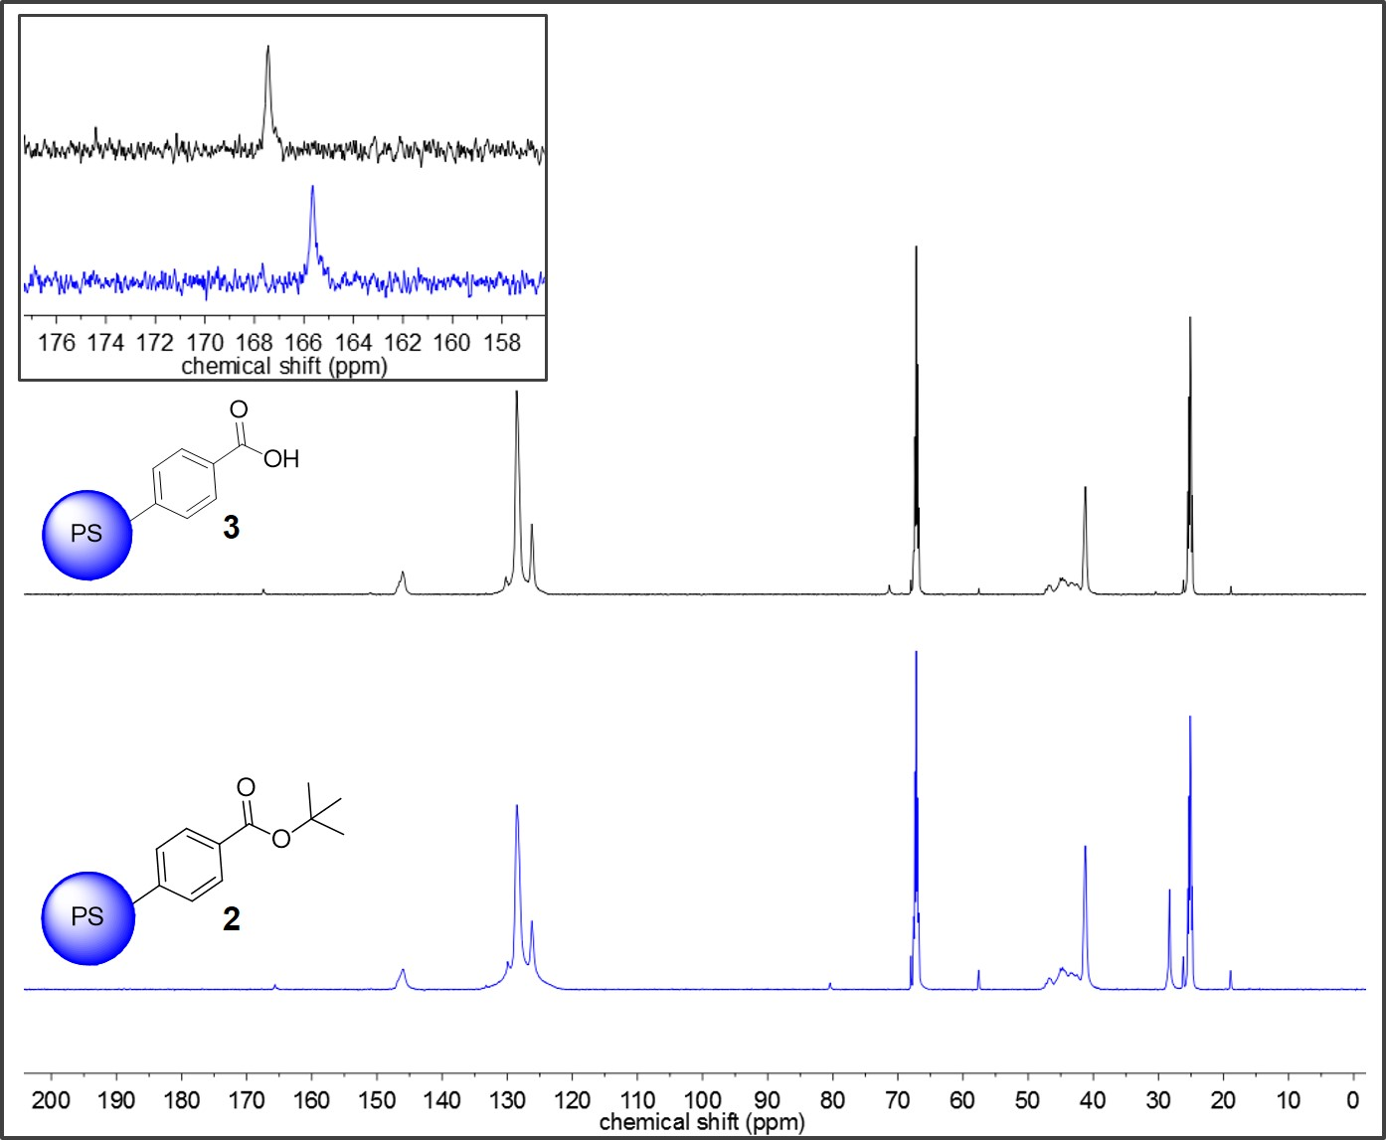

**Figure S1**. Gel-phase 13C NMR (THF-*d8*) of particles of **2** (blue) and **3** (black). Inset: carbonyl resonance shift.

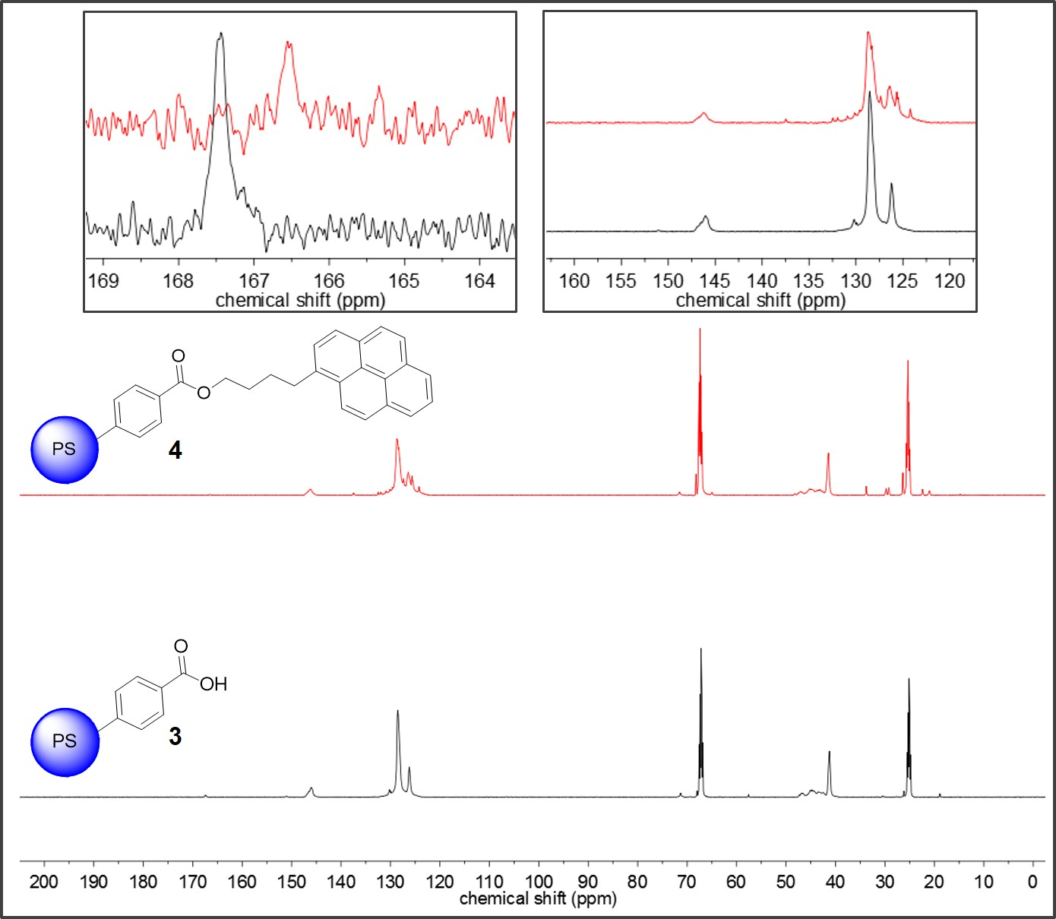

**Figure S2**. Gel-phase 13C NMR (THF-*d8*) of particles of **3** (black) and **4** (red). Insets: carbonyl resonance shift and aromatic region.

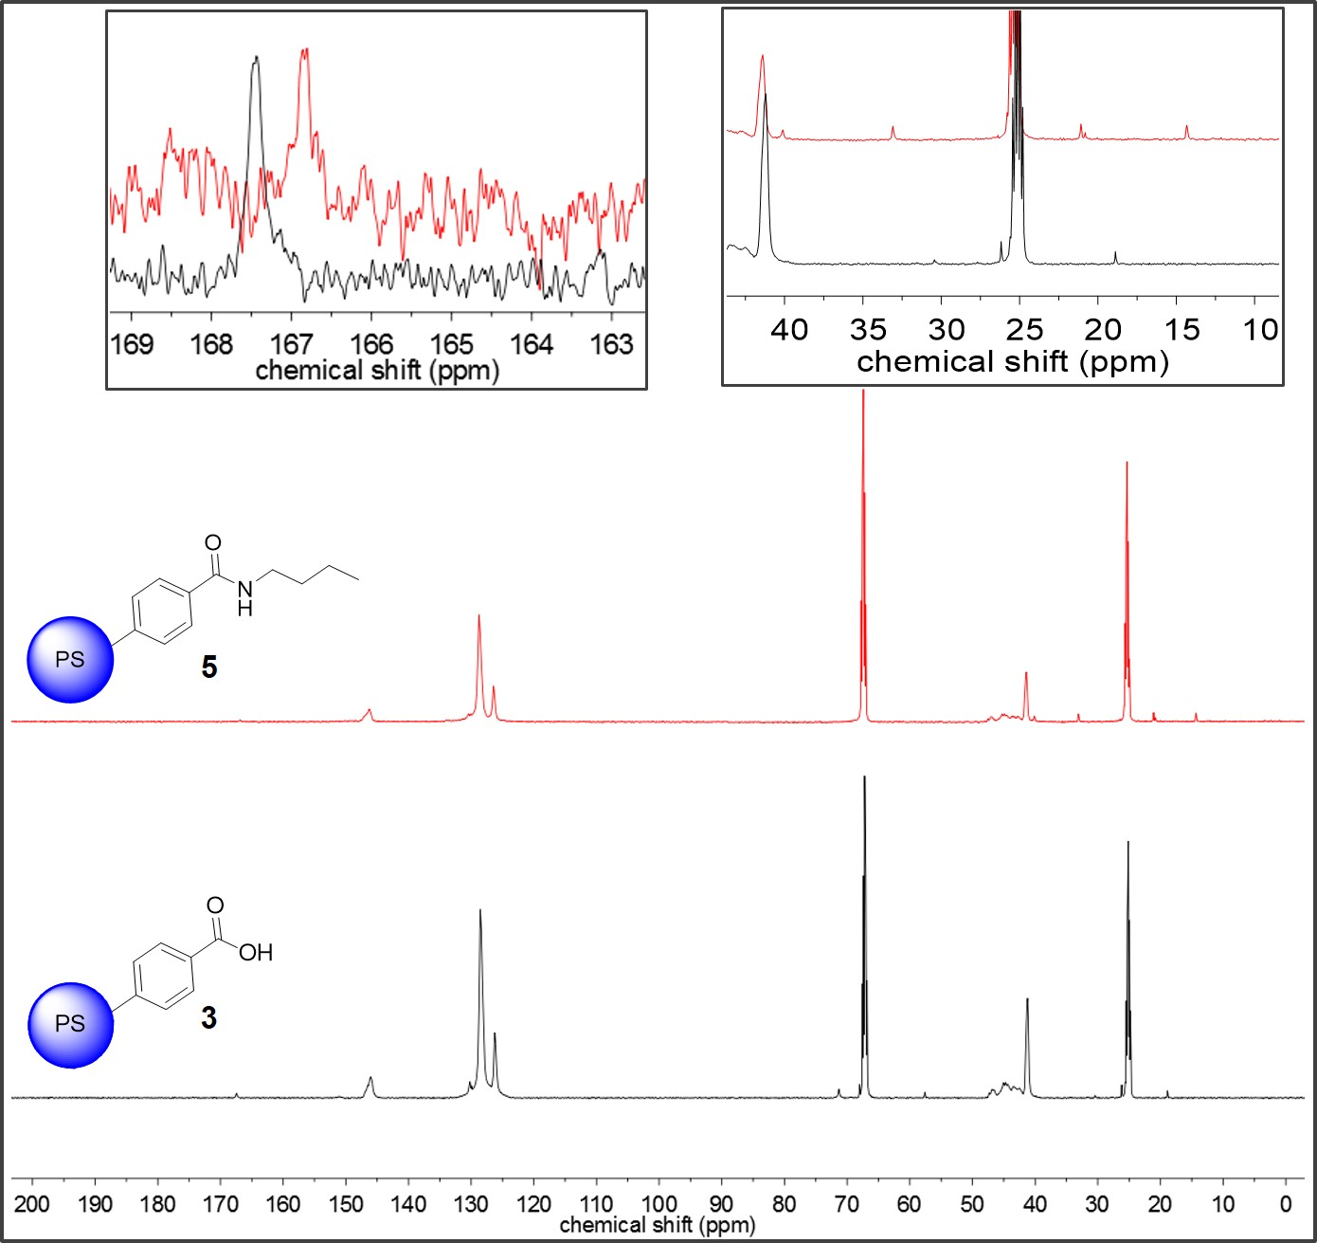

**Figure S3**. Gel-phase 13C NMR (THF-*d8*) of particles of **3** (black) and **5** (red). Insets: carbonyl resonance shift and aliphatic region.

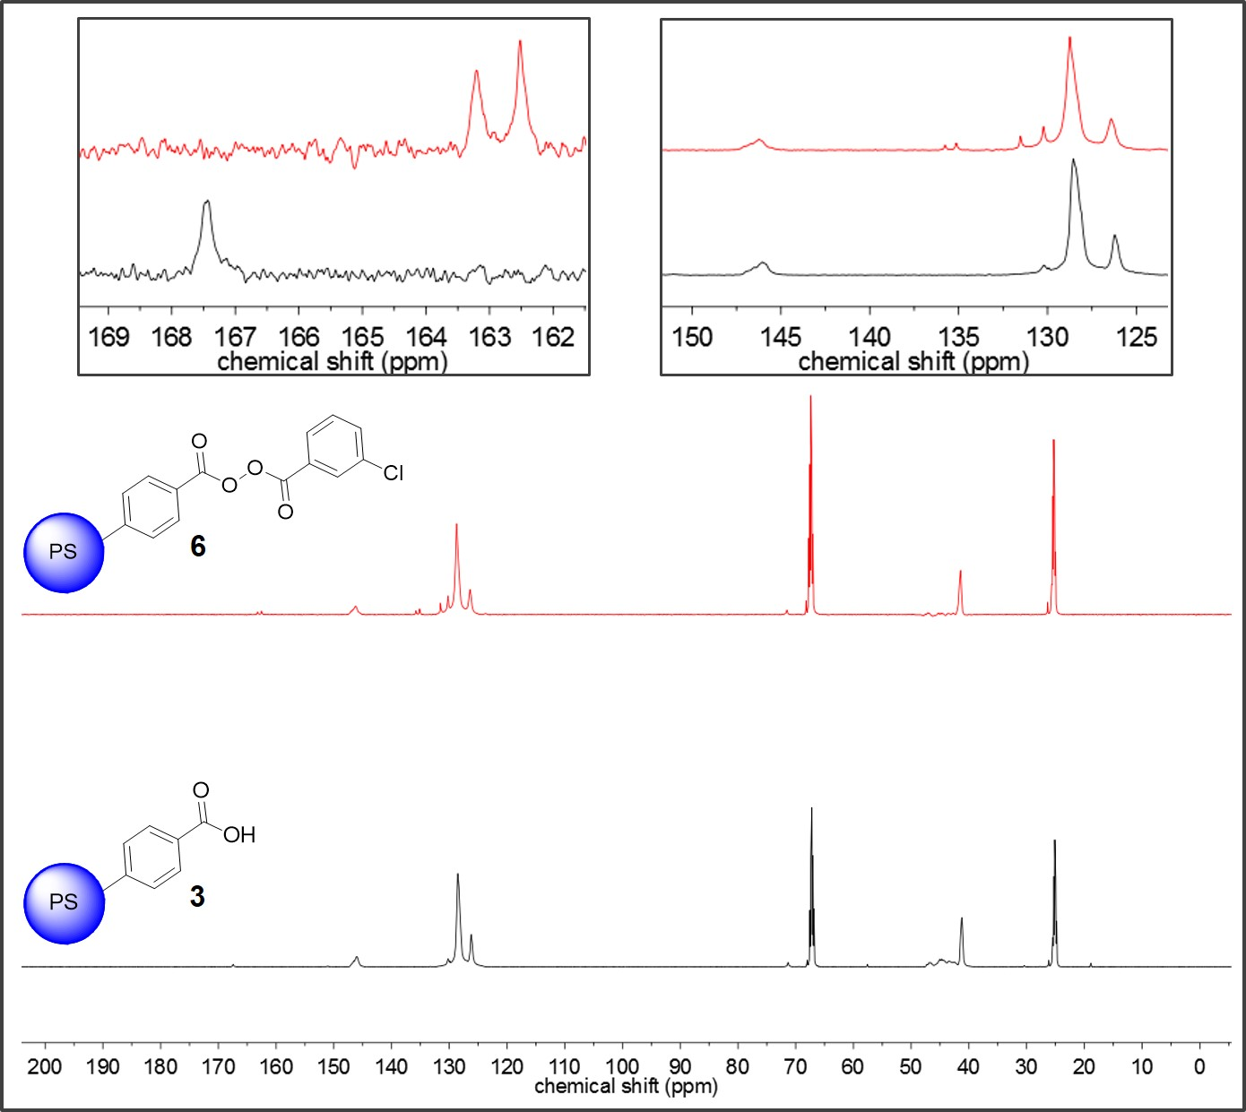

**Figure S4**. Gel-phase 13C NMR (THF-*d8*) of particles of **3** (black) and **6** (red). Insets: carbonyl resonance shift and aromatic region.

1. **Infrared spectra of particles**

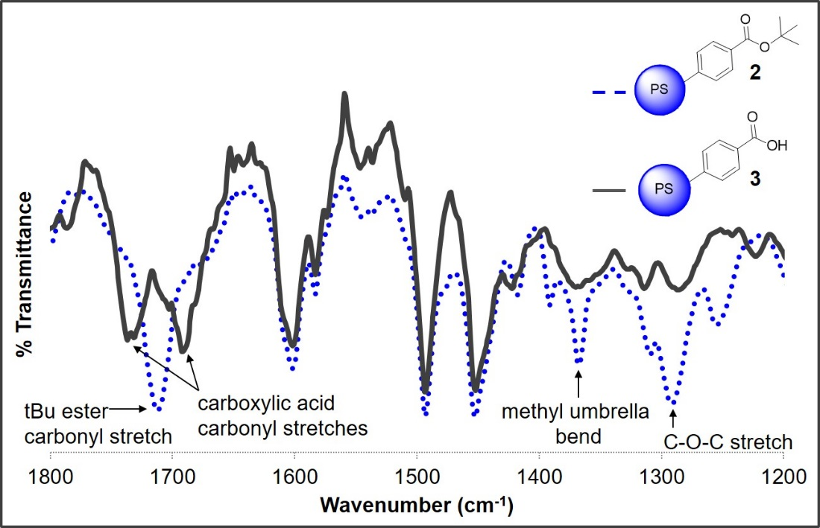

**Figure S5**. DRIFT spectra of microparticles of **2** (blue, dotted) and **3** (gray, solid). The ester carbonyl peak disappeared, while two peaks corresponding to the free and dimerized carboxylic acid appeared. The methyl and C-O-C stretches also disappeared in the deprotected particles.

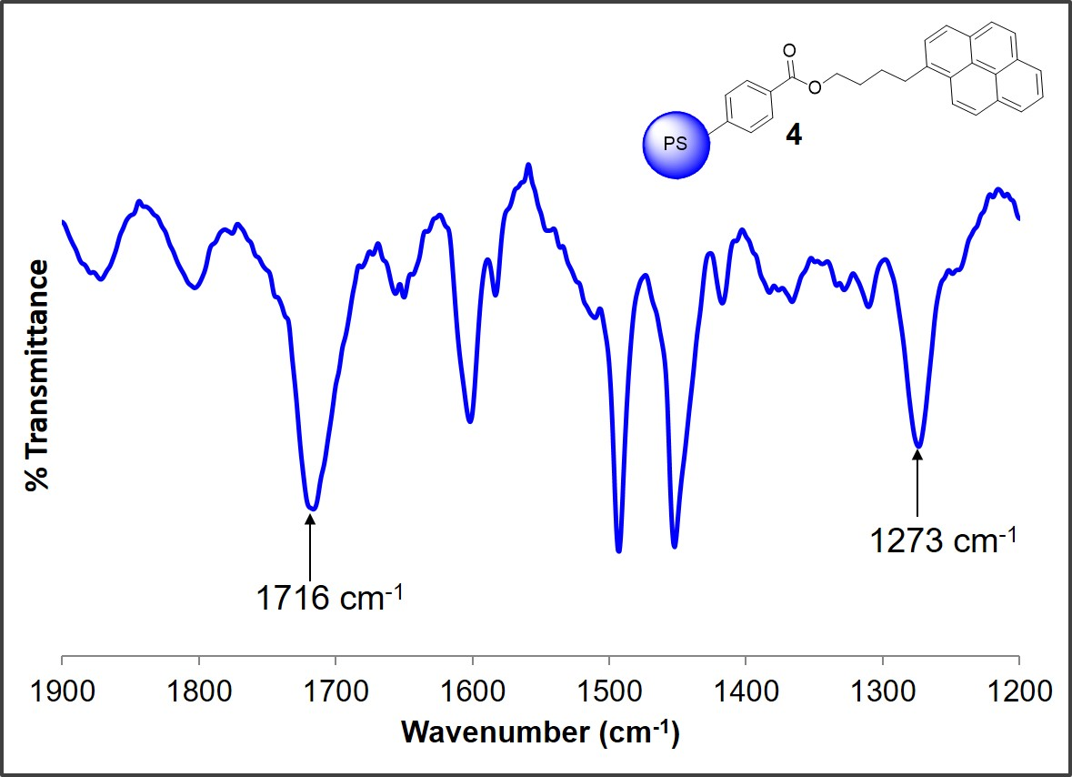

**Figure S6**. DRIFT spectrum of functionalized microparticles of **4**. The peaks corresponding to the carboxylic acid at 1732 and 1687 cm-1 disappeared, while a peak at 1716 cm-1 corresponding to the ester appeared. A peak at 1273 cm-1 corresponding to the C-O-C stretch appeared following functionalization.

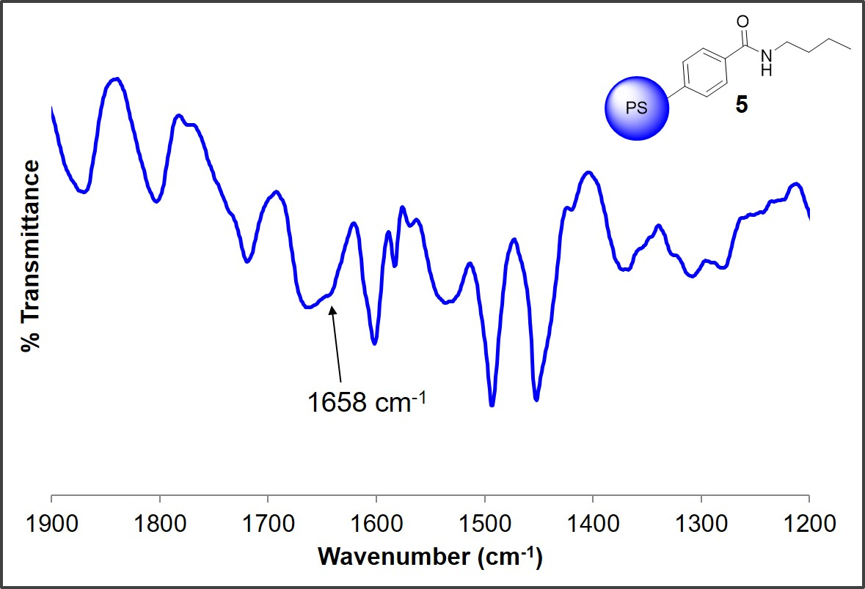

**Figure S7**. ATR-FTIR spectrum of functionalized microparticles of **5**. The peaks corresponding to the carboxylic acid at 1732 and 1687 cm-1 disappeared, while a broad peak at 1658 cm-1 corresponding to the amide appeared following functionalization.

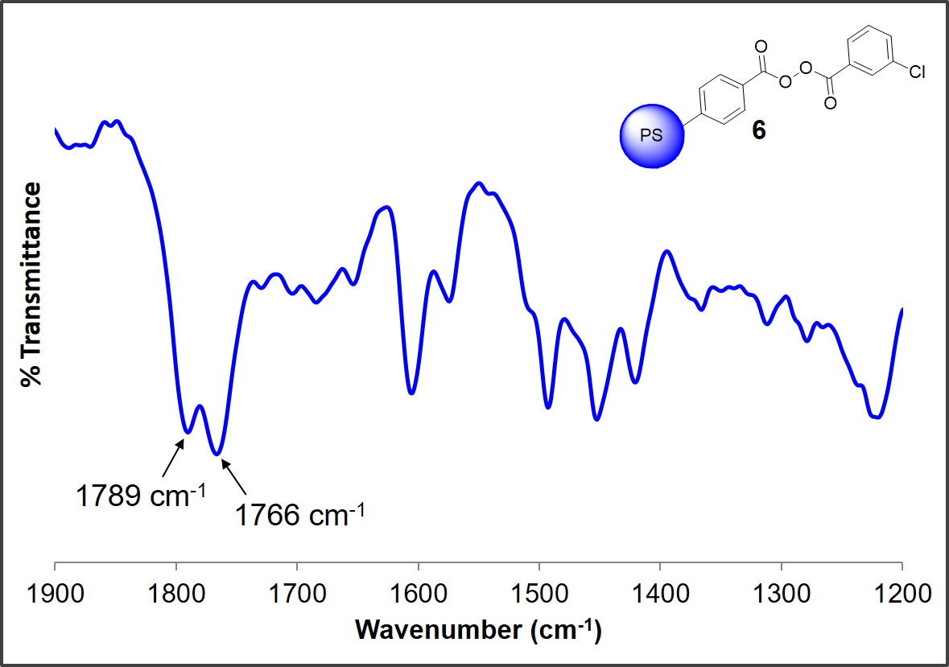

**Figure S8**. DRIFT spectrum of functionalized microparticles of **6**. The peaks corresponding to the carboxylic acid at 1732 and 1687 cm-1 disappeared, while two carbonyl peaks from the non-symmetric peroxide at 1766 and 1789 cm-1 appeared following functionalization.

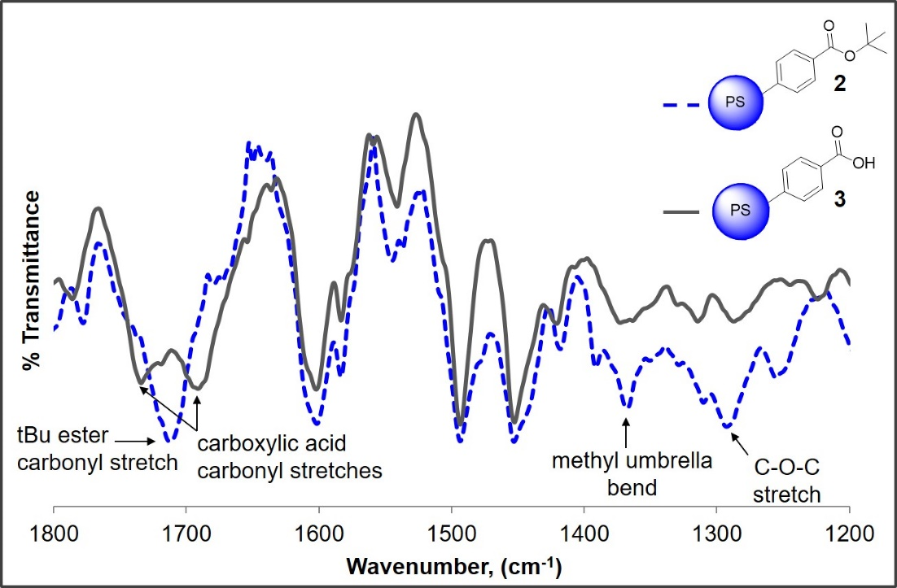

**Figure S9**. DRIFT spectra of particles **2** (blue, dotted) and **3** (gray, solid) synthesized by SFEP with 1 mmol initiator concentration. The ester carbonyl peak disappeared, while two peaks corresponding to the free and dimerized carboxylic acid appeared. The methyl bend and C‑O‑C stretch also disappeared in the deprotected particles.

1. **SEM images**

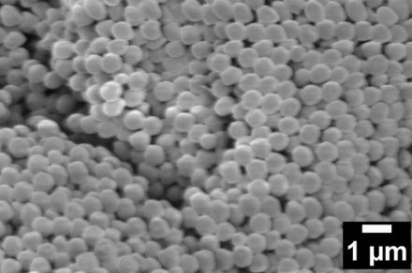

**Figure S10**. SEM images of particles of **2** synthesized by SFEP with 1 mmol KPS initiator.

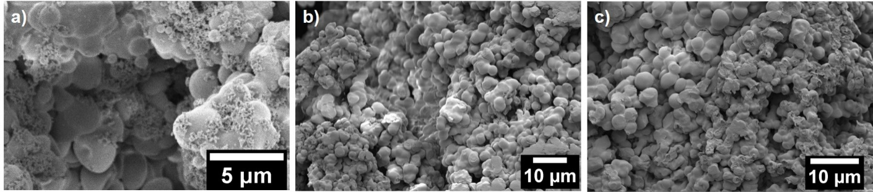

**Figure S11**. SEM images of particles of **2** synthesized by dispersion polymerization when second stage was added (a) in one portion by syringe, and (b,c) over a period of 30 min by cannula.

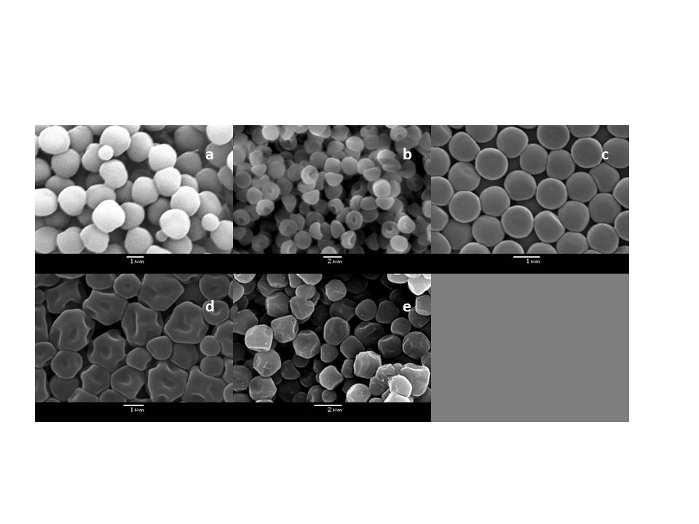

**Figure S12.** SEM images of microparticles of **2** synthesized by dispersion polymerization with varying addition times of comonomers **1** and DVB to the reaction mixture: (a) at the beginning of polymerization, (b) after one hour of polymerization, (c) after two hours of polymerization, (d) after three hours of polymerization, and (e) after four hours of polymerization.

1. **Optical images and videos**

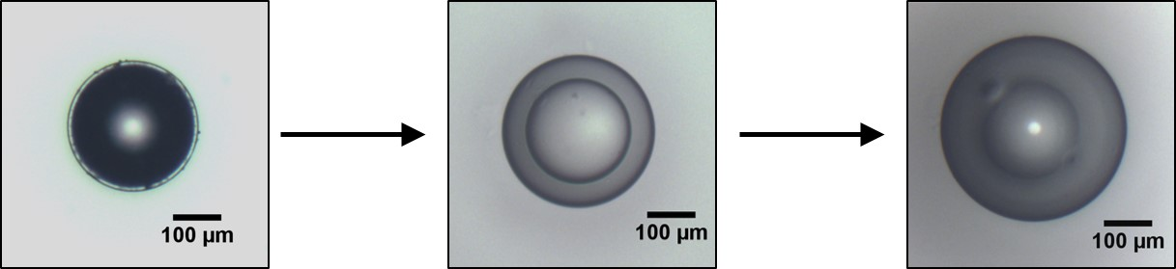

**Figure S13.** Representative optical images of carboxy-PS microparticle **3** with PEGDMA crosslinker (2.69 mol%) during swelling study in toluene.

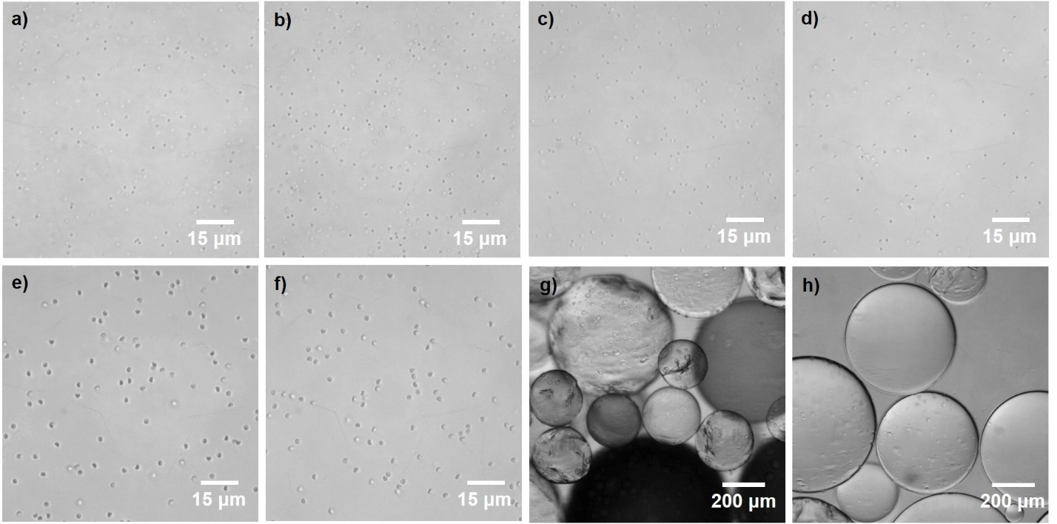

**Figure S14**. Optical microscopy images of particles **2** and **3** dispersed in DMF/EtOH solvent mixture: (a) ca. 600 nm particles of **2** synthesized via SFEP, (b) ca. 600 nm particles of **3**, (c) ca. 650 nm particles of **2** synthesized via SFEP with 1 mmol KPS initiator, (d) ca. 650 nm particles of **3**, (e) ca. 1.4 μm mushroom cap particles of **2** synthesized via dispersion polymerization, (f) ca. 1.4 μm mushroom cap particles of **3**, (g) ca. 200-500 μm particles of **2** synthesized via suspension polymerization, and (h) ca. 200-500 μm particles of **3**.

1. **Colloidal assembly**

Particles of **3** (synthesized by SFEP using 1 mmol KPS initiator) were dispersed in a methanol solution, which resulted in limited particle swelling. The particles were allowed to self-assemble overnight at 39 °C. Layers of the particles ranging from 1 to >5 layers were observable by SEM.

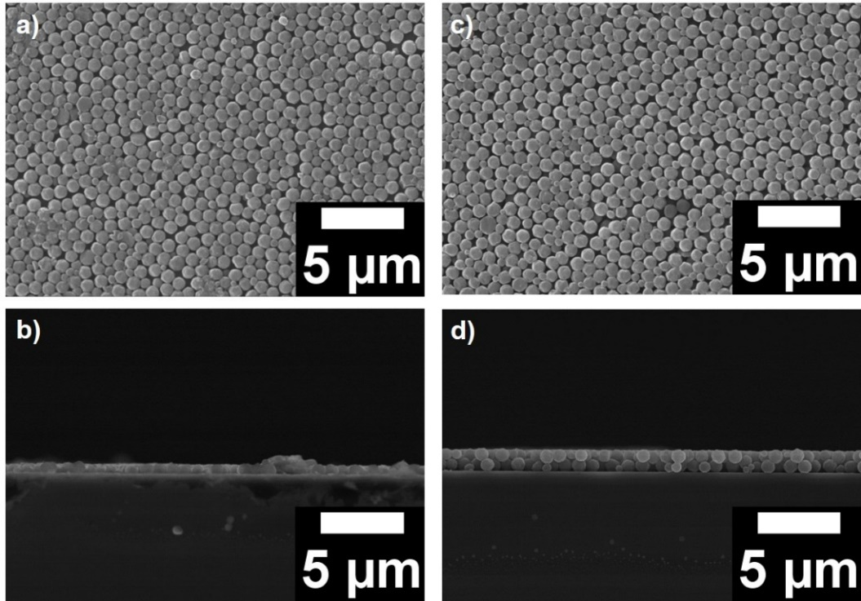

**Figure S15**. SEM images of **3**: (a) one layer and (b) two layers.

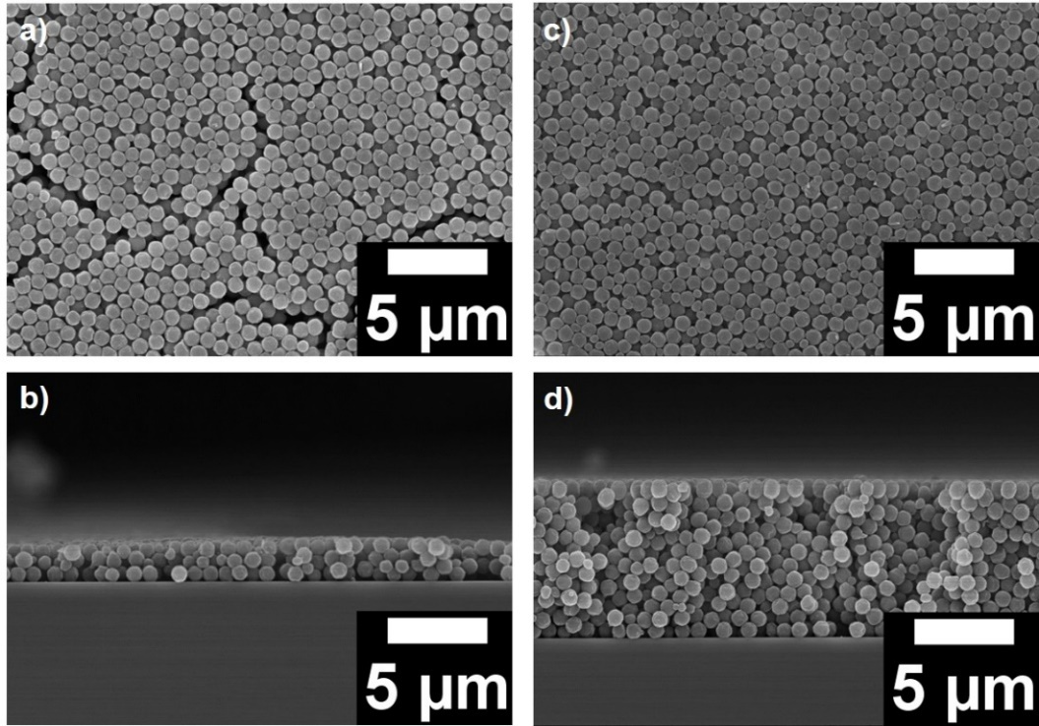

**Figure S16**. SEM images of **3**: (a) three layers and (b) greater than five layers.



**Figure S17**. FTIR reflectance spectra of **3** showing no Bragg reflection between 1.6-1.8 μm.

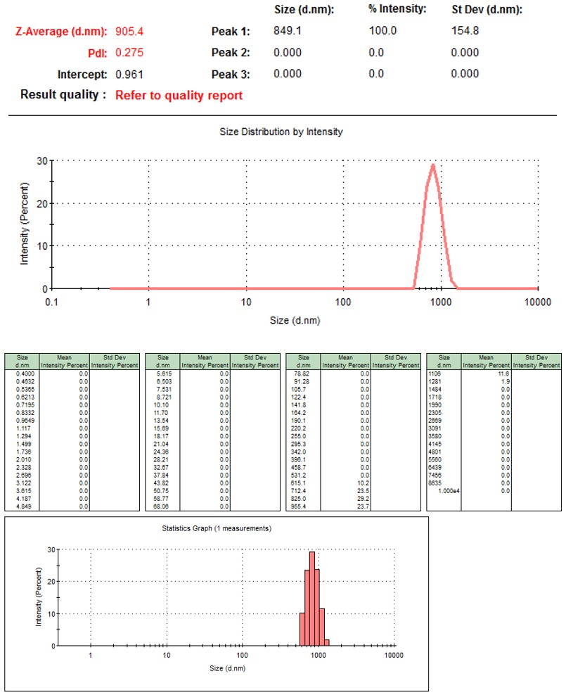

**Figure S18**. DLS data for **3** in methanol. The PDI is 0.275 and the standard deviation is 154.8 nm.

**8. Supplementary Movies**

**Supplementary Movie S1**: ca. 600 nm particles of **2** synthesized via SFEP and dispersed in DMF/EtOH solvent mixture. Frame rate: 17.21 fps (frames per second). The movie is played at 1x speed.

**Supplementary Movie S2**: ca. 600 nm particles of **3** synthesized via SFEP and dispersed in DMF/EtOH solvent mixture. Frame rate: 17.21 fps. The movie is played at 1x speed.

**Supplementary Movie S3**: ca. 650 nm particles of **2** synthesized via SFEP with 1 mmol KPS initiator and dispersed in DMF/EtOH solvent mixture. Frame rate: 17.21 fps. The movie is played at 1x speed.

**Supplementary Movie S4**: ca. 650 nm particles of **3** synthesized via SFEP with 1 mmol KPS initiator and dispersed in DMF/EtOH solvent mixture. Frame rate: 17.21 fps. The movie is played at 1x speed.

**Supplementary Movie S5**: ca. 1.4 μm mushroom cap particles of **2** synthesized via dispersion polymerization and dispersed in DMF/EtOH solvent mixture. Frame rate: 17.21 fps. The movie is played at 1x speed.

**Supplementary Movie S6**: ca. 1.4 μm mushroom cap particles of **2** synthesized via dispersion polymerization showing single particle rotational dynamics in DMF/EtOH solvent mixture. Frame rate: 32 fps. The movie is played at 1x speed.

**Supplementary Movie S7**: ca. 1.4 μm mushroom cap particles of **3** synthesized via dispersion polymerization and dispersed in DMF/EtOH solvent mixture. Frame rate: 17.21 fps. The movie is played at 1x speed.

**Supplementary Movie S8**: ca. 200-500 μm particles of **2** synthesized via suspension polymerization and dispersed in DMF/EtOH solvent mixture. Frame rate: 17.21 fps. The movie is played at 1x speed.

**Supplementary Movie S9**: ca. 200-500 μm particles of **3** synthesized via suspension polymerization and dispersed in DMF/EtOH solvent mixture. Frame rate: 17.21 fps. The movie is played at 1x speed.

**References**

(1) Pangborn, A. B.; Giardello, M. A.; Grubbs, R. H.; Rosen, R. K.; Timmers, F. J. *Organometallics* **1996**, *15*, 1518.

(2) Smith, A. B.; Risatti, C. A.; Atasoylu, O.; Bennett, C. S.; Liu, J.; Cheng, H.; TenDyke, K.; Xu, Q. *J. Am. Chem. Soc.* **2011**, *133*, 14042.