Table A.1 Decoupling state and explanation of the carbon footprint and economic growth

|  |  |  |  |  |  |
| --- | --- | --- | --- | --- | --- |
| Decoupling state | | δCF | δGDP | αn | Explanation |
| Decoupling | Strong decoupling | <0 | >0 | αn<0 | CF declines, and GDP still shows a growing trend. |
| Weak decoupling | >0 | <0 | 0<αn<e1 | Both CF and GDP are growing, and the GDP growth rate is greater than the CF growth rate. |
| Decay decoupling | <0 | <0 | αn>e2 | Both CF and GDP are decreasing, and the rate of GDP decline is less than the rate of CF decline. |
| Negative Decoupling | Weak negative Decoupling | <0 | <0 | 0<αn<e1 | Both CF and GDP are decreasing, and the rate of GDP decline is greater than the rate of CF decline. |
| Strong negative Decoupling | >0 | <0 | αn<0 | CF is growing, and GDP is decreasing. |
| Expansion negative Decoupling | >0 | >0 | αn>e2 | Both CF and GDP are growing, and the GDP growth rate is less than CF growth rate. |
| Connection | Decay connection | <0 | <0 | e1<αn<e2 | CF and GDP remain in a relatively synchronous decline. |
| Expansion connection | >0 | >0 | e1<αn<e2 | CF and GDP maintain a relatively simultaneous growth trend. |

Note: There is no case of a constant carbon footprint and GDP, and thus, the case of δCF=0 and δGDP=0 is not considered.

Fig. A.1 Trends in carbon footprint and carbon carrying capacity of Xi’an from 2007 to 2016

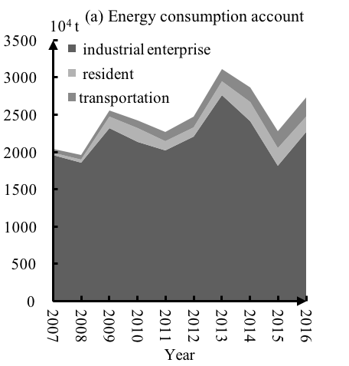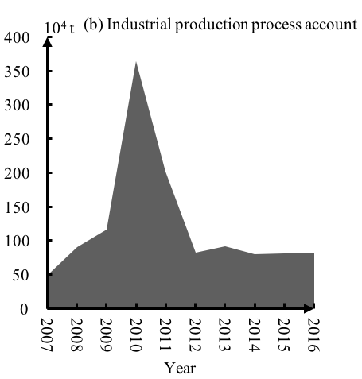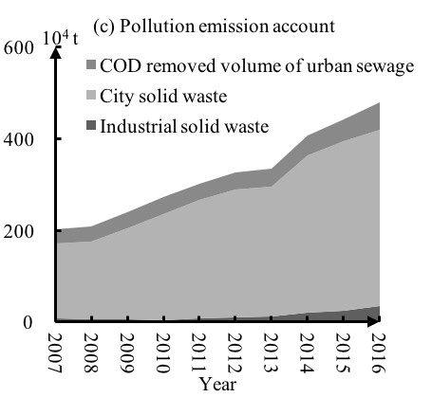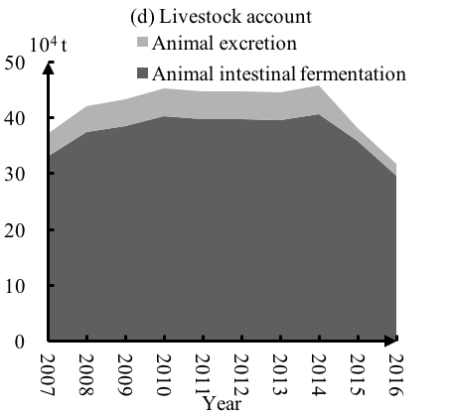

Fig. A.2 Trends in the energy consumption account, industrial production process account, pollution emission account and livestock account of Xi’an’s carbon footprint from 2007 to 2016

Fig. A.3 Trends in the carbon deficit and carbon deficit index during the period 2007-2016

Table A.2 The carbon deficit index change during the period 2007-2016

|  |  |  |  |  |  |  |  |  |  |  |
| --- | --- | --- | --- | --- | --- | --- | --- | --- | --- | --- |
| Year | 2007 | 2008 | 2009 | 2010 | 2011 | 2012 | 2013 | 2014 | 2015 | 2016 |
| CDI | - | -2.57% | 27.99% | 5.02% | -8.35% | 3.51% | 22.82% | -5.08% | -12.33% | 17.09% |

Table A.3 Decoupling effect of carbon footprint and economic growth in Xi’an from 2007 to 2016

|  |  |  |  |  |  |  |  |  |  |  |
| --- | --- | --- | --- | --- | --- | --- | --- | --- | --- | --- |
| Year | Total carbon footprint | | Energy consumption account | | Industrial production process account | | Pollution emission account | | Livestock account | |
| αn | State | αn | State | αn | State | αn | State | αn | State |
| 2007-2008 | -0.1 | Strong decoupling | -0.2 | Strong decoupling | 3.5 | Expansion negative Decoupling | 0.1 | Weak decoupling | 0.5 | Weak decoupling |
| 2008-2009 | 1.6 | Expansion negative Decoupling | 1.7 | Expansion negative Decoupling | 1.7 | Expansion negative Decoupling | 0.8 | Expansion connection | 0.2 | Weak decoupling |
| 2009-2010 | 0.3 | Weak decoupling | -0.3 | Strong decoupling | 11.2 | Expansion negative Decoupling | 0.7 | Weak decoupling | 0.2 | Weak decoupling |
| 2010-2011 | -0.5 | Strong decoupling | -0.3 | Strong decoupling | -2.3 | Strong decoupling | 0.6 | Weak decoupling | -0.1 | Strong decoupling |
| 2011-2012 | 0.3 | Weak decoupling | 0.7 | Weak decoupling | -4.4 | Strong decoupling | 0.6 | Weak decoupling | 0.0 | Weak decoupling |
| 2012-2013 | 1.9 | Expansion negative Decoupling | 2.2 | Expansion negative Decoupling | 0.9 | Expansion connection | 0.2 | Weak decoupling | -0.0 | Strong decoupling |
| 2013-2014 | -0.4 | Strong decoupling | -0.7 | Strong decoupling | -1.2 | Strong decoupling | 1.9 | Expansion negative Decoupling | 0.2 | Weak decoupling |
| 2014-2015 | -2.9 | Strong decoupling | -3.6 | Strong decoupling | 0.3 | Weak decoupling | 1.6 | Expansion negative Decoupling | -2.9 | Strong decoupling |
| 2015-2016 | 2.0 | Expansion negative Decoupling | 2.4 | Expansion negative Decoupling | 0.0 | Strong decoupling | 1.0 | Expansion connection | -2.1 | Strong decoupling |



Fig. A.4 Variable importance projection output graph of the PLS model