Appendix
Electrostatically assisted air coarse filtration for energy efficient ambient particles removal: long-term performance in real environment and influencing factors
Enze Tian ^{a, b}, Yilun Gao ^{a, b}, Jinhan Mo ^{a, b, *}
ª Department of Building Science, Tsinghua University, Beijing 100084, China
^{b} Beijing Key Laboratory of Indoor Air Quality Evaluation and Control, Beijing 100084, China

Corresponding Author
*E-mail: mojinhan@tsinghua.edu.cn; Tel: +86 10 62779994; Fax: +86 10 6277 3461;
Address: Department of Building Science, Tsinghua University, Beijing 100084, China

This supporting information (12 pages) includes 5 figures and 9 tables.

(a) Air temperature and moisture content
(b) Particle number concentration for 0.3 ~ 0.5 μm, 1 ~ 3 μm, and 5~ 10 μm particles
(c) Particle number concentration for 0.5 ~ 1 μm and 3 ~ 5 μm particles
Fig. A1. Environmental parameters during the operation period of EAA coarse filter.

(a) Charging voltage and charging current
(b) Polarizing voltage and polarizing current
Fig. A2. Operation parameters during the operation period of EAA coarse filter.

(a) Efficiencies for 0.5 ~ 1 μm particles | (b) Efficiencies for 1 ~ 3 μm particles
(c) Efficiencies for 3 ~ 5 μm particles | (d) Efficiencies for 5 ~ 10 μm particles
Fig. A3. Long-term single pass filtration efficiencies of the EAA coarse filter for 0.3 ~ 10 μm particles

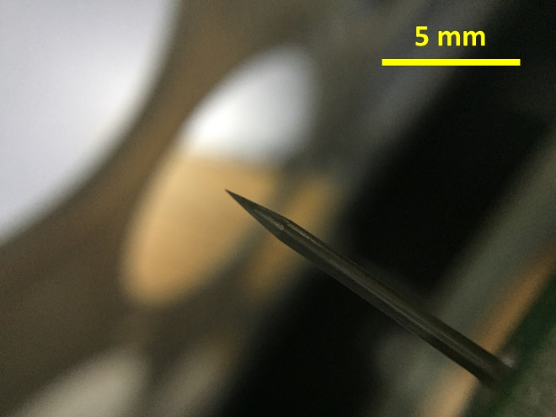 | 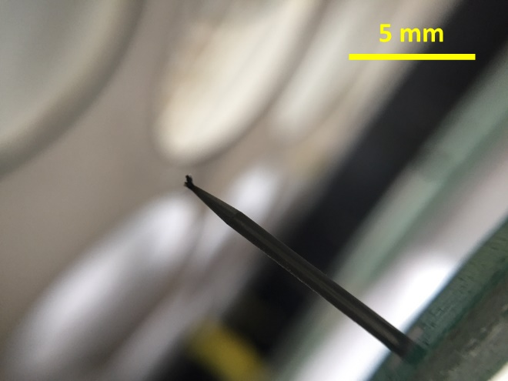
(a) New (the 1st day) | (b) Before cleaning (the 27th day)
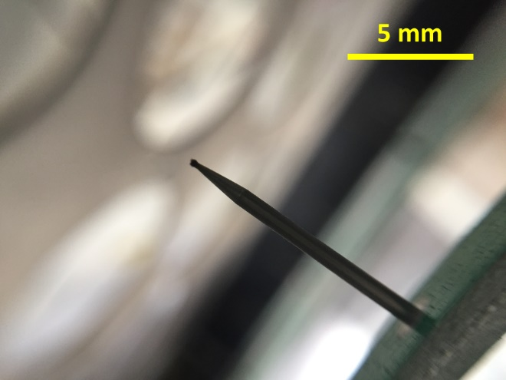 | 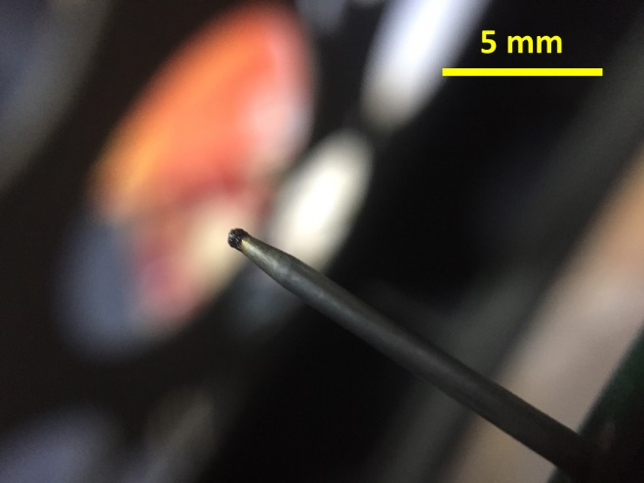
(c) After cleaning (the 28th day) | (d) At end (the 51st day)
Fig. A4. Morphology changes of a charging pin along the long-term experiment for EAA coarse filter.

Fig. A5. Long-term single pass filtration efficiency for 0.3 ~ 0.5 μm ambient particles and pressure drop of the conventional electret filter at face air velocity of 1 m/s.

Fig. A6. 0.3 ~ 0.5 μm ambient particle concentrations at downstream of EAA coarse filter and conventional electret filter.

Description for Tables A1 ~ A3 (in order to obtain the key factors influencing the charging stability by PCA method):
We obtained the correlation coefficients among the 9 influencing factors in Table A1. The factors with high correlation coefficient will be categorized in one principal component. We decided to extract 3 principal components from the 9 influencing factors according to the explained total variance shown in Table A2. Generally, the total variance up to certain number of the principal components should exceed 80% to ensure most of the data to be explained. Then, the correlation coefficients between the 9 influencing factors and the 3 principal components were shown in Table A3.

When several influencing factors dominates in one principal component, we can use the principal component to represent most characteristic of these influencing factors. At the same time, if these influencing factors have strong correlation among themselves, we can use the characteristic of one of them to represent the others. For example, the correlation coefficients of C_{n,up}(0.3 ~ 0.5), C_{n,up}(0.5 ~ 1), C_{n,up}(1 ~ 3), C_{m}(PM_{2.5}), and d_{air} were beyond 0.75 as shown in Table A1 and they dominated in principal component 1 as shown in Table A3. We used C_{n,up}(0.5 ~ 1) to represent the characteristics of C_{n,up}(0.3 ~ 0.5), C_{n,up}(1 ~ 3), and C_{m}(PM_{2.5}). Since d_{air} was a totally different parameter from C_{n,up}, we would discuss its influence separately. Similarly, we used C_{n,up}(3 ~ 5) to represent the characteristics of C_{n,up}(5 ~ 10), while discuss the influence of T_{air} and CA_{acc}(PM_{2.5}) separately. Therefore, we had 5 key parameters to discuss their influence on P_{c} of the EAA coarse filter, including T_{air}, d_{air}, C_{n,up}(0.5 ~ 1), C_{n,up}(3 ~ 5) and CA_{acc}(PM_{2.5}).

Table A1. Correlation matrix of influencing factors for charging power (P_{C}).
 |  | C_{n,up}  (0.3 ~ 0.5) | C_{n,up}  (0.5 ~ 1) | C_{n,up}  (1 ~ 3) | C_{n,up}  (3 ~ 5) | C_{n,up}  (5 ~ 10) | T_{air} | d_{air} | C_{m}  (PM_{2.5}) | CA_{acc}  (PM_{2.5})
Corre-lation | C_{n,up}(0.3 ~ 0.5) | 1.000 | 0.984 | 0.799 | 0.297 | 0.320 | 0.129 | 0.743 | 0.810 | 0.004
 | C_{n,up}(0.5 ~ 1) | 0.984 | 1.000 | 0.849 | 0.349 | 0.351 | 0.133 | 0.722 | 0.867 | 0.023
 | C_{n,up}(1 ~ 3) | 0.799 | 0.849 | 1.000 | 0.778 | 0.748 | 0.293 | 0.626 | 0.726 | 0.151
 | C_{n,up}(3 ~ 5) | 0.297 | 0.349 | 0.778 | 1.000 | 0.973 | 0.312 | 0.264 | 0.228 | 0.202
 | C_{n,up}(5 ~ 10) | 0.320 | 0.351 | 0.748 | 0.973 | 1.000 | 0.282 | 0.304 | 0.217 | 0.207
 | T_{air} | 0.129 | 0.133 | 0.293 | 0.312 | 0.282 | 1.000 | 0.449 | 0.055 | -0.132
 | d_{air} | 0.743 | 0.722 | 0.626 | 0.264 | 0.304 | 0.449 | 1.000 | 0.663 | -0.139
 | C_{m}(PM_{2.5}) | 0.810 | 0.867 | 0.726 | 0.228 | 0.217 | 0.055 | 0.663 | 1.000 | 0.021
 | CA_{acc}(PM_{2.5}) | 0.004 | 0.023 | 0.151 | 0.202 | 0.207 | -0.132 | -0.139 | 0.021 | 1.000
Determinant = 1.56 × 10⁻⁷

Table A2. Total variance explained of influencing factors for charging power (P_{C}).
Comp-  onent | Initial eigenvalues |  |  | Extraction sums of squared loadings |  |  | Rotation sums of squared loadings
 | Total | % of variance | cumulative % | Total | % of variance | cumulative % | Total | % of variance | cumulative %
1 | 4.791 | 53.233 | 53.233 | 4.791 | 53.233 | 53.233 | 3.884 | 43.151 | 43.151
2 | 1.785 | 19.836 | 73.069 | 1.785 | 19.836 | 73.069 | 2.633 | 29.252 | 72.403
3 | 1.226 | 13.626 | 86.695 | 1.226 | 13.626 | 86.695 | 1.286 | 14.291 | 86.695
4 | 0.704 | 7.825 | 94.520
5 | 0.245 | 2.725 | 97.245
6 | 0.205 | 2.273 | 99.518
7 | 0.036 | 0.396 | 99.914
8 | 0.006 | 0.063 | 99.977
9 | 0.002 | 0.023 | 100.000
Extraction method: principal component analysis

Table A3. Rotation component matrix of influencing factors for charging power (P_{C}). Rotation converged in 4 iterations.
Influencing factors | Principal component
 | 1 | 2 | 3
C_{n,up}(0.3 ~ 0.5) | 0.955 | 0.151 | 0.029
C_{n,up}(0.5 ~ 1) | 0.965 | 0.193 | 0.004
C_{n,up}(1 ~ 3) | 0.735 | 0.658 | 0.017
C_{n,up}(3 ~ 5) | 0.170 | 0.962 | 0.016
C_{n,up}(5 ~ 10) | 0.181 | 0.949 | 0.008
T_{air} | 0.045 | 0.399 | 0.766
d_{air} | 0.764 | 0.170 | 0.437
C_{m}(PM_{2.5}) | 0.924 | 0.061 | -0.045
CA_{acc}(PM_{2.5}) | -0.026 | 0.351 | -0.710
Extraction method: principal component analysis.
Rotation method: varimax with Kaiser normalization component scores.

Description for Tables A4 ~ A6 (in order to obtain the key factors influencing the filtration efficiency stability in early period by PCA method):

Similar to those in Description for Tables 1 ~ 3, we obtained the correlation coefficients among the 9 influencing factors in Table A4. We decided to extract 3 principal components from the 9 influencing factors according to the explained total variance shown in Table A5. And the correlation coefficients between the 9 influencing factors and the 3 principal components were shown in Table A6.

Similar to those in Description for Tables 1 ~ 3, the correlation coefficients of C_{n,up}(0.3 ~ 0.5), C_{n,up}(0.5 ~ 1), C_{n,up}(1 ~ 3), C_{m}(PM_{2.5}), and d_{air} were beyond 0.5 as shown in Table A4 and they dominated in principal component 1 as shown in Table A6. We used C_{n,up}(0.5 ~ 1) to represent the characteristics of C_{n,up}(0.3 ~ 0.5), C_{n,up}(1 ~ 3), and C_{m}(PM_{2.5}). Since d_{air} was a totally different parameter from C_{n,up}, we would discuss its influence separately. Similarly, we used C_{n,up}(3 ~ 5) to represent the characteristics of C_{n,up}(5 ~ 10), while discuss the influence of T_{air} and CA_{acc}(PM_{2.5}) separately. Therefore, we had 5 key parameters to discuss their influence on η(0.3 ~ 0.5) in Group #3 of the EAA coarse filter, including T_{air}, d_{air}, C_{n,up}(0.5 ~ 1), C_{n,up}(3 ~ 5) and CA_{acc}(PM_{2.5}).

Table A4. Correlation matrix of influencing factors for 0.3 ~ 0.5 μm particle single pass filtration efficiency (η(0.3 ~ 0.5)) in Group #3.
 |  | C_{n,up}  (0.3 ~ 0.5) | C_{n,up}  (0.5 ~ 1) | C_{n,up}  (1 ~ 3) | C_{n,up}  (3 ~ 5) | C_{n,up}  (5 ~ 10) | T_{air} | d_{air} | C_{m}  (PM_{2.5}) | CA_{acc}  (PM_{2.5})
Corre-lation | C_{n,up}(0.3 ~ 0.5) | 1.000 | 0.893 | 0.803 | 0.491 | 0.417 | -0.227 | 0.509 | 0.895 | 0.258
 | C_{n,up}(0.5 ~ 1) | 0.893 | 1.000 | 0.977 | 0.519 | 0.423 | -0.049 | 0.702 | 0.946 | 0.092
 | C_{n,up}(1 ~ 3) | 0.803 | 0.977 | 1.000 | 0.573 | 0.475 | 0.031 | 0.769 | 0.913 | 0.024
 | C_{n,up}(3 ~ 5) | 0.491 | 0.519 | 0.573 | 1.000 | 0.989 | 0.333 | 0.487 | 0.525 | 0.289
 | C_{n,up}(5 ~ 10) | 0.417 | 0.423 | 0.475 | 0.989 | 1.000 | 0.359 | 0.414 | 0.432 | 0.318
 | T_{air} | -0.227 | -0.049 | 0.031 | 0.333 | 0.359 | 1.000 | 0.163 | -0.064 | -0.021
 | d_{air} | 0.509 | 0.702 | 0.769 | 0.487 | 0.414 | 0.163 | 1.000 | 0.681 | -0.017
 | C_{m}(PM_{2.5}) | 0.895 | 0.946 | 0.913 | 0.525 | 0.432 | -0.064 | 0.681 | 1.000 | 0.138
 | CA_{acc}(PM_{2.5}) | 0.258 | 0.092 | 0.024 | 0.289 | 0.318 | -0.021 | -0.017 | 0.138 | 1.000
Determinant = 2.03 × 10⁻⁷

Table A5. Total variance explained of influencing factors for 0.3 ~ 0.5 μm particle single pass filtration efficiency (η(0.3 ~ 0.5)) in Group #3.
Comp-  onent | Initial eigenvalues |  |  | Extraction sums of squared loadings |  |  | Rotation sums of squared loadings
 | Total | % of variance | cumulative % | Total | % of variance | cumulative % | Total | % of variance | cumulative %
1 | 5.057 | 56.194 | 56.194 | 5.057 | 56.194 | 56.194 | 4.539 | 50.431 | 50.431
2 | 1.689 | 18.771 | 74.966 | 1.689 | 18.771 | 74.966 | 1.971 | 21.901 | 72.332
3 | 1.153 | 12.807 | 87.772 | 1.153 | 12.807 | 87.772 | 1.390 | 15.440 | 87.772
4 | 0.546 | 6.068 | 93.840
5 | 0.376 | 4.179 | 98.019
6 | 0.106 | 1.173 | 99.192
7 | 0.065 | 0.721 | 99.913
8 | 0.005 | 0.054 | 99.966
9 | 0.003 | 0.034 | 100.000
Extraction method: principal component analysis.

Table A6. Rotation component matrix of influencing factors for 0.3 ~ 0.5 μm particle single pass filtration efficiency (η(0.3 ~ 0.5)) in Group #3. Rotation converged in 4 iterations.
Influencing factors | Principal component
 | 1 | 2 | 3
C_{n,up}(0.3 ~ 0.5) | 0.889 | -0.084 | 0.331
C_{n,up}(0.5 ~ 1) | 0.977 | 0.071 | 0.072
C_{n,up}(1 ~ 3) | 0.959 | 0.185 | -0.011
C_{n,up}(3 ~ 5) | 0.474 | 0.726 | 0.404
C_{n,up}(5 ~ 10) | 0.372 | 0.755 | 0.442
T_{air} | -0.152 | 0.844 | -0.209
d_{air} | 0.760 | 0.332 | -0.174
C_{m}(PM_{2.5}) | 0.954 | 0.061 | 0.130
CA_{acc}(PM_{2.5}) | 0.002 | 0.045 | 0.909
Extraction method: principal component analysis.
Rotation method: varimax with Kaiser normalization component scores.

Description for Tables A7 ~ A9 (in order to obtain the key factors influencing the filtration efficiency stability in late period by PCA method):

Similar to those in Description for Tables 1 ~ 3, we obtained the correlation coefficients among the 9 influencing factors in Table A7. We decided to extract 3 principal components from the 9 influencing factors according to the explained total variance shown in Table A8. And the correlation coefficients between the 9 influencing factors and the 3 principal components were shown in Table A9.

Similar to those in Description for Tables 1 ~ 3, the correlation coefficients of C_{n,up}(0.3 ~ 0.5), C_{n,up}(0.5 ~ 1), C_{n,up}(1 ~ 3), C_{m}(PM_{2.5}), and d_{air} were beyond 0.5 as shown in Table A7 and they dominated in principal component 1 as shown in Table A9. We used C_{n,up}(0.5 ~ 1) to represent the characteristics of C_{n,up}(0.3 ~ 0.5), C_{n,up}(1 ~ 3), and C_{m}(PM_{2.5}). Since d_{air} was a totally different parameter from C_{n,up}, we would discuss its influence separately. Similarly, we used C_{n,up}(3 ~ 5) to represent the characteristics of C_{n,up}(5 ~ 10), while discuss the influence of T_{air} and CA_{acc}(PM_{2.5}) separately. Therefore, we had 5 key parameters to discuss their influence on η(0.3 ~ 0.5) in Group #7 of the EAA coarse filter, including T_{air}, d_{air}, C_{n,up}(0.5 ~ 1), C_{n,up}(3 ~ 5) and CA_{acc}(PM_{2.5}).

Table A7. Correlation matrix of influencing factors for 0.3 ~ 0.5 μm particle single pass filtration efficiency (η(0.3 ~ 0.5)) in Group #7.
 |  | C_{n,up}  (0.3 ~ 0.5) | C_{n,up}  (0.5 ~ 1) | C_{n,up}  (1 ~ 3) | C_{n,up}  (3 ~ 5) | C_{n,up}  (5 ~ 10) | T_{air} | d_{air} | C_{m}  (PM_{2.5}) | CA_{acc}  (PM_{2.5})
Corre-lation | C_{n,up}(0.3 ~ 0.5) | 1.000 | 0.990 | 0.929 | 0.492 | 0.445 | -0.261 | 0.538 | 0.969 | -0.145
 | C_{n,up}(0.5 ~ 1) | 0.990 | 1.000 | 0.945 | 0.506 | 0.457 | -0.241 | 0.556 | 0.957 | -0.160
 | C_{n,up}(1 ~ 3) | 0.929 | 0.945 | 1.000 | 0.713 | 0.666 | -0.150 | 0.617 | 0.905 | -0.200
 | C_{n,up}(3 ~ 5) | 0.492 | 0.506 | 0.713 | 1.000 | 0.991 | 0.192 | 0.576 | 0.518 | -0.248
 | C_{n,up}(5 ~ 10) | 0.445 | 0.457 | 0.666 | 0.991 | 1.000 | 0.235 | 0.564 | 0.475 | -0.262
 | T_{air} | -0.261 | -0.241 | -0.150 | 0.192 | 0.235 | 1.000 | 0.292 | -0.203 | -0.499
 | d_{air} | 0.538 | 0.556 | 0.617 | 0.576 | 0.564 | 0.292 | 1.000 | 0.583 | -0.760
 | C_{m}(PM_{2.5}) | 0.969 | 0.957 | 0.905 | 0.518 | 0.475 | -0.203 | 0.583 | 1.000 | -0.185
 | CA_{acc}(PM_{2.5}) | -0.145 | -0.160 | -0.200 | -0.248 | -0.262 | -0.499 | -0.760 | -0.185 | 1.000
Determinant = 3.37 × 10⁻⁸

Table A8. Total variance explained of influencing factors for 0.3 ~ 0.5 μm particle single pass filtration efficiency (η(0.3 ~ 0.5)) in Group #7.
Comp-  onent | Initial eigenvalues |  |  | Extraction sums of squared loadings |  |  | Rotation sums of squared loadings
 | Total | % of variance | cumulative % | Total | % of variance | cumulative % | Total | % of variance | cumulative %
1 | 5.278 | 58.642 | 58.642 | 5.278 | 58.642 | 58.642 | 4.128 | 45.863 | 45.863
2 | 2.039 | 22.659 | 81.301 | 2.039 | 22.659 | 81.301 | 2.233 | 24.815 | 70.678
3 | 1.051 | 11.679 | 92.979 | 1.051 | 11.679 | 92.979 | 2.007 | 22.302 | 92.979
4 | 0.412 | 4.581 | 97.561
5 | 0.118 | 1.315 | 98.876
6 | 0.067 | 0.743 | 99.618
7 | 0.021 | 0.234 | 99.853
8 | 0.007 | 0.083 | 99.936
9 | 0.006 | 0.064 | 100.000
Extraction method: principal component analysis

Table A9. Rotation component matrix of influencing factors for 0.3 ~ 0.5 μm particle single pass filtration efficiency (η(0.3 ~ 0.5)) in Group #7. Rotation converged in 5 iterations.
Influencing factors | Principal component
 | 1 | 2 | 3
C_{n,up}(0.3 ~ 0.5) | .967 | .196 | .031
C_{n,up}(0.5 ~ 1) | .962 | .211 | .049
C_{n,up}(1 ~ 3) | .866 | .456 | .080
C_{n,up}(3 ~ 5) | .328 | .922 | .167
C_{n,up}(5 ~ 10) | .273 | .935 | .188
T_{air} | -.415 | .285 | .698
d_{air} | .508 | .295 | .738
C_{m}(PM_{2.5}) | .941 | .223 | .087
CA_{acc}(PM_{2.5}) | -.134 | -.021 | -.946
Extraction method: principal component analysis.
Rotation method: varimax with Kaiser normalization component scores.

