Supporting Information

Anti-inflammatory kavalactones from Alpinia zerumbet

Yuto Nishidonoª, Ryo Okada^{b}, Yuuna Iwamaª, Tetsuya Okuyama^{b}, Mikio Nishizawa^{b}, Ken Tanaka^{a*}

ª College of Pharmaceutical Sciences, Ritsumeikan University, 1-1-1 Noji-Higashi, Kusatsu, Shiga 525-8577, Japan
^{b} Department of Biomedical Sciences, College of Life Sciences, Ritsumeikan University, 1-1-1 Noji-Higashi, Kusatsu, Shiga 525-8577, Japan

*To whom correspondence should be addressed
Ken Tanaka, Ph. D.
College of Pharmaceutical Sciences
Ritsumeikan University,
1-1-1 Noji-Higashi, Kusatsu, Shiga 525-8577, Japan
E-Mail: ktanaka@fc.ritsumei.ac.jp

Table of contents
Figure S1. ¹H NMR (400 MHz, CDCl₃) spectrum of compound 6. ……………………………...……3
Figure S2. ¹³C NMR (100 MHz, CDCl₃) spectrum of compound 6. ………………..…………………3
Figure S3. ¹H-¹H COSY (400 MHz, CDCl₃) spectrum of compound 6. ………………………………4
Figure S4. HMQC (400 MHz, CDCl₃) spectrum of compound 6. …………………….………………4
Figure S5. HMBC (400 MHz, CDCl₃) spectrum of compound 6. …………………….………………5
Figure S6. NOESY (400 MHz, CDCl₃) spectrum of compound 6. ……………………………………5

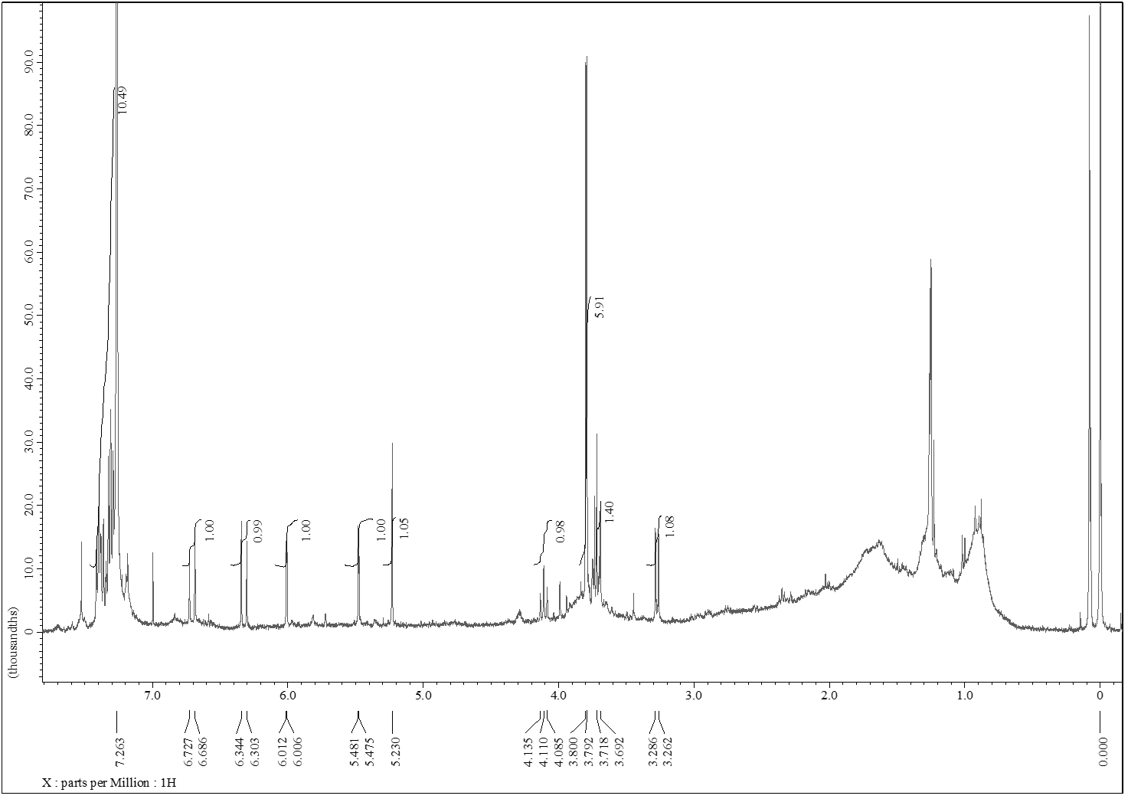
Figure S1. ¹H NMR (400 MHz, CDCl₃) spectrum of compound 6.

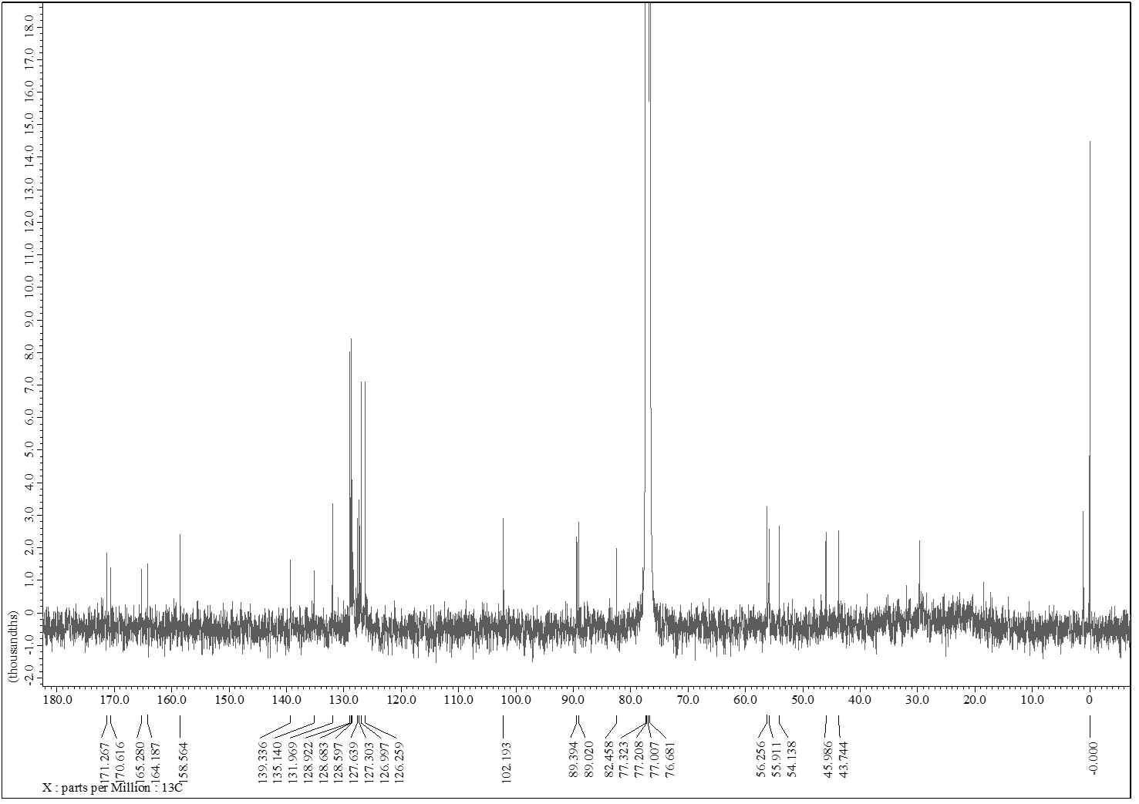
Figure S2. ¹³C NMR (100 MHz, CDCl₃) spectrum of compound 6.
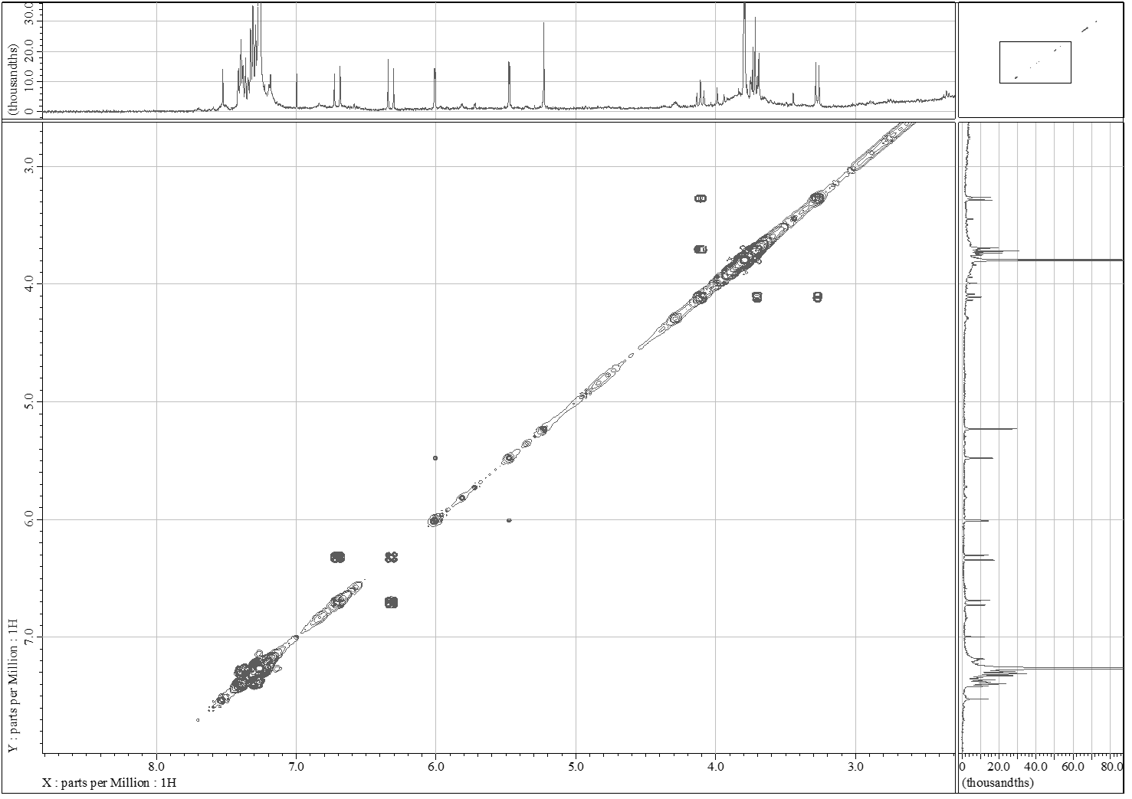
Figure S3. ¹H-¹H COSY (400 MHz, CDCl₃) spectrum of compound 6.

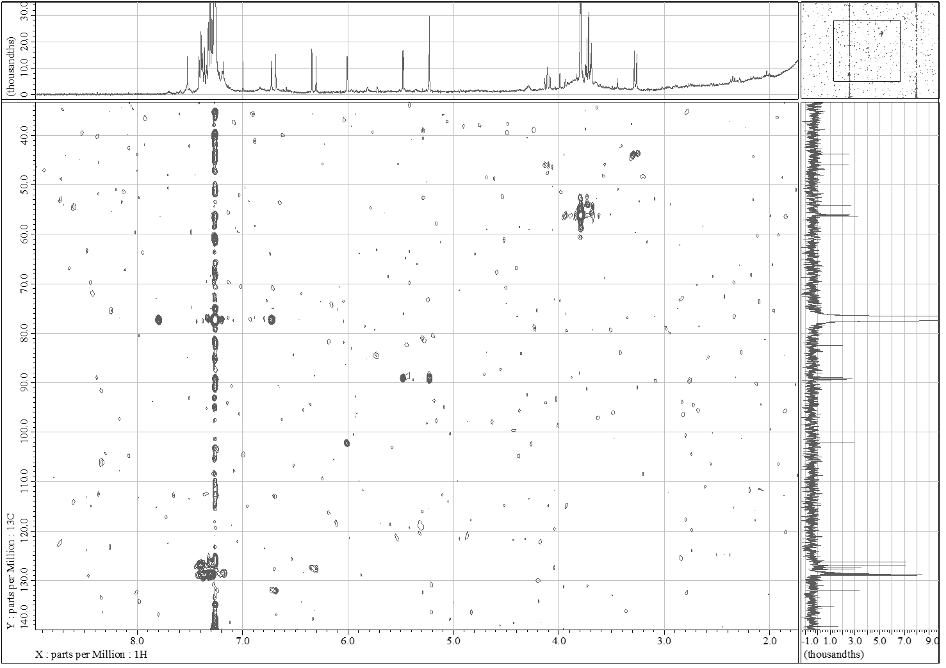
Figure S4. HMQC (400 MHz, CDCl₃) spectrum of compound 6.
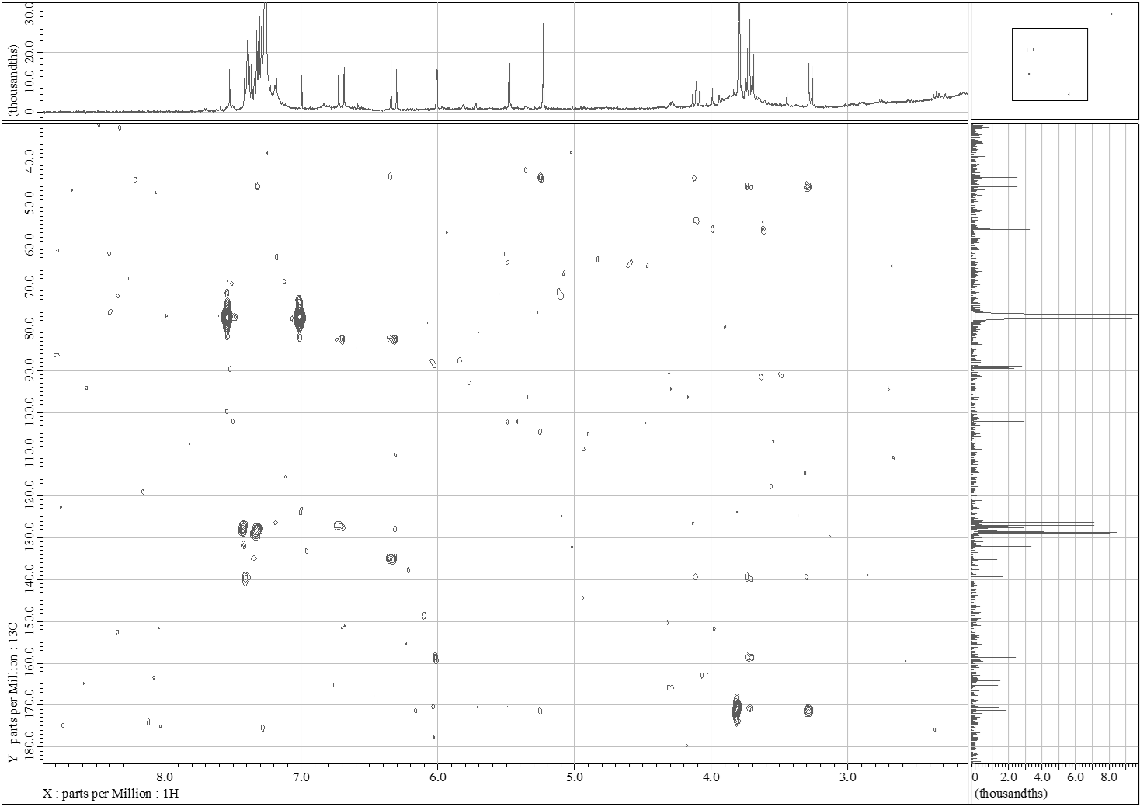
Figure S5. HMBC (400 MHz, CDCl₃) spectrum of compound 6.

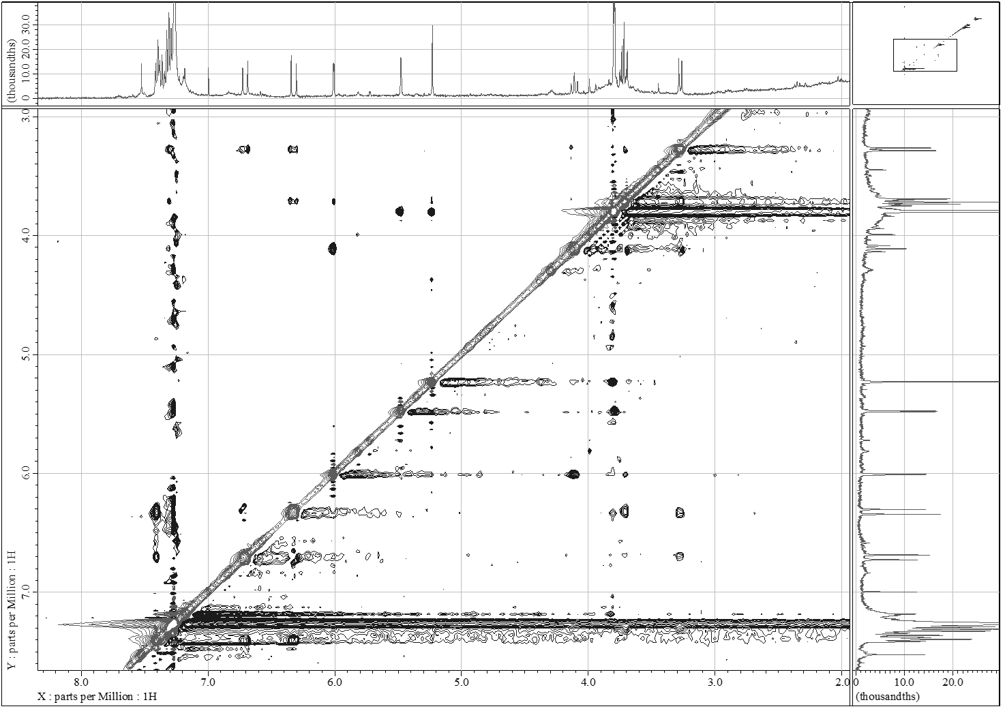
Figure S6. NOESY (400 MHz, CDCl₃) spectrum of compound 6.

