Figure S1: Experimental design and sample sizes (number of replicates) for each experiment. Tester cube experimental setup (top) was used for the direct effects and indirect effects experiments. The wood strip setup (bottom) was used in the interaction detail experiment. *The same 8 experimental units were included in both the direct and indirect effects experiments.
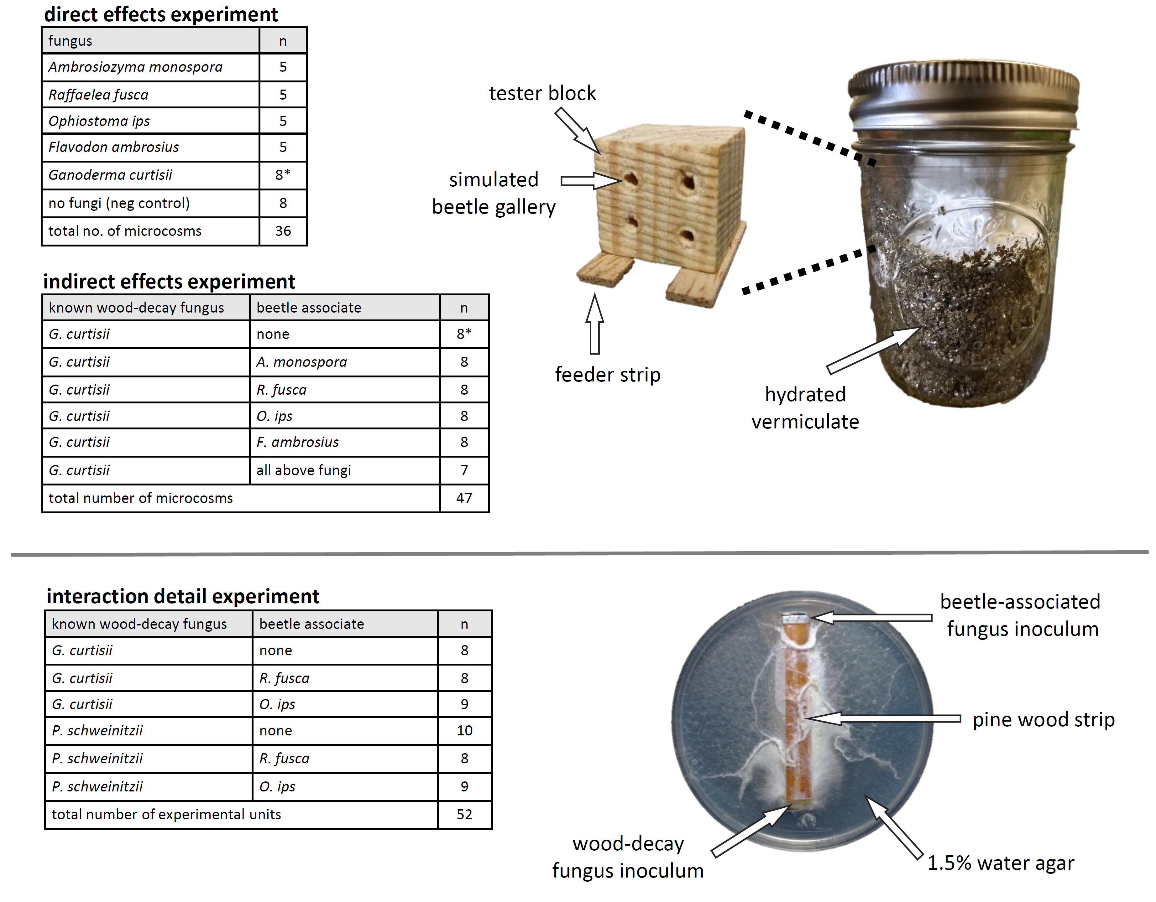

Figure S2: Experimental tester blocks inoculated with Ganoderma curtisii only (top row), and cubes pre-inoculated with Flavodon ambrosius then G. curtisii (bottom row). The texture and color of the hyphae from the two species are visibly different, with F. ambrosius being dense, spongy, and bright white, whereas G. curtisii is yellow on the top surfaces of the cubes and not spongy in texture. Ganoderma curtisii was not visible on cubes pre-inoculated with F. ambrosius.

