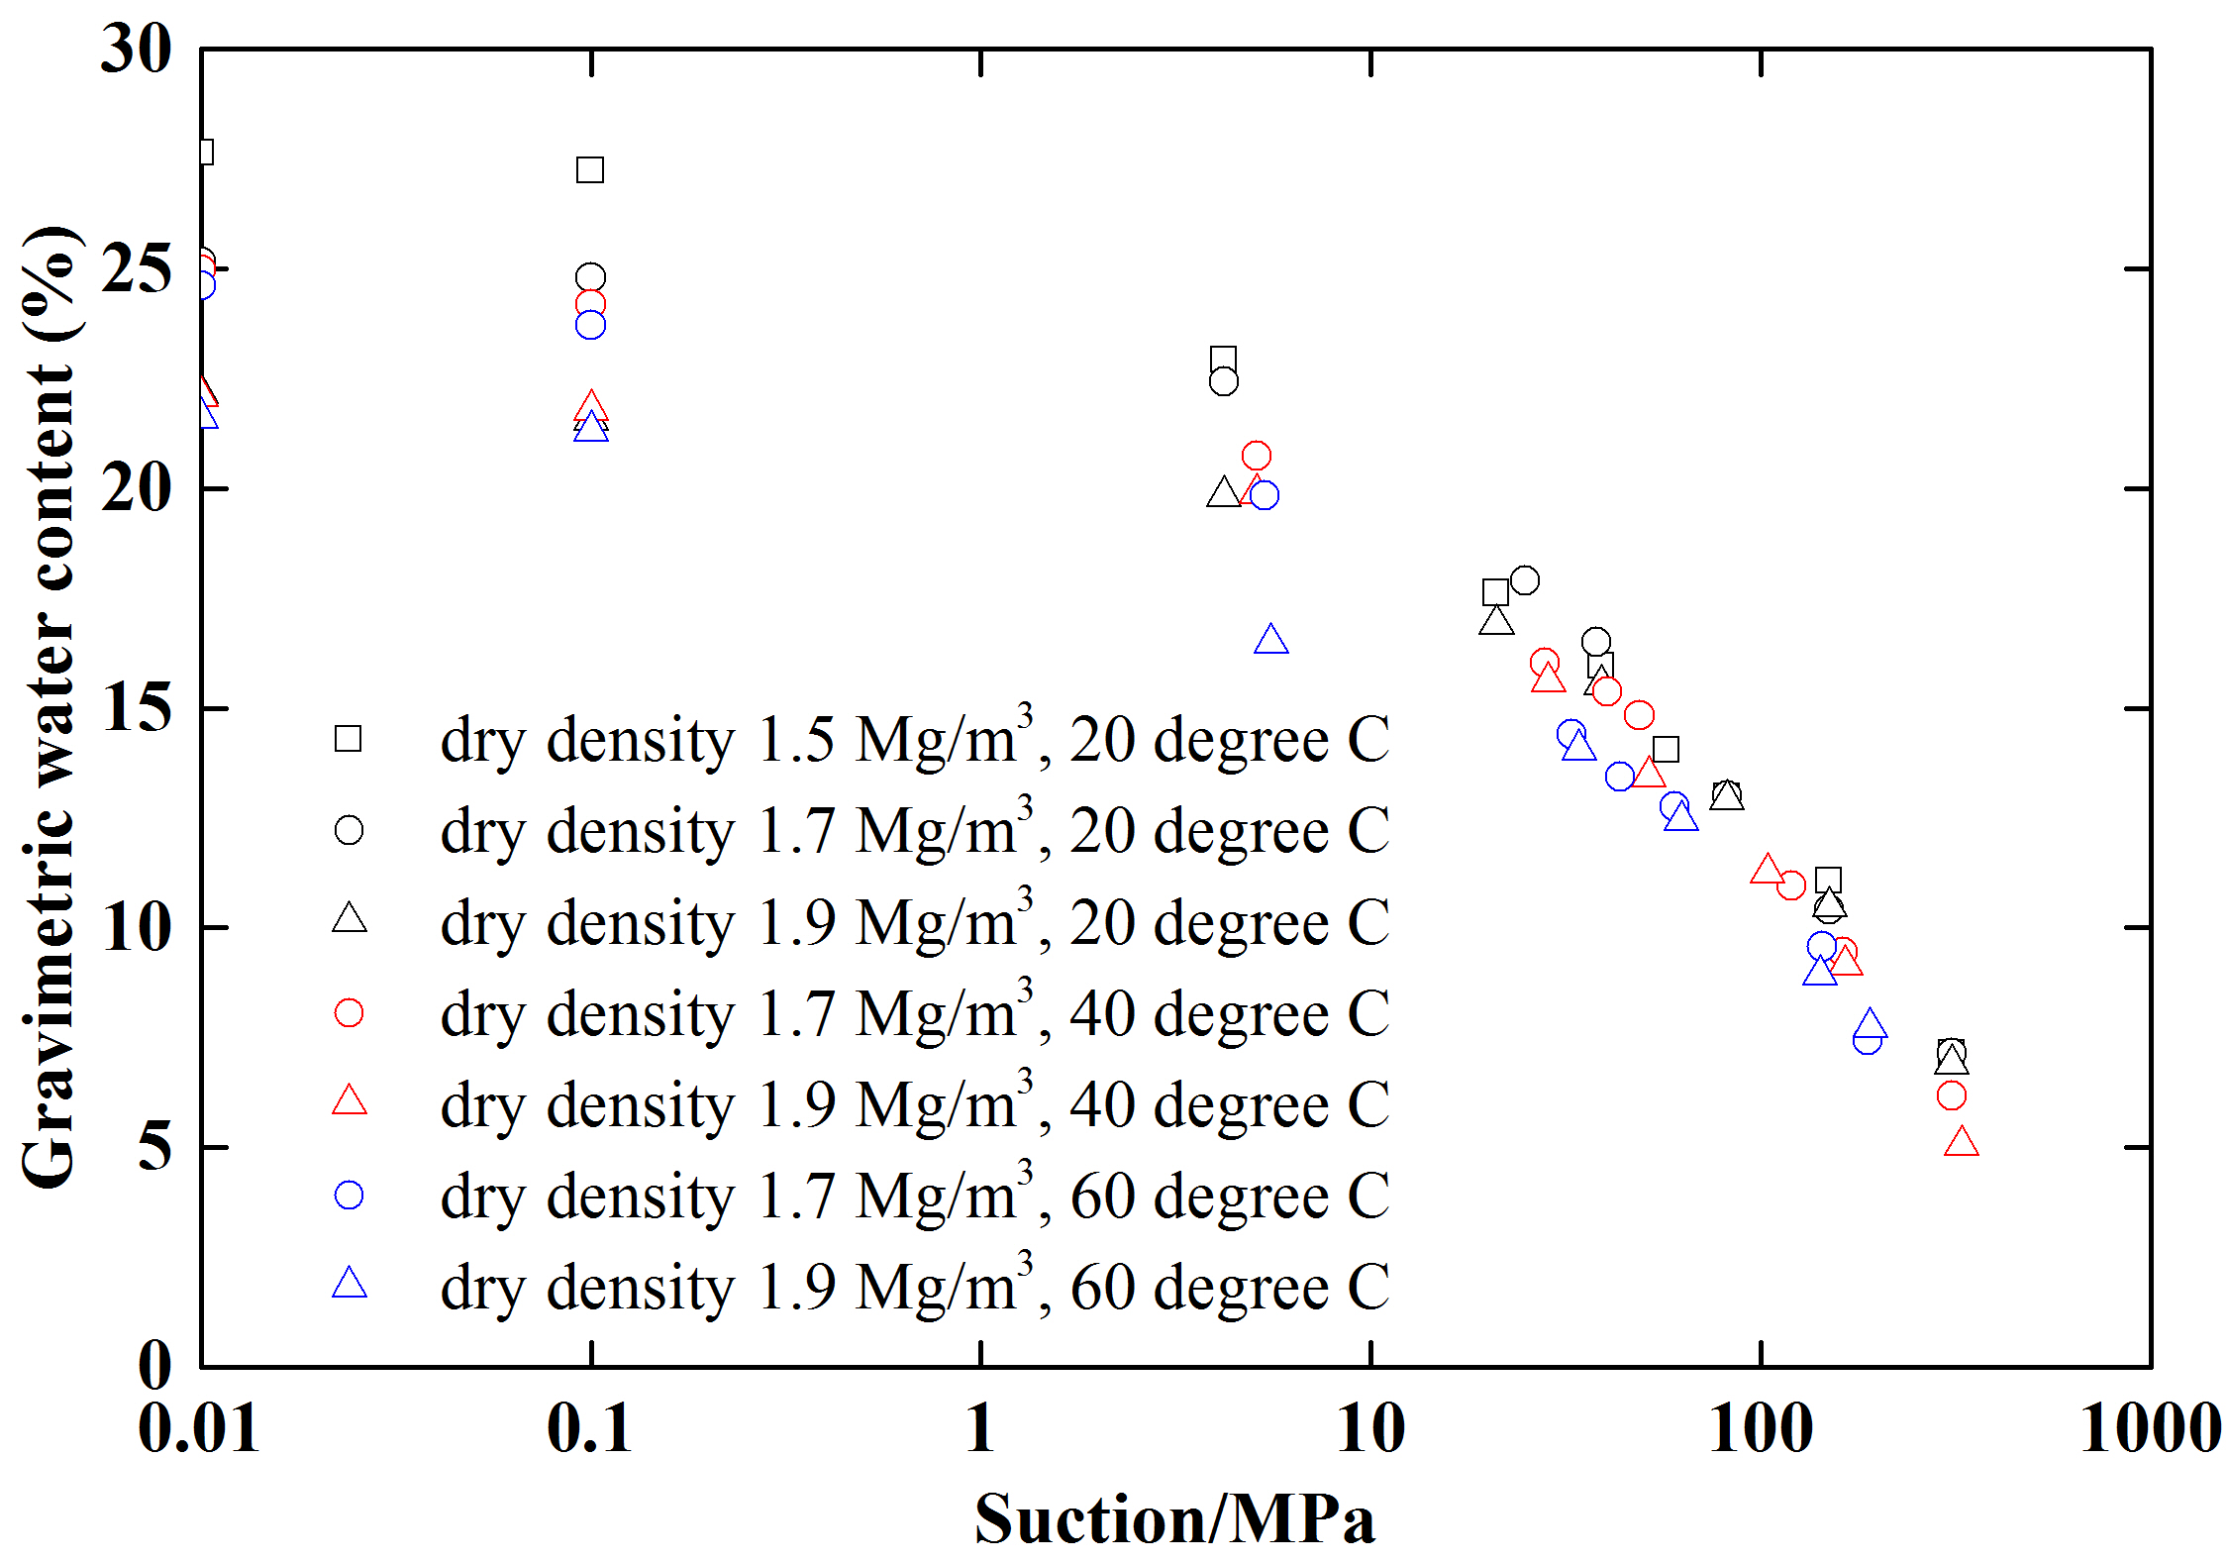
(a)
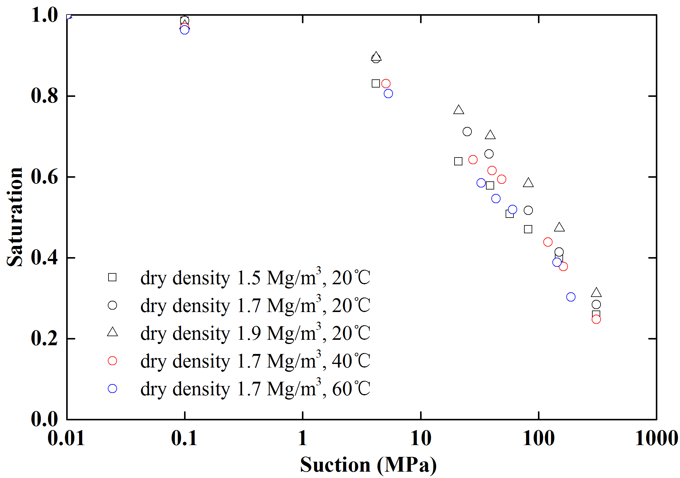
(b)
Fig.1 The SWR data sets for the confined GMZ01 bentonite samples under isochoric condition (a) gravimetric water content (from Wan et al. (2015) and Ye et al. (2015)); (b) degree of saturation (modified from (a))

