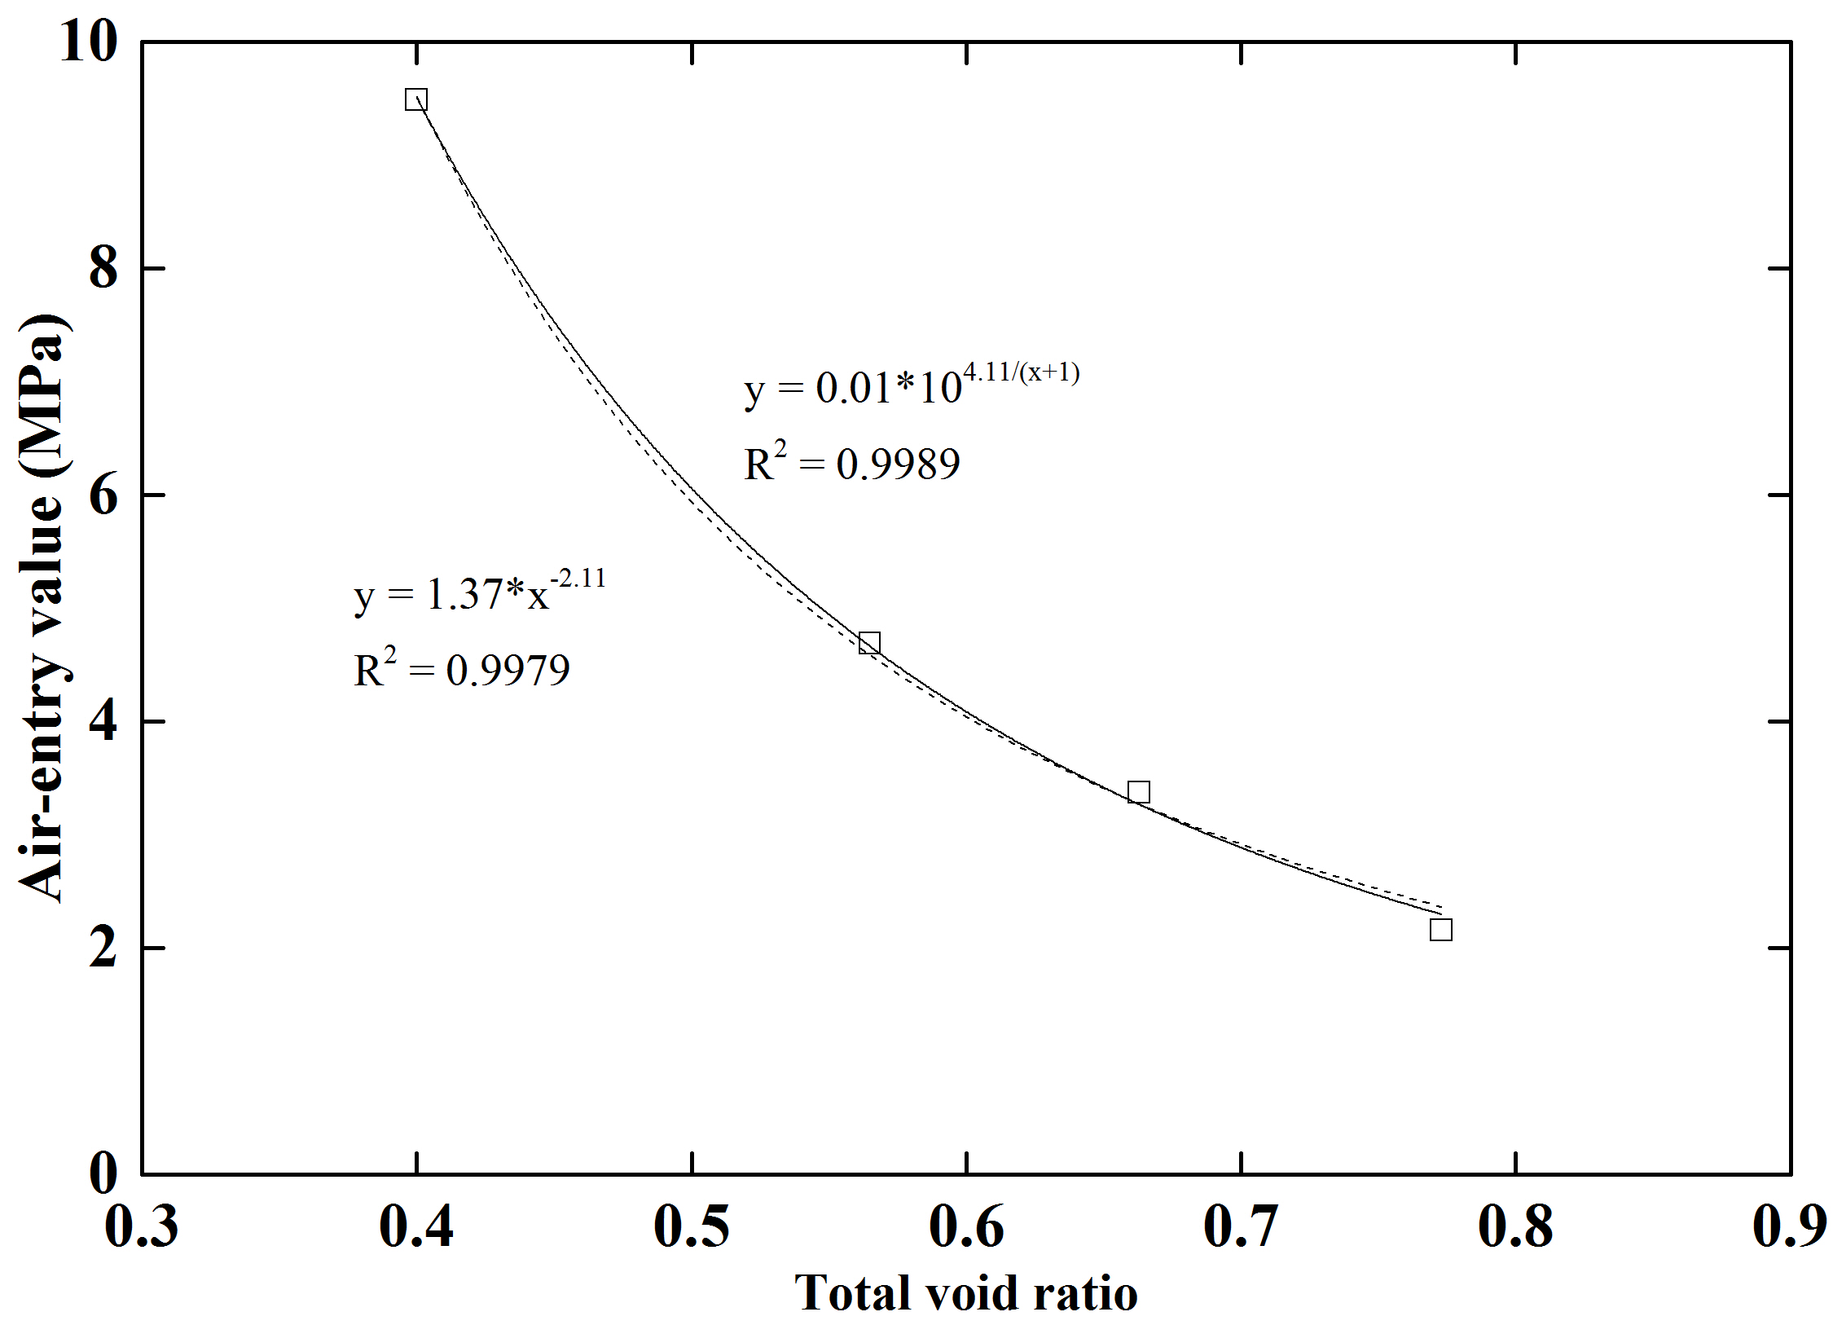
(a)
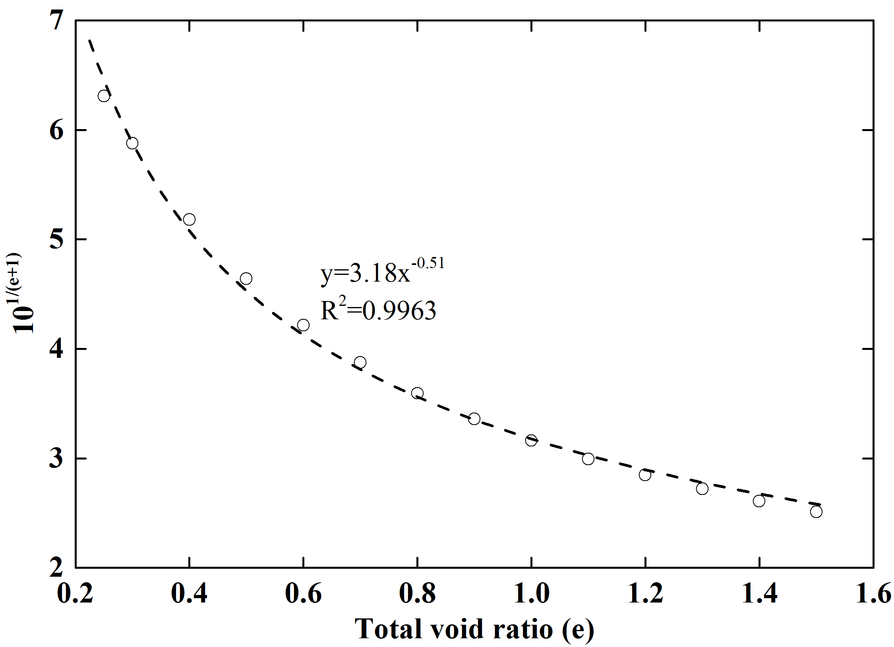
(b)
Fig. 3 Fitted curves of AEVs vs. total void ratios on confined GMZ01 bentonite samples (a) using different functions and (b) their relationship verification

