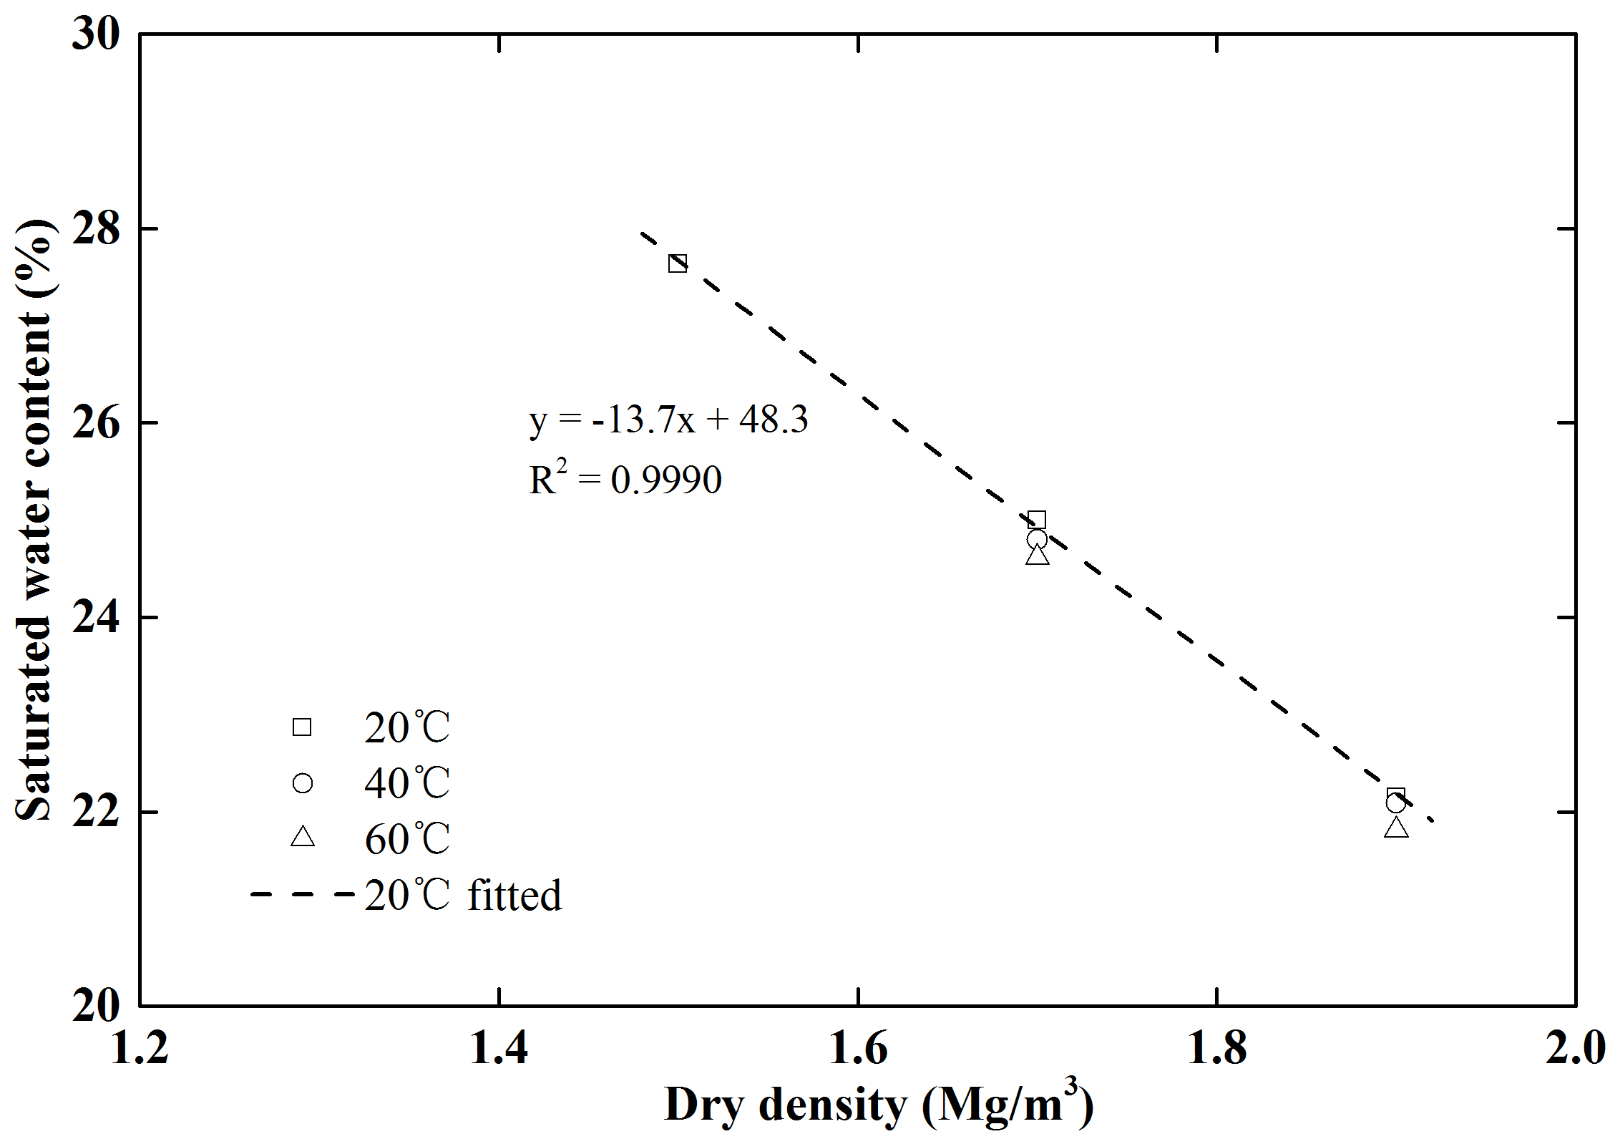
Fig. 2 Fitted curve of saturated water content versus dry density for the confined GMZ01 bentonite

