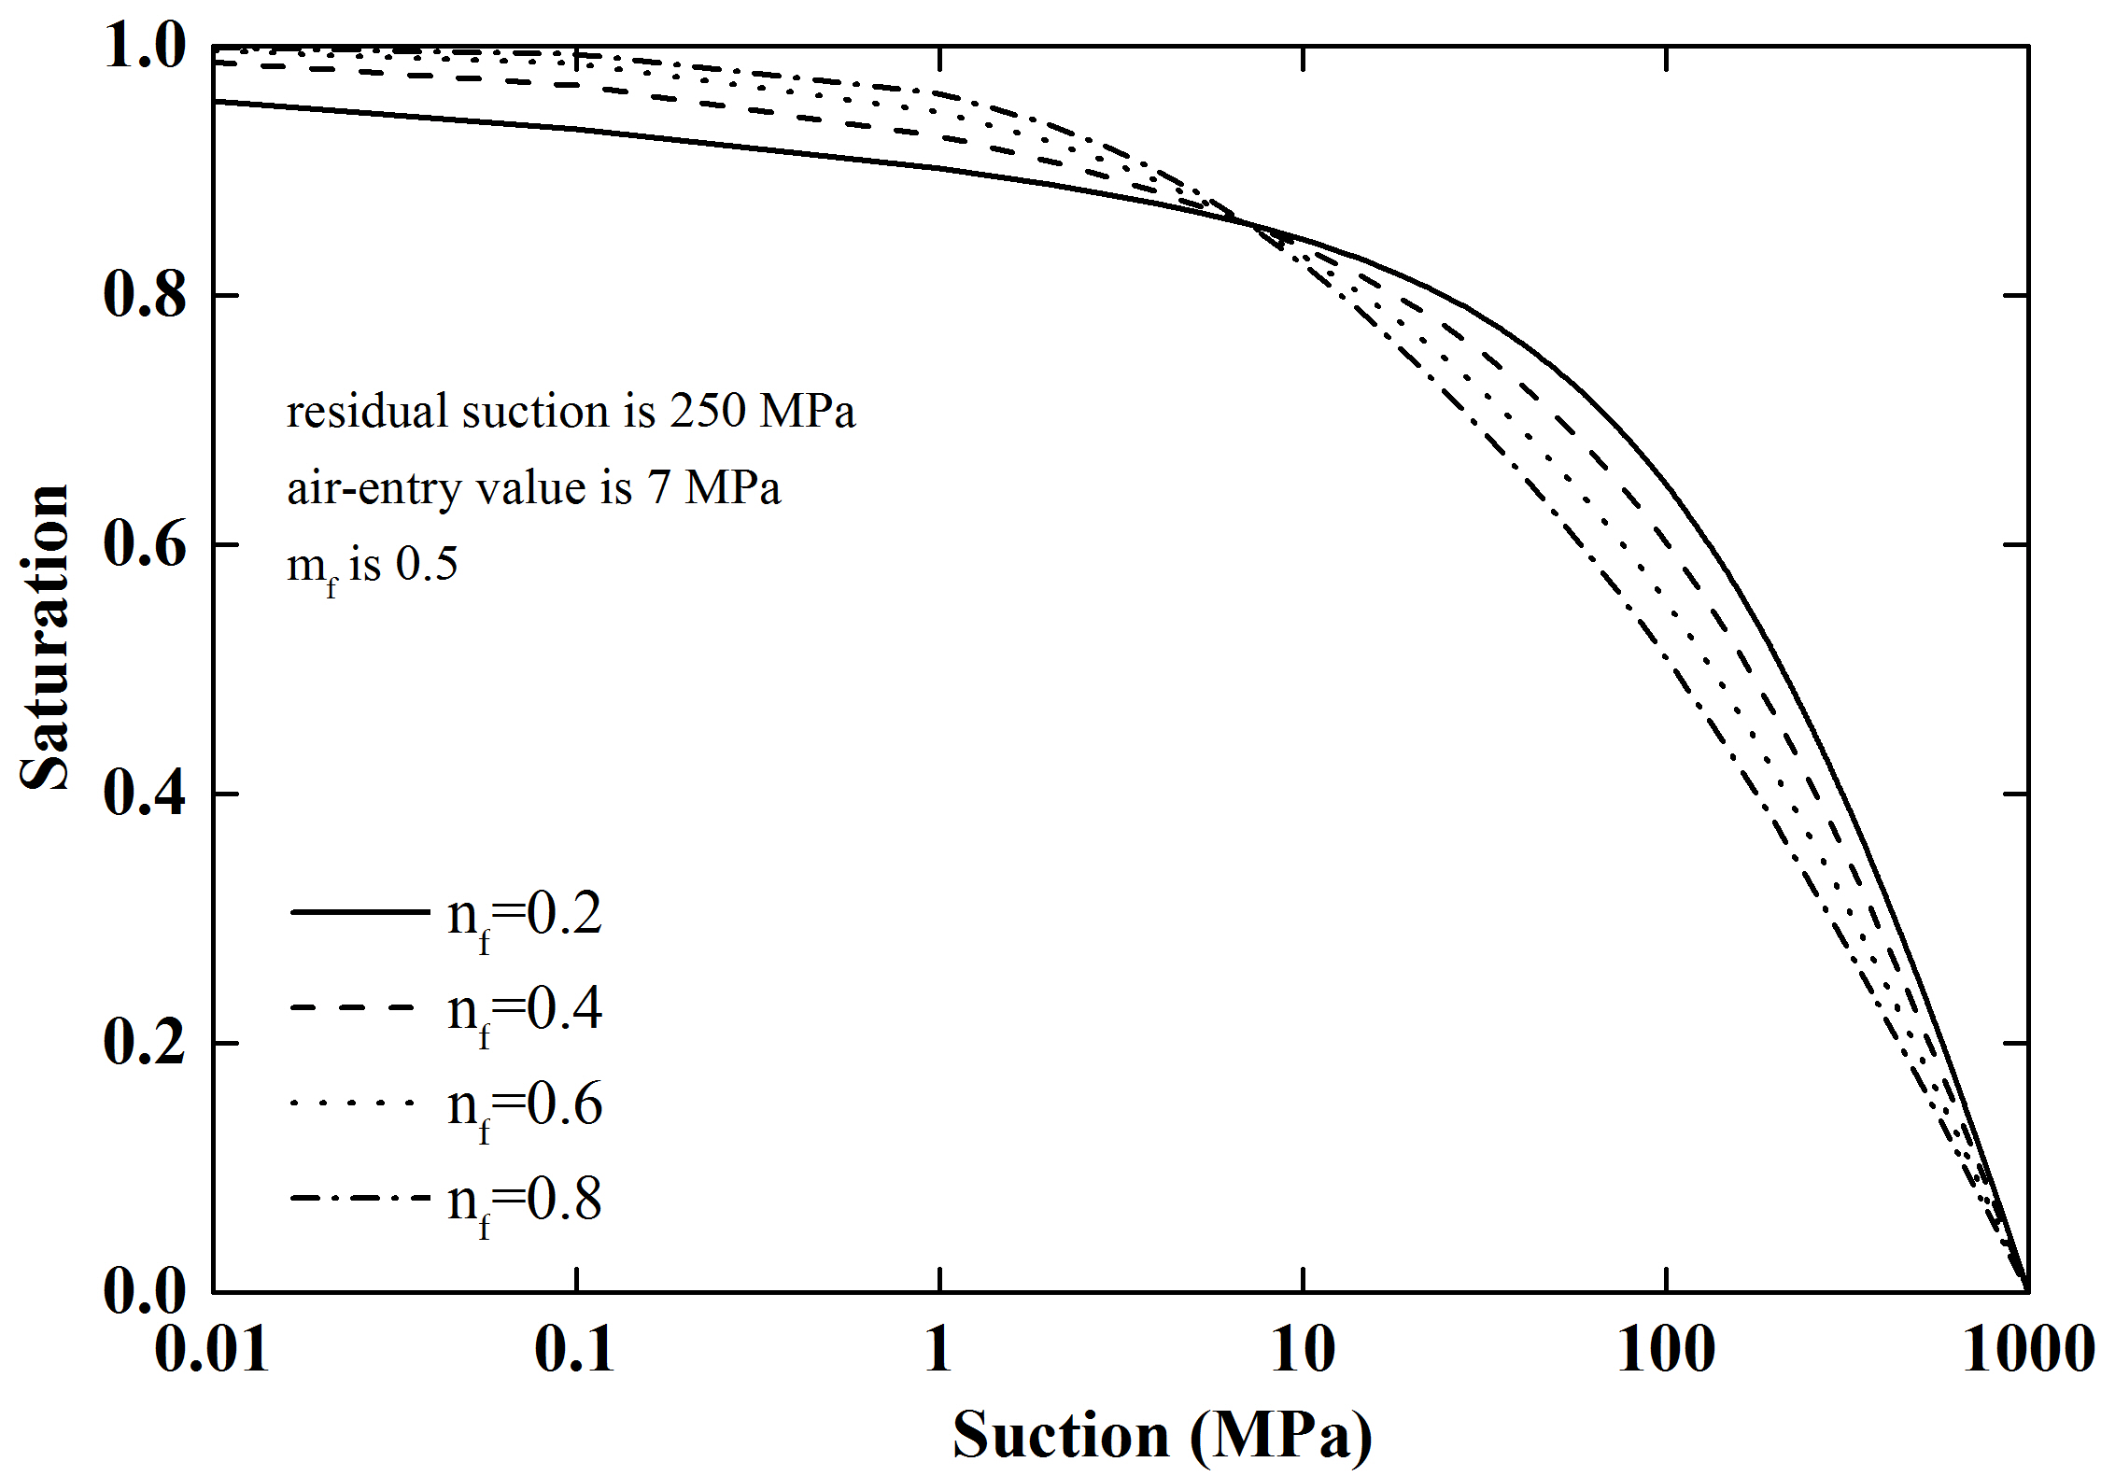
(a)
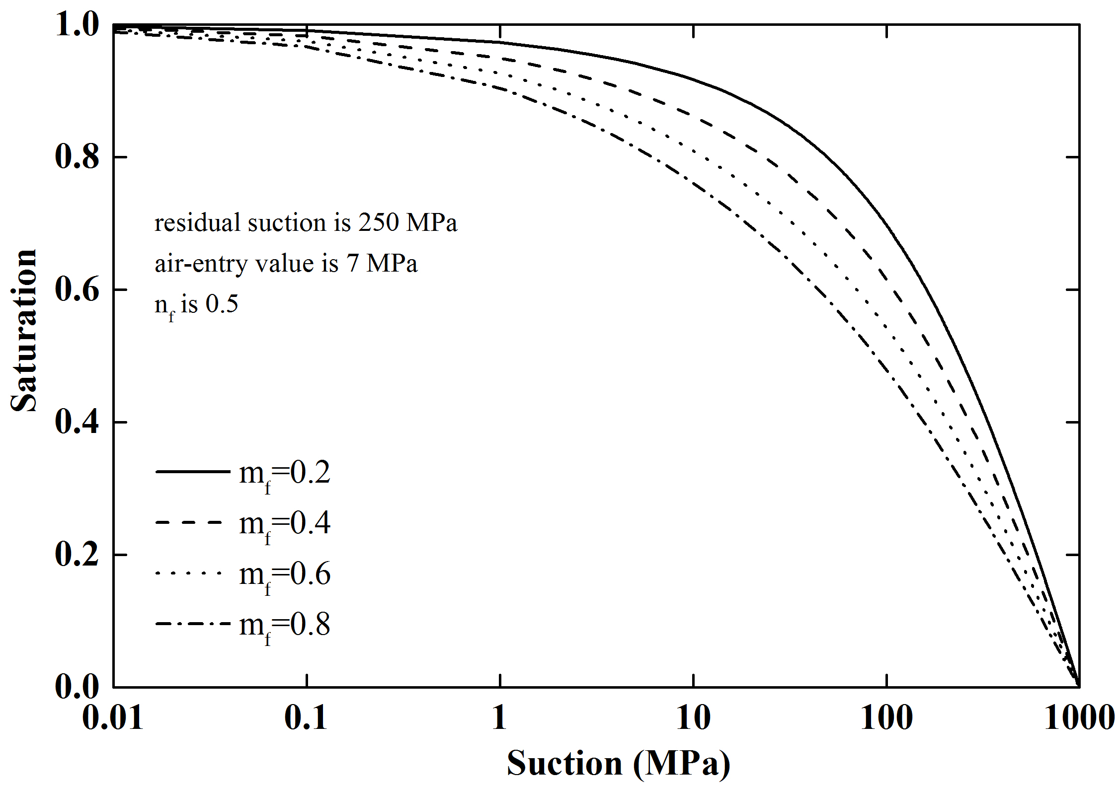
(b)
Fig.4 Fitted SWRCs for parameters’ assessments (a) n_{f}; (b) m_{f}

