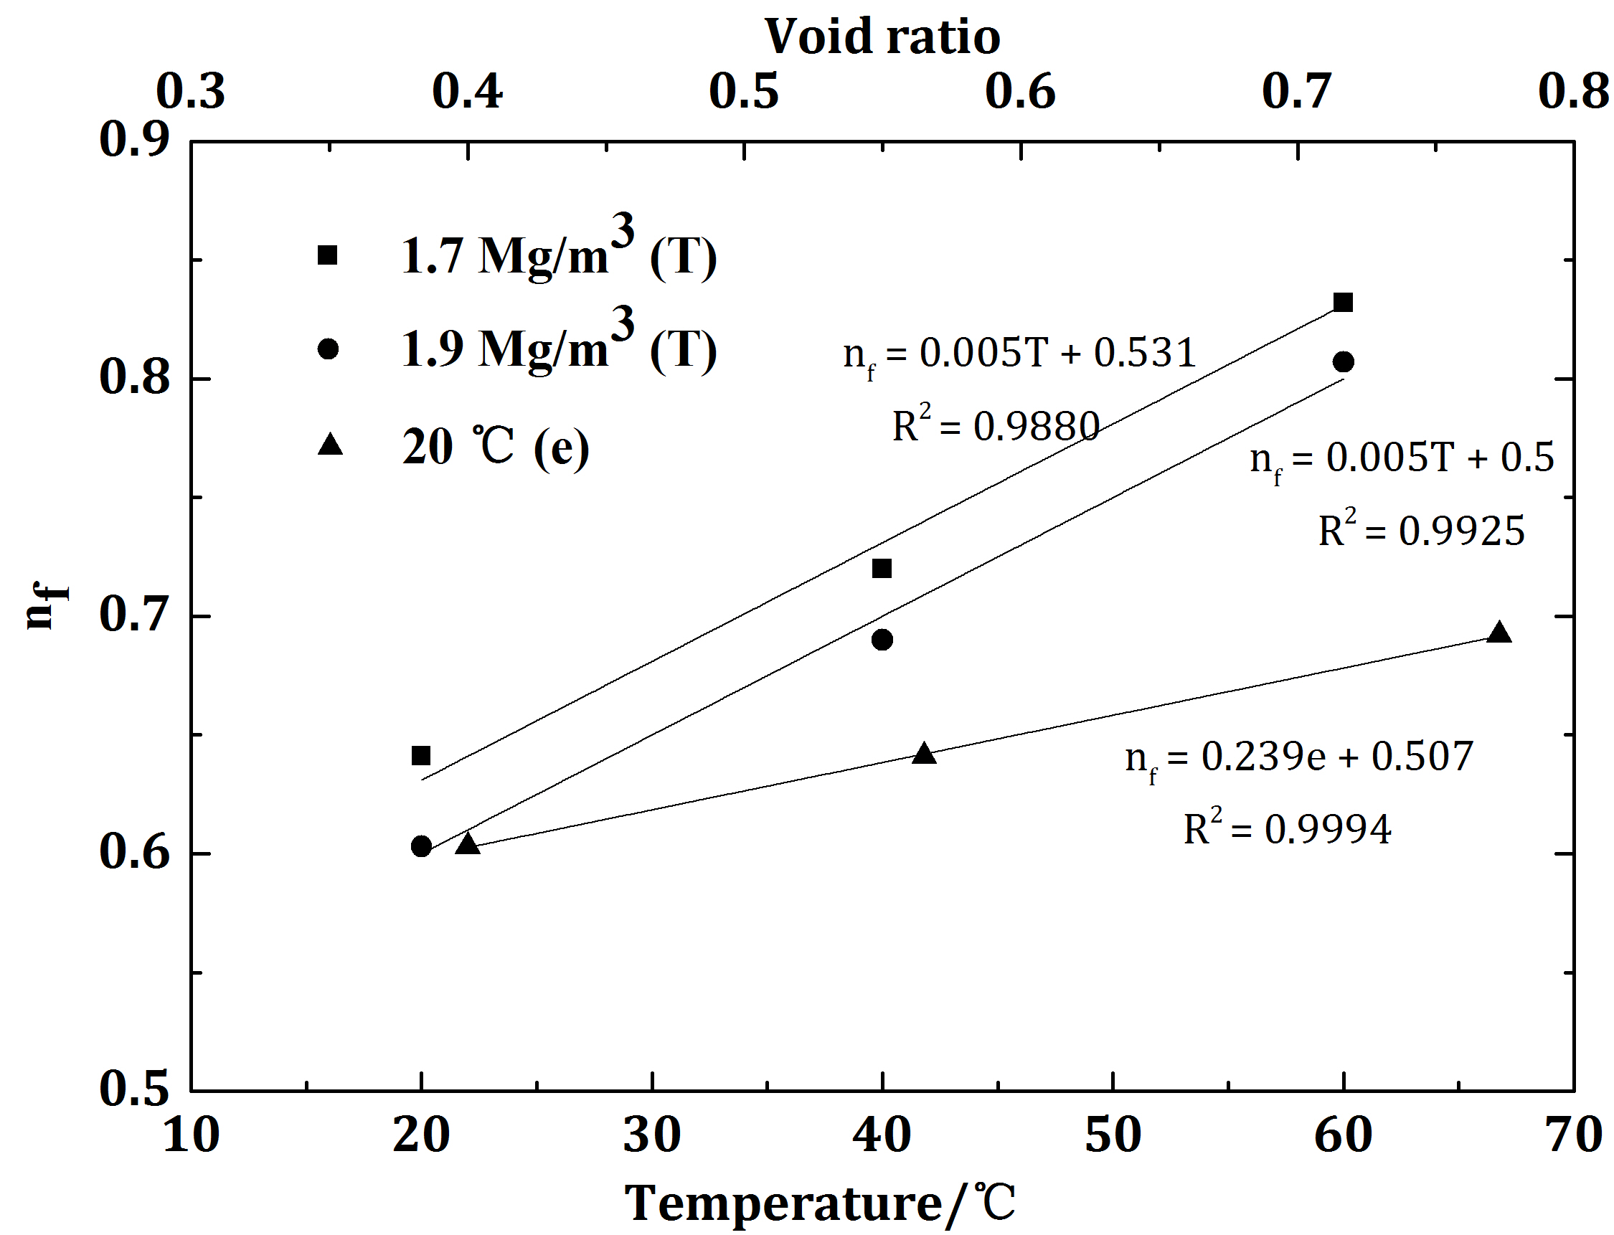
Fig. 5 Relationships between $n_{f}$ and void ratio / temperature for the confined GMZ01 bentonites

