Intestinal Tuberculosis Patients Manifested as Caecal and Adnexal Tumor: Case Serial of Three Patients

Irawaty Djaharuddin^{a,}, Mochammad Hatta^{b}, Safriadi^{c}, Nur Ahmad Tabriª

ªDepartment of Pulmonology and Respiratory Medicine, Faculty of Medicine, Universitas Hasanuddin Makassar, Indonesia
^{b}Molecular Biology and Immunology Laboratory for Infectious Diseases, Faculty of Medicine, Universitas Hasanuddin Makassar, Indonesia
^{c}Department of Internal Medicine, Faculty of Medicine, Universitas Hasanuddin Makassar, Indonesia

Email address :
Irawaty Djaharuddin : irawatymuzakkir@gmail.com
Mochammad Hatta : hattaram@yahoo.com
Safriadi : safriadi.musa@gmail.com
Nur Ahmad Tabri : nurahmad_59@yahoo.com

*Corresponding author:
Mochammad Hatta :
Molecular Biology and Immunology Laboratory for Infectious Diseases, Faculty of Medicine, Universitas Hasanuddin, Jl. Perintis Kemerdekaan Km.10 Tamalanrea, Makassar 90245, South Sulawesi, Indonesia
Email : hattaram@yahoo.com
ORCID ID : 0000-0002-8456-4203

ABSTRACT
Background: Tuberculosis (TB) is the most common infectious diseases worldwide. Cases of intestinal TB (ITB) also increased. Intestinal TB is the sixth highest manifestation of extrapulmonary TB, and can manifest in a variety of abdominal disorders or diseases. Clinical manifestations may be nonspecific with many conditions, including malignancies. Until now there is no single method that can detect ITB accurately. Hereby, we presents three cases of ITB that manifested as caecal and adnexal tumor.
Case report: First case, a 22-year-old male, presented with abdominal pain, post exploratory laparotomy, right hemicolectomy, and anastomosis end to side transversal ileocolical due to partial ileus obstruction from caecal tumor. The second and third cases, a 27-year-old and 39-year-old females, both presented with abdominal pain, post exploratory laparotomy due to ovarian cyst neoplasm. Histopathologic examination in all three cases showed chronic granulomatous inflammation et causa specific TB process. Hence, the patients were given anti-tuberculosis drugs (ATD).
Discussion: Intestinal TB is an extrapulmonary TB, which the most common affected location is the ileocaecal, accounts for 64% of the incidence of gastrointestinal TB. Ileocaecal have a variety of contributing factors including static condition, the amount of lymphoid tissue at this location, the most absorptive area and closer contact of the bacilli with the mucosa. Clinical symptoms found in ITB patients are almost the same as symptoms often found in pulmonary TB such as fever, weight loss, anorexia, and night sweats. Endoscopic findings and radiological or bacteriological signs and histopathological findings are the gold standard for ITB diagnosis.

Keywords: intestinal; extrapulmonary; tuberculosis

INTRODUCTION
Tuberculosis (TB) remains a worldwide major health problem, primarily in 30 countries with high burden of TB. At least one third world population infected with Mycobacterium tuberculosis and in risk for develop TB disease during their lifetime. WHO reported that in 2017 there are 10 million people developed TB disease globally, with 6.4 million new cases reported worldwide. Indonesia was in the third world rank in term of TB patients with mortality 40 per 100.000 populations. Annually, about 442.000 new case of TB in Indonesia.[1]
Tuberculosis typically affects the lungs (pulmonary TB), but can also affect other sites (extrapulmonary TB). Among all TB cases, extrapulmonary TB cases acquired 14% of total TB cases globally and 15% total TB cases in South-East Asia.[1] Intestinal TB (ITB) accounts for 2% of TB cases worldwide.[2]
Intestinal TB can manifest in a variety of abdominal ailments or diseases and only severe cases present a characteristic clinical feature so diagnosis of these patients commonly unrecognized or late diagnosed, resulting in high morbidity and mortality. Clinical manifestations that are nonspecific and sometimes resemble some other conditions including malignancy causing the diagnosis of ITB is difficult to be established accurately. Findings from endoscopic results and radiologic features of various stages of the disease have been very large, but the diagnosis is still difficult. Until now there is no single method that can detect intestinal TB accurately.[3,4] Among bacteriological examination, polymerase chain reaction (PCR) analyses of mucosal biopsy specimens from endoscopy have been shown to be a valuable tool in improving diagnostic yield, with high specificity, 95%. The PCR has also been found to be more sensitive than acid-fast bacilli (AFB) stain and culture in diagnosing ITB.[4] One study in Makassar, Indonesia found that multiplex PCR should be suitable for a rapid and correct diagnosis of patients suspected of having mycobacterial disease.[5] Early diagnosis, anti-tuberculosis drug (ATD) and surgical procedures are essential in preventing the occurrence of morbidity and mortality from ITB, so a combination of clinical assessment and examination of various modalities is needed. Patients with ITB are given ATD and consideration of surgery if they experience complications.[3, 4] Hereby, we reported three cases of ITB that manifested as caecal and adnexal tumor.

FIRST CASE
A 22-year-old post exploratory laparotomy male was consulted from department of digestive surgery with diagnosis of bowel obstruction due to caecal tumour. Patient complained of abdominal pain since one month before being treated at regional hospital and worsen in the last week when patient experienced continuous pain. Patients also complained cough occasionally. There is a history of diarrhoea, fever, loss of appetite, night sweat, and significant weight loss since the last one month. There was no history of given ATD nor close contact with active TB patient.
On examination, we found normal vital sign and generally well patient. On lung examination, no rales or wheezing were found. On abdominal examination, former laparotomy scar was found on abdominal medial line with no organomegaly. Rest of the abdominal examination, pelvic examination and revealed no abnormality (Figure 1).
Investigation was performed and revealed as follow: Chest x-ray showed infiltrates in both lung apexes. Whole abdominal CT-scan showed obstructive ileus. Haemoglobin was 9.4 g/dL and white blood cells (WBC) was 7,800/mm³. Sputum gram stain showed gram-positive Diplococcus and AFB stain were positive in 2 specimens. Other investigations were normal.
A right hemicolectomy and anastomosis end to side transversal ileocolical were performed. Then specimen from omental biopsy was sent for histopathological analysis which found chronic granulomatous inflammation caused by TB with inflammation-free resection tip without sign of malignancy (Figure 2). This patient was diagnosed with pulmonary and ITB. On discharge the patient was put on 6-months ATD treatment.

SECOND CASE
A 27-year-old female post exploratory laparotomy female was consulted from department of obstetry-gynaecologic with diagnosis cystic ovarian neoplasm. Patient was referred from regional hospital who complained of continuous abdominal pain accompanied by abdominal distension since the last one month. There is a history of fever, night sweat and significant weight loss since the last one month. There was history of close contact with TB patient and no history of given ATD.
On examination, we found normal vital sign and generally well patient. On lung examination, no rales or wheezing were found. On abdominal examination, former laparotomy scar was found on abdominal medial line without organomegaly. Rest of the abdominal examination, pelvic examination and revealed no abnormality (Figure 3).
Investigation was performed and revealed as follow: Chest x-ray showed right pleural effusion. Abdominal ultrasonography showed right ovarian mass with sign of malignant ascites, right nephropathy, and right pleural effusion. Whole abdominal CT-scan showed right adnexal mass with sign of malignant ascites. Haemoglobin was 11.9 g/dL, WBC was 5,900/mm³ and Ca-125 marker was >600 U/mL. Other investigations were normal.
A biopsy and adhesiolysis were performed, then specimen from omental biopsy sent for histopathological analysis which found chronic granulomatous inflammation caused by TB without sign of malignancy (Figure 4). This patient was diagnosed as ITB. On discharge the patient was put on 6-months ATD treatment.

THIRD CASE
A 38-year-old post exploratory laparotomy female was consulted from department of obstetric-gynaecologic with diagnosis ITB. Patient was referred from regional hospital who complained abdominal distension accompanied with colicky abdominal pain since the last one month. Patient was previously hospitalized without improvement. There is a history of constipation, loss of appetite, and significant weight loss since the last two months. There was no history of close contact with TB patient and given ATD.
On examination, we found normal vital sign and generally well patient. General physical examination revealed anemic conjunctiva. On lung examination, no rales or wheezing were found. On abdominal examination, former laparotomy scar was found on abdominal medial line without organomegaly. Rest of the abdominal examination, pelvic examination and revealed no abnormality (Figure 5).
Investigation was performed and revealed as follow: Abdominal ultrasonography showed adnexal cystic mass, fatty liver, and minimal ascites. Whole abdominal CT Scan showed ascites with malignancy signs and hepatomegaly accompanied with fatty liver. Hemoglobin was 9.8 g/dL, WBC was 6,300/mm³ and Ca-125 marker was 74.84 U/mL. The rest of the investigations, including chest x-ray, were within normal limits.
An exploratory laparotomy was performed, then specimen from peritoneal biopsy was sent for histopathological analysis found chronic granulomatous inflammation caused by TB without sign of malignancy (Figure 6). On discharge the patient was put on 6-months ATD treatment.

DISCUSSION
Clinical symptoms found in patients with ITB are almost the same as the symptoms that are often found in pulmonary TB such as fever, weight loss, anorexia, and night sweats.[6] In all three patients were found the clinical symptoms of TB.
Intestinal TB is an extrapulmonary TB, which the most common affected location is the ileocaecal, accounts for 64% of the incidence of gastrointestinal TB, followed by jejunum and large bowel. Intestinal TB commonly found in ileocaecal since it has a variety of contributing factors including static condition, the amount of lymphoid tissue at this location, the most absorptive area and closer contact of the bacilli with the mucosa.[6]
Pathophysiology of TB enteritis can occur through one in several ways: (1) ingestion of infected sputum in a patient with active pulmonary disease; (2) hematogenous or lymphatic spread from a distant focus; (3) direct extension from a contiguous site; and (4) ingestion of milk products infected with Mycobacterium bovis.[4,7]
The mycobacterium has a fatty capsule which resists digestion and interferes with release early in the gastrointestinal tract, explaining the rarity of proximal gastrointestinal lesions. The narrow lumen and relative stasis of the ileocaecal region allow digestion of the capsule and efficient absorption of the organism. Abundant lymphatic tissue for which the organism has an affinity further enhances infections at this site. Once in the submucosa, the bacillus colonizes the Peyer’s patches and initiates an inflammatory response, forming granulomas. The tubercles undergo caseous necrosis and release organisms into the lymphatics, allowing migration to regional nodes where further granulomas form. As the tubercles enlarge, the bowel wall becomes markedly thickened and small papillary elevations form in the mucosa. Combined with an associated endarteritis and lymphangitis, the superficial mucosa becomes edematous and circumferentially ulcerated. As the ulcers heal, deposition and contraction of collagen in the submucosa can lead to stricture formation. Thus, tuberculous enteritis can be classified grossly as ulcerative, hypertrophic, mixed ulcerohypertrophic, and fibrotic. The ulcerative form is more likely to be found in the small intestine and the hypertrophic form in the caecum.[4,6] In the first case, it was possible from hematogenous spread of active pulmonary TB, for the second patient was found a history of contact with active TB patients, while for the third patient, pathogenesis of the TB spread is unknown.
The manifestations of ITB can be divided into three categories: ulcerative form (60%), hypertrophic form (10%) and lesions such as mass (ulcerohypertrophic, 30%) that resemble malignancy. Manifestations depend on the immune system. Ulcerative forms occur in those with reduced immune responses. Manifestations can be nonspecific and show similarities to other gastrointestinal disorders, such as Crohn's disease, peptic ulcer, malignancy, sarcoidosis, fungal infections or idiopathic granulomatous gastritis.[9,10]
Because TB can affect any part of the gastrointestinal tract, the presenting symptoms often vary depending on the affected anatomic location of the disease. Based on study by Tripathi et al, patients most commonly presented with abdominal pain, fever, weight loss regardless of the anatomical involvement.[7] In accordance with this, review by Choi and Coyle showed that the most common symptoms were abdominal pain (81%), followed by weight loss (62%), fever (51%), nausea and vomiting (42%), diarrhea (29%), and constipation (22%) based on numerous studies.[4] In all three patients, common TB clinical manifestation were found such as fever, anorexia and weight loss. In the first patient there were symptoms of abdominal pain and ileus obstruction. The second and third patients there were an abdominal enlargement with palpable mass. Based on history taking, all three cases were a new case of TB. This finding is consistent with other TB studies, including a study in Makassar, Indonesia, among 225 TB patients with and without diabetes mellitus, the majority of patients were a new case of TB.[8] This is a reflection of Indonesia as one of high TB burden countries in the world.
Although there are no clinical, laboratory, endoscopic findings and radiological or bacteriological signs and histopathological findings are gold standards for the diagnosis, the diagnosis of ITB is usually made by radiology and histopathology. Sharma et al studied 70 cases of abdominal TB and found evidence of active or cured lesions in chest X-ray in 22 cases (46%). Biopsy methods include endoscopy, gastrointestinal mucosal biopsy, percutaneous biopsy, guided endoscopic ultrasound biopsy, and surgery (open or laparoscopic). In all three of these patients a biopsy was carried out with exploratory laparotomy and biopsy sampling was carried out on intestinal adhesions and a mass picture. Histopathological results in all three patients described granulomas with caseous necrosis, so diagnosis of ITB were confirmed. Caseous necrosis in granuloma is a histological feature of TB. In ITB, granulomas are presented as larger amount and larger size (>200 μm) in the mucosa and submucosa. Positive PCR and ascites fluid tests were found in 72% and 87.5% of patients.[10-12] Among bacteriological examination, PCR analyses of mucosal biopsy specimens from endoscopy have been shown to be a valuable tool in improving diagnostic yield, with a high specificity, 95%. The PCR has also been found to be more sensitive than acid-fast bacilli (AFB) stain and culture in diagnosing ITB.[4] A study in Makassar, Indonesia found that multiplex PCR should be suitable for a rapid and correct diagnosis of patients suspected of having mycobacterial disease.[5]
Therapy for ITB includes pharmacological anti-tuberculosis drugs and surgical therapy. The first choice for ITB management is anti-tuberculosis drugs. When patients are suspected of ITB, anti-tuberculosis drugs can be given in a full dose. Drugs administration is the same as for pulmonary TB. Conventional antituberculosis therapy for at least 6 months including the initial 2 months of HREZ (isoniazid, rifampicin, ethambutol and pyrazinamide) followed by 4 months of HR and this therapy is recommended in all patients with ITB in Indonesia. [13] Although there are some controversies where some clinicians treat for longer periods due to concerns that six months is not adequate to achieve cure and prevent relapse of the disease after the end of treatment, recent review from Cochrane found that six-month and nine-month regimens are probably similarly effective in terms of the chances of achieving cure and no evidence to suggest that six-month regimens are less safe for gastrointestinal and peritoneal TB than nine-month regimens.[14]
In all three patients antituberculosis drugs therapy after given 6 months showed clinical improvement in all patients. For the first patient, improvement can also be seen with smear sputum results that have been negative. Anti-tuberculosis alloys used in Indonesia are:
- Category 1: 2(HRZE)/4(HR)3 or 2(HRZE)/4(HR)
- Category 2: 2(HRZE)S/(HRZE)/5(HR)3E3 atau 2(HRZE)S/(HRZE)/5(HR)E
- Child Category: 2(HRZ)/4(HR) atau 2HRZE(S)/4-10HR
- Drug Resistance TB: consisting of 2nd-line anti-tuberculosis drugs such as Kanamycin, Kapreomycin, Levofloxacin, Etionamide, Cycloserine, Moxifloxacin, PAS, Bedaquilin, Clofazimin, Linezolid, Delamanid and other new TB drugs and 1-line anti-tuberculosis drugs, namely pyrazinamide and etambutol.[14]
Besides pharmacological therapy, surgery is the second choice for complications such as free perforation, significant bleeding, complete obstruction, abscess formation, large fistulae, and refractory to antimicrobial drugs. Obstruction is the most common complication; patients with multiple and/or long strictures are less likely to respond to medical therapy. Colonoscopic balloon dilation, which shown may become one of the alternatives, may be used to manage readily accessible, short and fibrous tuberculous ileal strictures causing subacute obstructive symptoms. Although the experience is very limited, this technique appears safe and may obviate the need for surgery.[15]

CONCLUSION
Three cases of intestinal TB have been reported with clinical manifestations of caecal tumor and adnexal tumors. Diagnosis were based from biopsy from exploration laparotomy in all three patients. The patients were then treated with fix dose combination of anti-tuberculosis therapy for 6 months. After 6 months, the patients’ treatment was declared successful clinically. Clinical manifestations that are not specific and sometimes resemble some other conditions including malignancy cause the diagnosis of ITB is difficult to establish accurately. Histopathological findings are the gold standard for the diagnosis of ITB. Pharmacological and surgery therapy can be performed for the management of ITB.

REFERENCES
1. WHO, Global Tuberculosis Report 2018. 2018, World Health Organization: Geneva. https://www.who.int/tb/publications/global_report/en/
2. Miah, A.R., et al., Clinicopathological profile of patients with abdominal tuberculosis. J Nepal Health Res Counc, 2011. 9(2): 169-75. PMID: 22929848
3. Murwaningrum, A., Abdullah, M., et al, Pendekatan Diagnosis dan Tatalaksana Tuberkulosis Intestinal di Indonesia. Jurnal Penyakit Dalam Indonesia, 2016. 3(3): p. 165-73. http://jurnalpenyakitdalam.ui.ac.id/index.php/jpdi/article/download/28/25
4. Choi, E.H. and W.J. Coyle, Gastrointestinal Tuberculosis. Microbiol Spectr, 2016. 4(6). doi:10.1128 /microbiolspec.TNMI7-0014-2016.
5. Hatta, M., Sultan, A.R., et al, Detection and Identification of Mycobacteria in Sputum from Suspected Tuberculosis Patients. BMC Res Notes, 2010. 3: 72. doi:10.1186/1756-0500-3-72
6. Debi, U., et al., Abdominal tuberculosis of the gastrointestinal tract: revisited. World J Gastroenterol, 2014. 20(40): p. 14831-40. DOI: 10.3748/wjg.v20.i40.14831
7. Tripathi, P.B. and A.D. Amarapurkar, Morphological spectrum of gastrointestinal tuberculosis. Trop Gastroenterol, 2009. 30(1): p. 35-9. PMID: 19624086
8. Fachri, M., Hatta, M., Abadi S., et al, Comparison of Acid Fast Bacilli Smear for Mycobacterium tuberculosis on Adult Pulmonary Tuberculosis Patients with Type 2 Diabetes Mellitus and without Type 2 Diabetes Mellitus. Resp Med Case Report, 2018. 23: p. 158-62. https://doi.org/10.1016/j.rmcr.2018.02.008
9. Chong, V.H. and K.S. Lim, Gastrointestinal tuberculosis. Singapore Med J, 2009. 50(6): p. 638-45; quiz 646. PMID: 19551320
10. Riyadh, M. and R. Hasan, Intestinal Tuberculosis. Vol. 5. 2017. https://www.researchgate.net/publication/319651530
11. Weledji, E.P. and B.T. Pokam, Abdominal tuberculosis: Is there a role for surgery? World J Gastrointest Surg, 2017. 9(8): p. 174-181. doi: 10.4240/wjgs.v9.i8.174
12. Sharma, M.P. and V. Bhatia, Abdominal tuberculosis. Indian J Med Res, 2004. 120(4): p. 305-15. PMID: 15520484
13. Regulation of the Minister of Health Republic of Indonesia No.67, M.o.H.R.o. Indonesia, Editor. 2016. http://hukor.kemkes.go.id/uploads/produk_hukum/PMK_No._67_ttg_Penanggulangan_Tuberkulosis_.pdf
14. Jullien, S., et al., Six-month therapy for abdominal tuberculosis. Cochrane Database Syst Rev, 2016. 11: p. CD012163. DOI: 10.1002/14651858.CD012163.pub2
15. Rathi, P. and P. Gambhire, Abdominal Tuberculosis. J Assoc Physicians India, 2016. 64(2): p. 38-47. PMID: 27730779

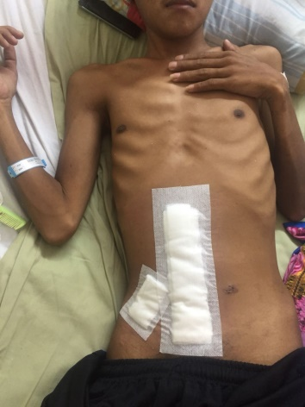
Figure 1. Patient profile of first case

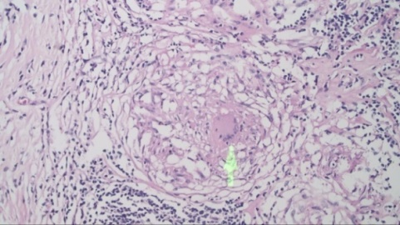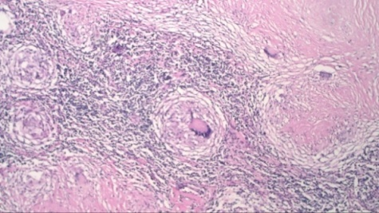
FIgure 2. Histopathological findings on first case

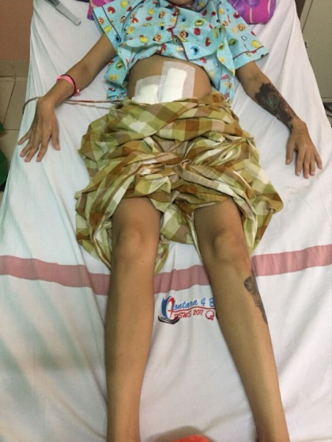
Figure 3. Patient profile of second case

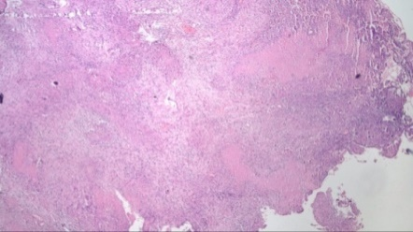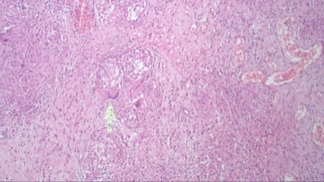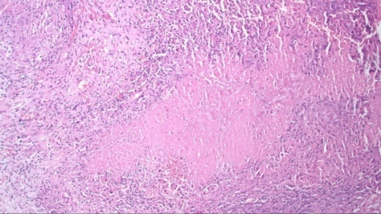
Figure 4. Histopathological findings on second case

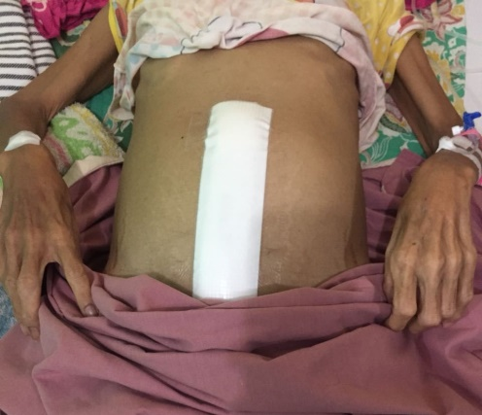
Figure 5. Patient profile of third case

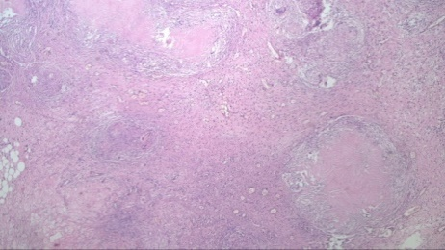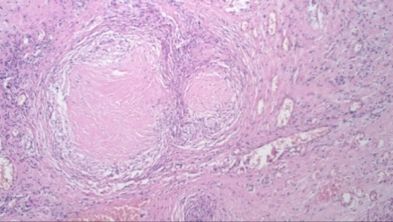
Figure 6. Histopathological findings on third case

