**Supporting Information**

**Optimization of the** **benzamide fragment targeting the S2’ site leads to potent Dipeptidyl Peptidase-IV inhibitors**

Xiaoyan Denga#, NaWanga #, Liuwei Menga, Siru Zhou a, Junli Huang a, Junhao Xingb, Weizhe Jiang a [1]*, Qing Li a [2]*

a *Pharmaceutical College, Guangxi Medical University, Nanning 530021, China;*

b *Department of Organic Chemistry and State Key Laboratory of Natural Medicines, China Pharmaceutical University, Nanjing 210009, China;*

*# Those authors contributed equally to this works*

1. **1H NMR, 13C NMR, MS and HPLC figures for compounds 6**, **8**, **10a-i, 17a-h**

Compound **6**



C:\Users\Administrator.2013-20190406GO\Desktop\图谱照片\6CC.tif



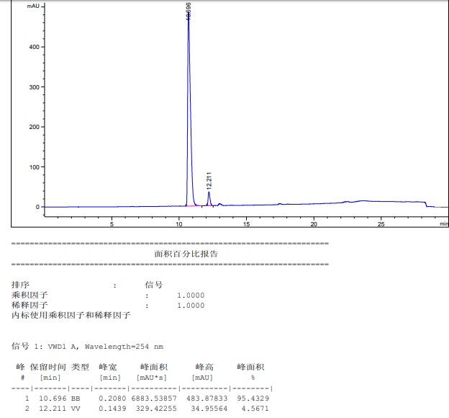

Compound **8**

**C:\Users\Administrator.2013-20190406GO\Desktop\图谱照片\8HH.tif**





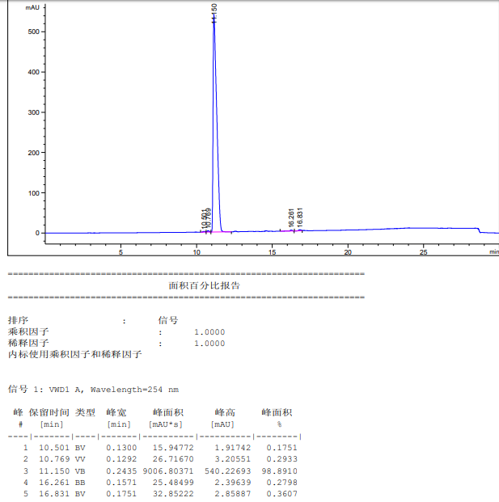

Compound **10a**







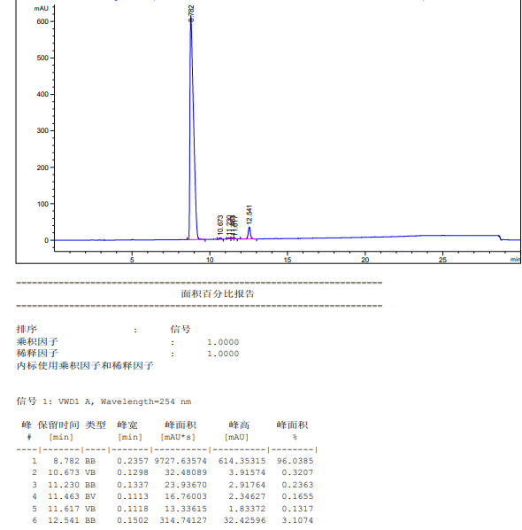

Compound **10b**







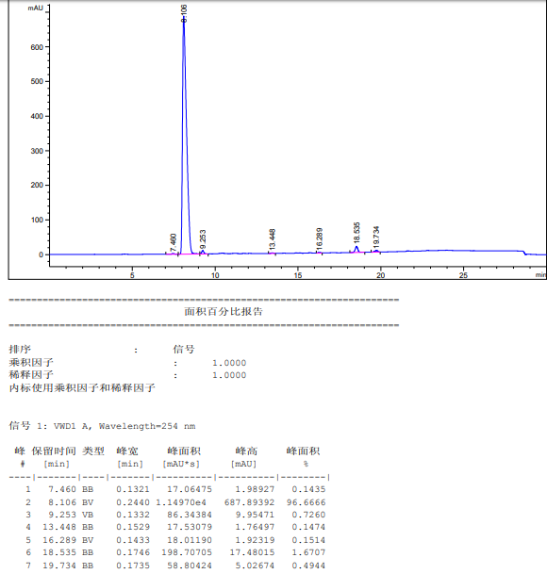

Compound **10c**







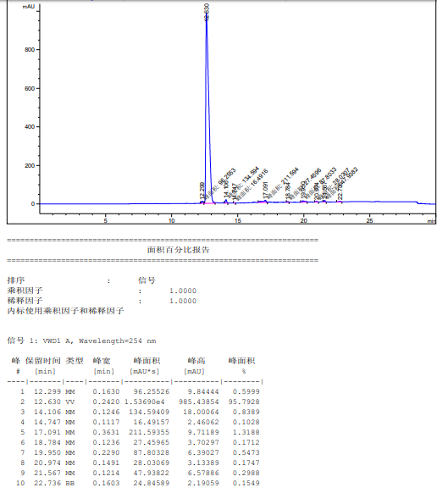

Compound **10d**





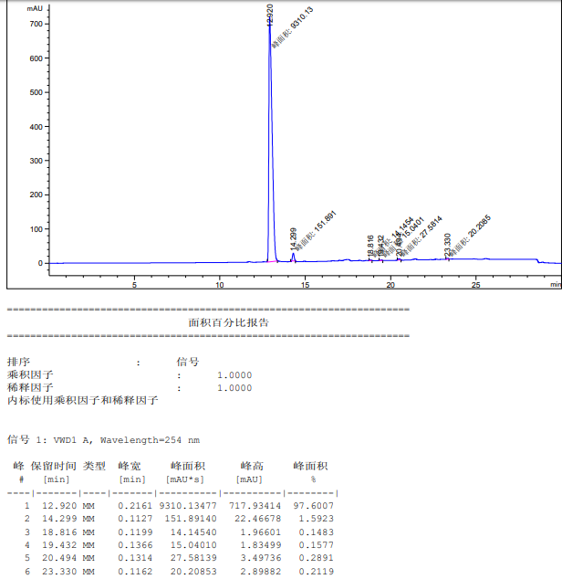

Compound **10e**







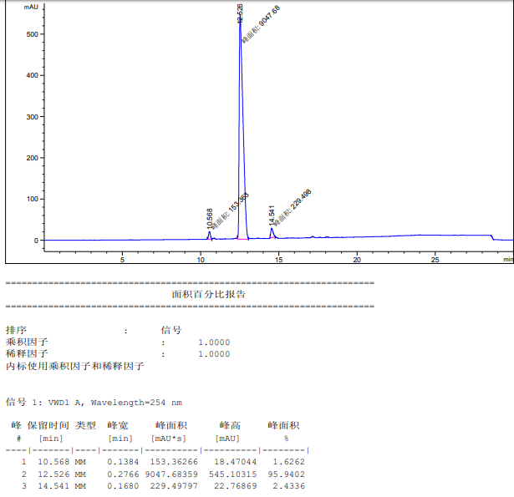

Compound **10f**





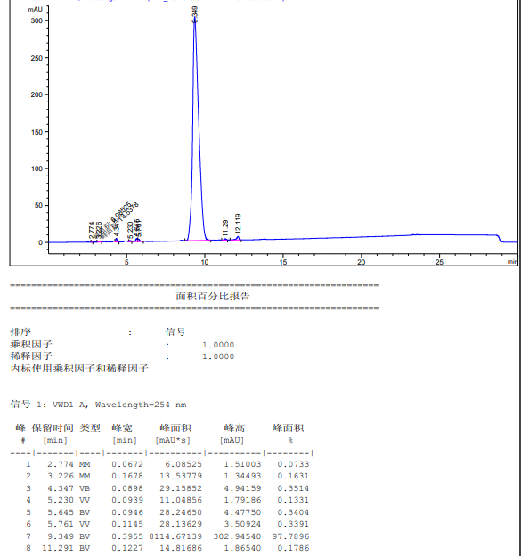

Compound **10g**







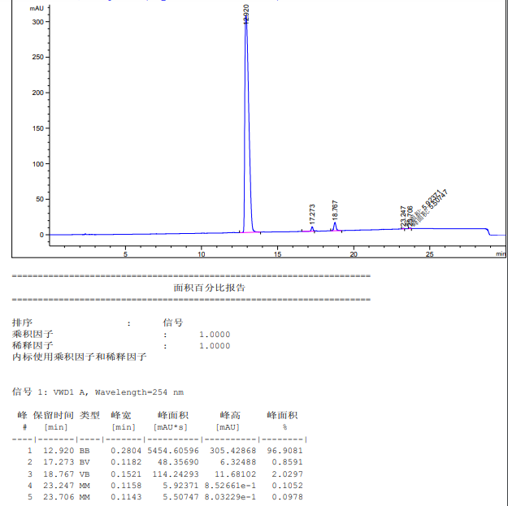

10h





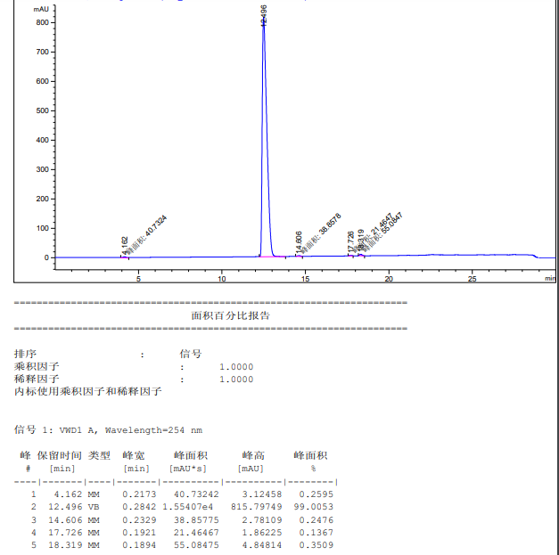

Compound **10i**







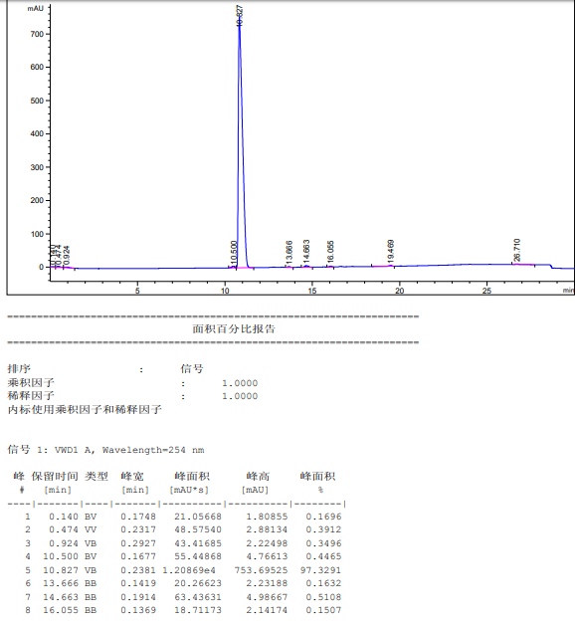

Compound **17a**







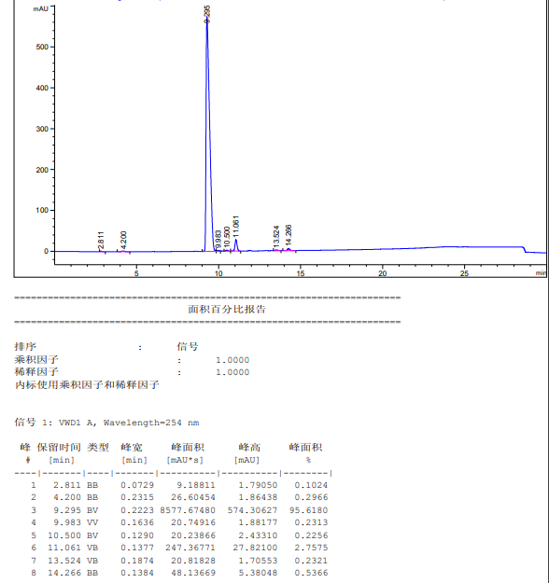

Compound **17b**







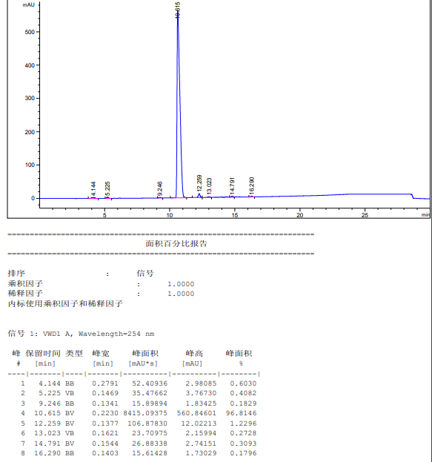

Compound **17c**







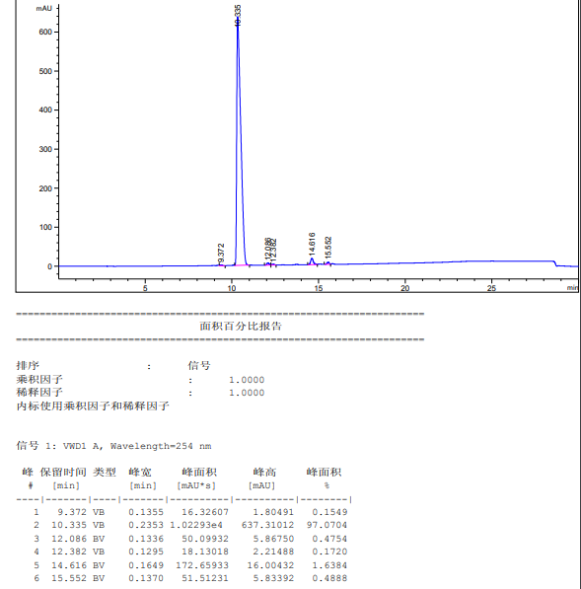

Compound **17d**







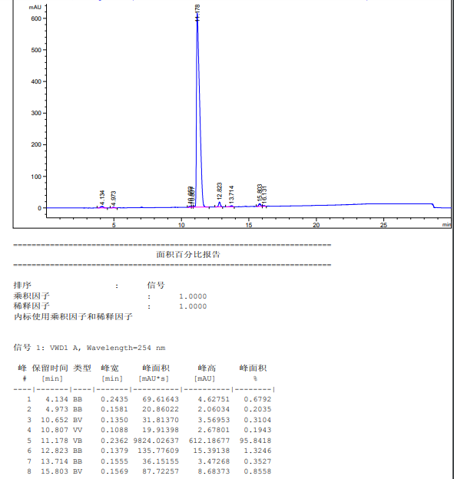

Compound **17e**







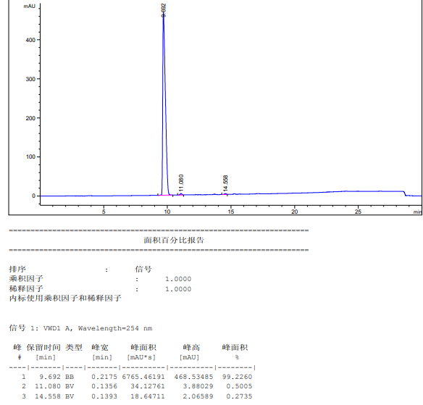

Compound **17f**







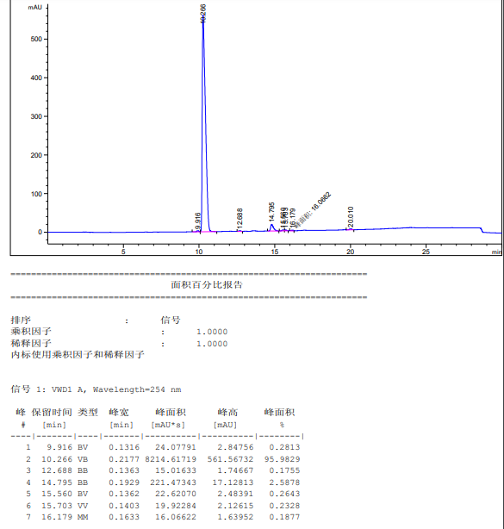

Compound **17g**







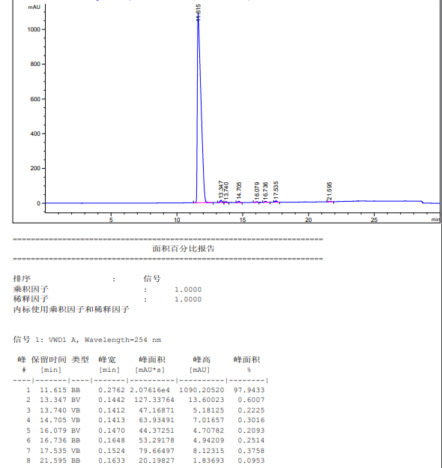

Compound **17h**







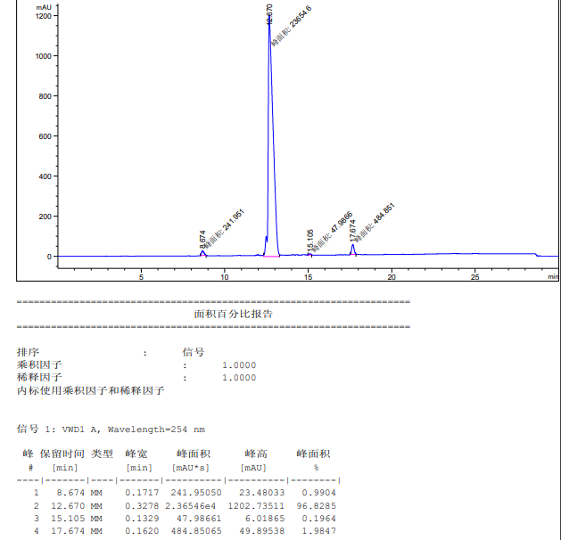

1.
2. Qing Li, Pharmaceutical College, Guangxi Medical University, Nanning 530021, Guangxi, PR China. Email: qingligxmu@163.com(Q. L.). Weizhe Jiang, Pharmaceutical College, Guangxi Medical University, Nanning 530021, Guangxi, PR China. Email: Weizhejiang63@163.com(W. Z.).