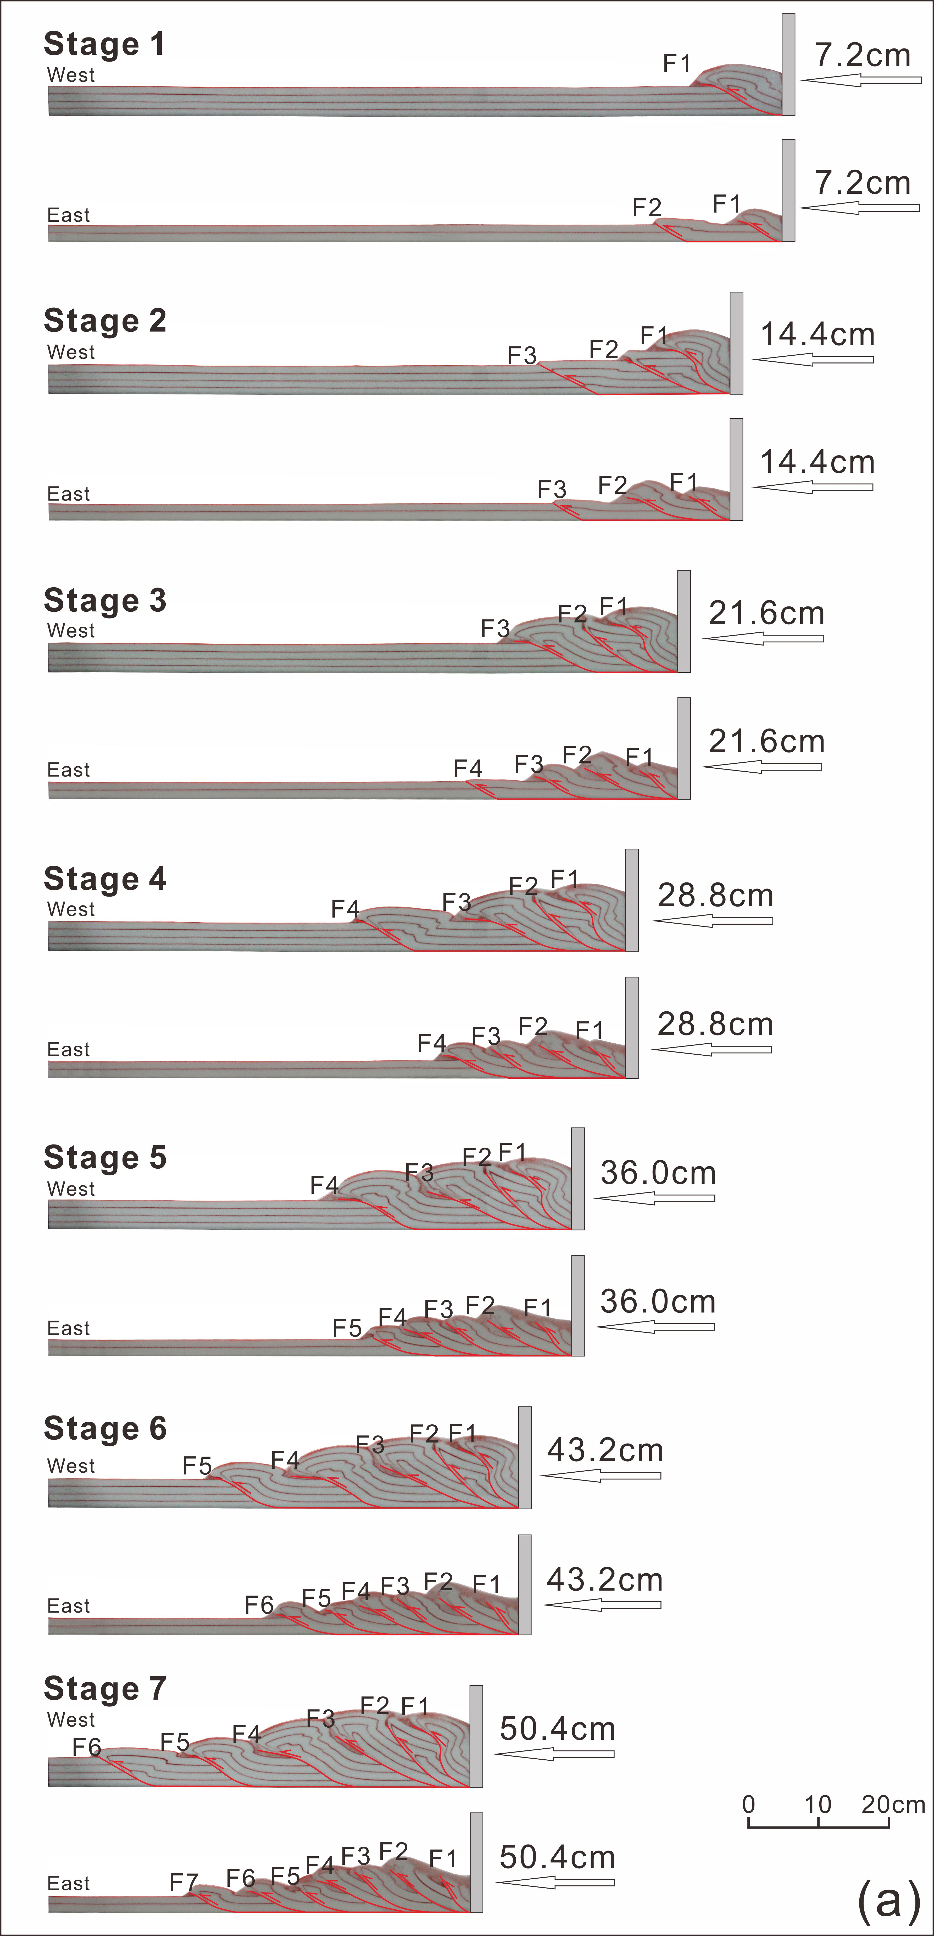
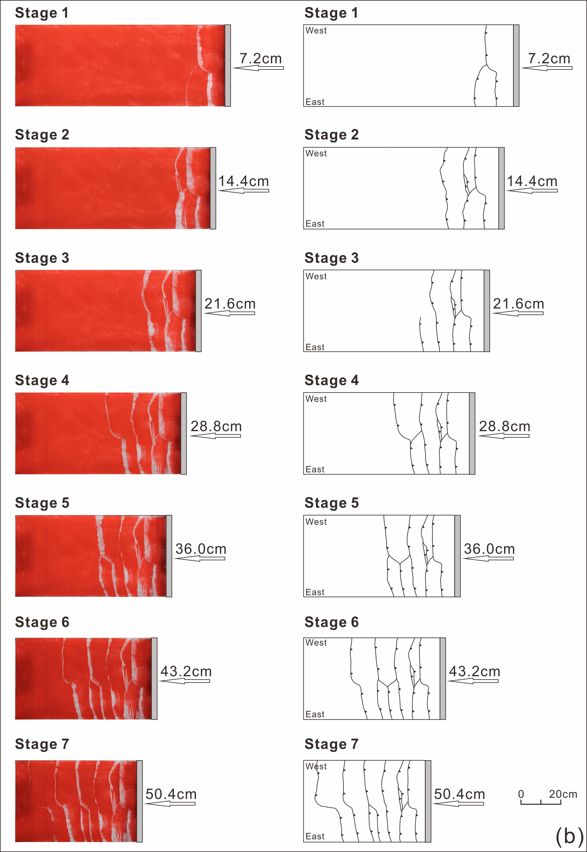
Fig. 6 Progressive evolution of Model 2 illustrated by sequential cross-sectional views (a) and corresponding plan views (b). F1-F7 denote the order of thrust appearance.

