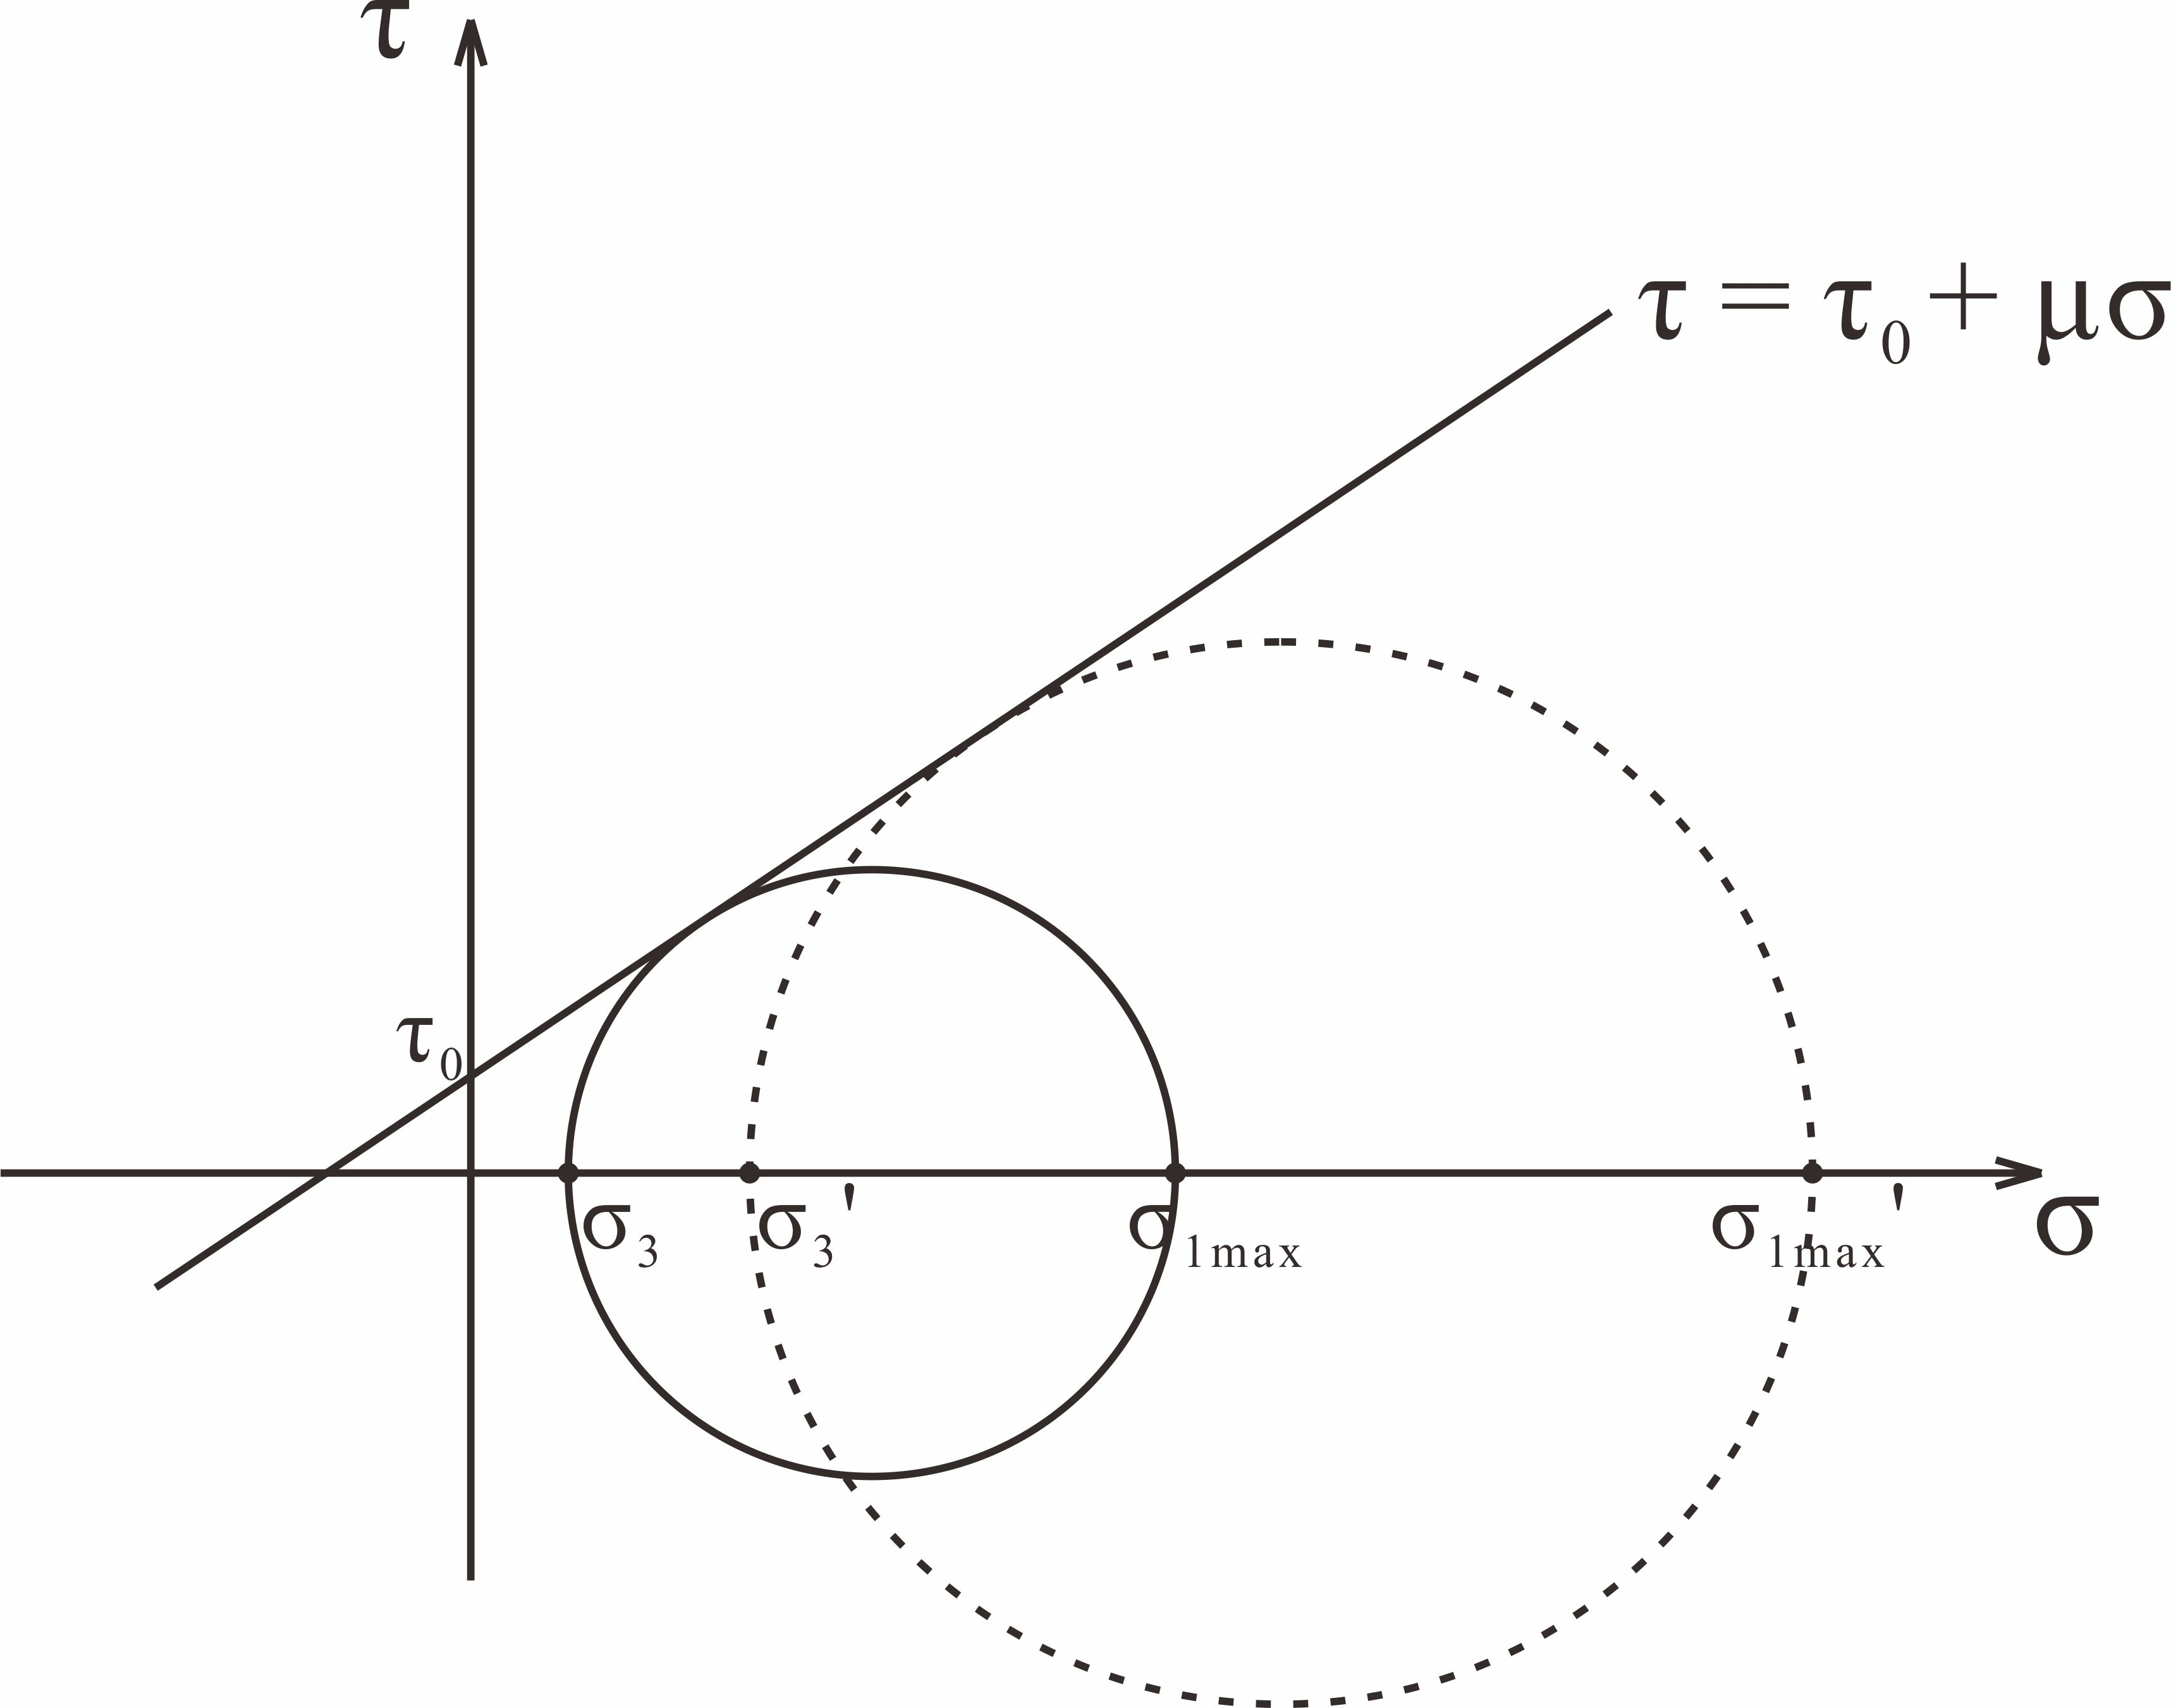
Fig. 12 Mohr diagram illustrating the state of stress on the verge of failure under different vertical stresses.

