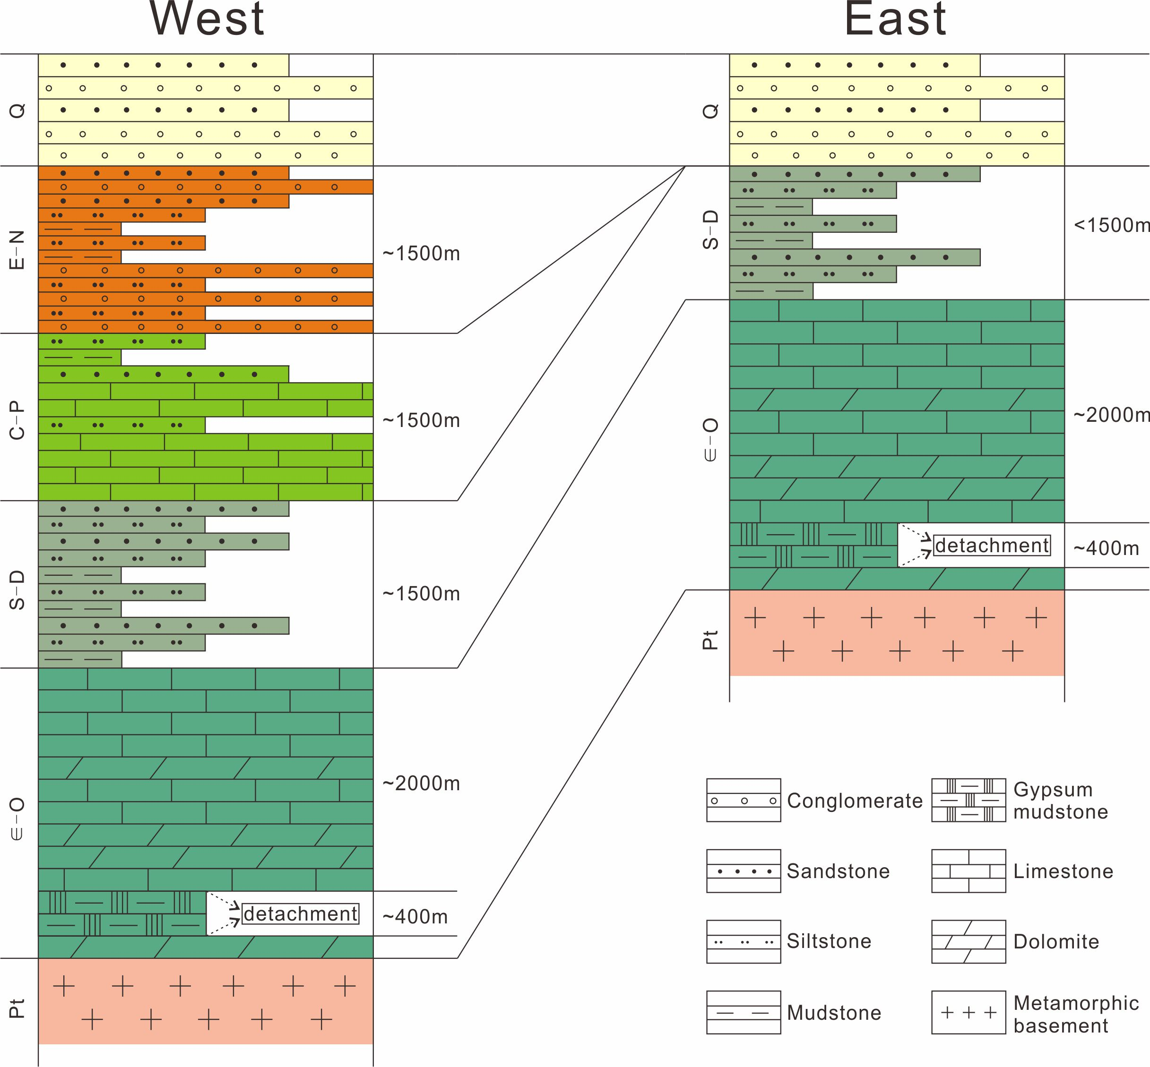
Fig. 3 Simplified stratigraphic columns at section of the study area. Lower-Middle Cambrian gypsiferous mudstones above the metamorphic basement make up the main décollement surface in the Keping fold-thrust belt. Overburden above this décollement is thicker in the west than in the east. Q: Quaternary; E-N: Paleogene-Neogene; C-P: Carboniferous-Permian; S-D: Silurian-Devonian; Є-O: Cambrian-Ordovician; Pt: Proterozoic.

