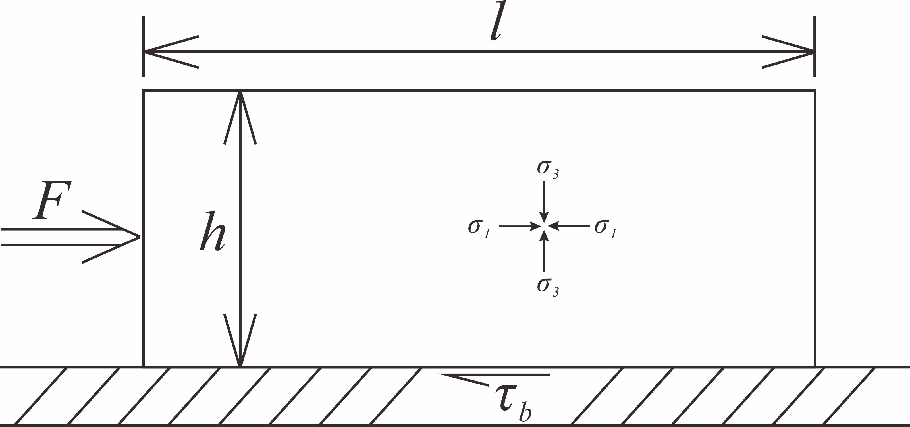
Fig. 11 Schematic diagram of a sand layer with uniform thickness and limit length subject to horizontal compression.

