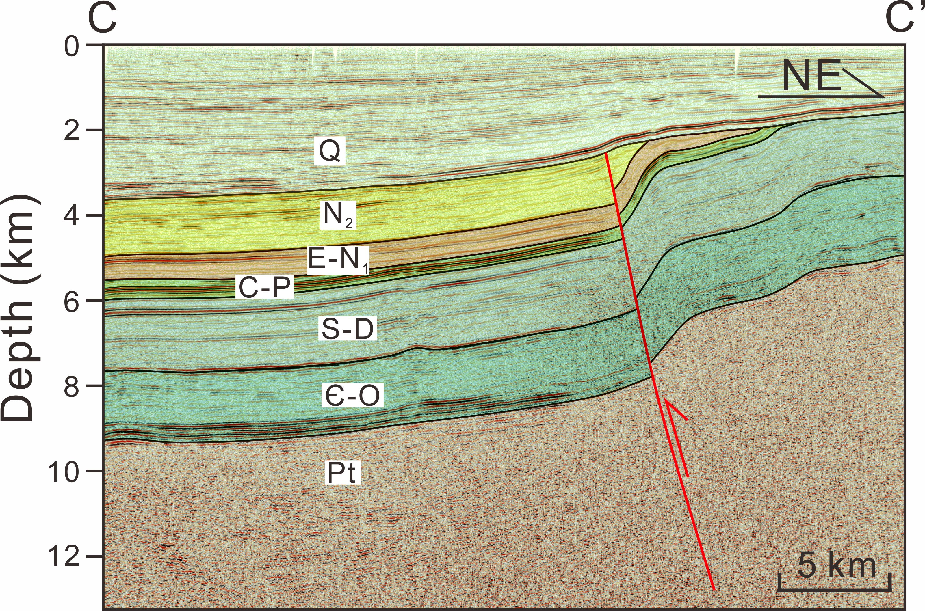
Fig. 13 Structural section across the Piqiang-Selibuya Fault (see Fig. 1b for section location). Q: Quaternary; N2: Pliocene; E-N1: Paleogene-Miocene; C-P: Carboniferous-Permian; S-D: Silurian-Devonian; Є-O: Cambrian-Ordovician; Pt: Proterozoic.

