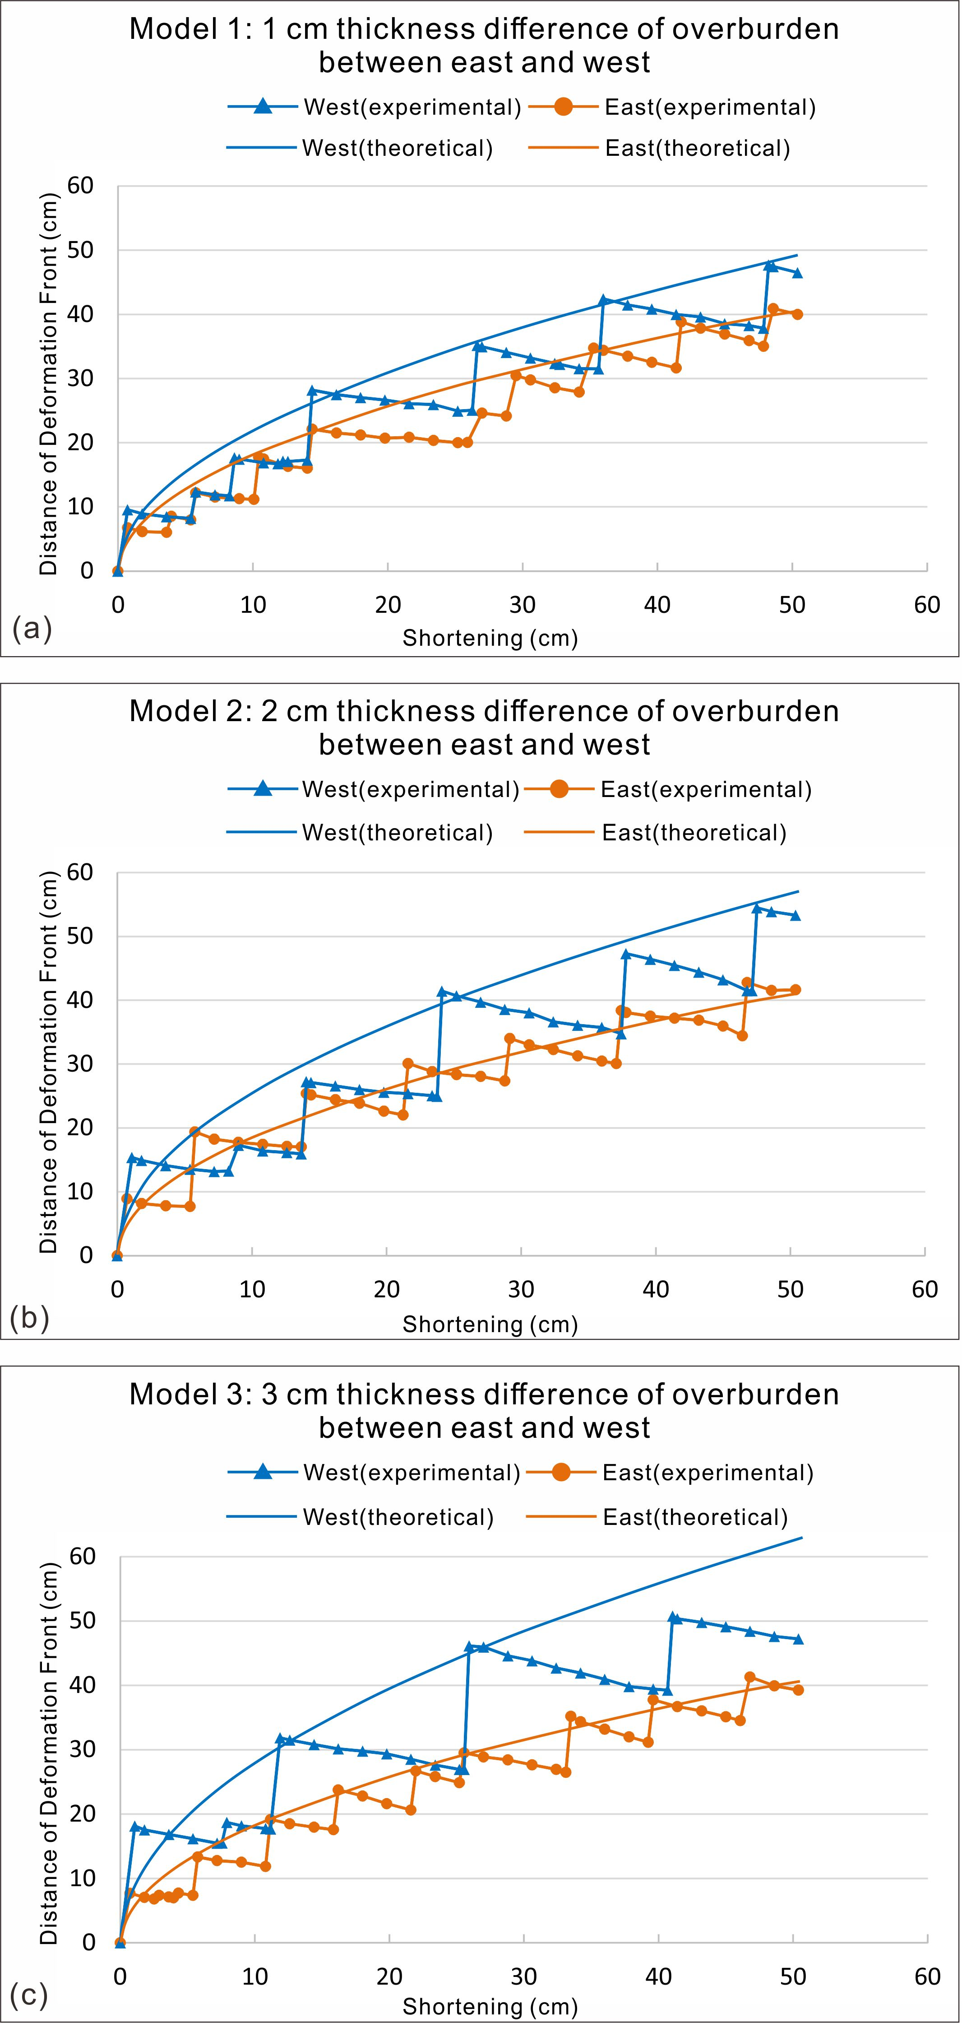
Fig. 9 Graphical plots displaying the distance between the deformation front and the backstop versus shortening. The smooth curves were generated by using the critical taper theory and mass balance in the growing wedge (Eq. 5). The stair-step shape curves were obtained from the experimental data.

