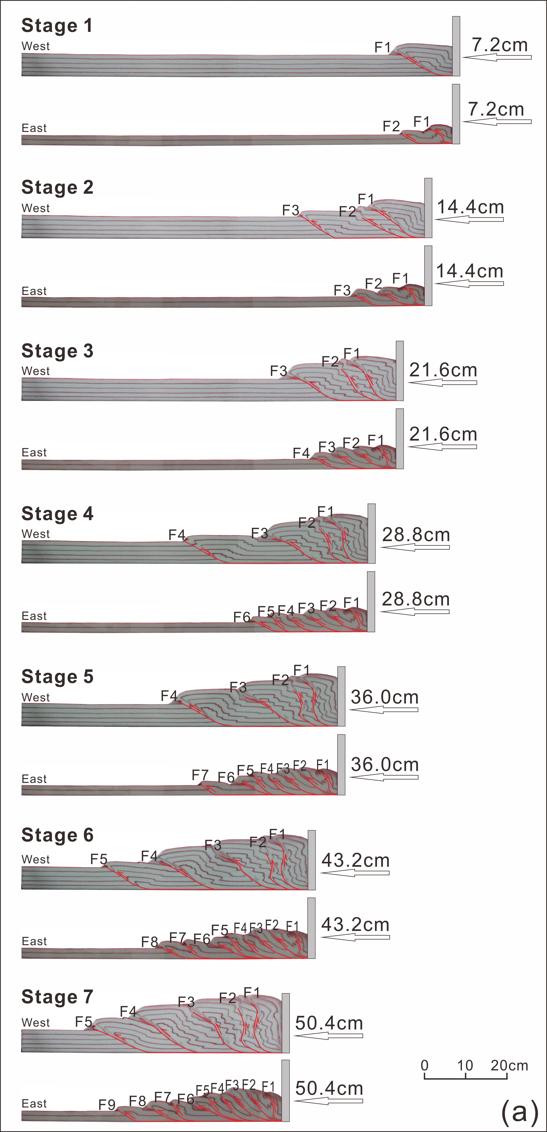
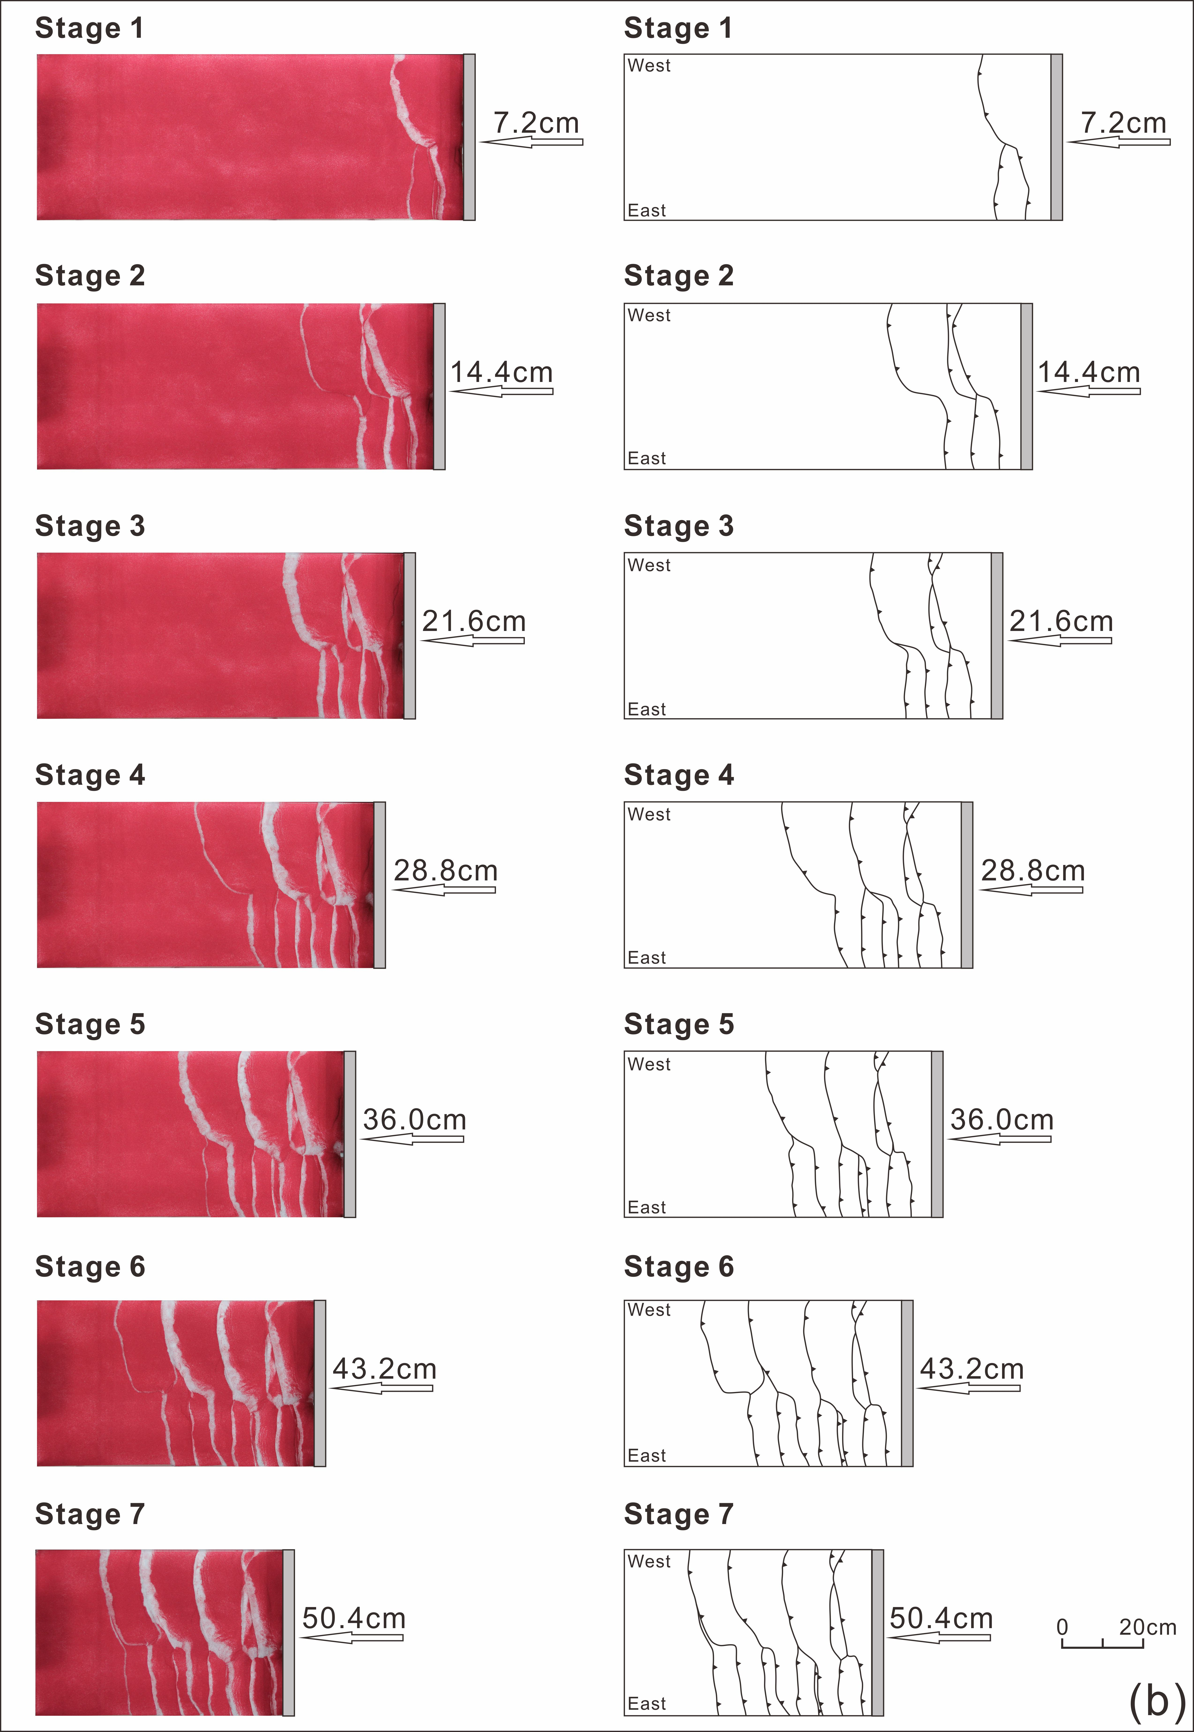
Fig. 7 Progressive evolution of Model 3 illustrated by sequential cross-sectional views (a) and corresponding plan views (b). F1-F9 denote the order of thrust appearance.

