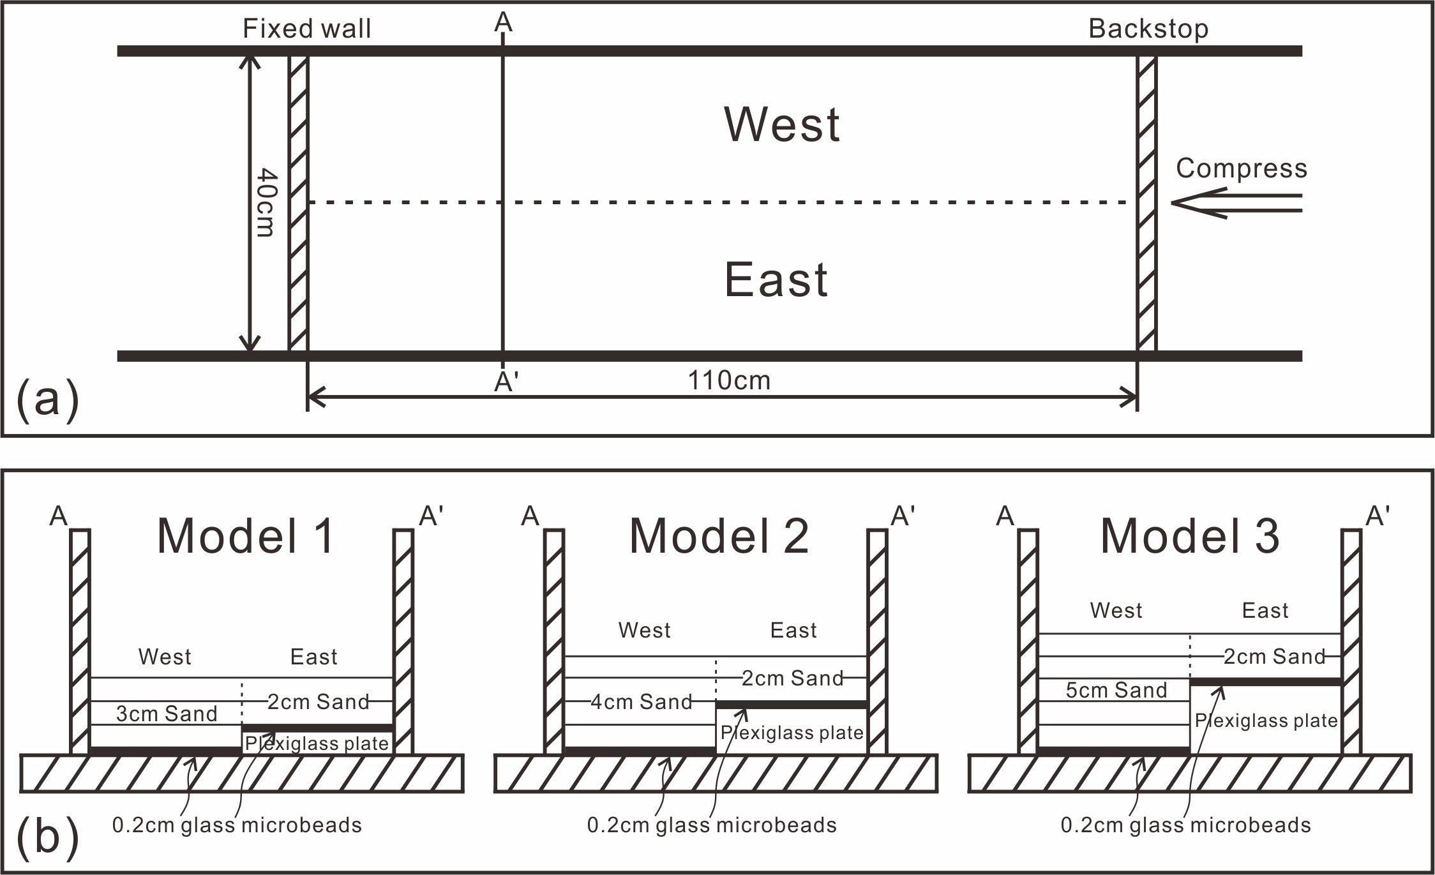
Fig. 4 Initial setups of experiments. (a) Plan view of the model configuration. (b) Cross-sectional view of each model configuration.

