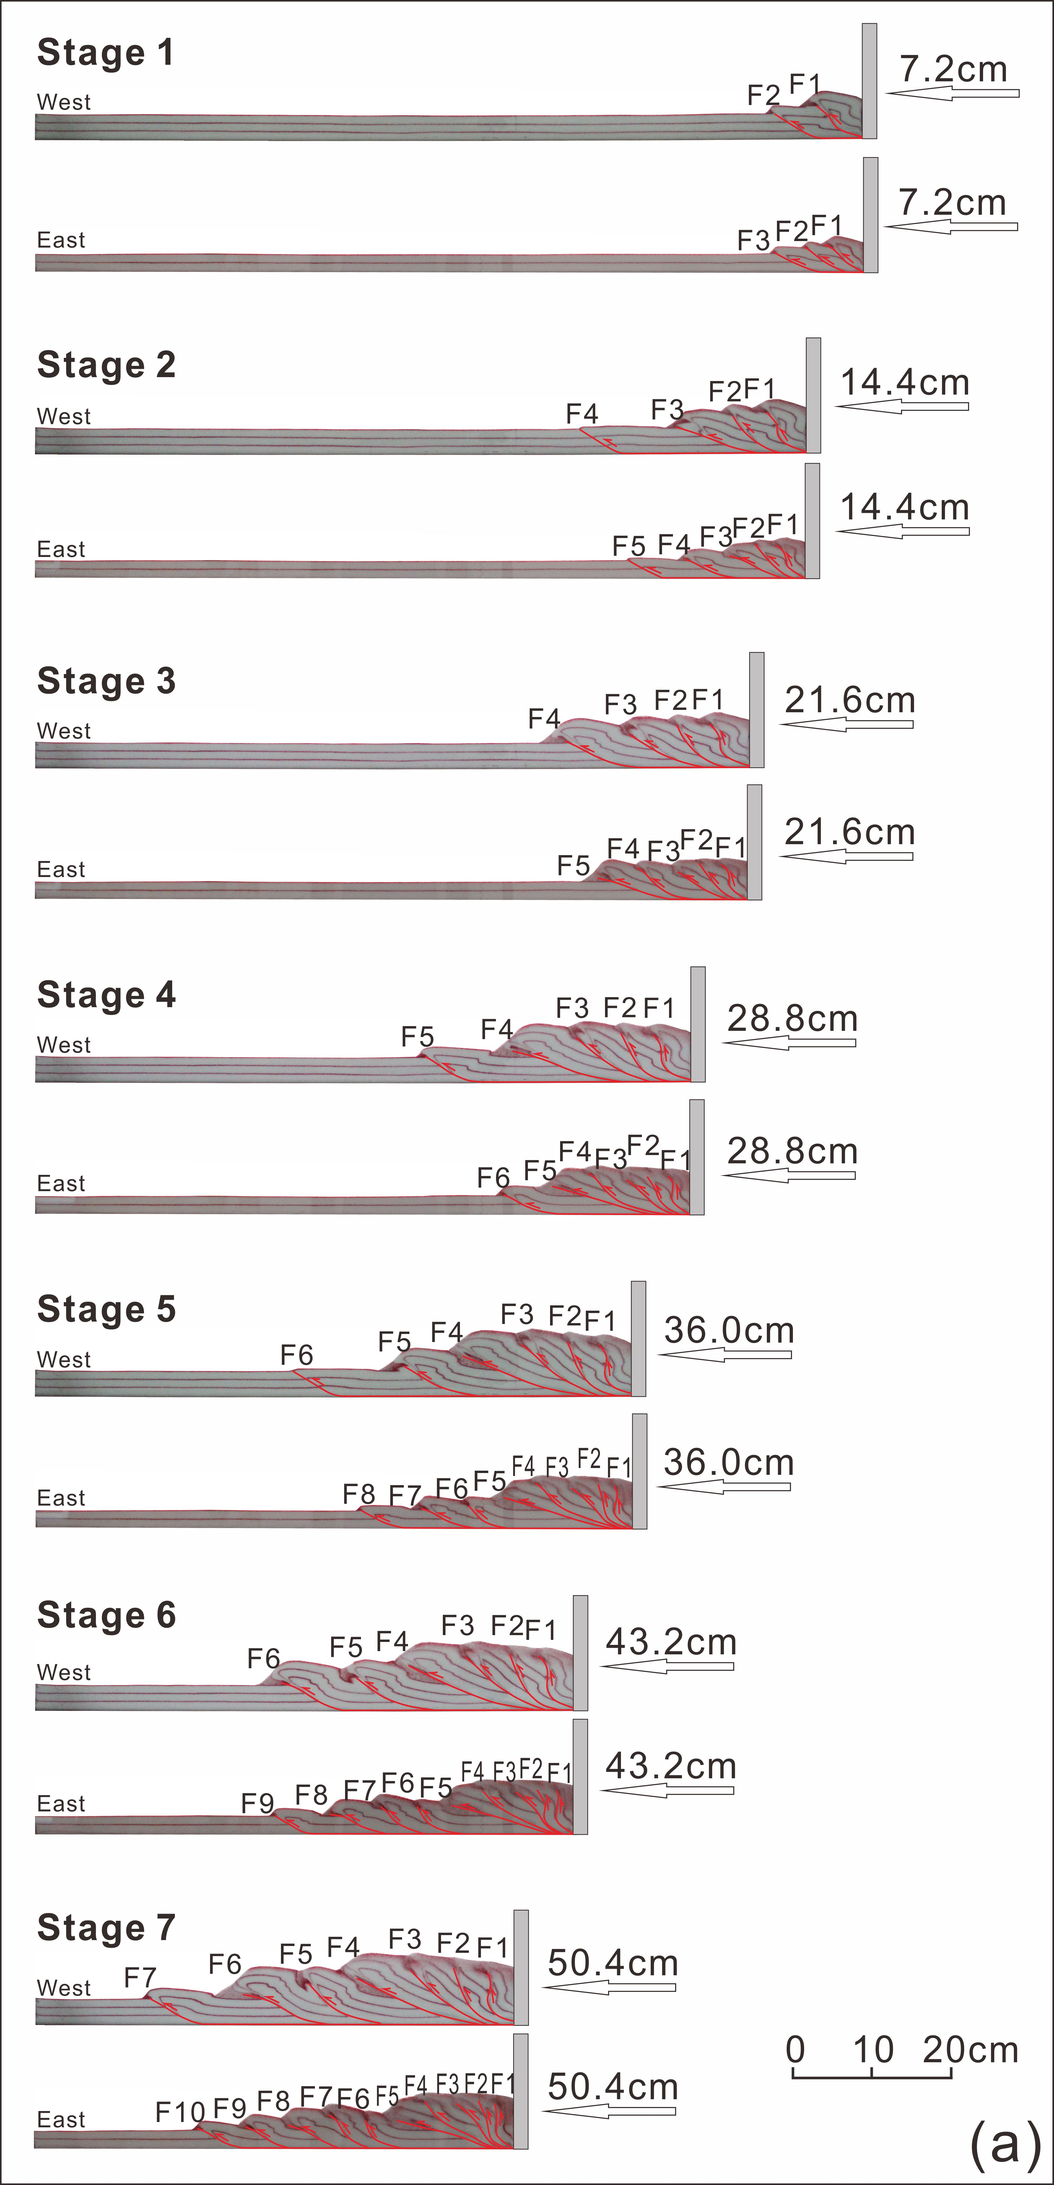
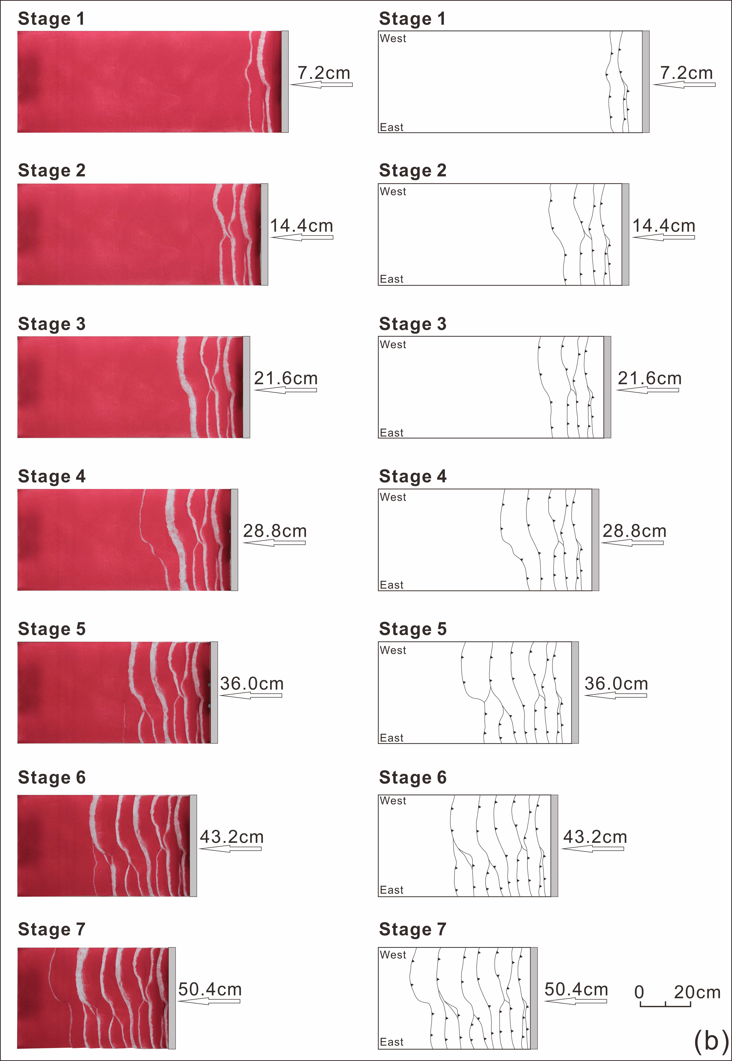
Fig. 5 Progressive evolution of Model 1 illustrated by sequential cross-sectional views (a) and corresponding plan views (b). F1-F10 denote the order of thrust appearance.

