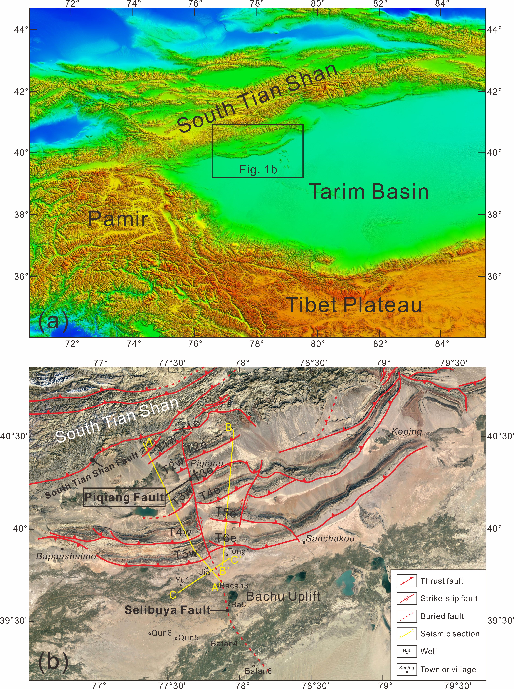
Fig. 1 Location of the Keping fold-thrust belt. (a) Map showing the study area located at the southern margin of the Tian Shan and the northwestern margin of the Tarim Basin. (b) Remote sensing image of the Keping fold-thrust belt. The structural interpretation is based on BGMRXP (1965a, 1965b), Turner et al. (2011), and Yang et al. (2017). T1w-T5w and T1e-T6e denote the order of thrust imbricate appearances.

