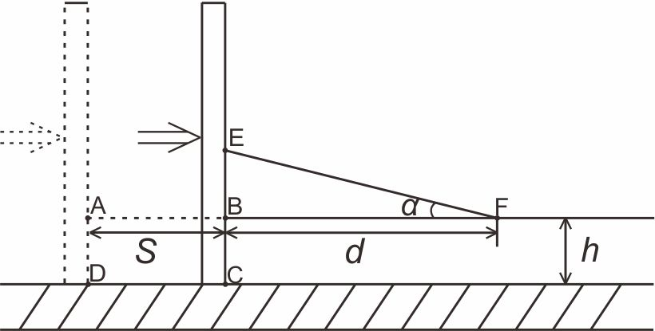
Fig. 8 Schematic diagram illustrating mass conservation in a growing wedge.

