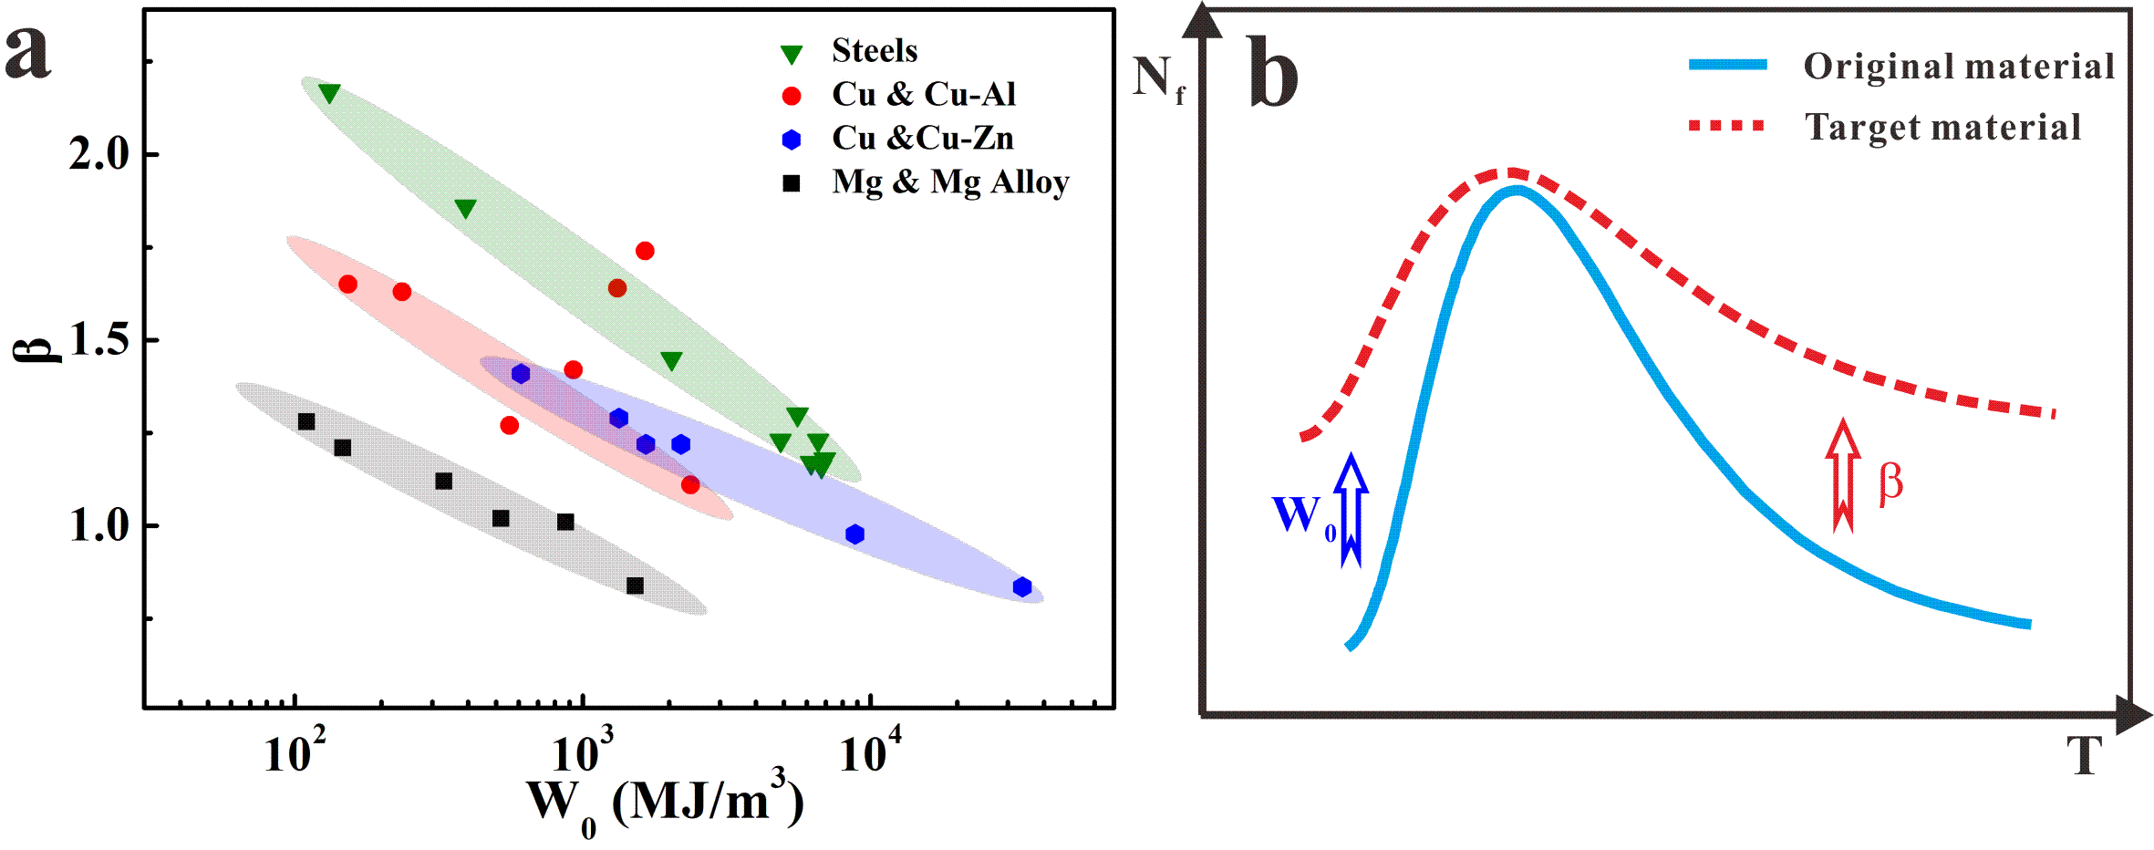
Fig. 1 Schematic diagram of improving LCF property: (a) summarization of the LCF parameters for metallic materials [25, 34]; (b) suggestion of improving LCF life based on fatigue parameters with the increase of temperature [29].
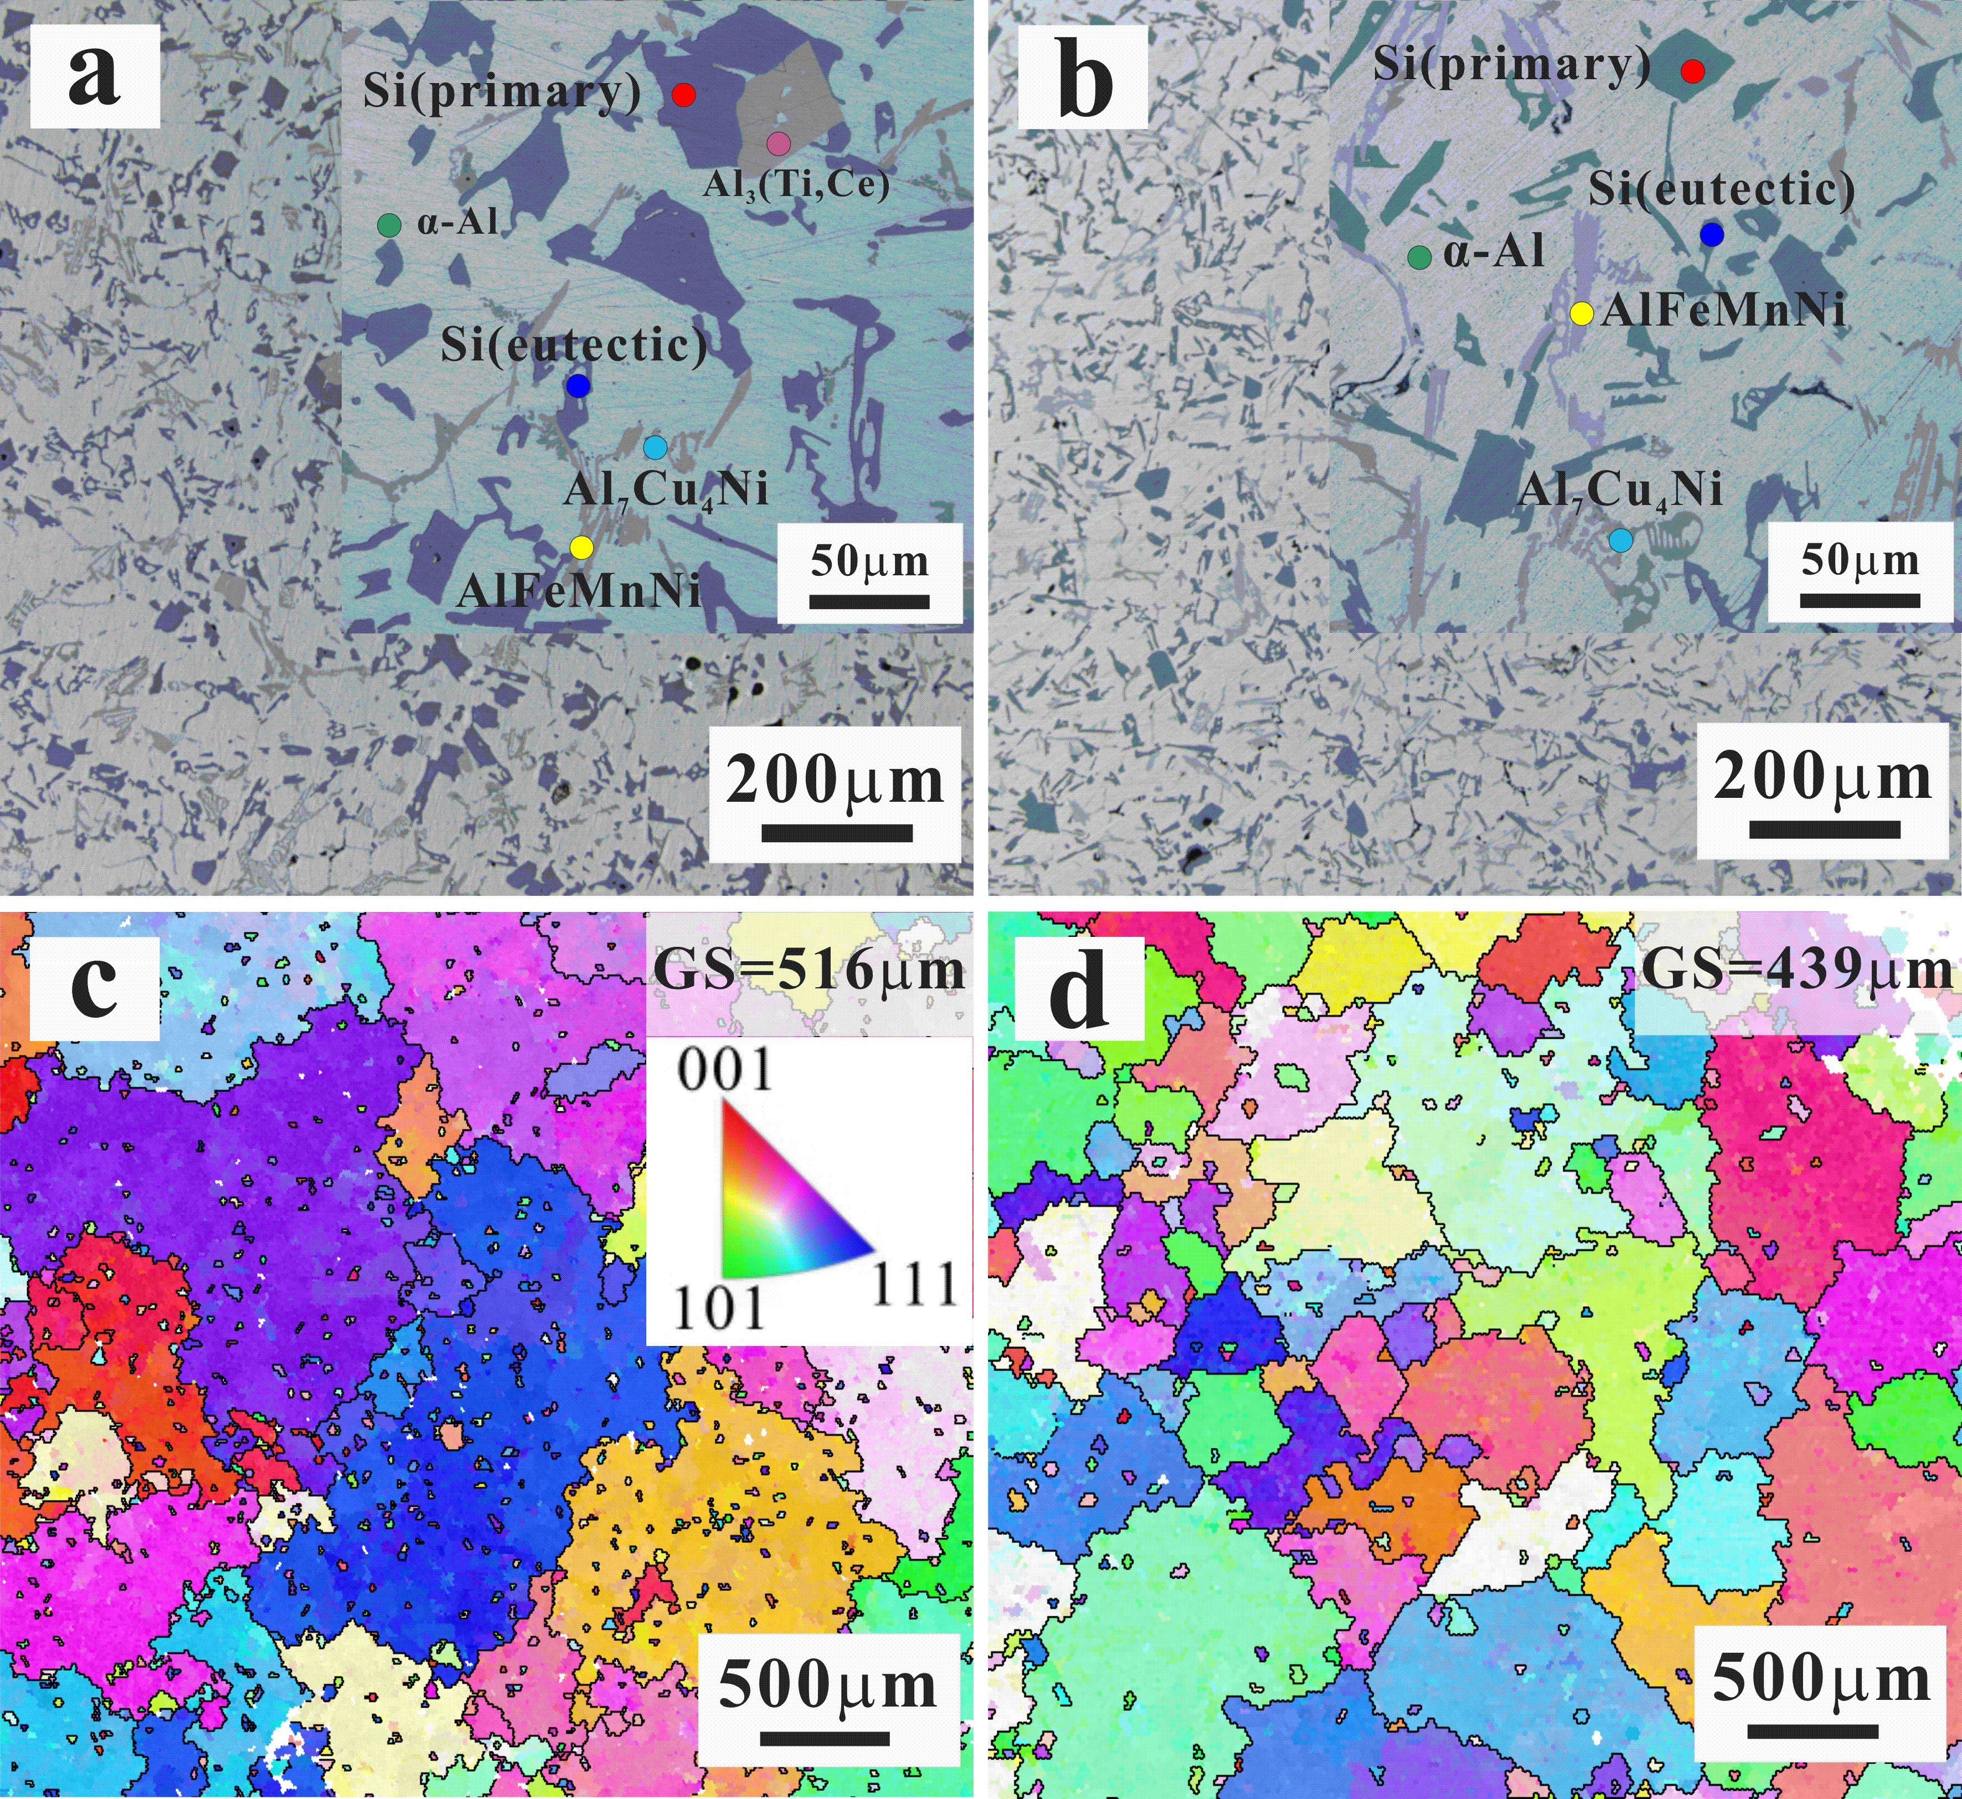
Fig. 2 Typical microstructure analysis of the two Al-Si piston alloys: OM observations of AC alloy (a) and UT alloy (b); (c)-(d) EBSD images of AC alloy and UT alloy.

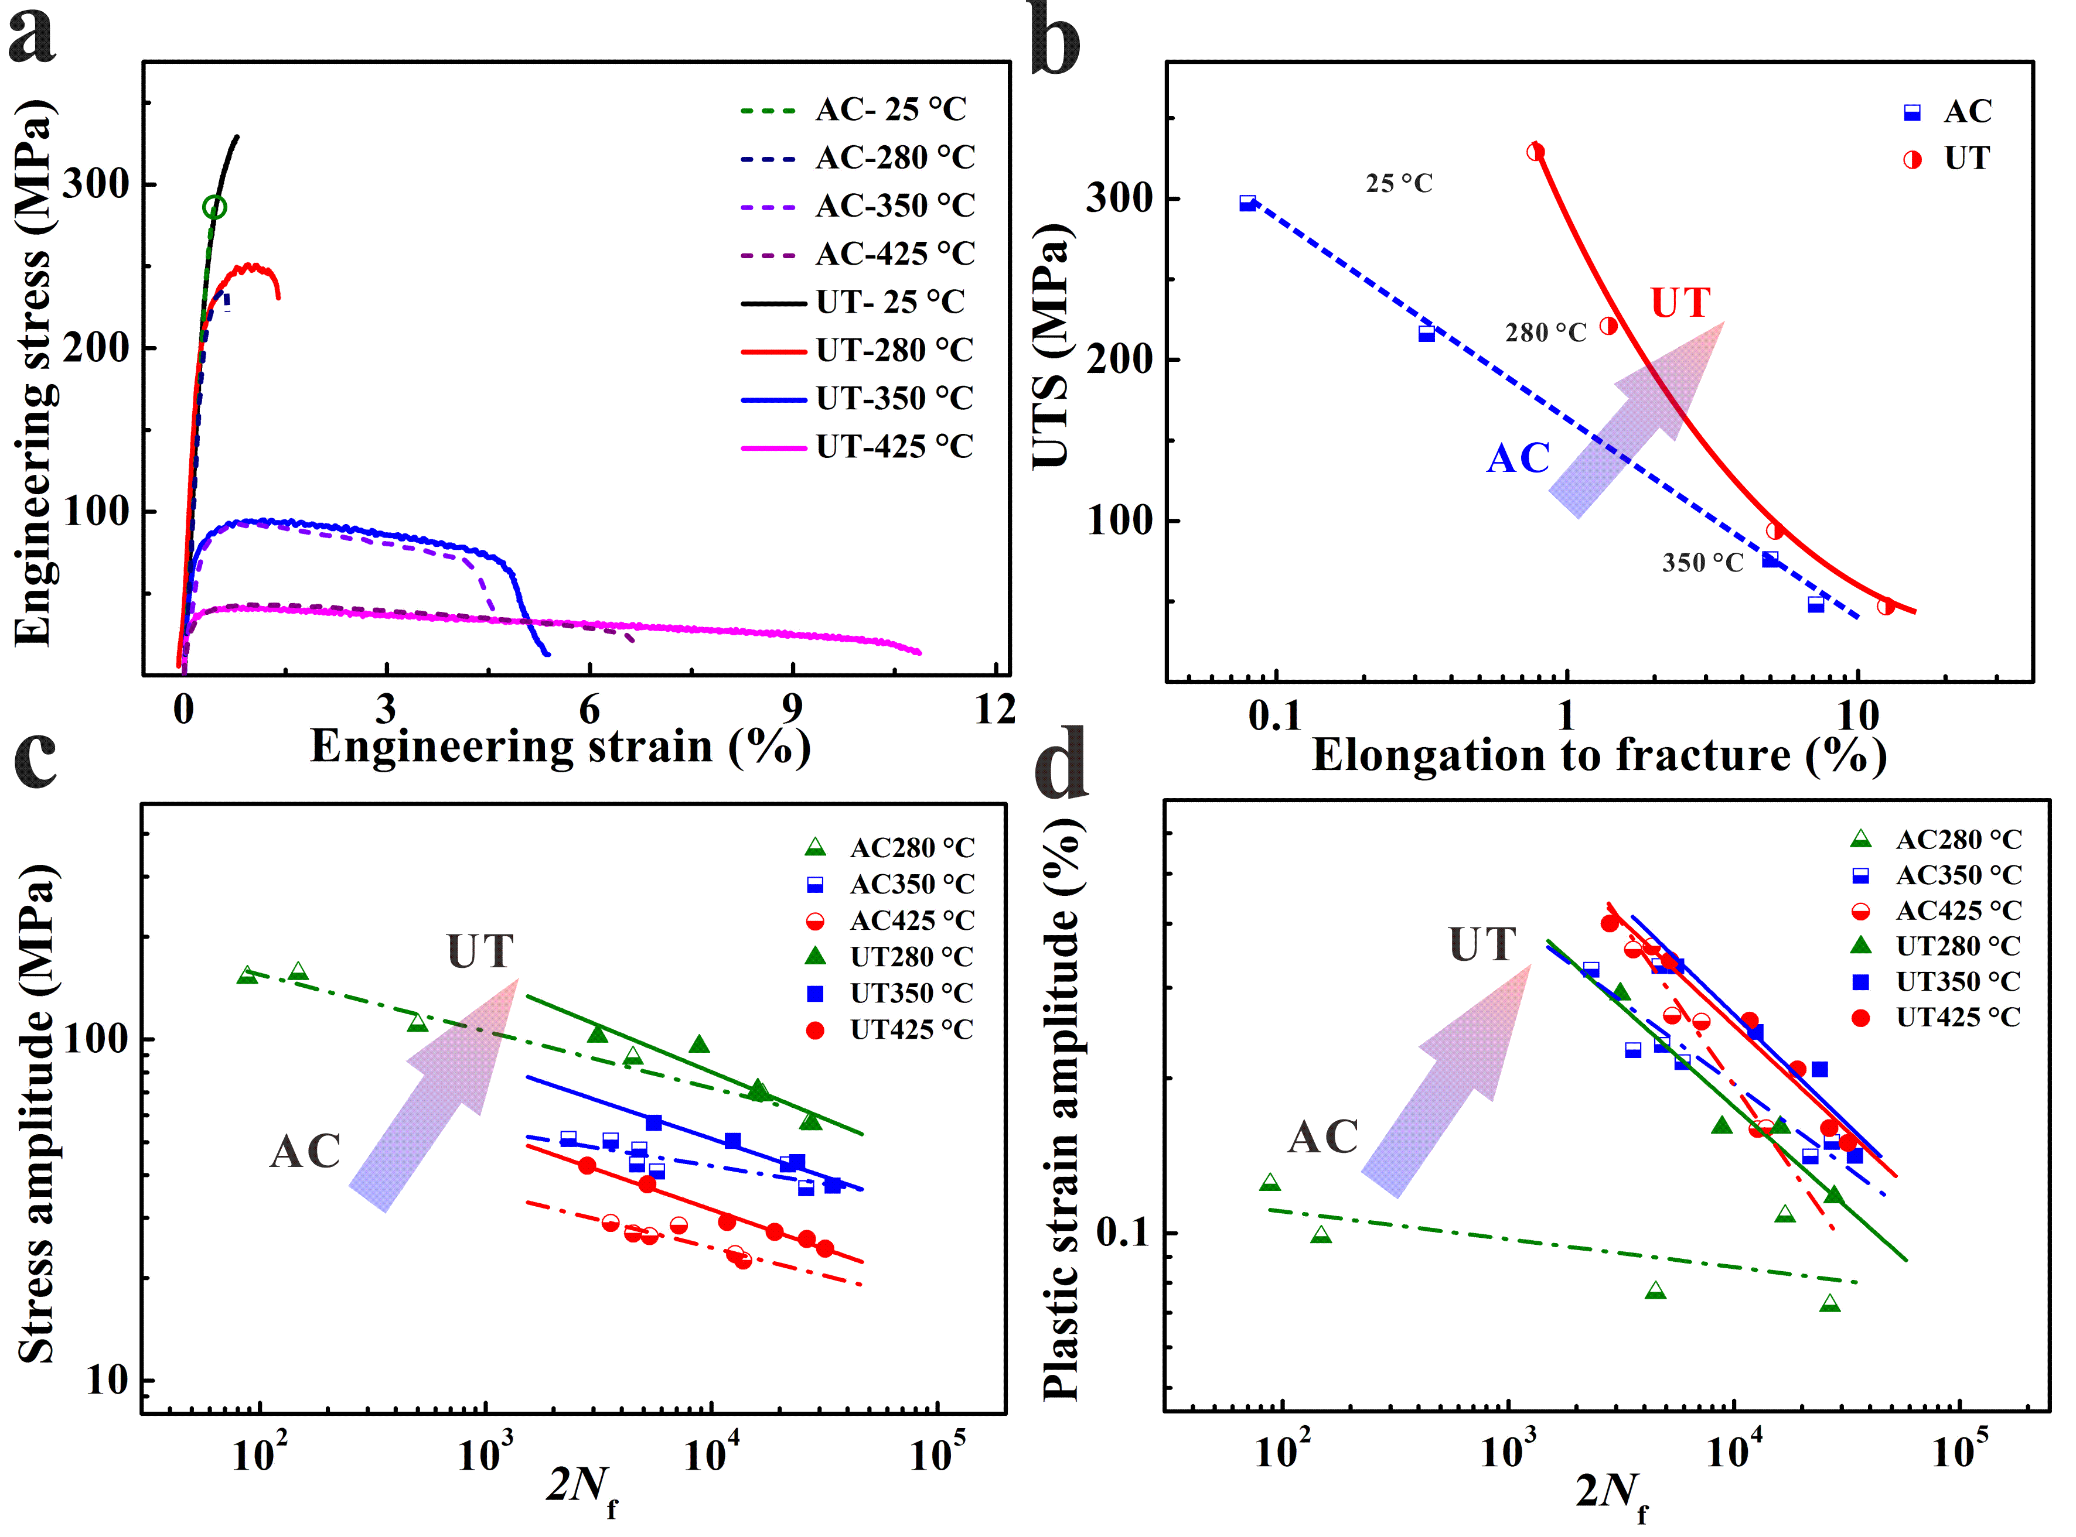
Fig. 3 Properties of the two Al-Si piston alloys at different temperatures: (a) tensile stress-strain curves; (b) the UTS and elongation to fracture; (c) relation between stress amplitude and 2N_{f}; (d) relation between plastic strain amplitude and 2N_{f}.

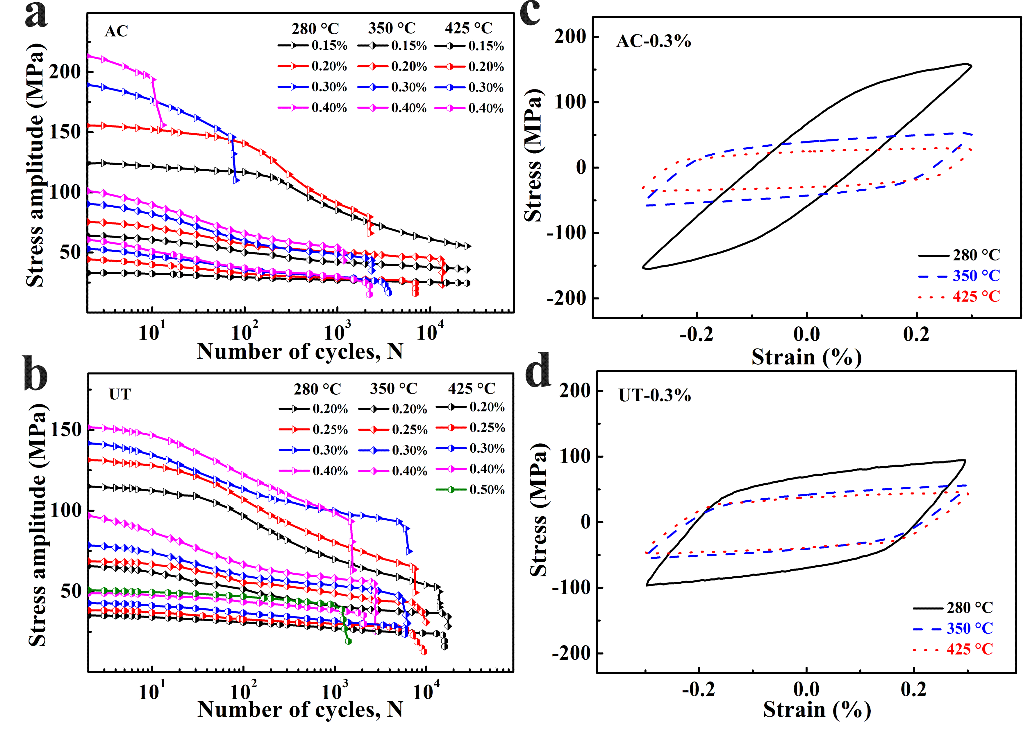Fig. 4 Cyclic deformation behaviors of Al-Si alloys prepared by AC (a, c) and UT (b, d) at elevated temperatures: (a)-(b) cyclic stress response curves; (c)-(d) half-life hysteresis loops.

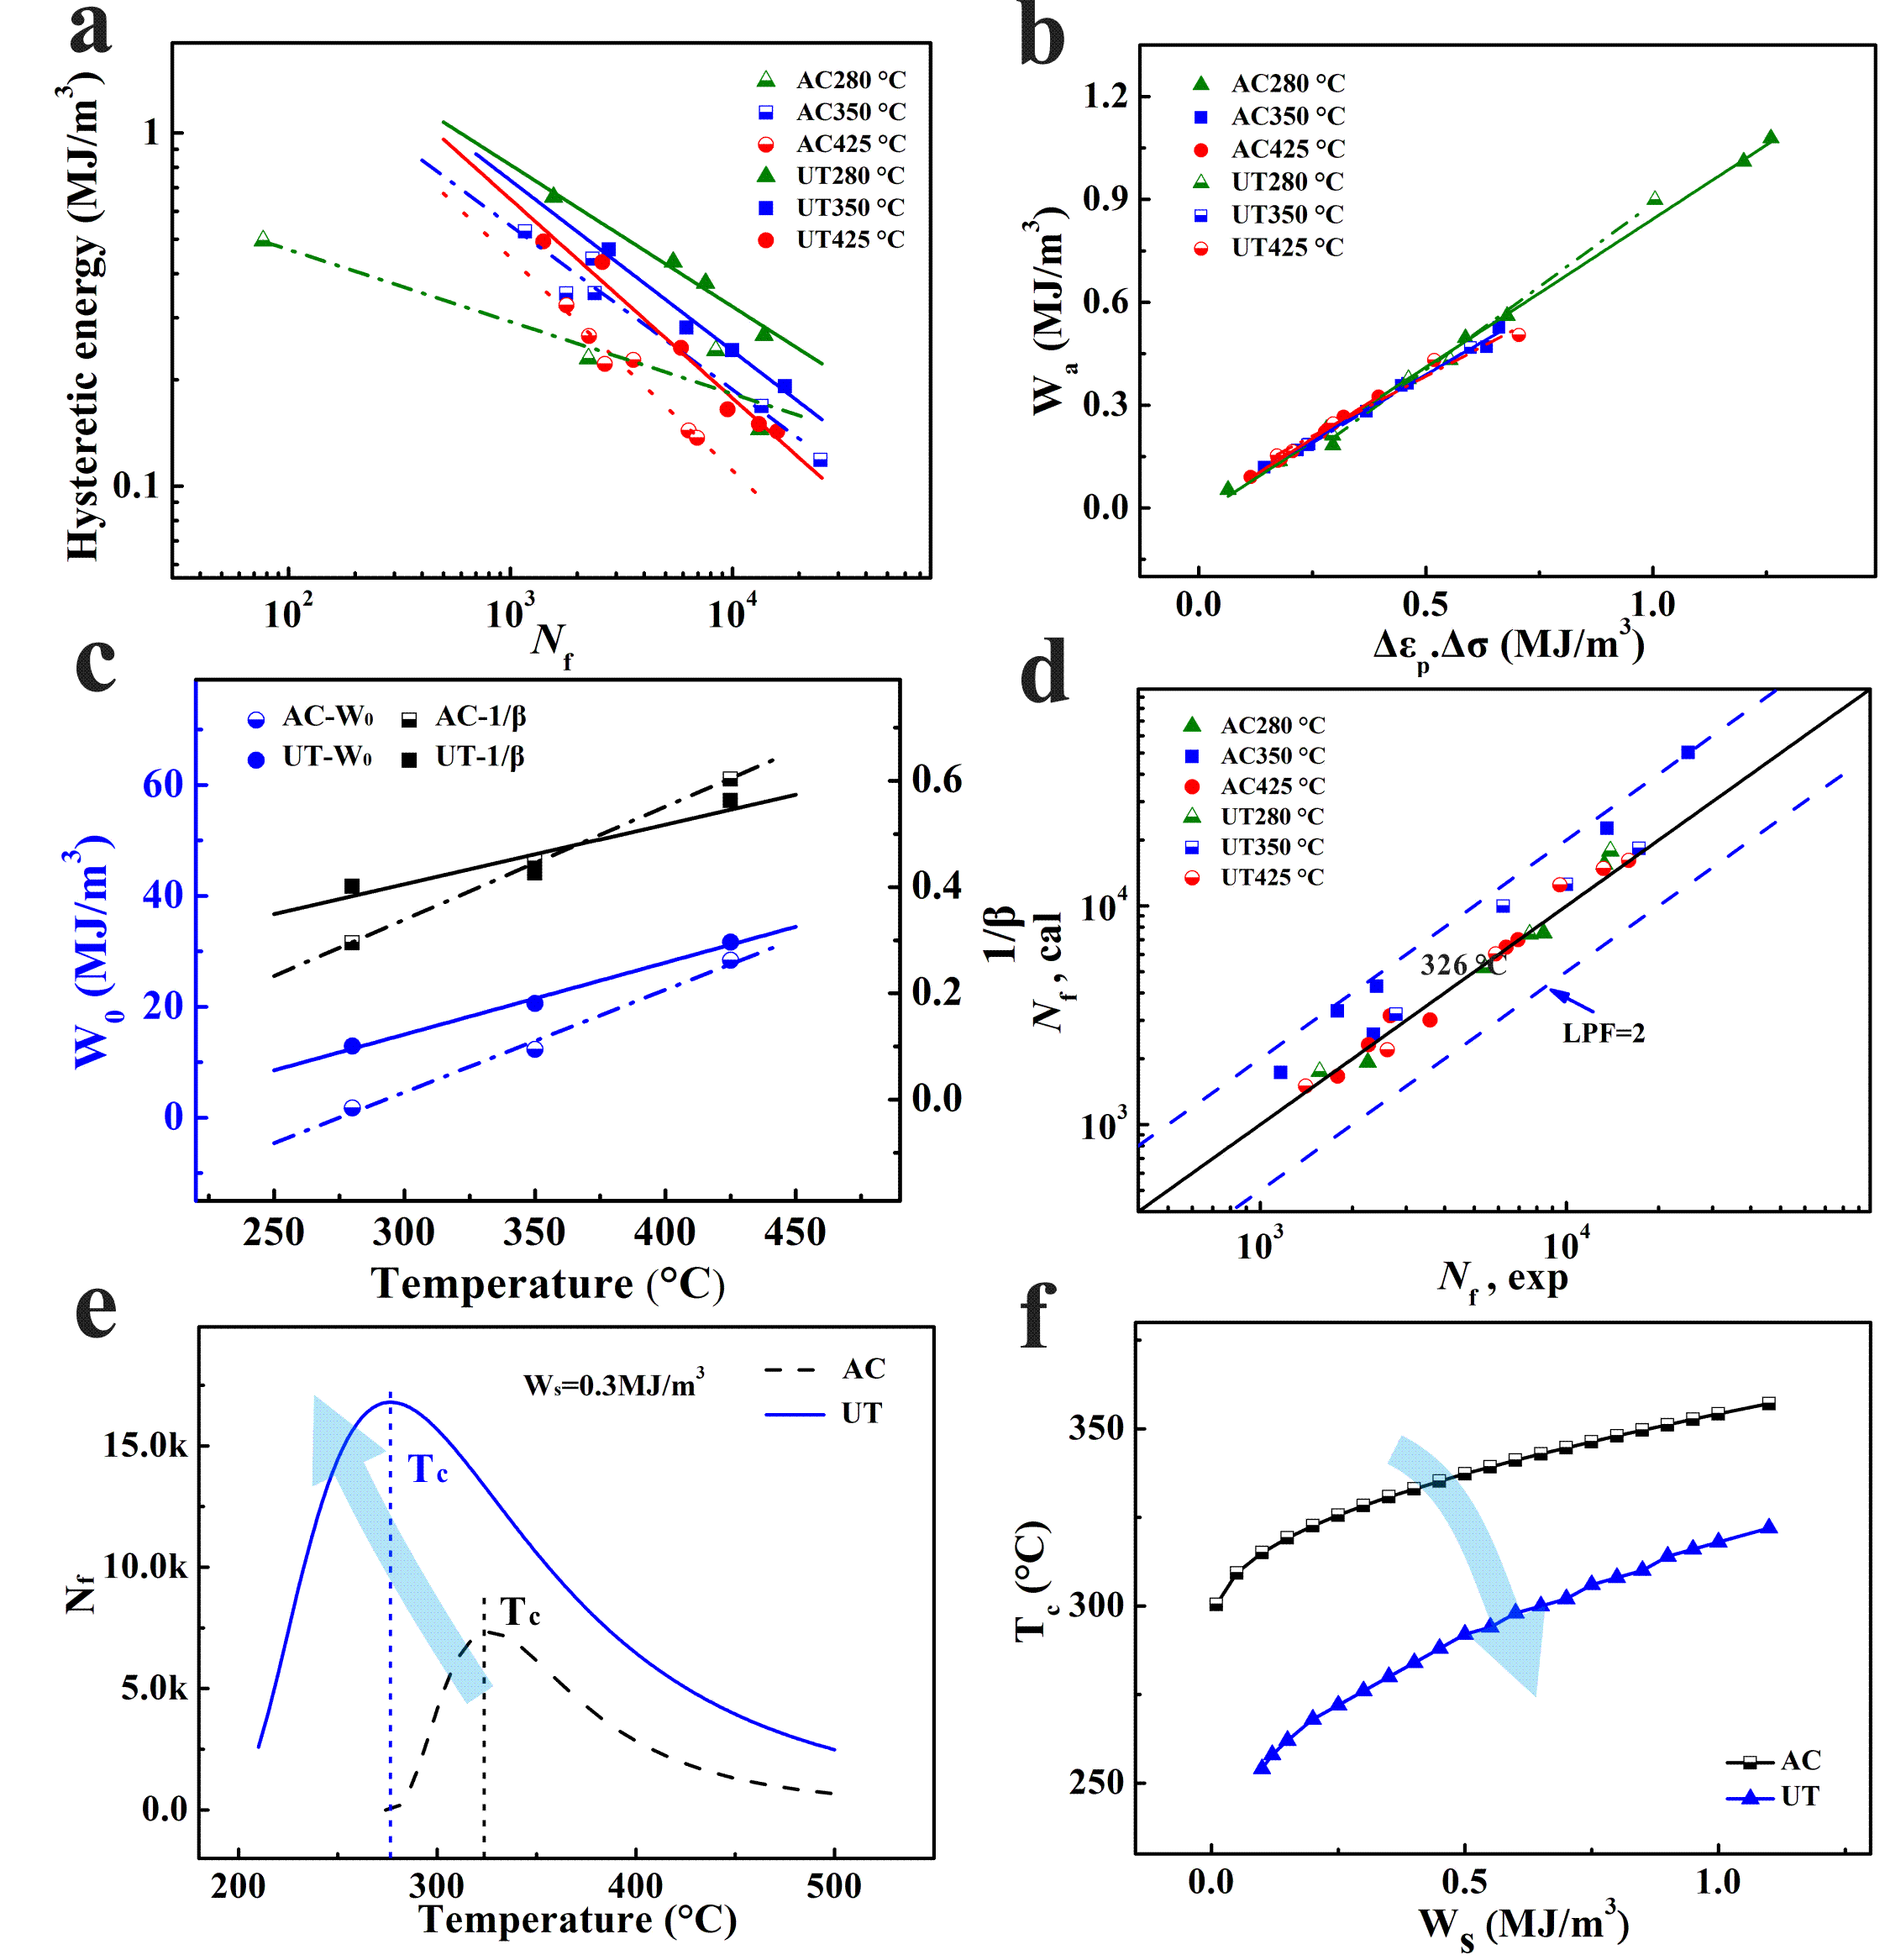
Fig. 5 (a) The relationships of hysteresis energy and fatigue life (N_{f}-W_{s}) for the AC and UT alloys at elevated temperatures; (b) liner relationship between hysteresis loop area W_{a} and the value of Δε_{p}⋅Δσ; (c) linear relationship between the parameters of hysteresis energy model and temperature; (d) The fatigue life obtained by the calculation and experiment; (e) relationship of N_{f}-T at a constant W_{s}; (f) The evolution of T_{c} with different W_{s}.

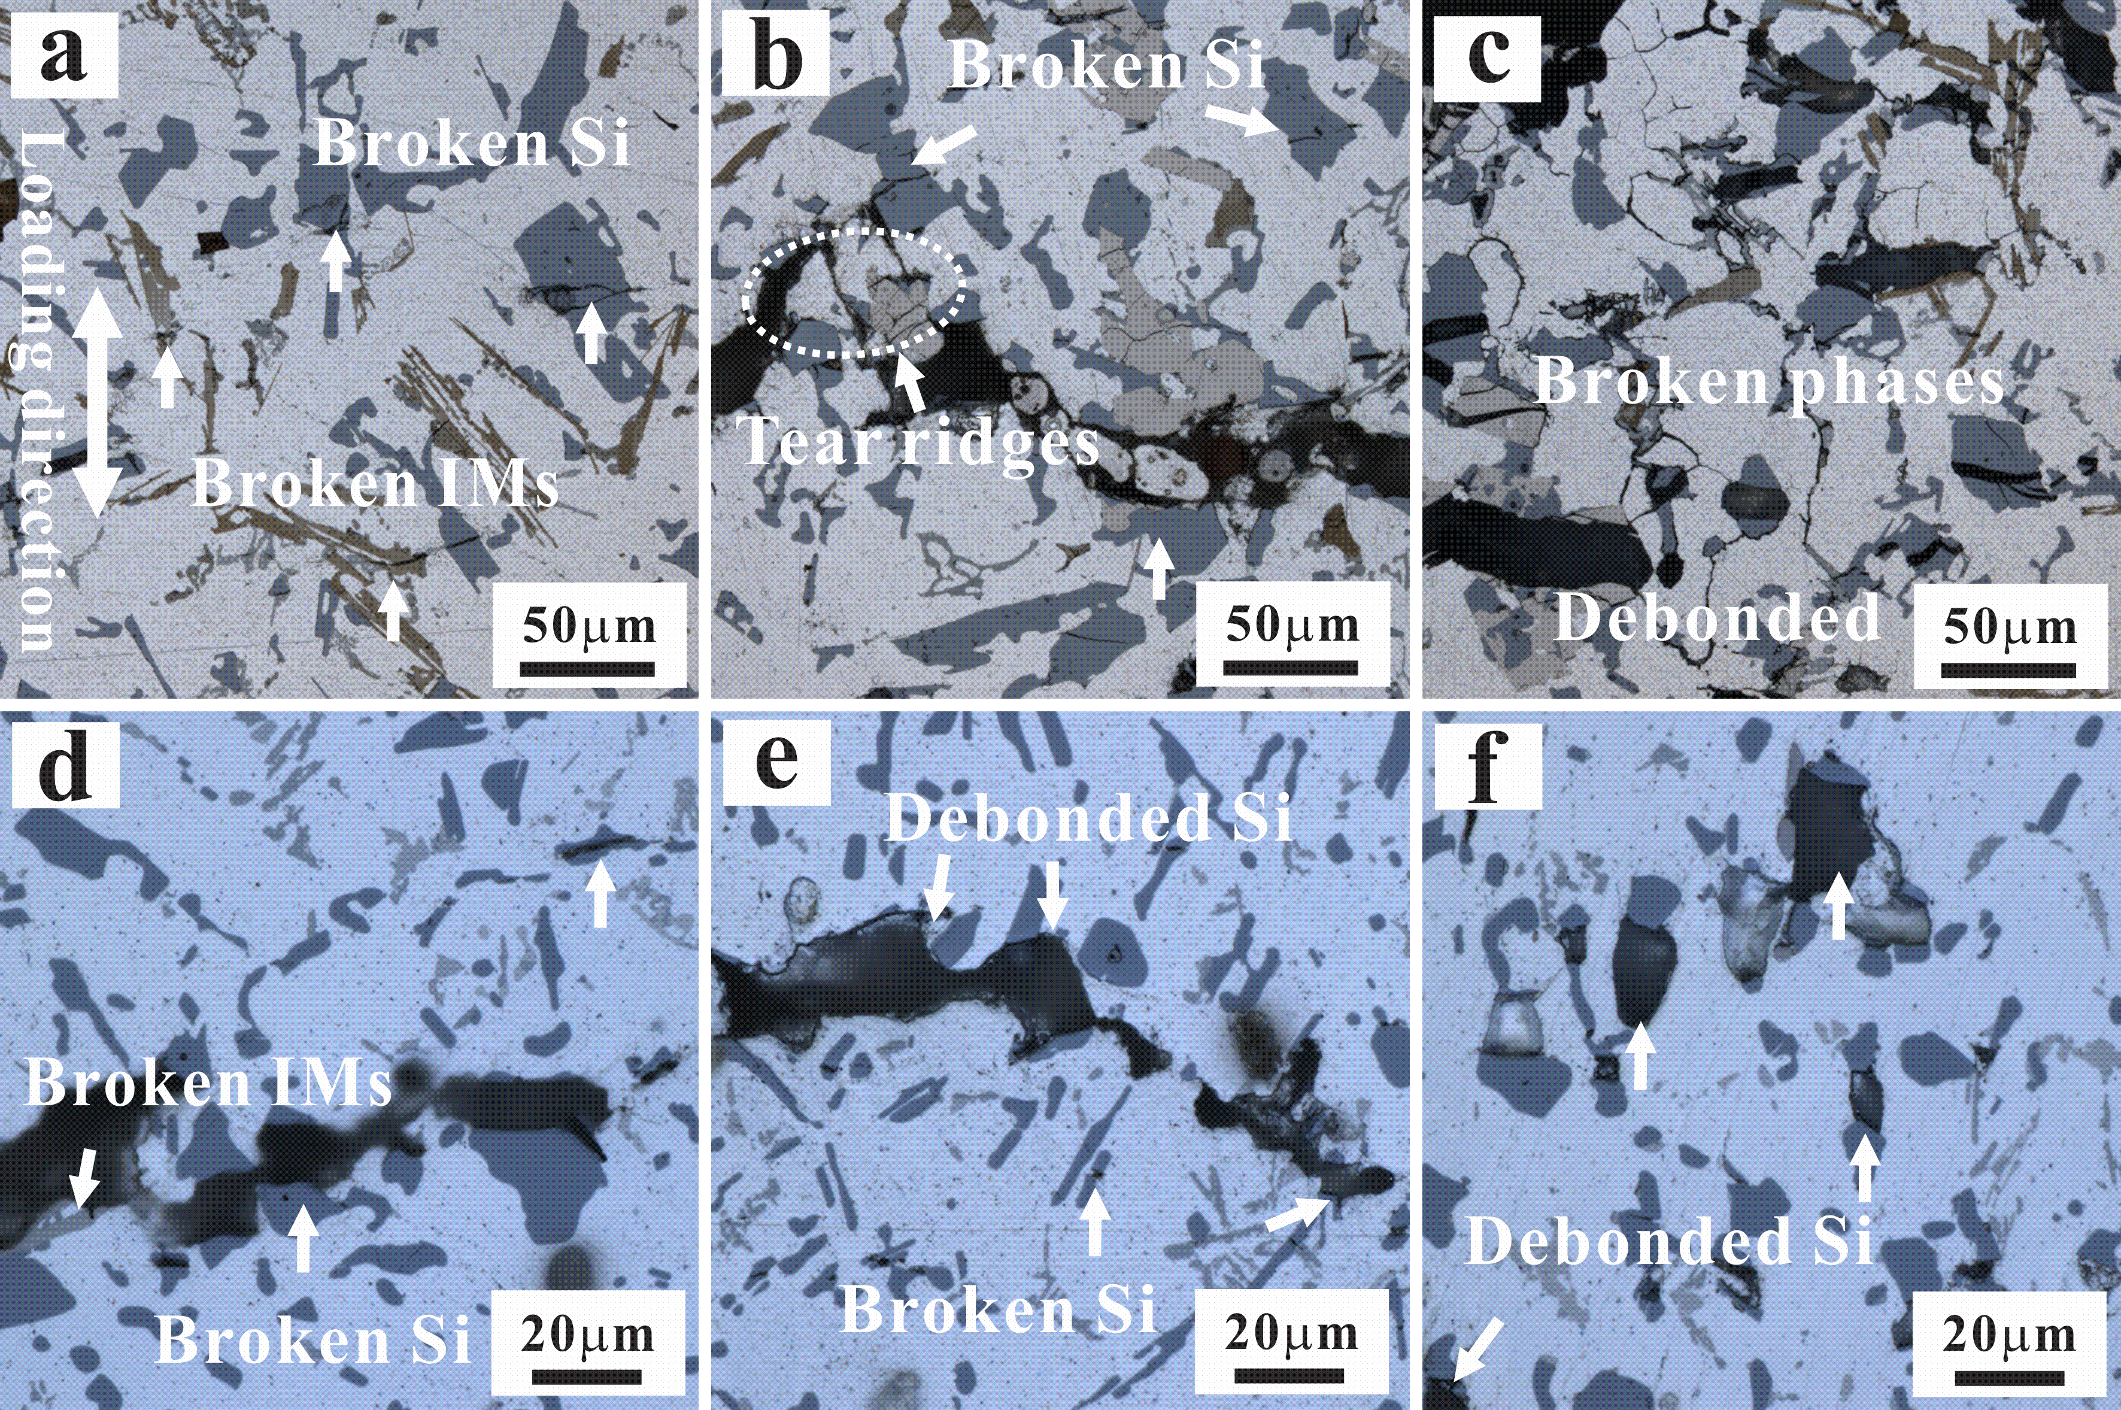
Fig. 6 Microscopic damage characteristics around main fatigue crack at Δε_{t}/2 of 0.2% and different temperatures after fracture: (a) AC-280 °C (N=2246); (b) AC-350 °C (N=13501); (c) AC-425 °C (N=6943); (d) UT-280 °C (N=13915); (e) UT-350 °C (N=17282); (f) UT-425 °C (N=15966).
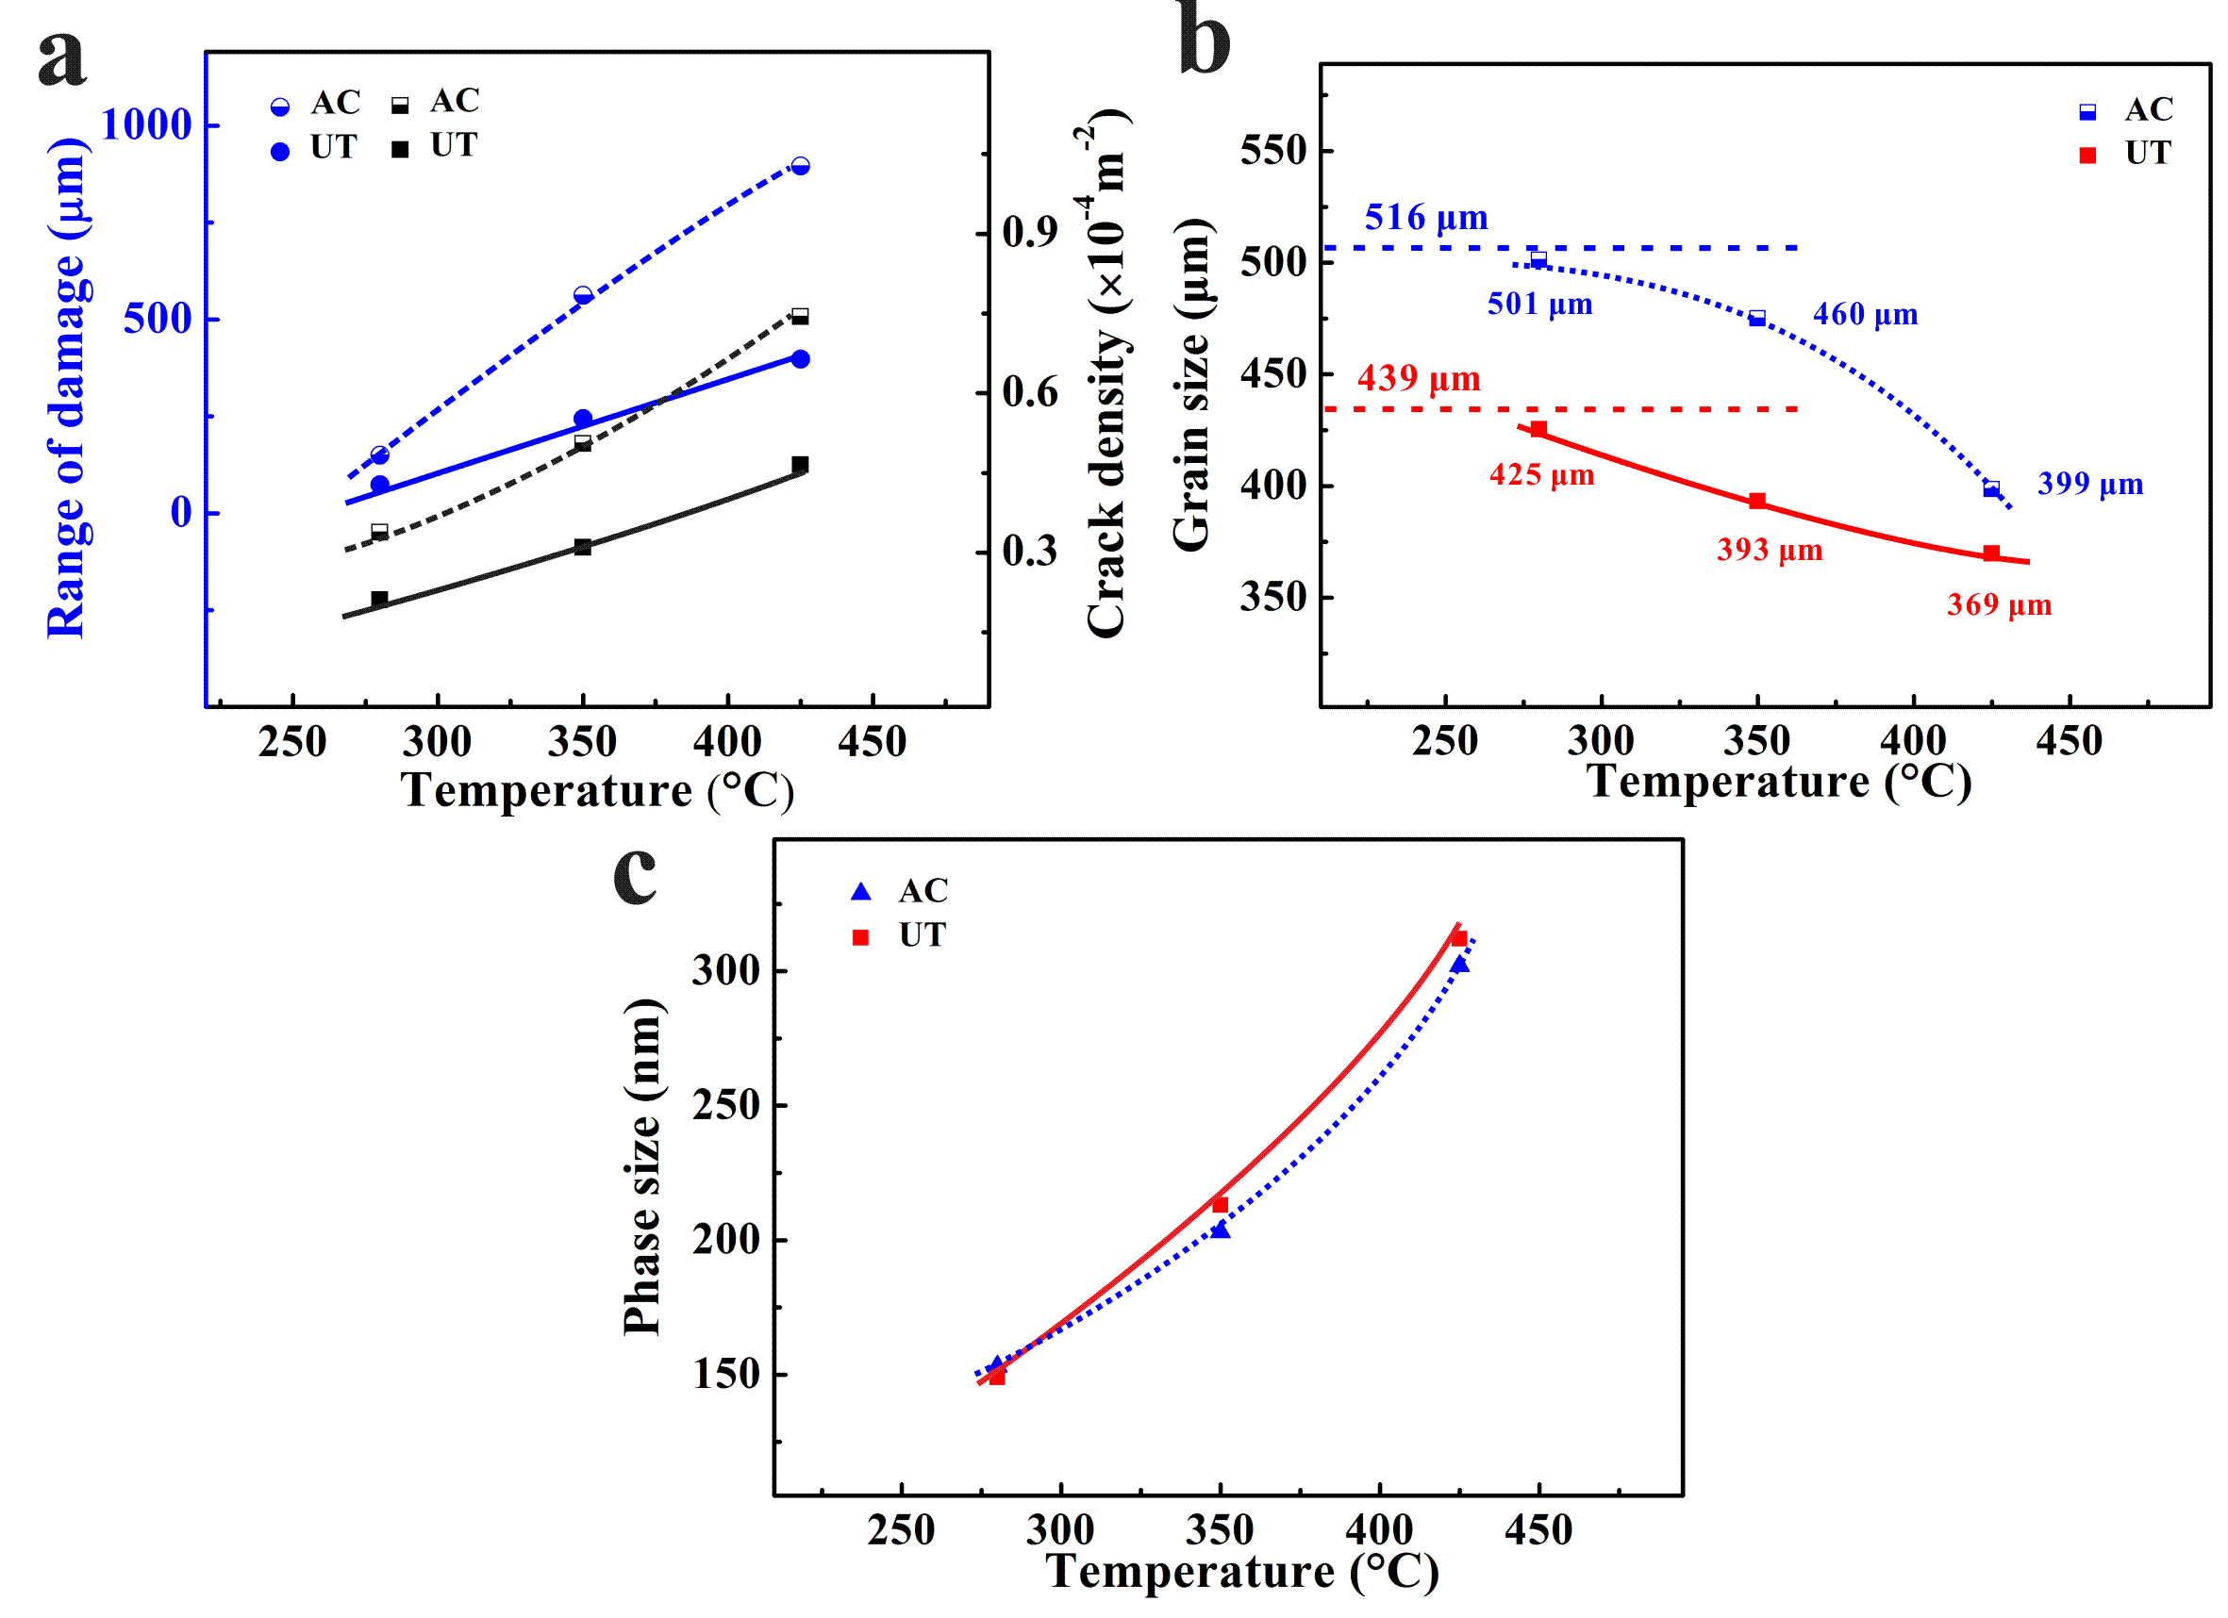
Fig. 7 Microscopic damage characteristics and analysis: (a) range of damage and crack density; (b) grain size evolution; (c) size of θ phase after fatigue.
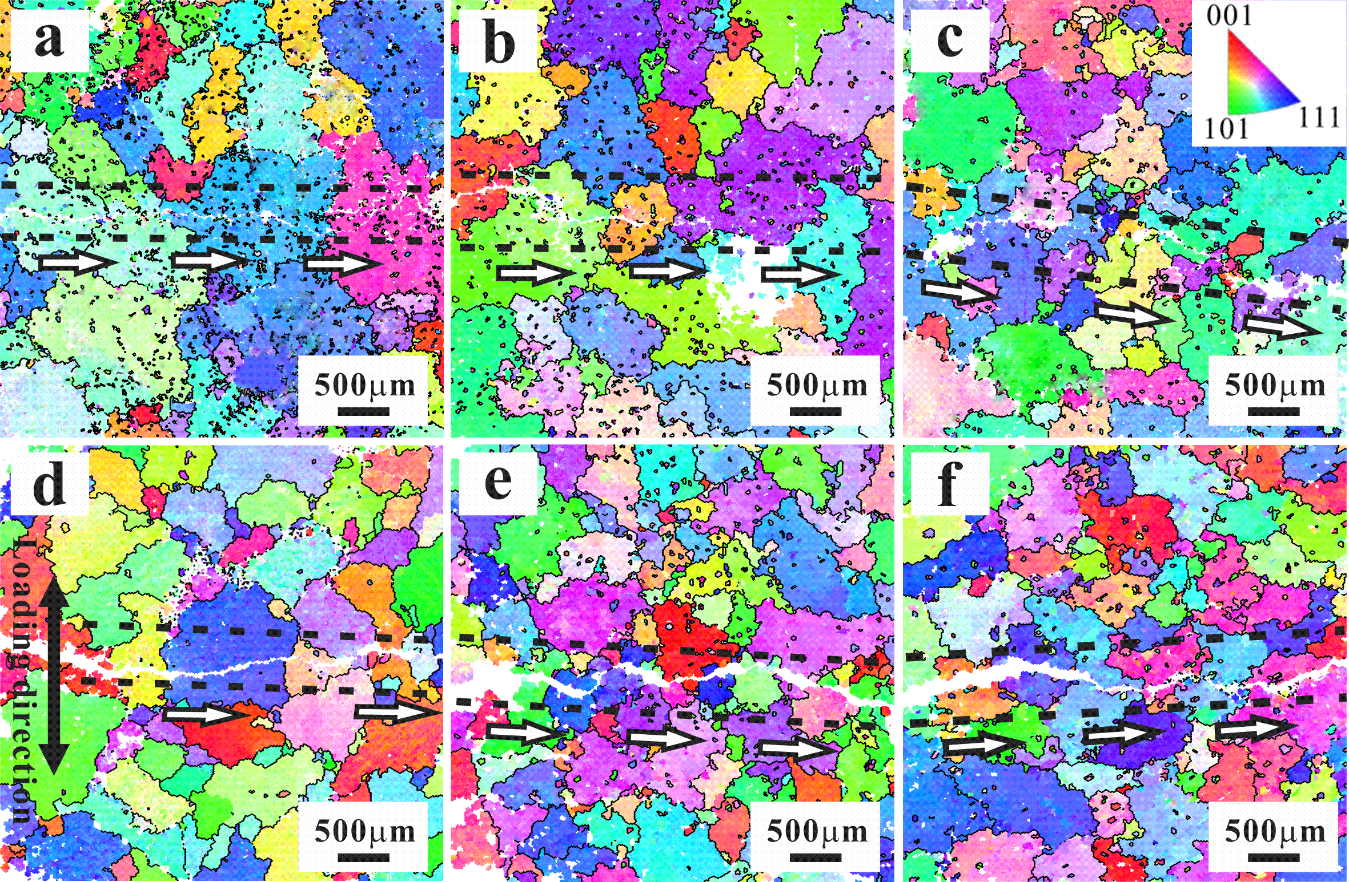
Fig. 8 EBSD image of fatigue crack propagation at Δε_{t}/2 of 0.2% and different temperatures: (a) AC-280 °C; (b) AC-350 °C; (c) AC-425 °C; (d) UT-280 °C; (e) UT-350 °C; (f) UT-425 °C.
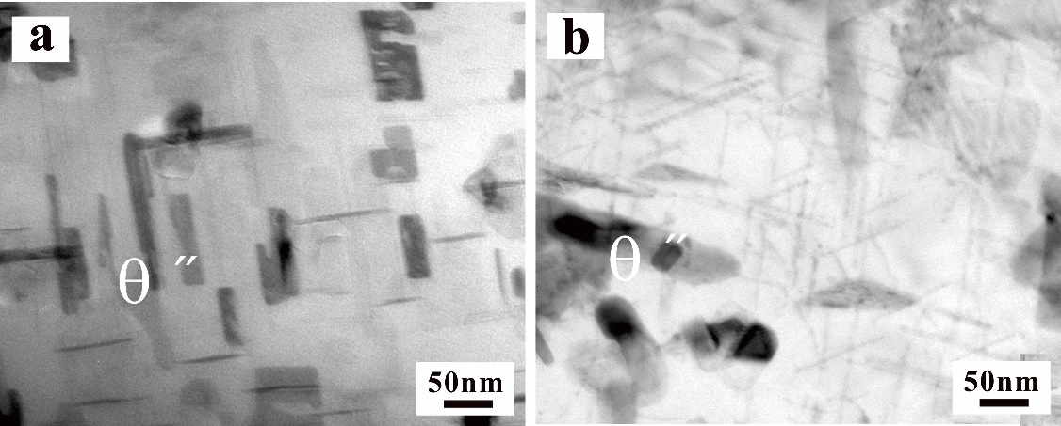
Fig. 9 The original microstructure: (a) AC material; (b) UT material.
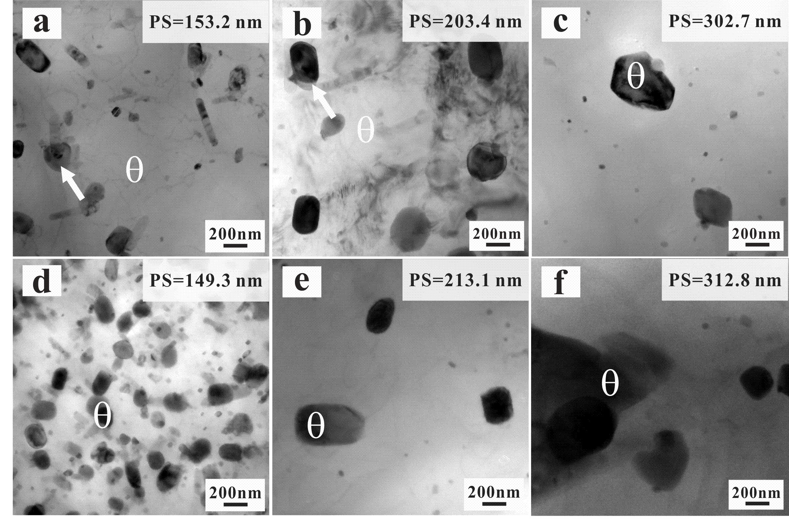
Fig. 10 The evolution of microscopic phases after fatigue at Δε_{t}/2 of 0.2% and different temperatures: (a)-(c) AC-280 °C, AC -350 °C and AC-425 °C; (d)-(f) UT-280 °C, UT -350 °C and UT-425 °C.
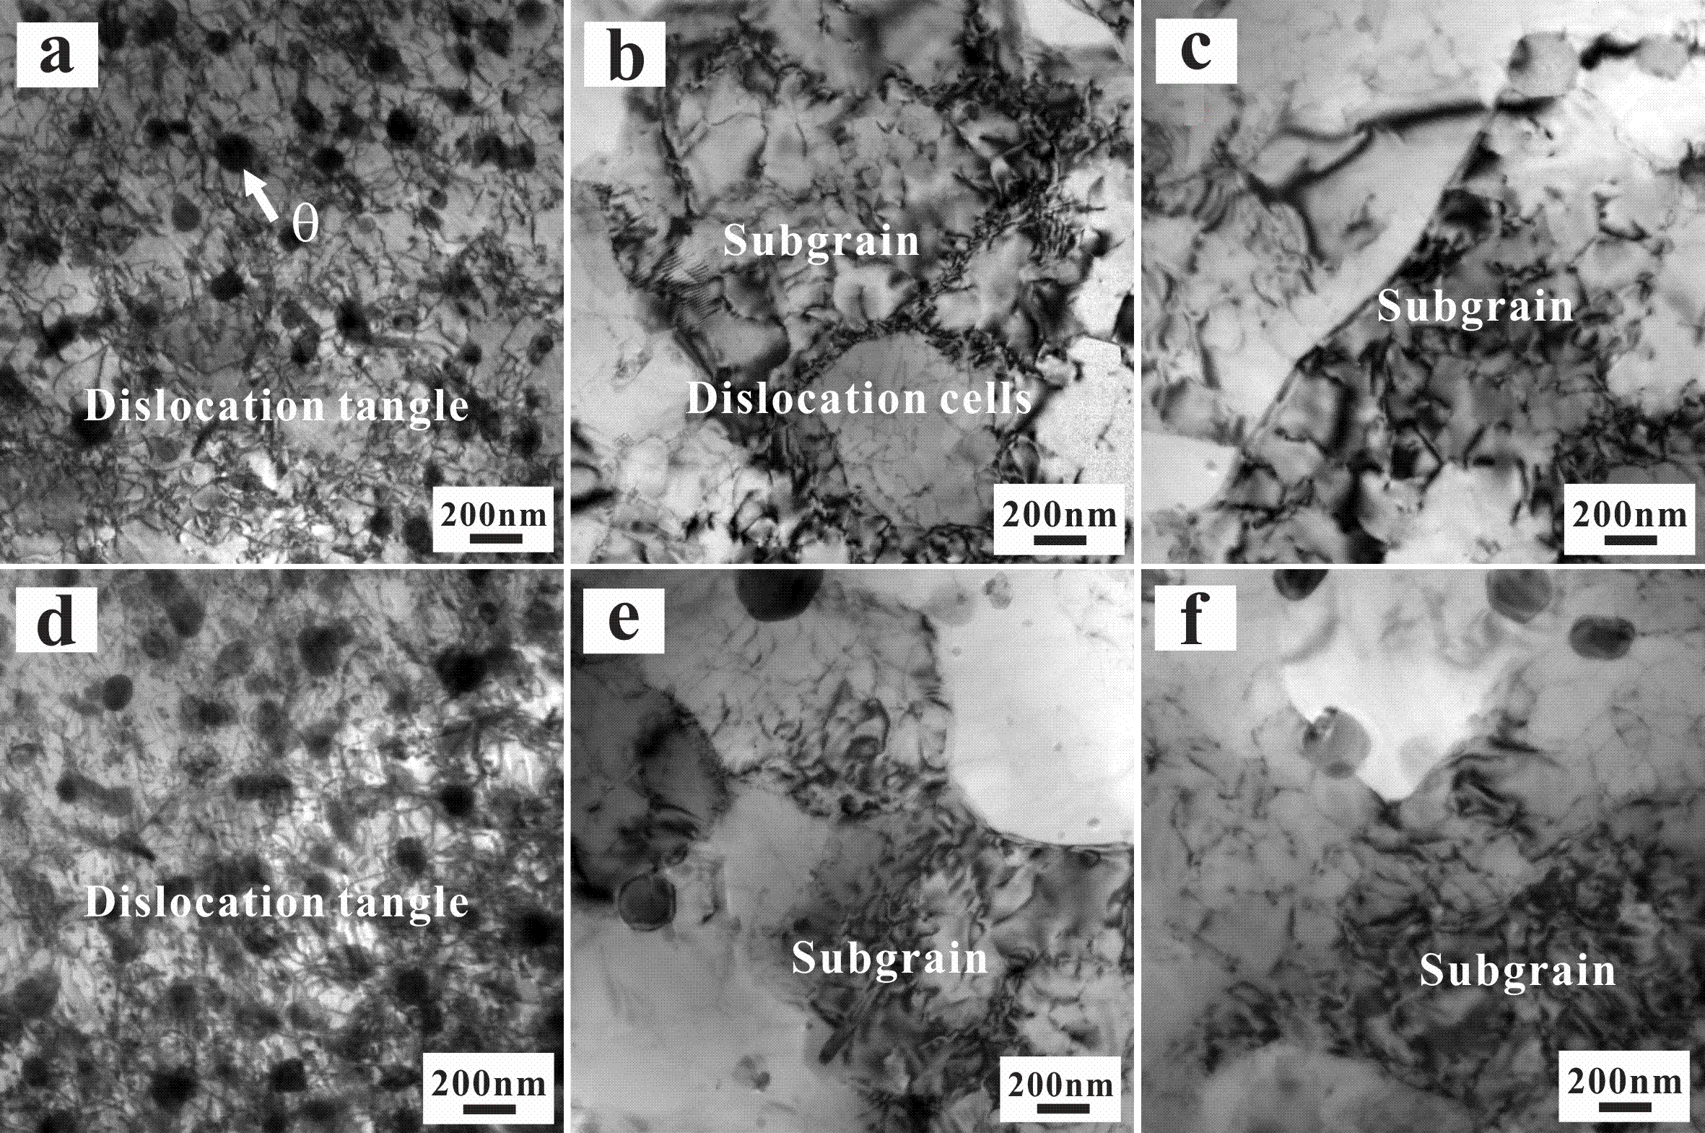
Fig. 11 TEM observation of the LCF samples at Δε_{t}/2 of 0.2% at different temperatures: (a) AC-280 °C; (b) AC-350 °C; (c) AC-425 °C; (d) UT-280 °C; (e) UT-350 °C; (f) UT-425 °C.
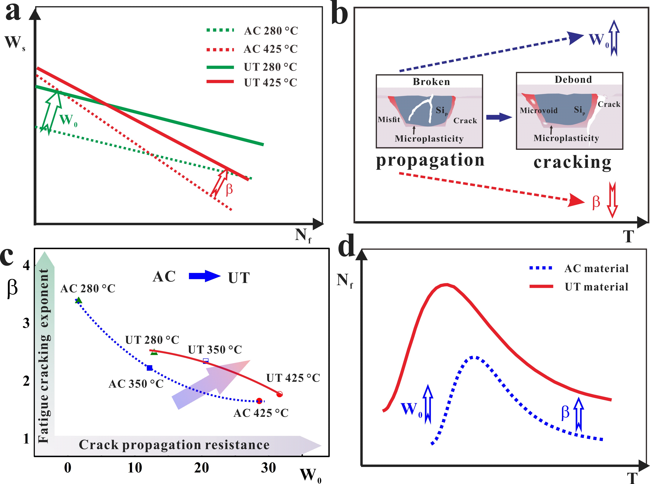
Fig. 12 Summary of the LCF behaviors and mechanism of the two alloys: (a) the influence of fatigue parameters evolution on fatigue life; (b) the change of fatigue damage mechanisms with temperature; (c) fatigue parameters evolution with increasing temperature; (d) schematic diagram of improving LCF property.

