Plasmonic Nanoparticle-based   
Epoxy Photocuring: a Deeper Look

*Adam T. Roberts 1,a,**†, Jian Yang 2* ,*†,   
Matthew E. Reish 3, Alessandro Alabastri4, Naomi J. Halas 2,4,5,  
Peter Nordlander 2,4, and Henry O. Everitt 1,4,\**

1U.S. Army Aviation & Missile RD&E Center, Redstone Arsenal, AL 35898, USA  
2Dept. of Physics and Astronomy, Rice University, Houston, TX 77005, USA

3Oak Ridge Institute of Science and Education, Redstone Arsenal, AL 35898, USA

4Dept. of Electrical and Computer Engineering, Rice University, Houston, TX 77005, USA

5Dept. of Chemistry, Rice University, Houston, TX 77005, USA

1Now at Northrup Grumman, Redondo Beach, CA

*†* Contributed equally

*Corresponding Author, e-mail: Henry.Everitt@rice.edu

**Contents**

Appendix A. Electromagnetic simulations 2

Appendix B. Heat Transfer simulations 2

Appendix C. Influence of parameters 4

Appendix D. Aluminum nanoparticles: practicality and stacking effects 9

Appendix E. Bond strength with no nanoparticles 12

References 17

**Appendix A. Electromagnetic simulations**

Electromagnetic simulations were performed in COMSOL Multiphysics 5.2a. To capture the experimental nanoparticle density, a periodic boundary condition with periods equal to average experimental inter-particle distance was applied. A nanosphere with diameter 40 nm was embedded in an epoxy film with n = 1.5 and sat on a glass substrate. Different refractive indexes for the epoxy film were tested and we found that the heating power does not vary much across a reasonable range of indexes. The permittivity for gold was taken from tabulated data[1]. For simulations done on aluminum nanoparticles, the permittivity data was taken from measured values for single-crystalline aluminum[2]. Incident plane wave with wavelength 532 nm illuminates the nanoparticle from the glass side. The absorption in the nanoparticles and transmission were recorded as functions of nanoparticle density and laser power, and served as input to the heat transfer module. The absorption was discounted by multiplying an aggregation coefficient b = 0.5 (unless otherwise stated). Transmission is assumed to increase by the same amount that absorption decreases due to aggregation.

**Appendix B. Heat transfer simulations**

The heat transfer equations and the entangled curing reaction were solved iteratively in COMSOL Multiphysics 5.2a. The heat transfer equation takes the form. For glass, . For the epoxy, these values were approximated based on literature reported values[3]: . We checked by adjusting these parameters, and the result does not change much. The reason for this is that the epoxy film is very thin, and the timescale for heat transfer is much smaller than that of the curing reaction. Therefore, the curing reaction rather than the heat transfer process is the rate-limiting step. The very tiny nanoparticle layer was neglected in the heat transfer process.

**

**Figure B1.** Function for the extinction coefficient of the epoxy glue.

The external heat source The plasmonic heating term is determined from the previous electromagnetic simulations. The optical heating term is the intrinsic absorption of the epoxy of transmitted light , which depends on both the curing state and the transmission calculated from the electromagnetic simulations. The extinction coefficient , where and are the extinction coefficients before and after curing, obtained from the main text **Fig. 1A**. The function takes a sigmoid-like behavior to account for the fast second temperature increase, as shown in **Fig. B1**. The exothermic heating . Here is the heat of reaction[3], and is the density of the resin. The heat dissipation into the surrounding air assumes the form . Here is the convection coefficient, and for normal air condition, [3]. is room temperature.

The curing equations were solved simultaneously and iteratively with the heat transfer equations. The curing equations take the following form:

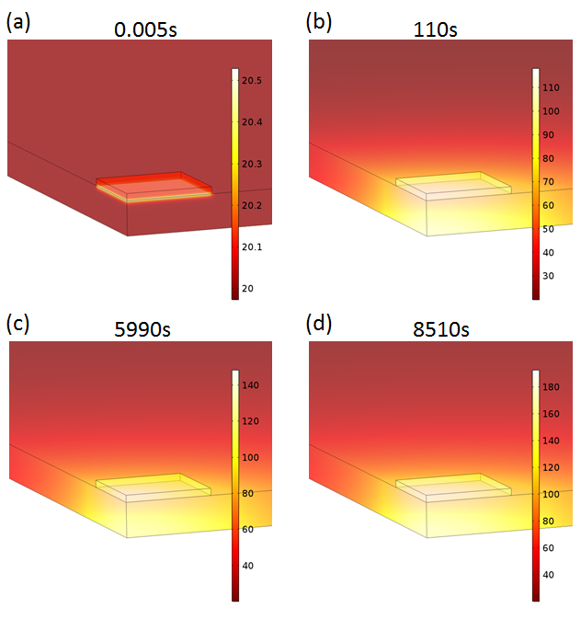

**Figure B2.** Simulated temperature profile at different curing stages. (a),(b),(c) and (d) correspond to the starting point of the four stages as shown in the main text Figure 3(D). Only the very initial plasmonic heating stage shows an inhomogeneous temperature distribution across the epoxy film. For all other stages, temperature distribution is homogeneous because the epoxy is very thin.

Where *E1* = 60 kJ/mol, *E2* = 45 kJ/mol, *A1* = 3376 s-1, *A2* = 1280 s-1, *m* = 1.85, *n* = 1.575, obtained by fitting to the experimental measurements, and R is the gas constant . At certain temperature given by the heat transfer module, the reaction evolves and values for and can be obtained. These values determine the external heat source and were iterated back to the heat transfer module.

As shown in **Fig. B2**, the temperature distribution is very homogeneous throughout the curing process except for the very beginning period.

**Appendix C. Influence of parameters**

To apply this model to our experimental configuration, these sets of equations are solved within a geometry that reproduces the experimental setup: a 1 mm thick glass microscope slide placed on top of the 200 μm thick epoxy film with a NP density of *NP* at the interface and illuminated uniformly by a laser operating at 532 nm focused on the sample for an intensity *IL*. With these experimentally determined conditions, we use the model to ascertain the dependence of the plateau duration *p*, pre-cure time *tp* + *p*, and plateau temperatures *Tp* and *Tf* on the key parameters of the model: activation energies *E1* (60 kJ/mol) and *E2* (45 kJ/mol), NP density *NP* ( cm-2) laser intensity *IL* (5 W/cm2) NP aggregation *b* (0.5) and thermal convection *h* (5 W/m2K) with the surrounding medium. Reference values for each parameter are presented in parentheses and are held constant as other parameters are adjusted one by one in the following discussion. Other parameters are obtained through fitting to experiments and held constant (*A1* = 3376 s-1, *A2* = 1280 s-1, *m* = 1.85, *n* = 1.575).

Ostensibly intrinsic properties of the epoxy film, the activation energies *E1* and *E2* have a profound effect on the curing time (**Fig. C1A,B**). Given previously reported values for (*E1*, *E2*) of (38.3, 20) and (57.3, 19.6) kJ/mol [3,4] and overall apparent activation energies ranging from 46 to 66.9 kJ/mol [5-8], our estimates for *E1* and *E2* of 60 and 45 kJ/mol from a qualitative analysis of the data are consistent with reported values. However, we found that fresh epoxy films cured in hundreds of seconds (**Fig. 2A**) while aged epoxy films cured in thousands of seconds (**Fig. 3B**), perhaps because the activation energy of the aged films has grown higher than that of the fresh films. Notice also that the slope of the cure from the first to second plateaus decreases with increasing activation energy but that the same plateau temperatures *Tp* and *Tf* are reached regardless of the value of *E1* or *E2*. This occurs because the uncured and cured absorption coefficients are not affected by the activation energies, so for a constant *IL* and *NP* the same temperatures are reached. The clear relationship between the duration of the first plateau *p* and the slope toward the second plateau are a consequence of the same decrease in cure rate with increasing activation energy. Compared with *E1* and *E2*, the effects of *A1* and *A2* are minor so they are simply treated as fitting parameters (see below).

Further examining **Equation 1**, it may appear that *k2* contributes little compared to *k1* until the cure is well underway because the former is multiplied by the curing fraction *m*. **Fig. 3D** confirms that alpha remains nearly zero until the end of the first plateau, but **Fig. C1A,B** reveal that the effects of increasing *E2* are quite similar to the effects of increasing *E1*, even during the first plateau. This surprising result is quickly understood when it is observed that *E2* < *E1*, so the exponential term in *k2* is larger. **Equation 1** suggests that *E1* is associated with the uncured portion *(1-)n* while *E2* is also associated with the cured portion of the epoxy *m* with 1 < *m,n* < 2 (see below). Note that the *(1-)n* term determines the second plateau, for when ** ⟶ 1, *d/dt* ⟶ 0 and the epoxy film is cured.

Moving beyond **Equation 1**, several other factors profoundly affect the curing rate. The dependence of the curing dynamics on NP concentration *NP* is perhaps the most complicated (**Fig. C1C**). As *NP* increases, there are more NPs to absorb the laser energy, so of course the local plasmonic heating increases. Notice that *Tp* increases and pre-cure time *tp* + *p* decreases with increasing *NP*. However, the behavior is not monotonic: increasing *NP* eventually reduces laser transmission, making less energy available for intrinsic absorption *QE*. This can be seen as a decrease in the slope toward the second plateau and the reduced *Tf* at the highest *NP*. This sensitivity on *NP* was confirmed experimentally (**Fig. 2A**) and represents good news for the practicality of this technique, as there is a maximum number of NPs required for optimal behavior, beyond which the decrease in curing time is marginal. Indeed, too many NPs would prevent a good adhesive bond, especially if the NPs are pressed onto the bonding surface of the epoxy film instead of distributed throughout the film.

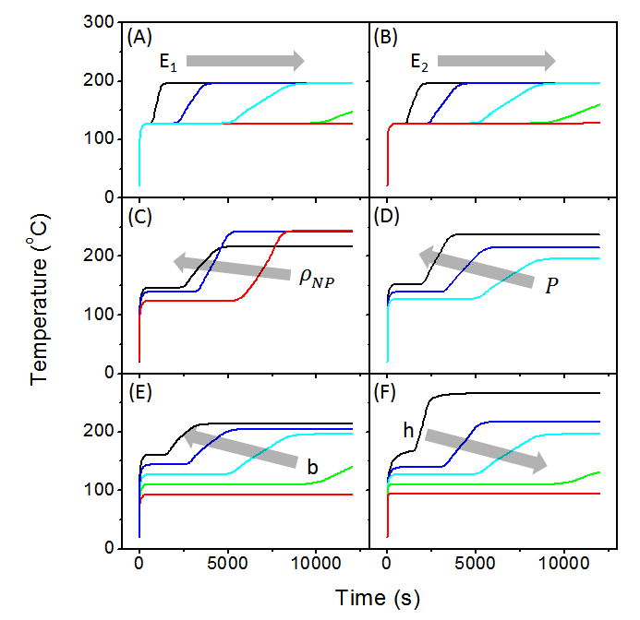

**Figure C1.** Dependence of the curing dynamics on the parameters in Equation 1. (A) and (B) plot the dependence on activation energies E1 and E2, respectively, using IL = 5 W/cm2. In (A), E1 = 50, 55, 60, 65, 70 kJ/mol. In (B), E2 = 35, 40, 45, 50, 55 kJ/mol. (C) and (D) plot the dependence on NP concentration and laser power, respectively. In (C),3.34, 1.11, 0.555 (using IL = 6 W/cm2 here to match experimental conditions). In (D), P = 5, 5.55, 6.16 W/cm2. (E) and (F) plot the dependence on NP aggregation and ambient convection, respectively, using IL = 5 W/cm2. In (E), b = 0.2, 0.35, 0.5, 0.65, 0.8. In (F), h = 1, 3, 5, 10, 20 W/m2K.

To address how the LSPR might redshift with increasing NP concentration, let us assume the NPs form a square lattice to estimate the inter-particle distance: ~15nm at the highest concentration (3.34x1010 cm-2) we studied. **Fig. C2** shows that even at the highest concentration near field coupling between NPs produces only a modest shift and broadening. More importantly, the increase in nanoparticle concentration also increases total plasmonic heating. We therefore conclude that the seemingly paradoxical behavior of decreasing final temperature at the highest NP concentration (**Fig. 3E**) is not due to a shift in plasmonic absorption but to the interplay between increasing absorption and decreasing transmission. This interplay between absorption and transmission suggests an optimal NP concentration. As shown in **Fig. C3**, both the plateau temperature and time to cure 95% vs NP concentration shows that there is an optimal NP concentration of ~2.2x1010 cm-2, and the sample prepared with this concentration did indeed produce the strongest bond (**Fig. 4A**). Our theoretical model gives us more insights into the process compared with a simple Arrhenius-type fitting to the experimental data.

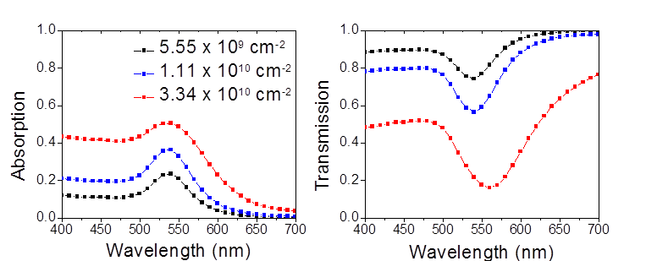

**Figure C2.** Predicted spectral evolution of the LSPR as a function of Au NP concentration.

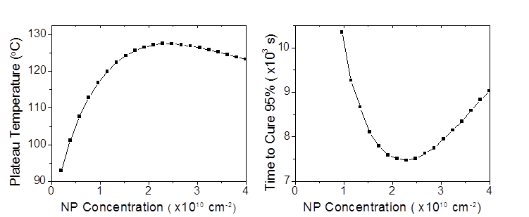

**Figure C3.** Dependence of predicted plateau temperature and time to cure 95% as a function of NP concentration.

By comparison, the dependence on laser intensity *IL* is more intuitive: a higher *IL* cures the epoxy film more quickly. **Fig. C1D** indicates the cure rate is quite sensitive to laser intensity, curing three times faster for an increase in *IL* by only 23%. Moreover, the increasing slopes between the first and second plateaus are a consequence of the increased optical absorption by the epoxy film induced by increasing laser intensities. Of course, there are limits here beyond those simply imposed by the available laser power, such as not scorching the composite materials to be bonded by the epoxy film and trading off increases in *NP* or *IL* to minimize the cost and cure time of the process. A related practical concern is that the scanning methodology depends on the chosen spot size and scan frequency.

The acceleration in pre-cure time *tp* + *p* with increasing *IL* was also confirmed experimentally (**Fig. 3H**). With fixed *NP* = 2.2 × 1010 NP/cm2, increasing *IL* from 5 to 6.16 W/cm2 increases both plateau temperatures and accelerates every step of the process. Given that these Au NPs may reshape or melt during heating, the similarity in the experimental curves at the two highest powers may be due to a partial melting of the Au NPs, causing them to generate and deliver less heat [9-12]. This effect, while not dynamically captured by the model, can be understood by looking at the curing dependence on the agglomeration parameter ‘*b*’ which is varied to describe the decrease of absorption due to particle aggregation during deposition onto the substrate. Future studies may consider a temperature dependent ‘*b*’ to follow in real time the aggregation effect on the curing process. Otherwise, our model qualitatively reproduces these experimental findings and indicates how the performance improves if the NPs do not melt.

Decreasing NP aggregation (increasing *b*) has the same effect as when laser intensity is increased. The parameter *b* is a multiplicative factor for nanoparticle absorption that accounts for NP aggregation during deposition and the associated modification of optical absorption to reduce plasmonic heating: *b* = 0 means complete aggregation and no NP absorption while *b* = 1 means no aggregation and full NP absorption. **Fig. C1E**, in which *b* is fixed for a given curing curve, shows how dramatically the curing process depends on the degree of aggregation. Aggregated particles produce less heating, so having a uniformly distributed NP layer most efficiently heats the adhesive. Since NP aggregation is difficult to prevent, it is likely that the some of the sample-to-sample variations observed in **Fig. 2A** arises from varying NP aggregation. Techniques to ensure maximum dispersity of the NPs within the epoxy film will be essential to any practical application of this technique.

The final parameter of interest is the convection coefficient *h*, a boundary condition used to characterize how effectively heat is removed from the laser heated region. Static air has *h* = 5 W/m2K [3], and **Fig. C1F** shows that in addition to significantly accelerated curing, lower convection also produces higher temperatures. Both of these expected behaviors indicate that the fastest curing occurs when air flow is restricted in the heated region. In our experiments, only a modest air flow was produced by an adjacent exhaust line added to sweep away any smoke produced if the laser scorched the composite. The thermal asymmetry seen in **Fig. 1D**, caused by heat rising vertically from the illuminated region, was seen to rotate toward the exhaust line as it was brought closer to the sample. We observed a commensurate sensitivity of the cure rate to the proximity of the exhaust pipe, confirming the predicted behaviors.

To assess the possibility of NP melting, we first note that we were not able to measure the LSP of the NPs following deposition onto the epoxy, so we cannot compare before and after spectra. The model, which assumes that absorption by the NPs does not change over the course of the experiment, reveals that absorption by the epoxy dominates absorption by the NPs once the cure begins (**Fig. 3C**). We modified the model to simulate what would happen if the NPs melted at different stages of the experiment. As **Fig. C4** indicates, whenever NP melting occurs, it immediately causes an abrupt drop in the temperature. This type of behavior was never observed in any of our experiments, although it is possible NP melting would occur after the second plateau temperature if the laser remained on. Consequently, our model strongly suggests the Au NPs have not melted during the cure. Even if we consider both experimental and simulated results and assume a partial melting occurs, we find that the NP absorption could not have decreased enough to stop or meaningfully modify the curing process. Thus, any loss of NP absorption once the cure begins has minimal effect on the predicted performance. These findings are consistent with what we reported in Figure 3C of the main text where it is shown how epoxy absorption becomes the dominating heat source after 6000s.

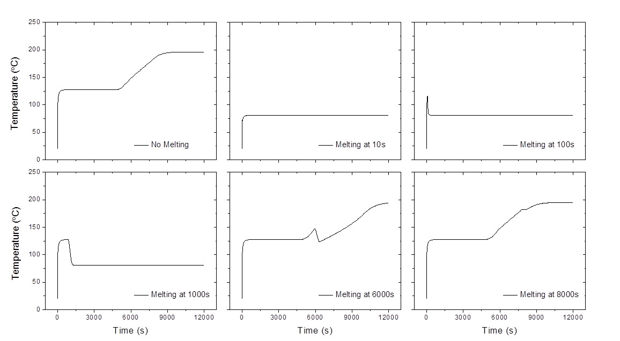

**Figure C4.** Predicted effect on the temporal evolution of the cure if the Au NPs melt at different times.

With these insights, the collective behaviors observed experimentally may now be understood. For example, since the slopes of the experimental curves plotted in **Fig. 2A** are unaffected by changing *NP*, the model indicates that the changes in *Tp* and *p* cannot be caused by changes in film activation energies, laser power, aggregation, or thermal convection and that the optimal value of *NP* has not been reached for these conditions (e.g. see **Fig. C1C**). Notice as well that highest *Tp* and fastest cure time did not occur for the highest *NP*, confirming the effect predicted by the model of decreased heating when NPs are too dense and/or aggregate too much. Indeed, the fastest cure rates will occur for an optimal NP density, uniformly dispersed in fresh epoxy films (with low activation energies) and low air flow using the maximum laser intensity below the scorching threshold of the composite. Further theoretical analyses of the dependence on NP diameter and other parameters used in the model are summarized below. Given the extreme sensitivity of cure rates on parameters that were not well controlled experimentally, especially NP aggregation, air convection, laser scan conditions, and age of epoxy film, the principal merit of this model is its ability to explain the sensitivity to these conditions qualitatively and intuitively ascertain optimal configurations.

We have investigated the influence of the activation energies on the heating behavior, but there are also other reaction parameters: . As we can see in **Fig. C5**, these parameters do not generate an effect as large as the activation energies.



**Figure C5.** Influence of other reaction parameters .

From the curing reaction equations, we can see that the activation energy *E1* is associated with the uncured portion *(1-)n* while *E2* is also associated with the cured portion of the epoxy *m* with 1 < *m,n* < 2. This statement is supported by the reaction rate decomposition as shown in **Fig. C6**. At the initial stage when there is only uncured epoxy, the *E1*component of the reaction rate dominates. As the curing gradually starts, the cured portion increases and the *E2* component plays a major role. Eventually the curing finishes and both components drop to zero.

**Figure C6.** Decomposition of the total reaction rate to E1 and E2 components.

**Figure C7.** Heating as a function of nanoparticle diameter.

Apart from the nanoparticle material and density, the size of the nanoparticle serves as an essential role in determining the energy of the plasmon resonance. **Fig. C7** shows the temperature evolution curves when different sizes of nanoparticles were used. As we can see from the figure, a diameter of 40 nm gives the optimized heating effect, which is the size we used in the experiments. Although the 60nm NPs have a larger absorption cross section, the NPs are embedded between the epoxy glue and the glass slide (refractive indices of ~1.5), so their LSPR redshifts to ~560nm. The LSPR of the 40nm NPs only redshifted to ~530nm, maintaining better overlap with the 532 nm wavelength laser*.*

**Appendix D. Aluminum nanoparticles: practicality and stacking effects**

Given that the expense of gold NPs prevents this technique from being widely applicable for large scale manufacturing, alternative plasmonic metals were considered that would be more practical. Perhaps the most compelling metal for this application is aluminum because of its high natural abundance, low cost to manufacture and process, and the fact that its plasmon resonance may be tuned throughout the ultraviolet and visible spectral regions [13-18]. Aluminum is particularly attractive for photothermal heating when it is noted that the easily fabricated large NPs required for operation in the visible spectral region are quite lossy - they have a broad plasmon resonance and an insidious native oxide.

To explore theoretically how well Al NPs accelerate curing, we used the Al dielectric function found in Cheng et. al. [19] to design spherical NPs with a plasmon resonance at 532nm. These Al NPs are much larger in diameter (130 nm) than the corresponding Au NPs (40 nm), causing scattering to dominate over absorption, so smaller (50 nm) off-resonant NPs with higher concentrations were also considered to enhance absorption. Unfortunately, a single layer of Al NPs, even if closely packed, produces insufficient heating, so multiple stacked layers are required to achieve comparable heating. Specifically, we modeled the system as multiple layers of close-packed 50 nm diameter Al NPs stacked at the interface between glass and the epoxy film (**Fig. D1A)**. For simplicity, the Al NPs are positioned on top of each other, but alternative packing configurations gave similar results (see below).

In **Fig. D1B** we plot the temporal evolution of the curing dynamics as the number of Al NP layers increases from 0 to 5. The epoxy cures at a speed comparable to the Au case shown in **Fig. 3B** with just two layers of Al NPs. Although stacking could increase plasmonic heating, it reduces the transmission of light, therefore limiting the amount of energy available for intrinsic epoxy absorption. Due to the trade-off between plasmonic heating and NPs layer optical transmission, the 4-layer case is actually worse than the 3-layer one, as shown in **Fig. D1B**. However, 5 layers exhibit much higher 1st and 2nd plateau temperatures and a remarkably faster curing which ends at around 2000 s.

This proof-of-concept calculation confirms how cost effective and earth-abundant aluminum NPs can be utilized for local curing of epoxy films. To ensure strong bonds, the stacked NPs should be dispersed within the epoxy volume which, thanks to the relatively low optical absorption prior to curing, would allow the input radiation to interact with the plasmonic NPs.

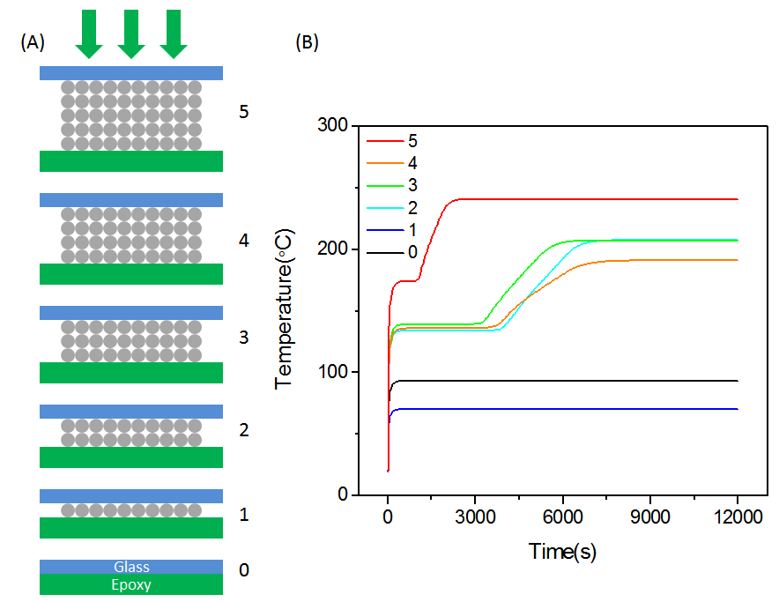

**Figure D1**. The case for Al nanoparticles. (A) Scheme suggesting the possibility to include multiple layers of Al nanoparticles to increase the global absorption. (B) Temperature dynamics when different layers of Al nanoparticles (from 0 to 5) are placed at the interface between glass slab and resin layer. Al NPs are considered to be 50 nm spheres.

The high bulk plasmon frequency of aluminum makes its plasmon resonance bluer than gold nanoparticles. However, to make its plasmon resonance at 532 nm, the particle would be much larger, causing scattering to dominate over absorption. Therefore, to generate similar heating effects, we used small nanoparticles but had to stack the particles to multiple layers. As shown in **Fig. D2**, for closely-packed structures, the ABCA and ABAB give similar behaviors. They give almost identical results with the cubic lattice case in the main text. Therefore, this is a simple stacking effect but not a lattice effect.

**Fig. D3** shows why the stacking effect is not monotonic. Although adding one layer of nanoparticle increases the absorption a little bit, it significantly reduces transmission, which results in a lower temperature. Two, three and four layers have similar heating effects. A five-layer structure has a significantly higher level of absorption, so the curing process is much faster.



**Figure D2.** Different closely packed stacking structures. Left: ABCA. Right: ABAB.   
These simulations were done on Al particles of diameter 40 nm.



**Figure D3.** Explanation of the non-monotonic behavior of the stacking effect for Al NPs. Although adding the first layer of Al nanoparticles increases absorption, it significantly reduces the transmission. This results in a reduction of the energy available to the epoxy, and therefore the epoxy reaches a lower temperature. Two, three and four layers have similar absorption and transmission values, so their curing curves appear almost identical. A five-layer structure has a significant increase in absorption, therefore the curing happens rapidly.

**Appendix E. Bond Strength with no Nanoparticles**

*Composite Coupon Samples*

The highly scattering, partially translucent composite coupon samples used for these bonding studies are shown below in Fig. E1.

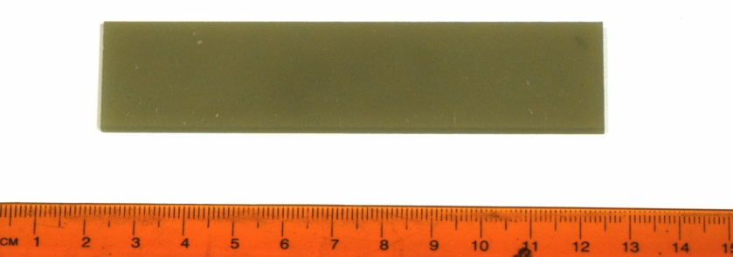

Figure E1. Thermoset composite coupon sample.

The coupons are thermoset composites measuring 1” × 4” × 0.086”. A 1” square piece was cut to perform the absorption measurements in an integrating sphere. The fractional optical absorption of the coupon sample is shown in Fig. E2. An absorption of 1 means that all light was absorbed and 0 means that none of the light was absorbed. In other words, absorption of 0 does not indicate that all of the light is transmitted but that all of the light is scattered, reflected, or transmitted.

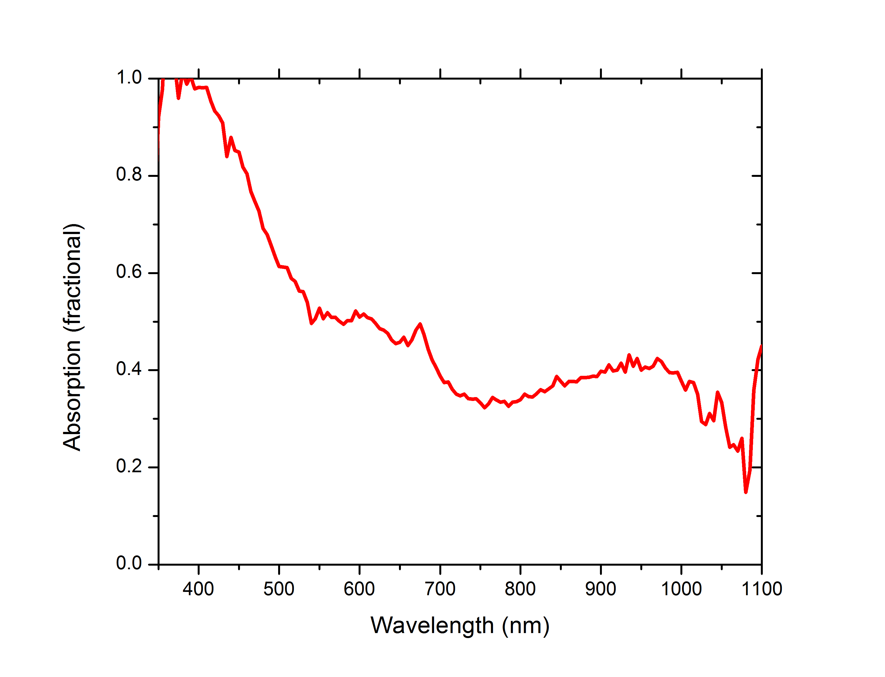

Figure E2. Fraction absorption of coupon sample.

*Reflection and Transmission measurements*

To bond the composite coupons together, the laser light will have to transmit through the coupons and heat the epoxy film at the interface between two pieces. In any material, the incident light is reflected, transmitted, and absorbed. The reflected and transmitted components will also have diffuse (random scatter) and specular (unscattered) components. These different components are illustrated in Fig. E3.

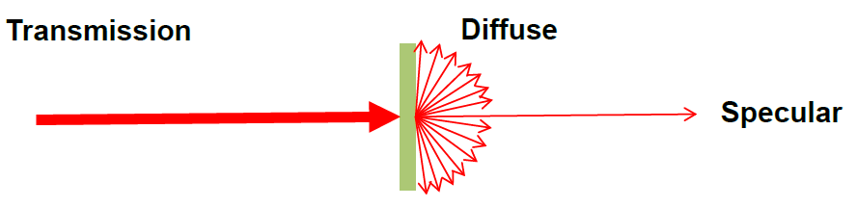 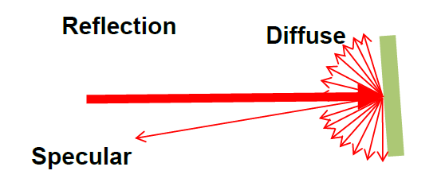

**Figure E3**. Diffuse and Specular Transmission through (left) and from (right) the composite.

Because the composite is made up of many different layers or fibers and resin, the diffuse component of both the reflection and the transmission will be quite large. This will limit the ability to tightly focus the laser for welding in a small region.

To measure the diffuse and specular transmission (and reflection), a 6 inch integrating sphere was used with a Newport power meter and a HeNe laser (632.8 nm). For the transmission measurements, the HeNe was sent through the integrating sphere such that the sample could be placed at the entrance aperture, while at the exit aperture, either a beam dump which absorbs all the light or a diffuse reflector which scatters all of the light back into the sphere can be mounted. The power meter was fixed at a port on top of the sphere. The baseline power was measured without the sample at the entrance port, and then the sample was mounted and the power transmitted through the coupon and into the integrating sphere was measured with both the diffuse reflector and the beam dump at the exit port. With the beam dump in place, only the diffuse transmission is measured since the specular portion is captured by the beam dump. With the diffuse reflector in place, the diffuse and the specular transmission are measured. A very similar procedure is followed to measure the diffuse and specular reflection. To measure the reflection, the laser propagates through the integrating sphere before striking the sample. The diffuse and specular light reflected from the sample is then captured by the integrating sphere.

The results from the reflection and transmission measurements are shown in Table E1. The absorption measurement originates from the measurements shown in Fig. E2. When added together the values reach 99.88+/-0.70%, which accounts for all of the incident light within the margin of error. Notably, only 12% of the light is lost to reflection (diffuse and specular combined). The rest of the light is transmitted to the bondline, or is absorbed into the material. While transmitted light is better for heating the bondline, light absorbed in the composite will still be converted into heat which will be conducted into the adhesive, although at a lower rate.

Table E1. Composite Reflection, Transmission, and Absorption

|  |  |  |
| --- | --- | --- |
|  | Diffuse | Specular |
| Reflection | 11.21 +/- 0.13% | 1.49 +/- 0.17% |
| Transmission | 33.05 +/- 0.70% | 6.54 +/- 0.27% |
| Absorption | * 1. /- 0.67% | |

# *Optical Layout*

The optical layout of the laser heating experiment is shown in **Fig. E4**. The laser is a 10 W, 532 nm wavelength frequency-doubled Nd-doped YAG source called Sprout, by Lighthouse Photonics. The beam is steered onto a set of gimbaled mirrors which can sweep the beam into any arbitrary shape. Rastering the beam provides control to the laser distribution on the sample. The beam was rastered in a Lissajous pattern with the vertical direction oscillating in a sine wave at 130Hz and the horizontal direction oscillating in a sine wave at 100 Hz. This pattern would generate uniform heat over the coverage area, but with slightly higer temperatures near the edges. To monitor the temperature of the samples, a FLIR model T450sc captured video of the experiments.

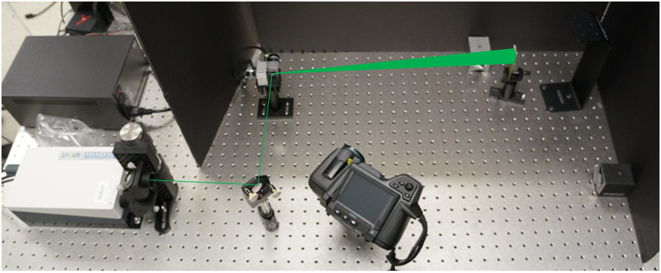

**Figure E4**. Laser Heating Optical Layout

*Coupon Heating*

Before bonding the samples, the composite coupons were heated with the laser to determine the laser power requirements for activating the adhesive. The FM 300 adhesive cures at 177 °C (350 °F) for an hour. Achieving this level of heating in the composite alone will determine whether or not the adhesive can be cured with this laser system. When performing a lap joint, half of the laser power (at 532 nm) will be absorbed by the first section of composite. After that, one third of the laser power will transmit to the adhesive. This means that achieving the target temperature in a single composite sample will indicate that curing is possible.

The coupon samples were heated with the laser in a 0.9 × 0.9” square pattern. A thermal image of a coupon sample being heated with 10 W of laser power is shown in **Fig. E5A**. The composite had an average temperature of 173 °C (343 °F) where it was being heated by the laser at 10 watts. Where the laser was not illuminating the composite, the temperature dropped such that 0.63” away from the heated area, the temperature was below 38 °C (100 °F). As seen in the inset of **Fig. E5B**, the composite temperature is linear with the laser power for the range of available power. Each additional watt increased the temperature by 16 °C.

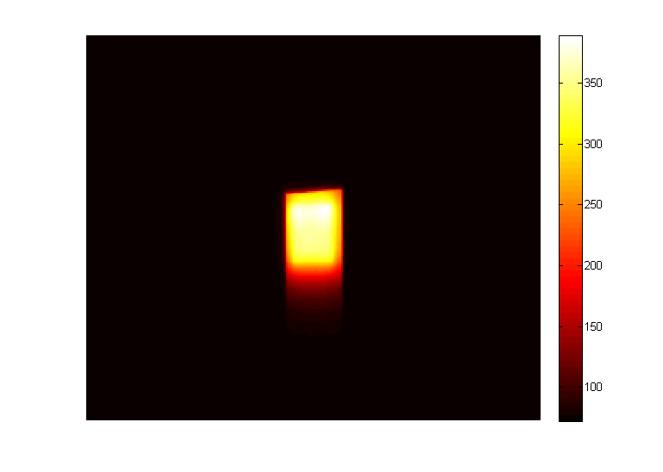

**(A)**

**(B)**

**Figure E5**. (A) Composite heated by laser. (B) Measured temperature of the composite as a function of laser power below the onset of scorching.

The linear response holds for laser powers below the laser damage threshold. An image of typical laser damage is shown in **Fig. E6**. The damage spot on the right shows the onset of laser damage, while the spot on the left shows complete laser burning of the material (visibly scorched). The dark spots which appear as the laser damages the composite increase the local absorption and create an intense hot spot. For these composites, the onset of laser damage occurred when the material reached about 232 °C (450 °F). Bonding and welding with a laser requires careful monitoring because these runaway processes can quickly damage the part being produced or modified.

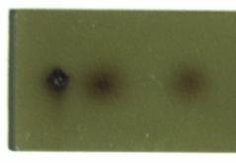

**Figure E6**. Laser Damaged Composite

*Laser Bonding with no Nanoparticles*

The composite samples were bonded in a 1” lap joint. A thermal image of the samples being bonded is shown in **Fig. 4**. The joint was clamped during the cure at both ends of the joint. The temperature of the joint was controlled to follow a 30 minute ramp time to 177 °C (350 °F), and then held at 177 °C (350 °F) for one hour. As the FM 300 cured, the laser power had to be decreased due to increased absorption in the epoxy layer.

The bonded samples were tested for bond strength with lap shear measurements [20]. These measurements were performed by AMRDEC’s Aerospace Materials group. The samples are pulled along the axis of the bond until the bond breaks. **Fig. E7** shows the load force required to stretch the bond to each extension. The sudden decrease in load indicates that the bond has broken. There are three measurements of the laser bonded composites shown in **Fig. E7**. These bonds were created using a 1-D raster (rather than 2D, as shown above), and oscillating the sample mechanically across the laser beam. As we learned how to improve the raster of the sample, each trial yielded increased bond strength. The best performance was a 4000 N (890 pounds) load before bond breakage. At this point, the composite samples themselves began to fail, rather than the epoxy. The best bond had a 0.6” × 0.5” area that showed a high-quality bond, which would make the peak strength about 2970 psi. The manufacturer’s specifications of the FM 300 lap shear strength are 5145 psi, using metal samples. Because the composite failed before the adhesive in the best bonds, it is likely that the laser welding was reaching the peak performance of the adhesive.

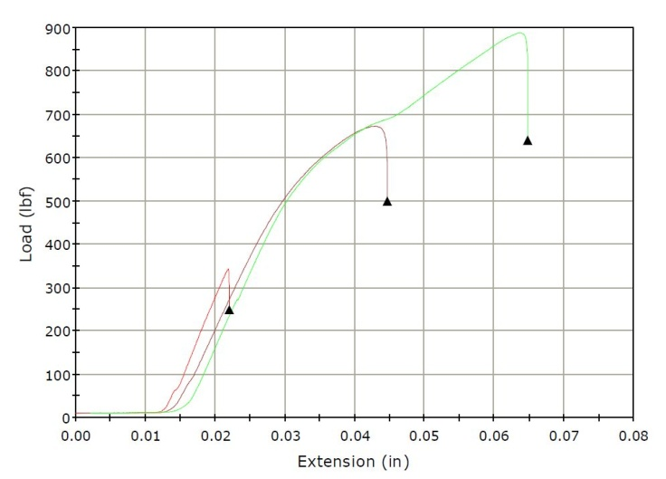

**Figure E7**. Lap Shear Tests with No Nanoparticles

**References**

[1] P. B. Johnson, R. W. Christy, ‘Optical Constants of Noble Metals.’ Physical Review B, 1972, 6, 12.

[2] F. Cheng, P-H. Su, J. Choi, S. Gwo, X. Li, and C-K. Shih, ‘Epitaxial Growth of Atomically Smooth Aluminum on Silicon and Its Intrinsic Optical Properties.’ ACS Nano, 2016, 10(11), pp9852-9860.

[3] J. Zhang, Y. Xu, P. Huang, in *e-Polymers*, Vol. 10, 41 (2010).

[4] L. Sun, Thermal rheological analysis of cure process of epoxy prepreg, Louisiana State University, Doctoral Thesis, 2002.

[5] K. Horie, H. Hiura, M. Sawada, I. Mita, H. Kambe, *J. Polym. Sci. Part A-1 Polym. Chem.* **1970**, *8*, 1357.

[6] M. A. Acitelli, R. B. Prime, E. Sacher, *Polymer (Guildf).* **1971**, *12*, 335.

[7] R. B. Prime, E. Sacher, *Polymer (Guildf).* **1972**, *13*, 455.

[8] S. Sourour, M. R. Kamal, *Thermochim. Acta* **1976**, *14*, 41.

[9] A. Plech, V. Kotaidis, S. Grésillon, C. Dahmen, G. von Plessen, *Phys. Rev. B* **2004**, *70*, 195423.

[10] J. Wang, Y. Chen, X. Chen, J. Hao, M. Yan, M. Qiu, *Opt. Express* **2011**, *19*, 14726.

[11] S. Inasawa, M. Sugiyama, Y. Yamaguchi, *J. Phys. Chem. B* **2005**, *109*, 3104.

[12] G. Baffou, *Thermoplasmonics: Heating Metal Nanoparticles Using Light*; Cambridge University Press: Cambridge, UK, 2017.

[13] M. W. Knight, L. Liu, Y. Wang, L. Brown, S. Mukherjee, N. S. King, H. O. Everitt, P. Nordlander, N. J. Halas, *Nano Lett.* **2012**.

[14] M. W. Knight, N. S. King, L. Liu, H. O. Everitt, P. Nordlander, N. J. Halas, *ACS Nano* **2014**.

[15] F. Bisio, R. Proietti Zaccaria, R. Moroni, G. Maidecchi, A. Alabastri, G. Gonella, A. Giglia, L. Andolfi, S. Nannarone, L. Mattera, M. Canepa, *ACS Nano* **2014**, *8*, 9239.

[16] M. J. McClain, A. E. Schlather, E. Ringe, N. S. King, L. Liu, A. Manjavacas, M. W. Knight, I. Kumar, K. H. Whitmire, H. O. Everitt, P. Nordlander, N. J. Halas, *Nano Lett.* **2015**, 150325060327007.

[17] M. L. Tseng, J. Yang, M. Semmlinger, C. Zhang, P. Nordlander, N. J. Halas, *Nano Lett.* **2017**, *17*, 6034.

[18] B. D. Clark, C. R. Jacobson, M. Lou, J. Yang, L. Zhou, S. Gottheim, C. J. DeSantis, P. Nordlander, N. J. Halas, *Nano Lett.* **2017**.

[19] F. Cheng, P.-H. Su, J. Choi, S. Gwo, X. Li, C.-K. Shih, *ACS Nano* **2016**, *10*, 9852.

[20] https://www.admet.com/how-to-perform-an-adhesive-lap-joint-shear-strength-test-astm-d1002/.