GEMS model for chloride binding

Author: Petter Hemstad

Date: 01/03/2019

This documents details the current GEMS v3.4-model used to predict the phase assemblage of our chloride binding samples. It is divided into three sub-models that model three different types of samples: HCl-exposure samples, CaCl2 isotherm samples and NaCl isotherm samples.

Thank you to Klaartje De Weerdt for the original model on which this one is based, and for help developing the model. Also many thanks to Barbara Lothenbach for very helpful discussion and help with some difficult questions.

# Updates

In this version we are attempting to resolve issues caused by Mg and conclude on the topic of hydrogarnet. Fe-hydrogarnet is included, whilst Fe-Al-hydrogarnet is not. To disable Fe-Al-hydrogarnet, the maximum amount of the phase has been set to 0 (see Section 3.2). The Al-uptake of C-S-H is set to 0.05 mol Al/mol Si based on EDS results.

Magnesium is partially blocked from forming other phases by setting the minimum amount of MgO in the system to almost equal half the total molar amount of Mg put in. Brucite has been disabled, and the remaining Mg goes to form hydrotalcite.

# Input materials

This model uses only one input material, which is OPC clinker.

Table 1- Chemical composition of the Portland cement (OPC) used determined with XRF [wt. %].

|  |  |  |  |  |  |  |  |  |  |  |  |
| --- | --- | --- | --- | --- | --- | --- | --- | --- | --- | --- | --- |
|  | **SiO2** | **Al2O3** | **TiO2** | **MnO** | **Fe2O3** | **CaO** | **MgO** | **K2O** | **Na2O** | **SO3** | **P2O5** |
| OPC | 19.91 | 5.15 | 0.28 | 0.06 | 3.42 | 62.73 | 2.34 | 1.09 | 0.48 | 3.16 | 0.11 |

The input data window in GEMS:

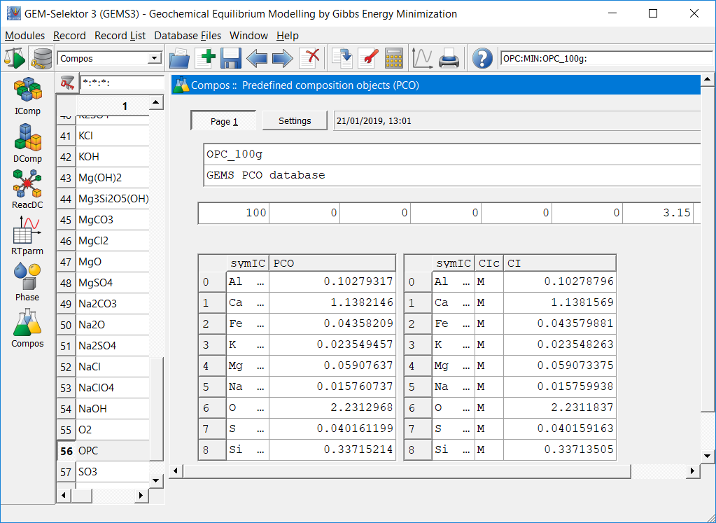

## Assumptions

This method has a variable reaction degree between 0 and 1, with (1 – reaction degree) of the OPC added to the final equilibrium composition. This can be easily be varied by changing the “modC[1][1]”-value in controls.

# Chloride exposure

## Single equilibrium

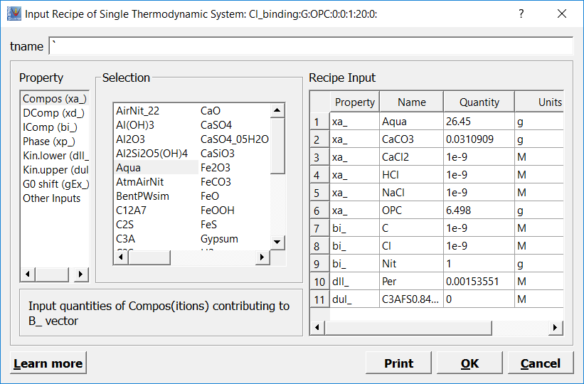

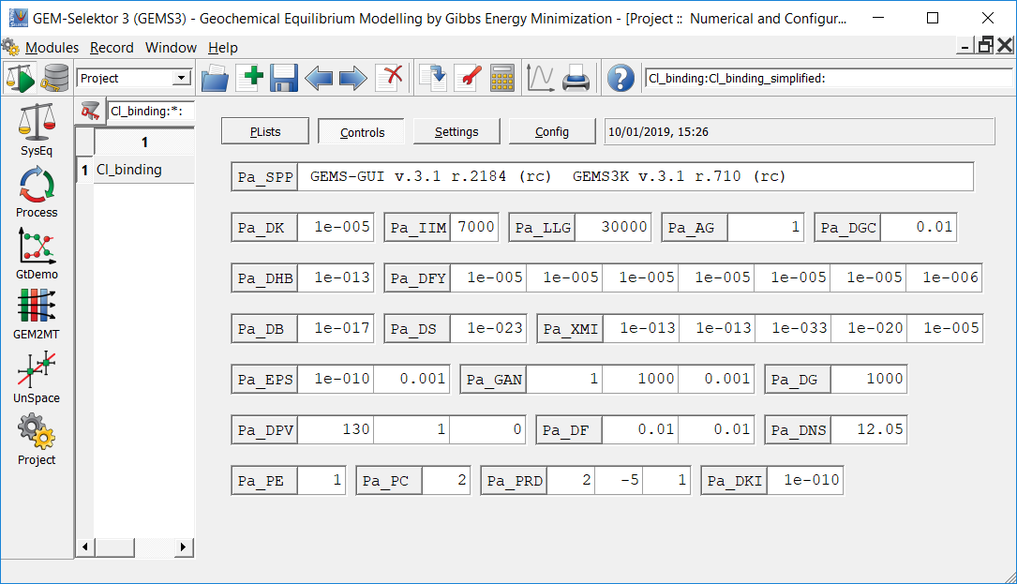

## Phases enabled in the model

The red circle indicates the disabling of Al-Fe-hydrogarnet.

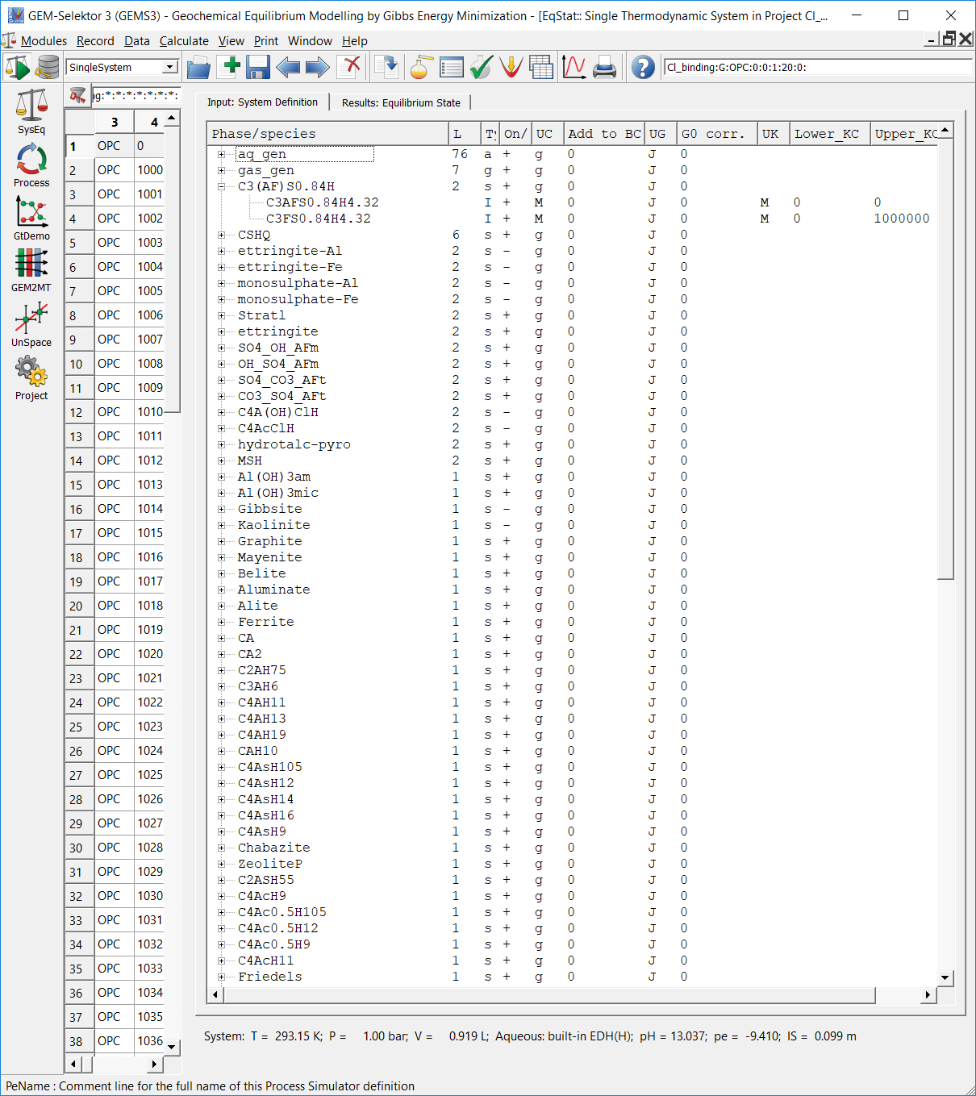

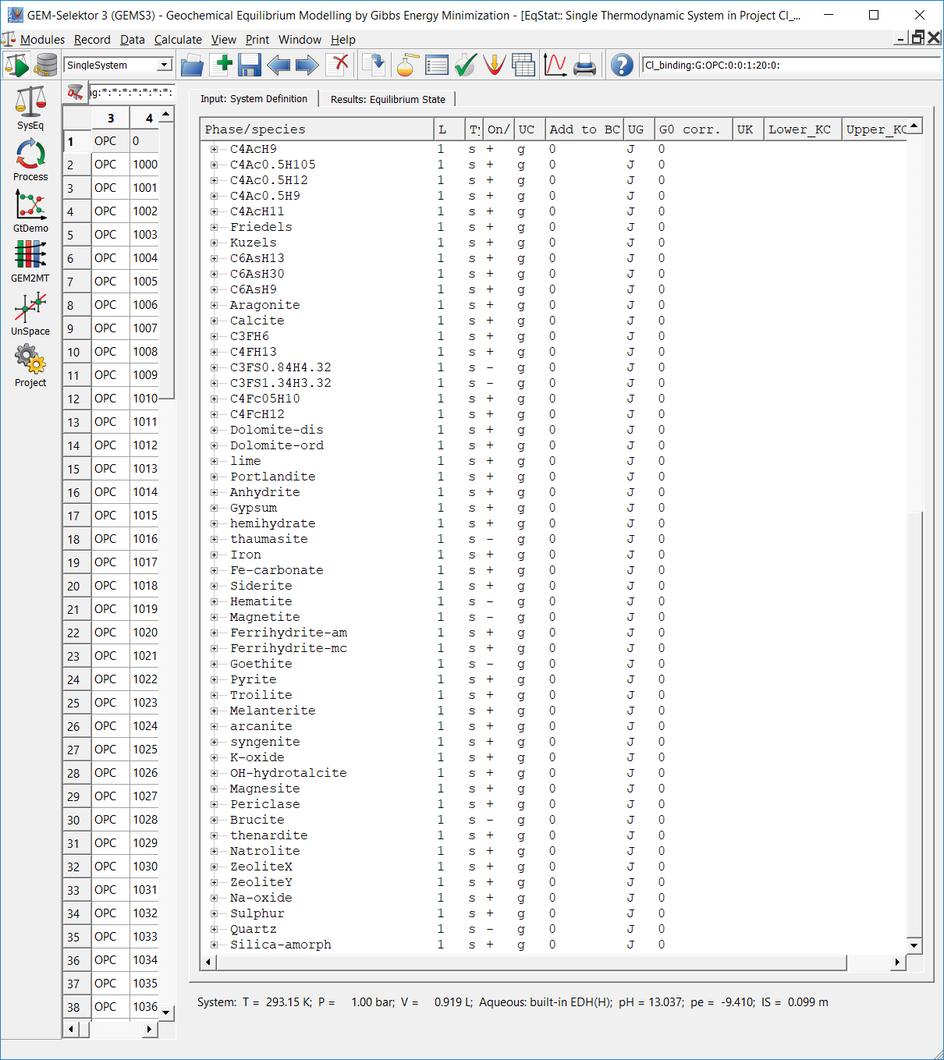

## Setting MgO-content

SEM-images indicate a very low degree of reaction for Mg in the cement paste, and it mostly appears as MgO-particles. To reflect this in the model, a majority of the total Mg-content is locked in MgO. The way this is done is by finding the total molar amount of Mg in the single file: 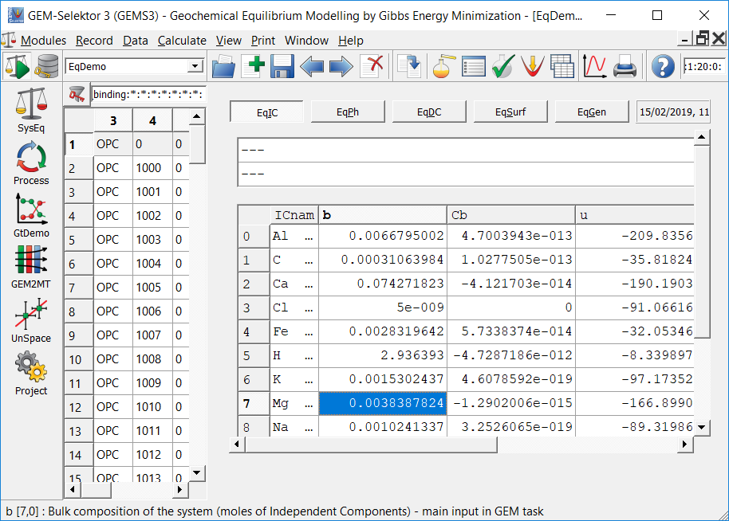

A number lower than the b(Mg)-value is then put into the model (in “dll” under “DComp”) as the required minimum amount of MgO in the system. Inputting the value directly leads to an error in the process as the software is unable to find a convergent calculation of the mass balance.

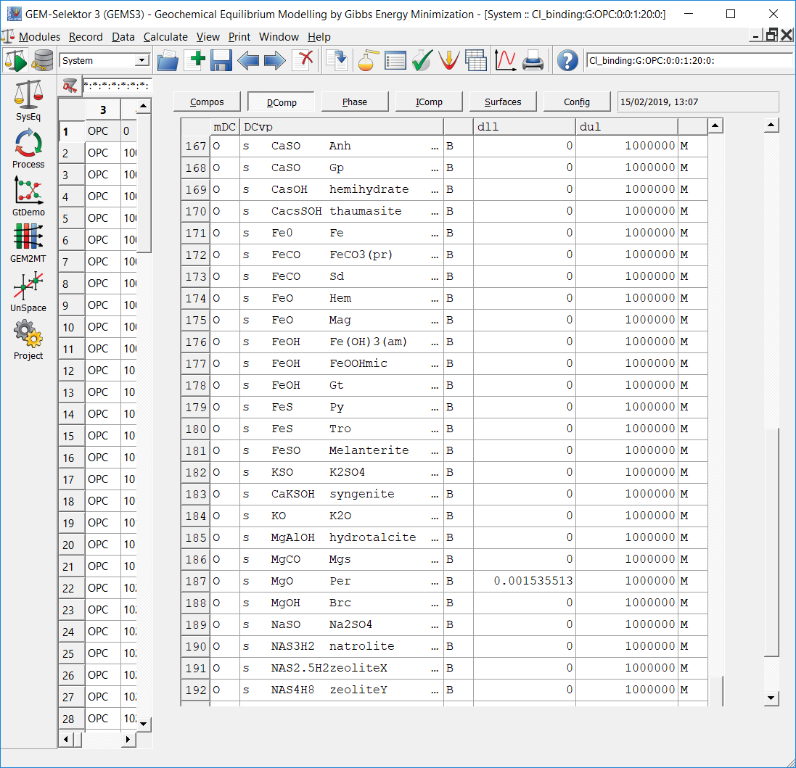

# Process

There are three different processes in the model. “CCR HCl model” models the HCl-exposure samples in our test setup: 15 g wet cement paste exposed to 20 ml 1.5 mol/L NaCl and increasing volumes (0-40 mL) 4 mol/L HCl. “CCR CaCl2 isotherm” and “CCR NaCl isotherm” model the isotherm samples: 15 g wet cement paste exposed to 20 ml CaCl2 or NaCl solutions with Cl-concentrations ranging from 0 to 3.9 mol/L.

The sampling has been merged so that both solid and liquid phase results are in the same model. For the most parts the results are only direct output from the model, meaning that the actual chloride binding has to be calculated elsewhere (i.e. in excel). This will hopefully make the model more flexible.

## Input: “Controls”-code

### CaCl2-model

$Version date: 01.03.2019

$ ------------------------------------------------------------------

$ Linear counter, 40 steps from 0 to 0.039

$ Represents the concentration of the NaCl exposure solution

modC[J][0] =: cNu;

$ ------------------------------------------------------------------

$ Here, the mod[J][1]-column is used to define variables that can

$ be easily changed in the model.

$ This value is the degree of reaction.

modC[1][1] =: 0.7;

$ ------------------------------------------------------------------

$ The simulated samples contain 15 g well-hydrated cement paste.

$ This simulated paste is supposed to model our real paste.

$ The real paste was made with an original w/c-ratio of 0.5,

$ then it was crushed up and an additional 30 wt% water was added.

$ Despite this, TGA experiments show that the paste contains 29 wt% free water

$ and about 15% bound water, for an overall w/c ratio of 0.75.

$ This means the paste has ~ 57 wt% OPC and 43 wt% water

$ Amount of water added in g, 43 wt% of paste is water, 20 ml NaCl added

xa_[{Aqua}] =: 15*0.43+20;

$ ------------------------------------------------------------------

$ Adding Calcite to add carbonates [g]

$ TGA of OPC: 0.2wt% loss of carbonates, so mass of calcite is

$ wtloss*m(CaCO3)/m(CO2)

xa_[{CaCO3}] =: modC[1][1]*0.57*15*0.002*100/44;

$ ------------------------------------------------------------------

$ Amount reactive Portland cement in g

$ 15 g hydrated paste, 57 wt% OPC

$ Using reaction degree, only parts of the paste reacts

$ In sampling, unreacted OPC equal to (1 - Reaction Degree) is added

$ Also subtracting the amount of calcite added for carbonates

xa_[{OPC}] =: modC[1][1]*15*0.57 - modC[1][1]*0.57*15*0.002*100/44;

$ ------------------------------------------------------------------

$ Addition of 20 ml CaCl2 solution of increasing concentrations.

$ Mol of CaCl2 added, increasing concentrations times 20 ml

$ Chloride concentration ranges from 0 to 3.9 mol/L

xa_[{CaCl2}] =: 0.02*cNu*100/2;

$ ------------------------------------------------------------------

$ Al-uptake of CSH:

$ From SEM-EDS, there is roughly 0.05 Al/Si [mol/mol]

xd_[{AlOHam}] =: ((cNu <0.) ? 0 : 0-bXa[{CSHQ}][{Si}]*0.05);

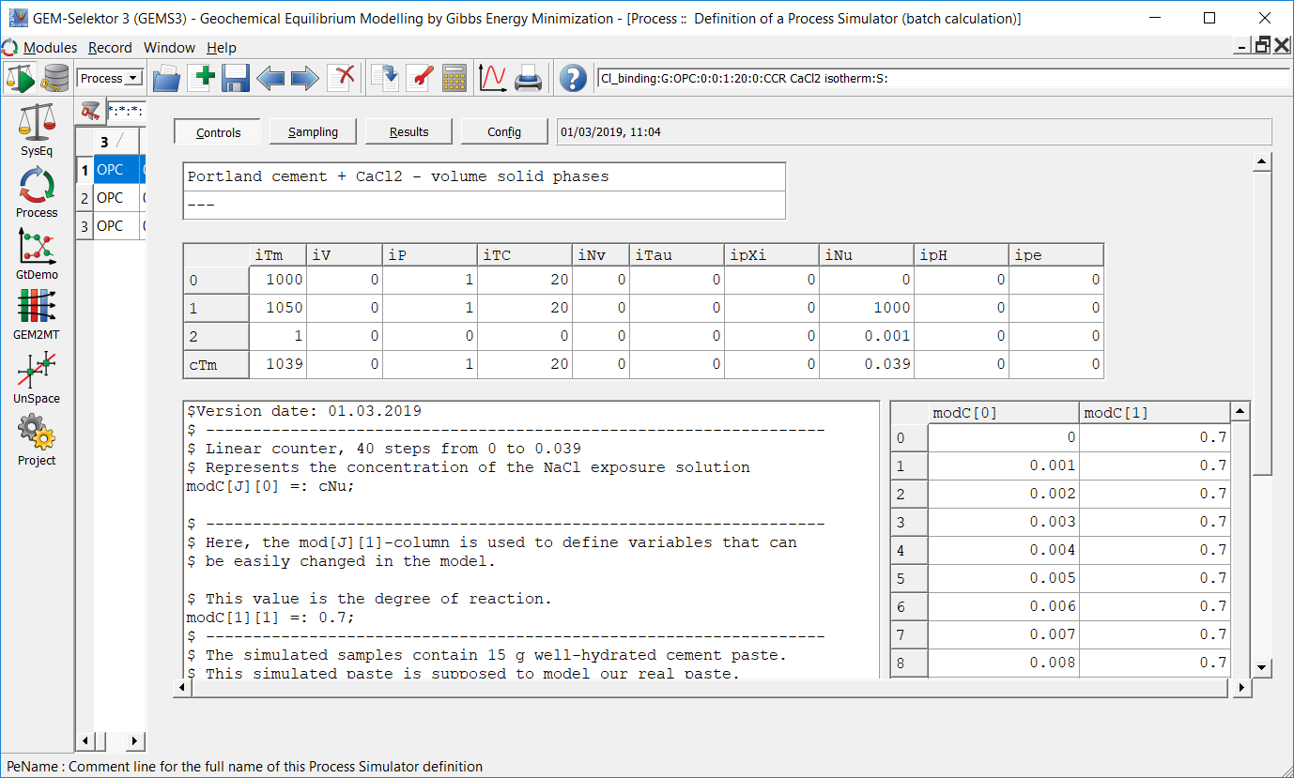

### HCl-model

$Version date: 01.03.2019

$ ------------------------------------------------------------------

$ Linear counter, 40 steps from 0 to 0.039

$ Represents litre of HCl added

modC[J][0] =: cNu;

$ ------------------------------------------------------------------

$ Here, the mod[J][1]-column is used to define variables that can

$ be easily changed in the model.

$ This value is the degree of reaction.

modC[1][1] =: 0.7;

$ ------------------------------------------------------------------

$ The simulated samples contain 15 g well-hydrated cement paste.

$ This simulated paste is supposed to model our real paste.

$ The real paste was made with an original w/c-ratio of 0.5,

$ then it was crushed up and an additional 30 wt% water was added.

$ Despite this, TGA experiments show that the paste contains 29 wt% free water

$ and about 15% bound water, for an overall w/c ratio of 0.75.

$ This means the paste has ~ 57 wt% OPC and 43 wt% water

$ Amount of water added in g, 43 wt% of paste is water, 20 ml NaCl added,

$ + HCl added in litre multiplied by 1000 to get grams of water

xa_[{Aqua}] =: 15*0.43+20+1000*cNu;

$ ------------------------------------------------------------------

$ Adding Calcite to add carbonates [g]

$ TGA of OPC: 0.2wt% loss of carbonates, so mass of calcite is

$ wtloss*m(CaCO3)/m(CO2)

xa_[{CaCO3}] =: modC[1][1]*0.57*15*0.002*100/44;

$ ------------------------------------------------------------------

$ Amount reactive Portland cement in g

$ 15 g hydrated paste, 57 wt% OPC

$ Using reaction degree, only parts of the paste reacts

$ In sampling, unreacted OPC equal to (1 - Reaction Degree) is added

$ Also subtracting the amount of calcite added for carbonates

xa_[{OPC}] =: modC[1][1]*15*0.57 - modC[1][1]*0.57*15*0.002*100/44;

$ ------------------------------------------------------------------

$ The samples are exposed to an NaCl-solution

$ The amount in mol is the concentration (1.5 mol/L) times the volume (20 ml)

xa_[{NaCl}] =: 0.020*1.5;

$ ------------------------------------------------------------------

$ The counter increases the amount of 4 mol/L HCl added

$ Mol of HCl = concentration (mol/L) * volume (L)

xa_[{HCl}] =: 4*cNu;

$ ------------------------------------------------------------------

$ Al-uptake of CSH:

$ From SEM-EDS, there is roughly 0.05Al/Si [mol/mol]

xd_[{AlOHam}] =: ((cNu <0) ? 0 : 0-bXa[{CSHQ}][{Si}]*0.05);

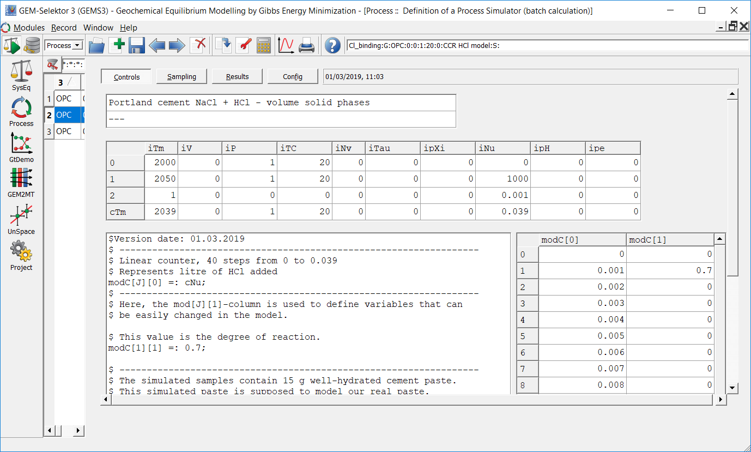

### NaCl-model

$Version date: 01.03.2019

$ ------------------------------------------------------------------

$ Linear counter, 40 steps from 0 to 0.039

$ Represents the concentration of the NaCl exposure solution

modC[J][0] =: cNu;

$ ------------------------------------------------------------------

$ Here, the mod[J][1]-column is used to define variables that can

$ be easily changed in the model.

$ This value is the degree of reaction.

modC[1][1] =: 0.7;

$ ------------------------------------------------------------------

$ The simulated samples contain 15 g well-hydrated cement paste.

$ This simulated paste is supposed to model our real paste.

$ The real paste was made with an original w/c-ratio of 0.5,

$ then it was crushed up and an additional 30 wt% water was added.

$ Despite this, TGA experiments show that the paste contains 29 wt% free water

$ and about 15% bound water, for an overall w/c ratio of 0.75.

$ This means the paste has ~ 57 wt% OPC and 43 wt% water

$ Amount of water added in g, 43 wt% of paste is water, 20 ml NaCl added

xa_[{Aqua}] =: 15*0.43+20;

$ ------------------------------------------------------------------

$ Adding Calcite to add carbonates [g]

$ TGA of OPC: 0.2wt% loss of carbonates, so mass of calcite is

$ wtloss*m(CaCO3)/m(CO2)

xa_[{CaCO3}] =: modC[1][1]*0.57*15*0.002*100/44;

$ ------------------------------------------------------------------

$ Amount reactive Portland cement in g

$ 15 g hydrated paste, 57 wt% OPC

$ Using reaction degree, only parts of the paste reacts

$ In sampling, unreacted OPC equal to (1 - Reaction Degree) is added

$ Also subtracting the amount of calcite added for carbonates

xa_[{OPC}] =: modC[1][1]*15*0.57 - modC[1][1]*0.57*15*0.002*100/44;

$ ------------------------------------------------------------------

$ Addition of 20 ml NaCl solution of increasing concentrations.

$ Mol of NaCl added, increasing concentrations times 20 ml

$ Chloride concentration ranges from 0 to 3.9 mol/L

xa_[{NaCl}] =: 0.02*cNu*100;

$ ------------------------------------------------------------------

$ Al-uptake of CSH:

$ From SEM-EDS, there is roughly 0.05 Al/Si [mol/mol]

xd_[{AlOHam}] =: ((cNu <0) ? 0 : 0-bXa[{CSHQ}][{Si}]*0.05);

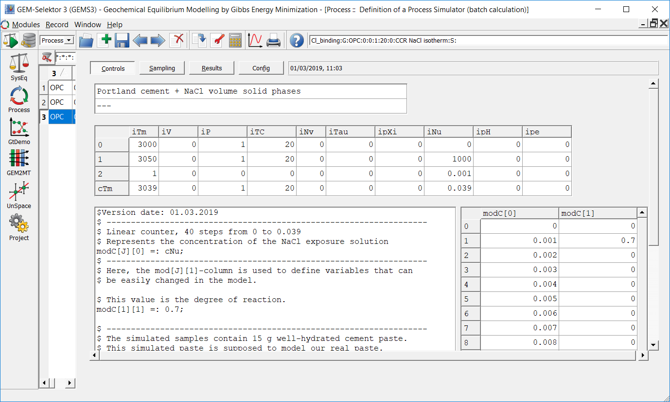

## Output: “Sampling”-code

### Sampling for NaCl and CaCl2

$ Counter for calculation steps:

xp[J] =: J;

$ phVol = volume of phase in cm^3 [cm^3]

$ Xa = amount of phase in the system [mol]

$ bXa = amount of element in a given phase [mol]

$ Unreacted OPC, if required.

$ Mass divided by density to find volume

$ (1-Reaction degree) * 15 g wet paste * 0.57 wt% OPC in wet paste / density of OPC in g/cm3 , + carbonates

yp[J][0] =: (1-modC[1][1])*15*0.57/3.15 + phVol[{Calcite}];

$ ------------------------------------------------------------------

$ Outputs, volumes in [cm^3]

$ CSH, adding volume for Al-uptake (xd is negative, therefore minus)

yp[J][1] =: phVol[{CSHQ}]+phVol[{C3(AF)S0.84H}]-31.956*xd_[{AlOHam}];

$ Portlandite

yp[J][2] =: phVol[{Portlandite}];

$ AFt, sum of the included AFt-phases

yp[J][3] =: phVol[{ettringite}]+phVol[{SO4_CO3_AFt}]+phVol[{CO3_SO4_AFt}];

$Friedel's salt and monocarbonate solid solution

yp[J][4] =: phVol[{Friedels}];

$Ferrihydrate

yp[J][5] =: phVol[{Ferrihydrite-mc}];

$Natrolite

yp[J][6] =: phVol[{Natrolite}];

$Gypsum

yp[J][7] =: phVol[{Gypsum}];

$Amorphous silica

yp[J][8] =: phVol[{Silica-amorph}];

$MSH

yp[J][9] =: phVol[{MSH}];

$Periclase

yp[J][10] =: phVol[{Periclase}];

$Gas volume

yp[J][11] =: phVol[{OH-hydrotalcite}];

$Water

yp[J][12] =: phVol[{aq_gen}];

$ ------------------------------------------------------------------

$ This section details calculation of the amount of portlandite normalized

$ to the dry OPC content

$ Mass of portlandite:

yp[J][13] =: phM[{Portlandite}];

$ Mass of all solid phases combined [g]

yp[J][14] =: yp[J][0]+phM[{CSHQ}]+phM[{C3(AF)S0.84H}]+ phM[{Portlandite}]+phM[{ettringite}]+phM[{SO4_CO3_AFt}]+phM[{CO3_SO4_AFt}] + phM[{Friedels}] + phM[{Ferrihydrite-mc}] + phM[{Natrolite}] + phM[{Gypsum}] + phM[{Silica-amorph}] +phM[{MSH}] + phM[{Periclase}];

$wt% of portlandite normalized to the initial mass of OPC [%]

yp[J][15] =: 100*yp[J][13]/(15*0.57);

$-------------------------------------------------------------------

$ Details for chloride binding calculation

$ Mol of Friedels salt/Monocarbonate solid solution

yp[J][16] =: Xa[{Friedels}];

$ Mol of Cl in Friedel?s salt/Monocarbonate solid solution

$yp[J][17] =: bXa[{C4AcClH }][{Cl}];

$ Total mol Cl in the system

yp[J][18] =: b[{Cl}];

$ Mol Cl in aqueous phase

yp[J][19] =: bXa[{aq_gen}][{Cl}];

$ Chloride binding

yp[J][20] =: 35.45*(yp[J][18] - yp[J][19])/(15*0.71);

$Note that mol Cl in system minus mol Cl in Friedels salt should equal mol Cl in aqueous phase

$-------------------------------------------------------------------

$ General liquid phase information

$pH of liquid phase

yp[J][21] =: pH;

$Mass of water

yp[J][22] =: phM[{aq_gen}];

$ Outputs molar concentrations (mol/L) of elements in the liquid phase

$ Mol of element in water divided by (Volume water in mL * 0.001 litre/mL)

yp[J][23] =: bXa[{aq_gen}][{Al}]/(0.001*phVol[{aq_gen}]);

yp[J][24] =: bXa[{aq_gen}][{C}]/(0.001*phVol[{aq_gen}]);

yp[J][25] =: bXa[{aq_gen}][{Ca}]/(0.001*phVol[{aq_gen}]);

yp[J][26] =: bXa[{aq_gen}][{Cl}]/(0.001*phVol[{aq_gen}]);

yp[J][27] =: bXa[{aq_gen}][{Fe}]/(0.001*phVol[{aq_gen}]);

yp[J][28] =: bXa[{aq_gen}][{H}]/(0.001*phVol[{aq_gen}]);

yp[J][29] =: bXa[{aq_gen}][{K}]/(0.001*phVol[{aq_gen}]);

yp[J][30] =: bXa[{aq_gen}][{Mg}]/(0.001*phVol[{aq_gen}]);

yp[J][31] =: bXa[{aq_gen}][{Na}]/(0.001*phVol[{aq_gen}]);

yp[J][32] =: bXa[{aq_gen}][{Nit}]/(0.001*phVol[{aq_gen}]);

yp[J][33] =: bXa[{aq_gen}][{O}]/(0.001*phVol[{aq_gen}]);

yp[J][34] =: bXa[{aq_gen}][{S}]/(0.001*phVol[{aq_gen}]);

$-------------------------------------------------------------------

$ C-S-H composition for Ca/Si-ratio etc

$ Mol of CSH

yp[J][35] =: Xa[{CSHQ}];

$ Amount of different elements in CSH [total mol]

yp[J][36] =: bXa[{CSHQ}][{Ca}];

yp[J][37] =: bXa[{CSHQ}][{Si}];

yp[J][38] =: bXa[{CSHQ}][{K}];

yp[J][39] =: bXa[{CSHQ}][{Na}];

yp[J][40] =: bXa[{CSHQ}][{H}];

yp[J][41] =: bXa[{CSHQ}][{O}];

yp[J][42] =: bXa[{CSHQ}][{Al}];

$-------------------------------------------------------------------

$ Composition of gas [total mol]

yp[J][43] =: bXa[{gas_gen}][{Ca}];

yp[J][44] =: bXa[{gas_gen}][{Cl}];

yp[J][45] =: bXa[{gas_gen}][{Al}];

yp[J][46] =: bXa[{gas_gen}][{C}];

yp[J][47] =: bXa[{gas_gen}][{O}];

yp[J][48] =: bXa[{gas_gen}][{H}];

$-------------------------------------------------------------------

$ Free water contribution from the cement paste: Any water not added as chloride solution [ml]

yp[J][49] =: yp[J][12] -20;

$ Water released from the paste

yp[J][50] =: yp[J][49] - 15*0.43;

### Sampling for HCl-model

$ Counter for calculation steps:

xp[J] =: J;

$ phVol = volume of phase in cm^3 [cm^3]

$ Xa = amount of phase in the system [mol]

$ bXa = amount of element in a given phase [mol]

$ Unreacted OPC, if required.

$ Mass divided by density to find volume

$ (1-Reaction degree) * 15 g wet paste * 0.57 wt% OPC in wet paste / density of OPC in g/cm3 , + carbonates

yp[J][0] =: (1-modC[1][1])*15*0.57/3.15 + phVol[{Calcite}];

$ ------------------------------------------------------------------

$ Outputs, volumes in [cm^3]

$ CSH, adding volume for Al-uptake (xd is negative, therefore minus)

yp[J][1] =: phVol[{CSHQ}]+phVol[{C3(AF)S0.84H}]-31.956*xd_[{AlOHam}];

$ Portlandite

yp[J][2] =: phVol[{Portlandite}];

$ AFt, sum of the included AFt-phases

yp[J][3] =: phVol[{ettringite}]+phVol[{SO4_CO3_AFt}]+phVol[{CO3_SO4_AFt}];

$Friedel's salt and monocarbonate solid solution

yp[J][4] =: phVol[{Friedels}];

$Ferrihydrate

yp[J][5] =: phVol[{Ferrihydrite-mc}];

$Natrolite

yp[J][6] =: phVol[{Natrolite}];

$Gypsum

yp[J][7] =: phVol[{Gypsum}];

$Amorphous silica

yp[J][8] =: phVol[{Silica-amorph}];

$MSH

yp[J][9] =: phVol[{MSH}];

$MgO

yp[J][10] =: phVol[{Periclase}];

$Gas volume

yp[J][11] =: phVol[{OH-hydrotalcite}];

$Water

yp[J][12] =: phVol[{aq_gen}];

$ ------------------------------------------------------------------

$ This section details calculation of the amount of portlandite normalized

$ to the dry OPC content

$ Mass of portlandite:

yp[J][13] =: phM[{Portlandite}];

$ Mass of all solid phases combined [g]

yp[J][14] =: yp[J][0]+phM[{CSHQ}]+phM[{C3(AF)S0.84H}]+ phM[{Portlandite}]+phM[{ettringite}]+phM[{SO4_CO3_AFt}]+phM[{CO3_SO4_AFt}] + phM[{Friedels}] + phM[{Ferrihydrite-mc}] + phM[{Natrolite}] + phM[{Gypsum}] + phM[{Silica-amorph}] +phM[{MSH}] + phM[{Periclase}];

$wt% of portlandite normalized to the initial mass of OPC [%]

yp[J][15] =: 100*yp[J][13]/(15*0.57);

$-------------------------------------------------------------------

$ Details for chloride binding calculation

$ Mol of Friedels salt/Monocarbonate solid solution

yp[J][16] =: Xa[{Friedels}];

$ Mol of Cl in Friedel?s salt/Monocarbonate solid solution

$yp[J][17] =: bXa[{C4AcClH }][{Cl}];

$ Total mol Cl in the system

yp[J][18] =: b[{Cl}];

$ Mol Cl in aqueous phase

yp[J][19] =: bXa[{aq_gen}][{Cl}];

$ Chloride binding

yp[J][20] =: 35.45*(yp[J][18] - yp[J][19])/(15*0.71);

$Note that mol Cl in system minus mol Cl in Friedels salt should equal mol Cl in aqueous phase

$-------------------------------------------------------------------

$ General liquid phase information

$pH of liquid phase

yp[J][21] =: pH;

$Mass of water

yp[J][22] =: phM[{aq_gen}];

$ Outputs molar concentrations (mol/L) of elements in the liquid phase

$ Mol of element in water divided by (Volume water in mL * 0.001 litre/mL)

yp[J][23] =: bXa[{aq_gen}][{Al}]/(0.001*phVol[{aq_gen}]);

yp[J][24] =: bXa[{aq_gen}][{C}]/(0.001*phVol[{aq_gen}]);

yp[J][25] =: bXa[{aq_gen}][{Ca}]/(0.001*phVol[{aq_gen}]);

yp[J][26] =: bXa[{aq_gen}][{Cl}]/(0.001*phVol[{aq_gen}]);

yp[J][27] =: bXa[{aq_gen}][{Fe}]/(0.001*phVol[{aq_gen}]);

yp[J][28] =: bXa[{aq_gen}][{H}]/(0.001*phVol[{aq_gen}]);

yp[J][29] =: bXa[{aq_gen}][{K}]/(0.001*phVol[{aq_gen}]);

yp[J][30] =: bXa[{aq_gen}][{Mg}]/(0.001*phVol[{aq_gen}]);

yp[J][31] =: bXa[{aq_gen}][{Na}]/(0.001*phVol[{aq_gen}]);

yp[J][32] =: bXa[{aq_gen}][{Nit}]/(0.001*phVol[{aq_gen}]);

yp[J][33] =: bXa[{aq_gen}][{O}]/(0.001*phVol[{aq_gen}]);

yp[J][34] =: bXa[{aq_gen}][{S}]/(0.001*phVol[{aq_gen}]);

$-------------------------------------------------------------------

$ C-S-H composition for Ca/Si-ratio etc

$ Mol of CSH

yp[J][35] =: Xa[{CSHQ}];

$ Amount of different elements in CSH [total mol]

yp[J][36] =: bXa[{CSHQ}][{Ca}];

yp[J][37] =: bXa[{CSHQ}][{Si}];

yp[J][38] =: bXa[{CSHQ}][{K}];

yp[J][39] =: bXa[{CSHQ}][{Na}];

yp[J][40] =: bXa[{CSHQ}][{H}];

yp[J][41] =: bXa[{CSHQ}][{O}];

yp[J][42] =: bXa[{CSHQ}][{Al}];

$-------------------------------------------------------------------

$ Composition of gas [total mol]

yp[J][43] =: bXa[{gas_gen}][{Ca}];

yp[J][44] =: bXa[{gas_gen}][{Cl}];

yp[J][45] =: bXa[{gas_gen}][{Al}];

yp[J][46] =: bXa[{gas_gen}][{C}];

yp[J][47] =: bXa[{gas_gen}][{O}];

yp[J][48] =: bXa[{gas_gen}][{H}];

$-----------------------------------------------------------------------------------------

$ Free water contribution from the cement paste: Any water not added as chloride solution [ml]

yp[J][49] =: yp[J][12] -20-1000*cNu;

$ Water released from the paste

yp[J][50] =: yp[J][49] - 15*0.43;

## Results

### HCl-model

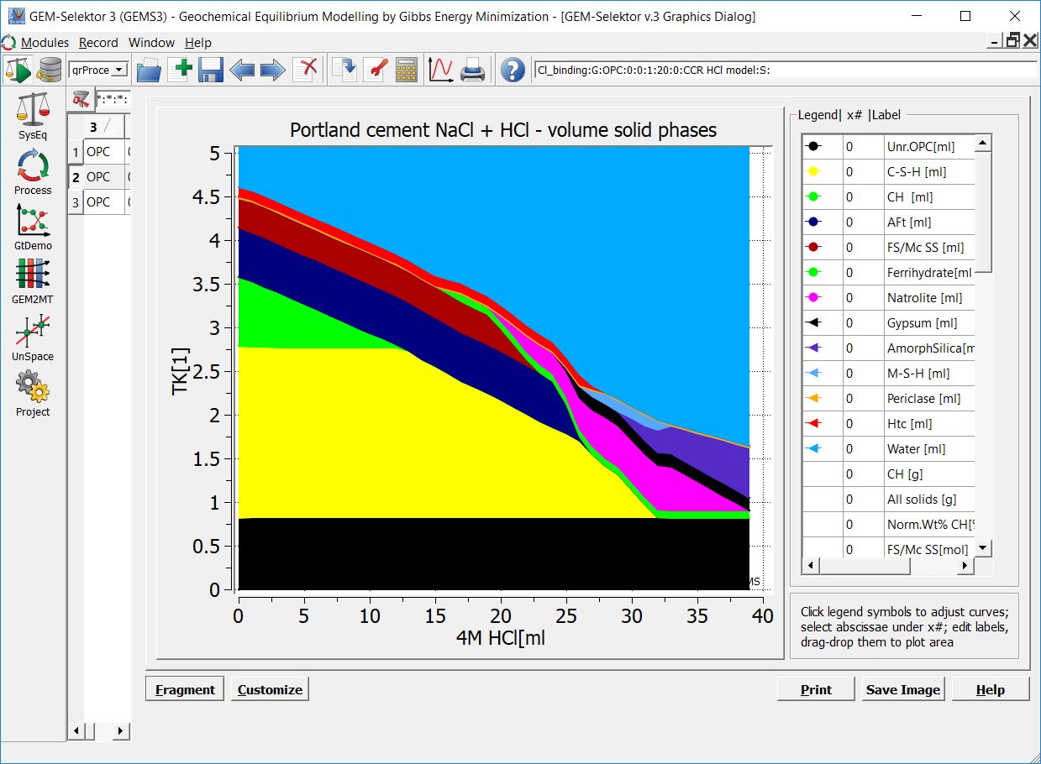

### CaCl2-model

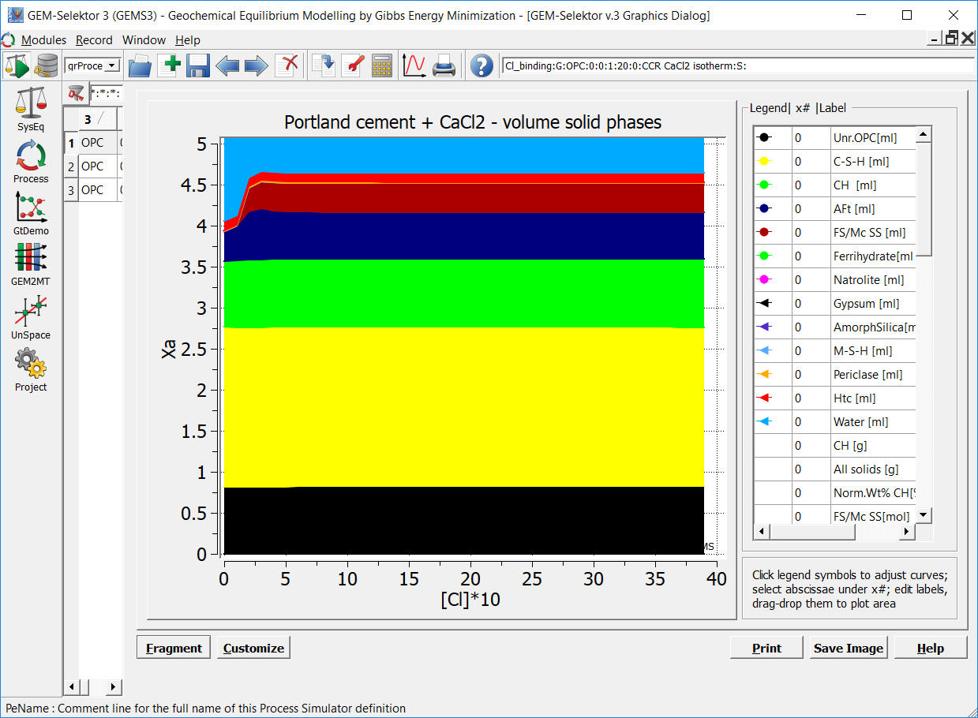

### NaCl-model

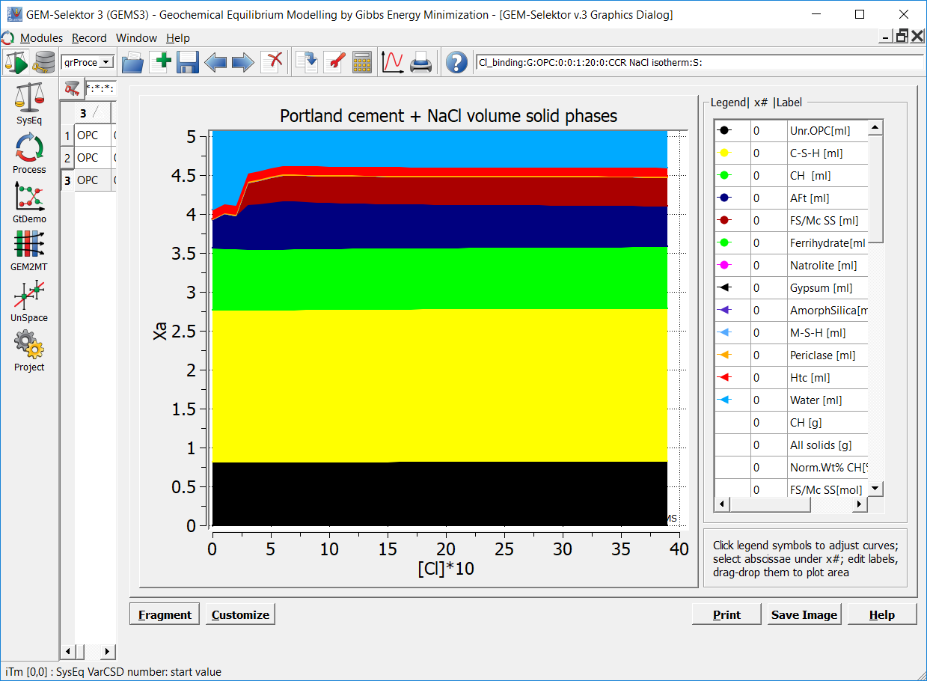

### Chloride binding

Currently the actual chloride binding is calculated in the model sampling code. The following equation is used:

|  |  |
| --- | --- |
|  | 1 |

NCl,bound is the chloride binding in grams chloride per gram cement paste with no free water, MCl is the molar mass of chloride, nCl,tot is the total molar amount of chloride in the model, nCl,aqua is the molar amount of chloride in the liquid phase, and mOPC is the amount of OPC in the model.

These figures show a variety of different experimental data compared to the results of the current model.







