# Supplemental Data

Spatial Analysis, Buffer Analysis Around Metro Stations

**Metro Buffer Analysis: New Buildings**

| Development Characteristics | Total | Buildings Constructed in Half Mile of Metro Station | | Buildings Constructed not within Half Mile of Metro Station | |
| --- | --- | --- | --- | --- | --- |
| Number | % of Total | Number | % of Total |
| Citywide | 26,144 | 1,486 | 6% | 24,658 | 94% |
| Single Family Dwelling | 19,931 | 506 | 3% | 19,425 | 97% |
| Multi-Family Dwelling | 3,972 | 620 | 16% | 3,352 | 84% |
| Commercial | 1,329 | 218 | 16% | 1,111 | 84% |
| Other 1 | 912 | 142 | 16% | 770 | 84% |
| *Note.* Building age data has been obtained from the 2014 Los Angeles County Assessor data for 2014.   1. “Other” includes industrial, institutional, recreational, and miscellaneous buildings. | | | | | |

**Metro Buffer Analysis, ARO Projects**

| Project Characteristics | Total | ARO Projects in Half Mile of Metro Station | | ARO Projects not within Half Mile of Metro Station | |
| --- | --- | --- | --- | --- | --- |
| Number | % of Total Project | Number | % of Total Projects |
| Citywide | 153 | 110 | 72% | 43 | 28% |
| Number of Dwelling Units1 | 13,358 | 10,716 | 80% | 2,642 | 20% |
| Commercial Condominiums | 689 | 670 | 97% | 19 | 3% |
| Square Footage of Commercial Space | 164,853 | 92,853 | 56% | 72,000 | 44% |
| Conversion Date Range 2 | 1999-2014 | 2000-2014 |  | 1999-2013 |  |
| 1. The number of dwelling units, commercial condominiums and square footage of commercial space are approximations made through numbers provided by vesting tentative tract maps, zoning administrator determinations, and building permits. These different forms often had conflicting numbers of units, commercial spaces, and parking spaces.  2. Conversion date ranges from the date of the zoning administrator’s approval to the date when the permit was issued. | | | | | |

**Metro Buffer Analysis, Community Plan Areas**

|  |  |
| --- | --- |
| Central City (1/2 Mile from Pershing Square, Civic Center, Little Tokyo/Arts District, Metro Center, Pico, Grand Metro Stations) | |
| Number of ARO Projects | 81 |
| Number of Dwelling Units | 8,928 |
| Square Footage of Commercial Space | 55,352 square feet of commercial/retail space |
| Number of Commercial Condominiums | 643 |
| Conversion Date Range | 1999-2014 |
| Hollywood (1/2 Mile from Hollywood/Highland, Hollywood/Vine Metro Stations) | |
| Number of ARO Projects | 10 |
| Number of Dwelling Units | 506 |
| Square Footage of Commercial Space | 10,000 square feet of commercial/retail space |
| Number of Commercial Condominiums | 21 |
| Conversion Date Range | 2003-2014 |
| North Hollywood (1/2 Mile from North Hollywood Metro Station) | |
| Number of ARO Projects | 1 |
| Number of Dwelling Units | 5 |
| Square Footage of Commercial Space | 0 |
| Number of Commercial Condominiums | 0 |
| Conversion Date | Date not available |
| Northeast (1/2 Mile from Lincoln Heights/Cypress Park Station) | |
| Number of ARO Projects | 3 |
| Number of Dwelling Units | 138 |
| Square Footage of Commercial Space | Data not available |
| Number of Commercial Condominiums | 6 |
| Conversion Date | 2003-2006 |
| Wilshire (1/2 Mile from Wilshire / Western & Wilshire / Normandie & Wilshire / Vermont Metro Stations) | |
| Number of ARO Projects | 4 |
| Number of Dwelling Units | 388 |
| Square Footage of Commercial Space | 27,500 square feet |
| Number of Commercial Condominiums | Data not available |
| Conversion Date | 2005-2006 |
| Westlake (1/2 Mile from Metro Center Metro Station) | |
| Number of ARO Projects | 2 |
| Number of Dwelling Units | 455 |
| Square Footage of Commercial Space | Data not available |
| Number of Commercial Condominiums | Data not available |
| Conversion Date | 2005-2007 |
| Central City North (1/2 Mile from Chinatown, Union, Little Tokyo/Arts District, Pico/Aliso Metro Stations) | |
| Number of ARO Projects | 7 |
| Number of Dwelling Units | 195 |
| Square Footage of Commercial Space | Data not available |
| Number of Commercial Condominiums | Data not available |
| Conversion Date | 2004-2012 |

**ARO Projects Compared to Buildings Constructed Between 1999 and 2013, Central City Area**

| Development Category | Total | Half Mile of Metro Station | | Not within Half Mile of Metro Station | |
| --- | --- | --- | --- | --- | --- |
| Number | % of Total Projects/Buildings | Number | % of Total Projects/Buildings |
| Buildings 1999 - 2013 | 128 | 74 | 6% | 54 | 94% |
| ARO Projects | 86 | 80 | 93% | 6 | 7% |
| Ratio of New Buildings to ARO Projects | 1.5:1 | 1:1 |  | 9:1 |  |

**Spatial Distribution of ARO Projects (ARO Incentive Areas)**

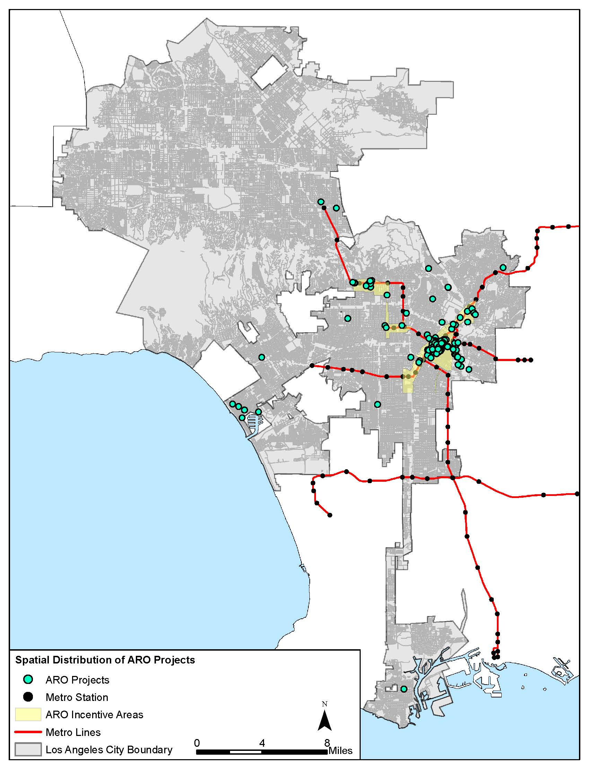

**Spatial Distribution of ARO Projects (Community Plan Areas)**

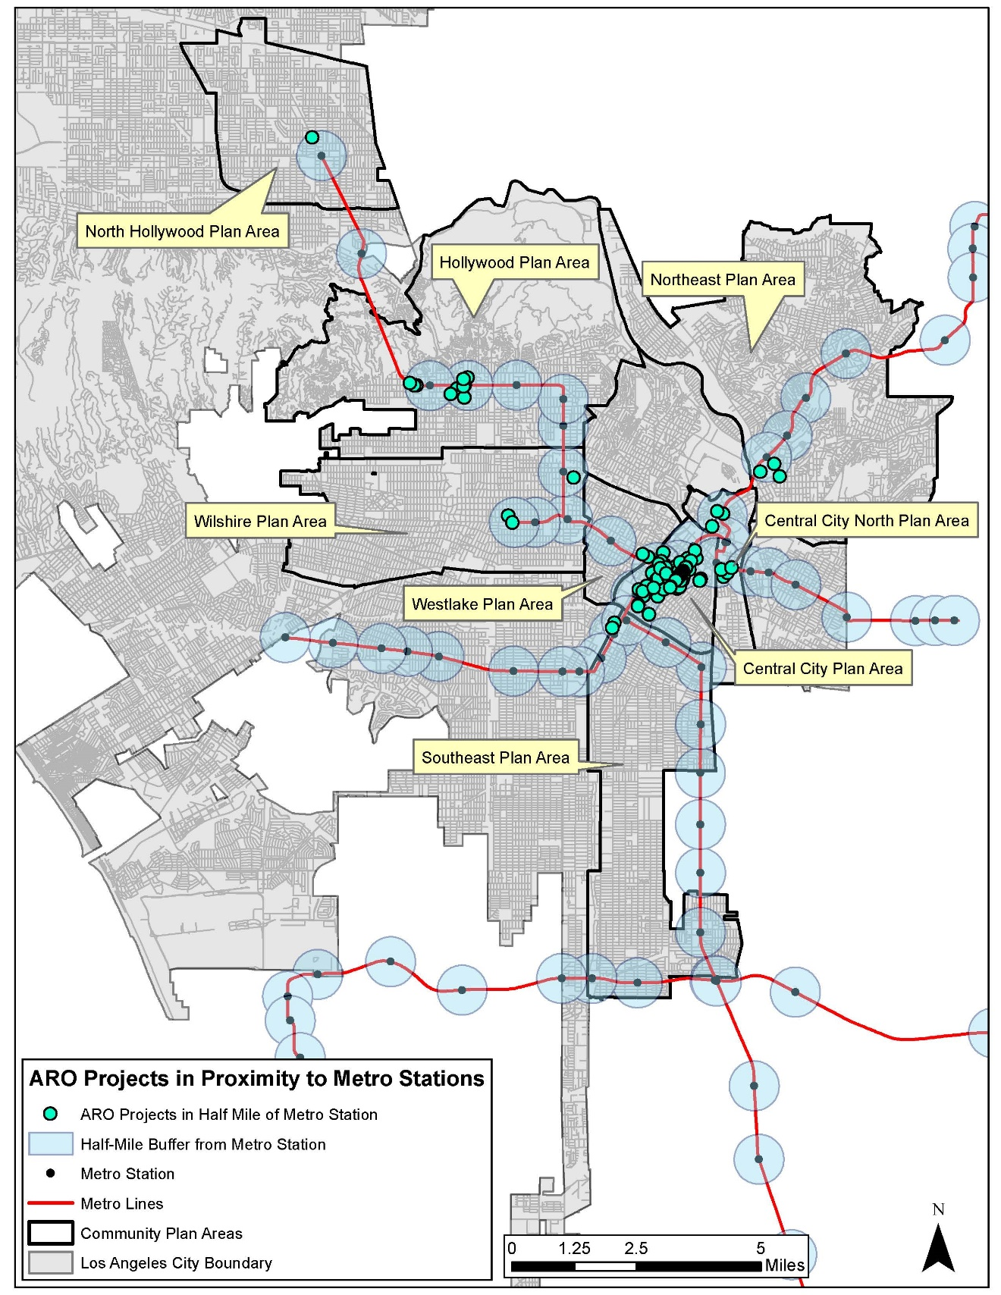

Buffer Analysis Around Metro Stations (Permit Data)

**Metro Buffer Analysis - New Building Permits (January 2013 – January 2015)**

| Development Characteristics | Total | New Development Permitted in Half Mile of Metro Station | | New Development Permitted Not Within Half Mile of Metro Station | |
| --- | --- | --- | --- | --- | --- |
| Number | % of Total Permits | Number | % of Total Permits |
| Citywide | 5,778 | 279 | 5.26% | 5,509 | 94.73% |
| 1 or 2 Family Dwelling | 4,755 | 159 | 4.83% | 4,596 | 95.34% |
| Apartment | 439 | 36 | 2.75% | 403 | 79.54% |
| Commercial | 594 | 84 | 0.62% | 510 | 6.97% |
| Central City | 35 | 27 | 1.45% | 8 | 8.83% |
| Central City North | 22 | 5 | 0.00% | 17 | 0.00% |
| Hollywood | 297 | 33 | 0.47% | 264 | 0.14% |
| North Hollywood | 135 | 3 | 0.09% | 132 | 0.29% |
| Northeast | 184 | 9 | 0.57% | 175 | 4.57% |
| Wilshire | 312 | 22 | 0.05% | 290 | 2.28% |
| Westlake | 15 | 5 | 0.16% | 10 | 3.03% |
| Southeast | 431 | 99 | 0.38% | 332 | 5.02% |
| *Note.* New construction permit data has been obtained from the DataLA, the open data portal for the City of Los Angeles (https://data.lacity.org/). This dataset only includes building permits from January 2013 to January 2015. Earlier permit data is available from 2001 to 2014 through Plan Check and Inspection Disks, inspection from the Department of Building and Safety (DBS). These disks only include monthly permit data, they cost $11 each and they must be purchased in person from the DBS office in Los Angeles. Earlier permit data (prior to 2001) must be viewed on microfilm at the DBS office. | | | | | |

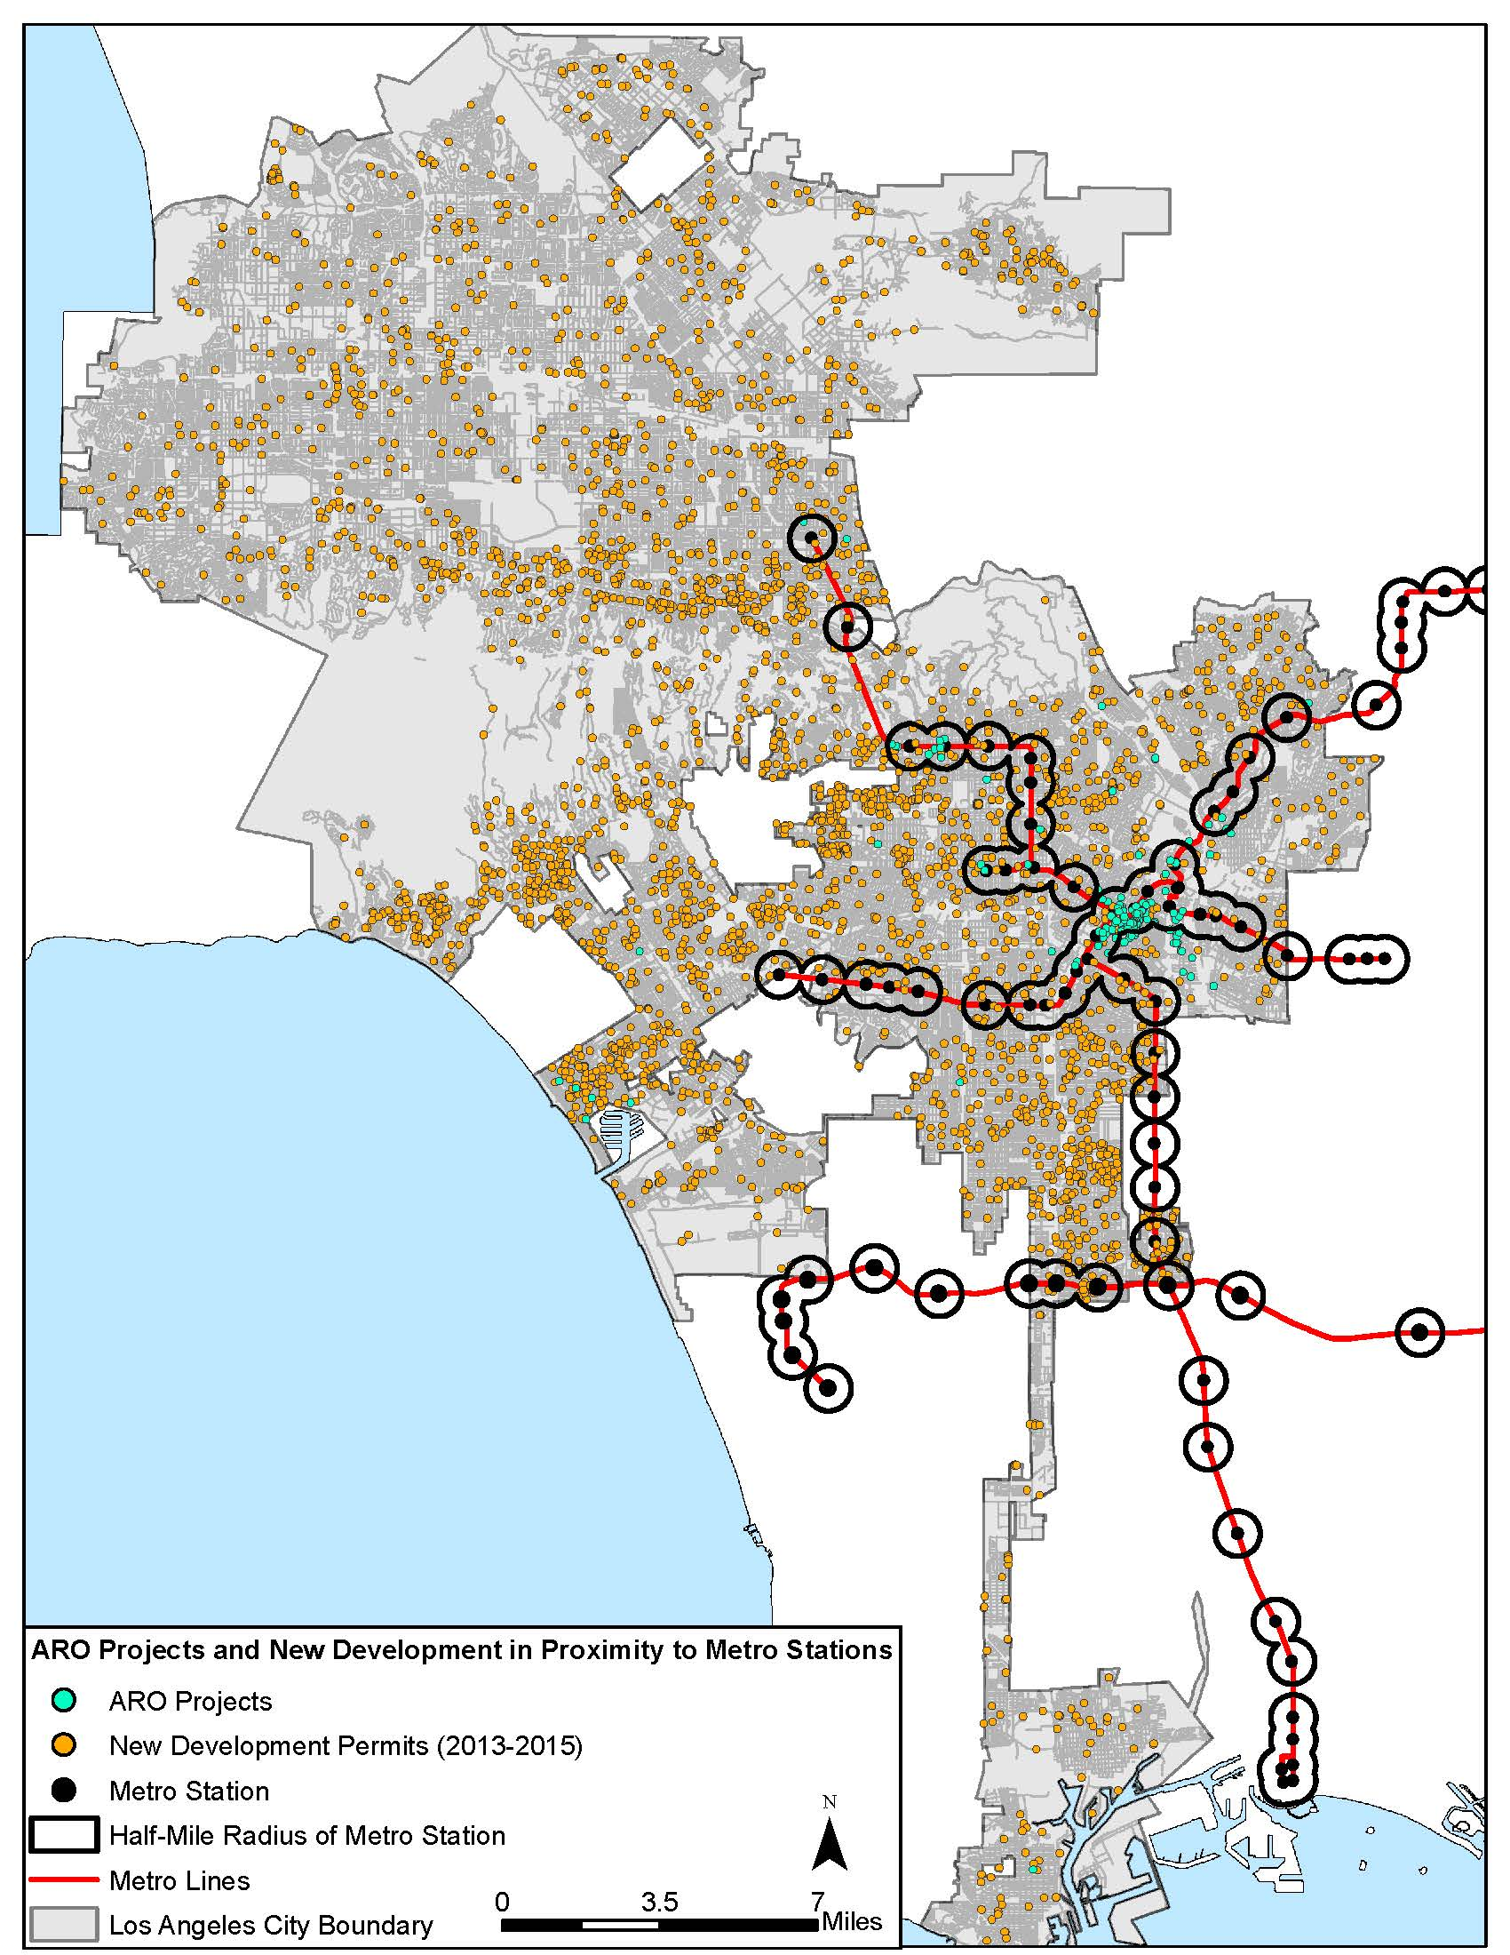**ARO Projects and New Development Permits**

**New Development Permits in Proximity to Transit**

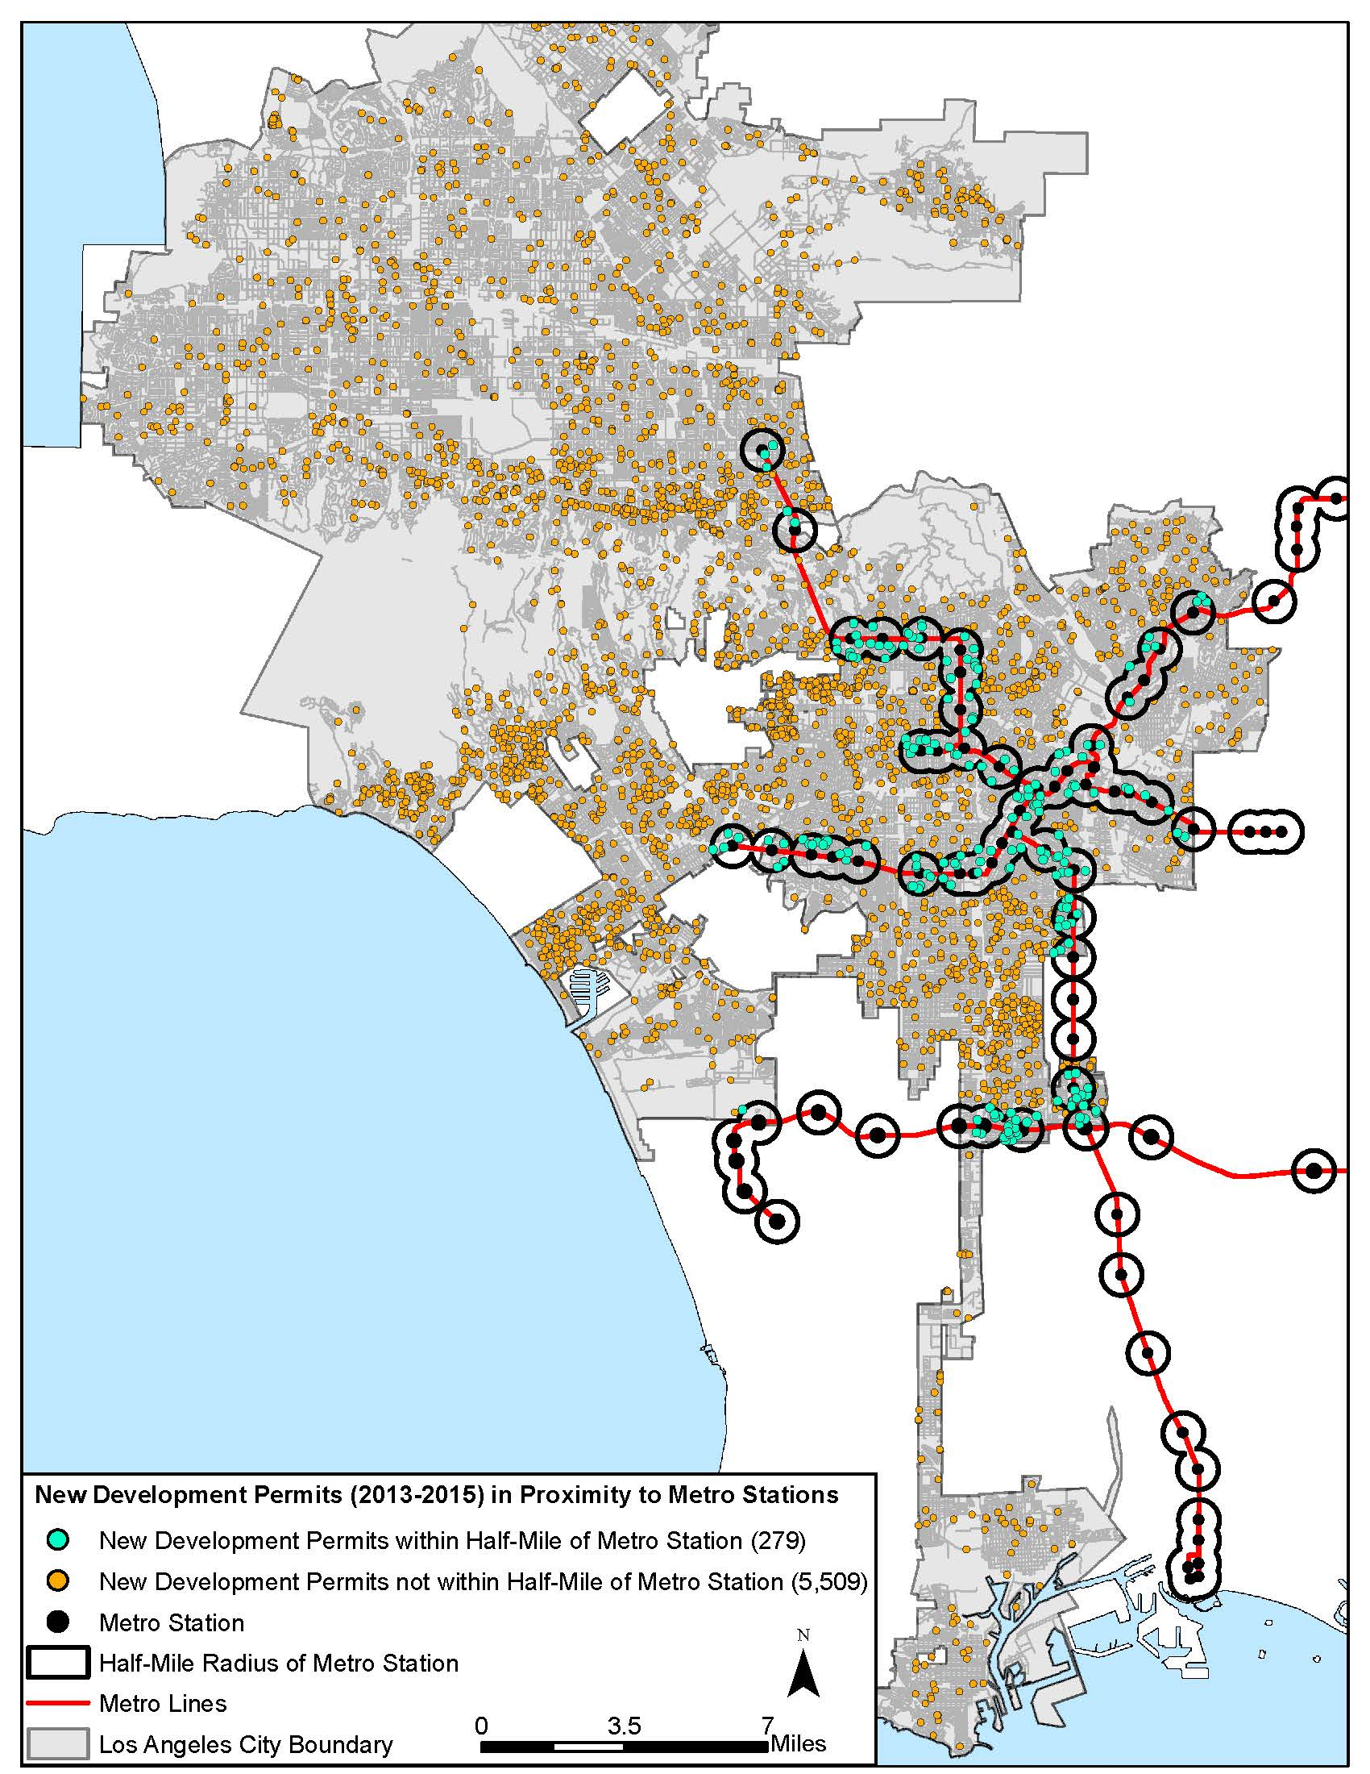

**ARO Projects compared to New Development Permits**

| Development Category | Total | Half Mile of Metro Station | | Not within Half Mile of Metro Station | |
| --- | --- | --- | --- | --- | --- |
| Number | % of Total Projects/Permits | Number | % of Total Projects/Permits |
| New Development Permits | 5,778 | 279 | 5% | 5,509 | 95% |
| ARO Projects | 153 | 110 | 72% | 43 | 28% |
| Ratio of New Development Permits to ARO Projects | 38:1 | 3:1 |  | 128:1 |  |

ARO Projects in High Quality Transit Areas (HQTA) and Transit Priority Areas (TPA)

**ARO Projects in HQTAs and TPAs**

| Project Characteristics | Total | ARO Projects Inside SCAG Transit Priority Areas & HQTAs | | ARO Projects Only Inside SCAG HQTAs | | ARO Projects Outside SCAG Transit Priority Areas & HQTAs | | |
| --- | --- | --- | --- | --- | --- | --- | --- | --- |
| Number | % of Total Projects | Number | % of Total Projects | Number | % of Total Projects | |
| Citywide | 153 | 145 | 95% | 7 | 5% | 1 | 1% | |
| Number of Dwelling Units1 | 13,358 | 13,145 | 98% | 213 | 2% | Data Not Available | Data Not Available | |
| Commercial Condominiums | 689 | 689 | 100% | Data Not Available | Data Not Available | Data Not Available | Data Not Available | |
| Square Footage of Commercial Space | 164,853 | 164,853 | 100% | Data Not Available | 0% | Data Not Available | Data Not Available | |
| Conversion Date Range 2 | 1999-2014 | 1999-2014 |  | 2003-2007 |  | 2005-2006 |  | |
| 1. The number of dwelling units, commercial condominiums and square footage of commercial space are approximations made through numbers provided by vesting tentative tract maps, zoning administrator determinations, and building permits. These different forms often had conflicting numbers of units, commercial spaces, and parking spaces.  2. Conversion date ranges from the date of the zoning administrator’s approval to the date when the permit was issued. | | | | | | | |

**New Development Permits (2013 – 2015) in HQTAs and TPAs**

| Development Characteristics | Total | New Development Permitted Inside SCAG HQTAs | | New Development Permitted Outside SCAG HQTAs | |
| --- | --- | --- | --- | --- | --- |
| Number | % of Total Permits | Number | % of Total Permits |
| Citywide | 5,778 | 4,922 | 85% | 866 | 15% |
| 1 or 2 Family Dwelling | 4,755 | 4,004 | 84% | 751 | 19% |
| Apartment | 439 | 411 | 94% | 28 | 7% |
| Commercial | 594 | 507 | 85% | 87 | 17% |
| *Note.* New construction permit data has been obtained from the DataLA, the open data portal for the City of Los Angeles (https://data.lacity.org/). This dataset only includes building permits from January 2013 to January 2015. Earlier permit data is available from 2001 to 2014 through Plan Check and Inspection Disks, inspection from the Department of Building and Safety (DBS). These disks only include monthly permit data, they cost $11 each and they must be purchased in person from the DBS office in Los Angeles. Earlier permit data (prior to 2001) must be viewed on microfilm at the DBS office. | | | | | |

**HQTAs - ARO Projects compared to New Development Permits**

| Development Category | Total | Inside SCAG HQTAs | | Outside SCAG HQTAs | |
| --- | --- | --- | --- | --- | --- |
| Number | % of Total Projects/Permits | Number | % of Total of Projects/Permits |
| New Development Permits | 5,778 | 4,922 | 85% | 866 | 15% |
| ARO Projects | 153 | 152 | 72% | 1 | .01% |
| Ratio of New Development Permits to ARO Projects | 38:1 | 32:1 |  | 866:1 |  |

**ARO Projects in HQTAs and TPAs**

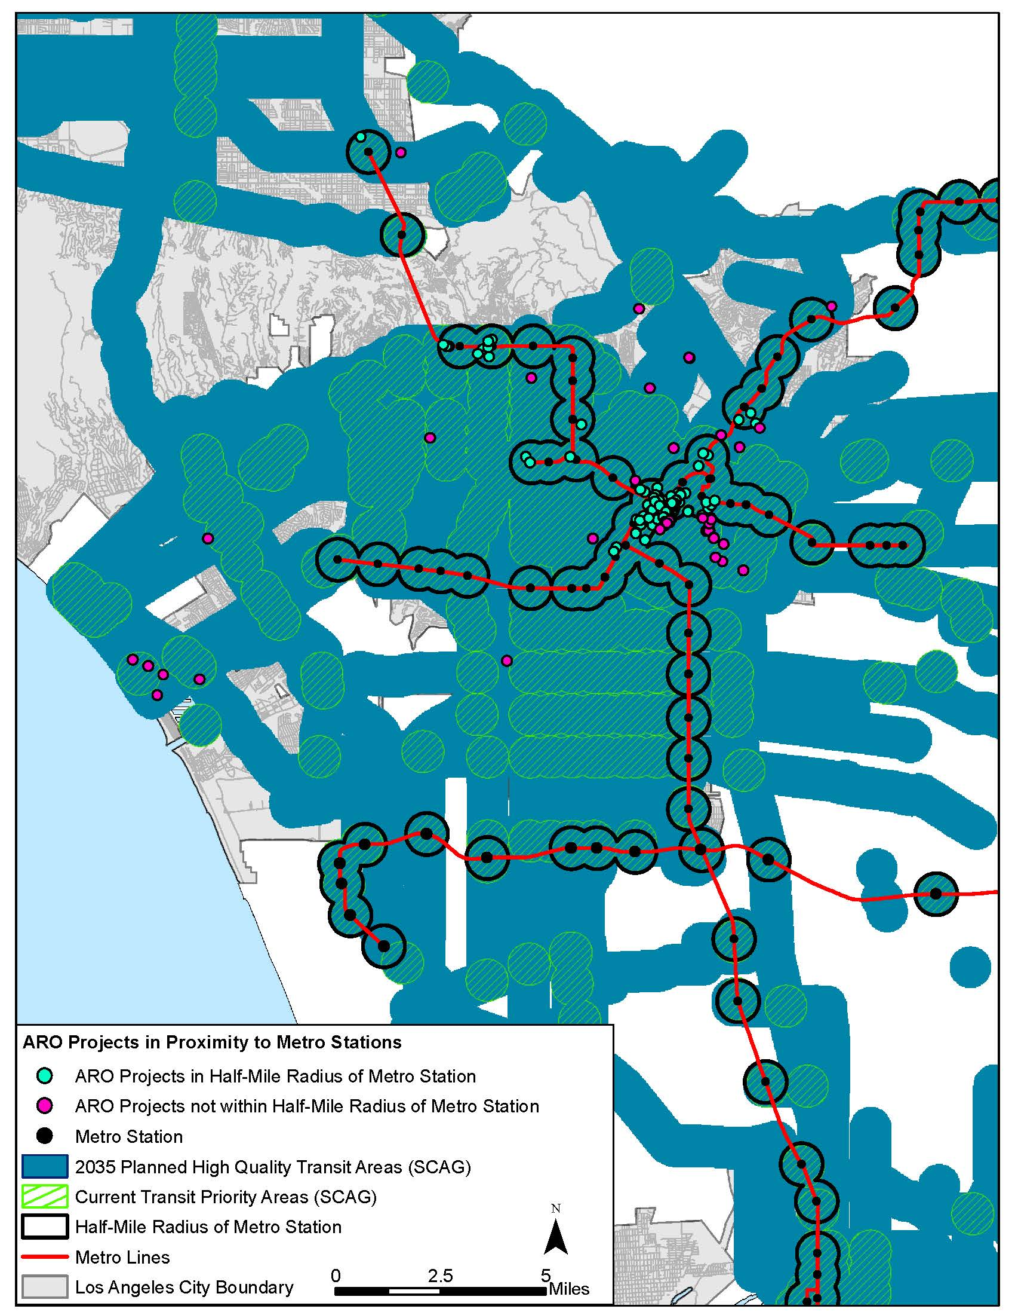

* 1. **ARO Projects Located in Higher-Intensity Land Use Districts**

**ARO Projects Regional Inside Regional Land Use Centers**

| Project Characteristics | Total | ARO Projects inside Selected Region Land Use Centers | | ARO Projects not inside Selected Regional Land Use Centers | |
| --- | --- | --- | --- | --- | --- |
| Number | % of Total Projects | Number | % of Total Projects |
| Citywide | 153 | 72 | 47% | 43 | 53% |
| Number of Dwelling Units1 | 13,296 | 7,635 | 57% | 5,661 | 43% |
| Commercial Condominiums or Units | 689 | 644 | 93% | 45 | 7% |
| Square Footage of Commercial Space | 164,853 | 91,646 | 56% | 73,207 | 44% |
| Conversion Date Range2 | 1999-2014 | 1999-2014 |  | 1999-2014 |  |
| 1. The number of dwelling units, commercial condominiums and square footage of commercial space are approximations made through numbers provided by vesting tentative tract maps, zoning administrator determinations, and building permits. These different forms often had conflicting numbers of units, commercial spaces, and parking spaces.  2. Conversion date ranges from the date of the zoning administrator’s approval to the date when the permit was issued. | | | | | |

**New Development Permits (2013-2015) Inside Regional Land Use Centers**

| Development Characteristics | Total | New Development Permitted Inside Selected Regional Land Use Centers | | New Development Permitted Outside Selected Regional Land Use Centers | |
| --- | --- | --- | --- | --- | --- |
| Number | % of Total Permits | Number | % of Total Permits |
| Citywide | 5,778 | 33 | 1% | 5,745 | 99% |
| 1 or 2 Family Dwelling | 4,755 | 0 | 0% | 4,755 | 100% |
| Apartment | 439 | 14 | 3% | 425 | 97% |
| Commercial | 594 | 19 | 3% | 575 | 97% |
| *Note.* New construction permit data has been obtained from the DataLA, the open data portal for the City of Los Angeles (https://data.lacity.org/). This dataset only includes building permits from January 2013 to January 2015. Earlier permit data is available from 2001 to 2014 through Plan Check and Inspection Disks, inspection from the Department of Building and Safety (DBS). These disks only include monthly permit data, they cost $11 each and they must be purchased in person from the DBS office in Los Angeles. Earlier permit data (prior to 2001) must be viewed on microfilm at the DBS office. | | | | | |

**Regional Land Use Centers - ARO Projects Compared to New Development Permits**

| Development Category | Total | Inside Selected Regional Land Use Centers | | Outside Selected Regional Land Use Centers | |
| --- | --- | --- | --- | --- | --- |
| Number | % of Total Projects/Permits | Number | % of Total of Projects/Permits |
| New Development Permits | 5,778 | 33 | 1% | 5,745 | 99% |
| ARO Projects | 153 | 72 | 47% | 43 | 53% |
| Ratio of New Development Permits to ARO Projects | 38:1 | .46:1 |  | 134:1 |  |

**ARO Projects Inside Community Land Use Centers**

| Project Characteristics | Total | ARO Projects Inside Selected Community Land Use Centers | | ARO Projects Not Inside Selected Community Land Use Centers | |
| --- | --- | --- | --- | --- | --- |
| Number | % of Total Projects | Number | % of Total Projects |
| Citywide | 153 | 12 | 8% | 141 | 92% |
| Number of Dwelling Units1 | 13,296 | 1,233 | 9% | 12,063 | 91% |
| Commercial Condominiums or Units | 689 | 12 | 2% | 677 | 98% |
| Square Footage of Commercial Space | 164,853 | Data Not Available | 0% | 164,853 | 100% |
| Conversion Date Range 2 | 1999-2014 | 2000-2007 |  | 1999-2014 |  |
| 1. The number of dwelling units, commercial condominiums and square footage of commercial space are approximations made through numbers provided by vesting tentative tract maps, zoning administrator determinations, and building permits. These different forms often had conflicting numbers of units, commercial spaces, and parking spaces.  2. Conversion date ranges from the date of the zoning administrator’s approval to the date when the permit was issued. | | | | | |

**New Development Permits (2013-2015) Inside Community Land Use Centers**

| Development Characteristics | Total | New Development Permitted Inside Selected Community Land Use Centers | | New Development Permitted Outside Selected Community Land Use Centers | |
| --- | --- | --- | --- | --- | --- |
| Number | % of Total Permits | Number | % of Total Permits |
| Citywide | 5,778 | 17 | .3% | 5,761 | 99.7% |
| 1 or 2 Family Dwelling | 4,755 | 5 | .1% | 4,750 | 99.9% |
| Apartment | 439 | 3 | .7% | 425 | 99.3% |
| Commercial | 594 | 9 | 1.5% | 575 | 98.5% |
| *Note.* New construction permit data has been obtained from the DataLA, the open data portal for the City of Los Angeles (https://data.lacity.org/). This dataset only includes building permits from January 2013 to January 2015. Earlier permit data is available from 2001 to 2014 through Plan Check and Inspection Disks, inspection from the Department of Building and Safety (DBS). These disks only include monthly permit data, they cost $11 each and they must be purchased in person from the DBS office in Los Angeles. Earlier permit data (prior to 2001) must be viewed on microfilm at the DBS office. | | | | | |

**Community Land Use Centers, ARO Projects Compared to New Development Permits**

| Development Category | Total | Inside Community Land Use Centers | | Outside Community Land Use Centers | |
| --- | --- | --- | --- | --- | --- |
| Number | % of Total Projects/Permits | Number | % of Total of Projects/Permits |
| New Development Permits | 5,778 | 17 | .3% | 5,761 | 99.7% |
| ARO Projects | 153 | 12 | 8% | 141 | 92% |
| Ratio of New Development Permits to ARO Projects | 38:1 | 1.4:1 |  | 41:1 |  |

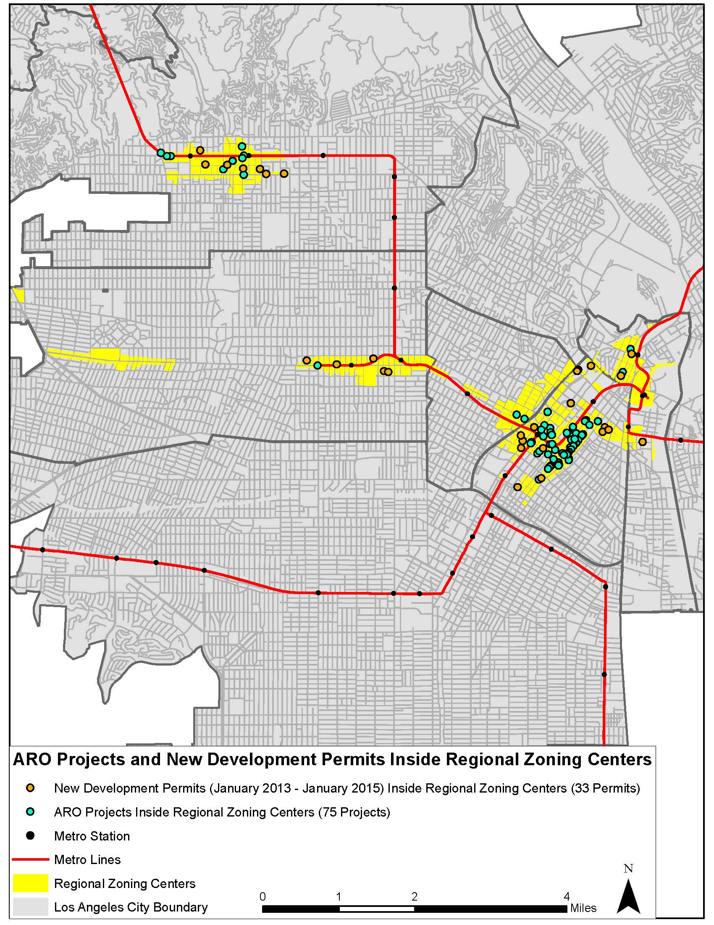**ARO Projects and New Development Inside Regional Centers**

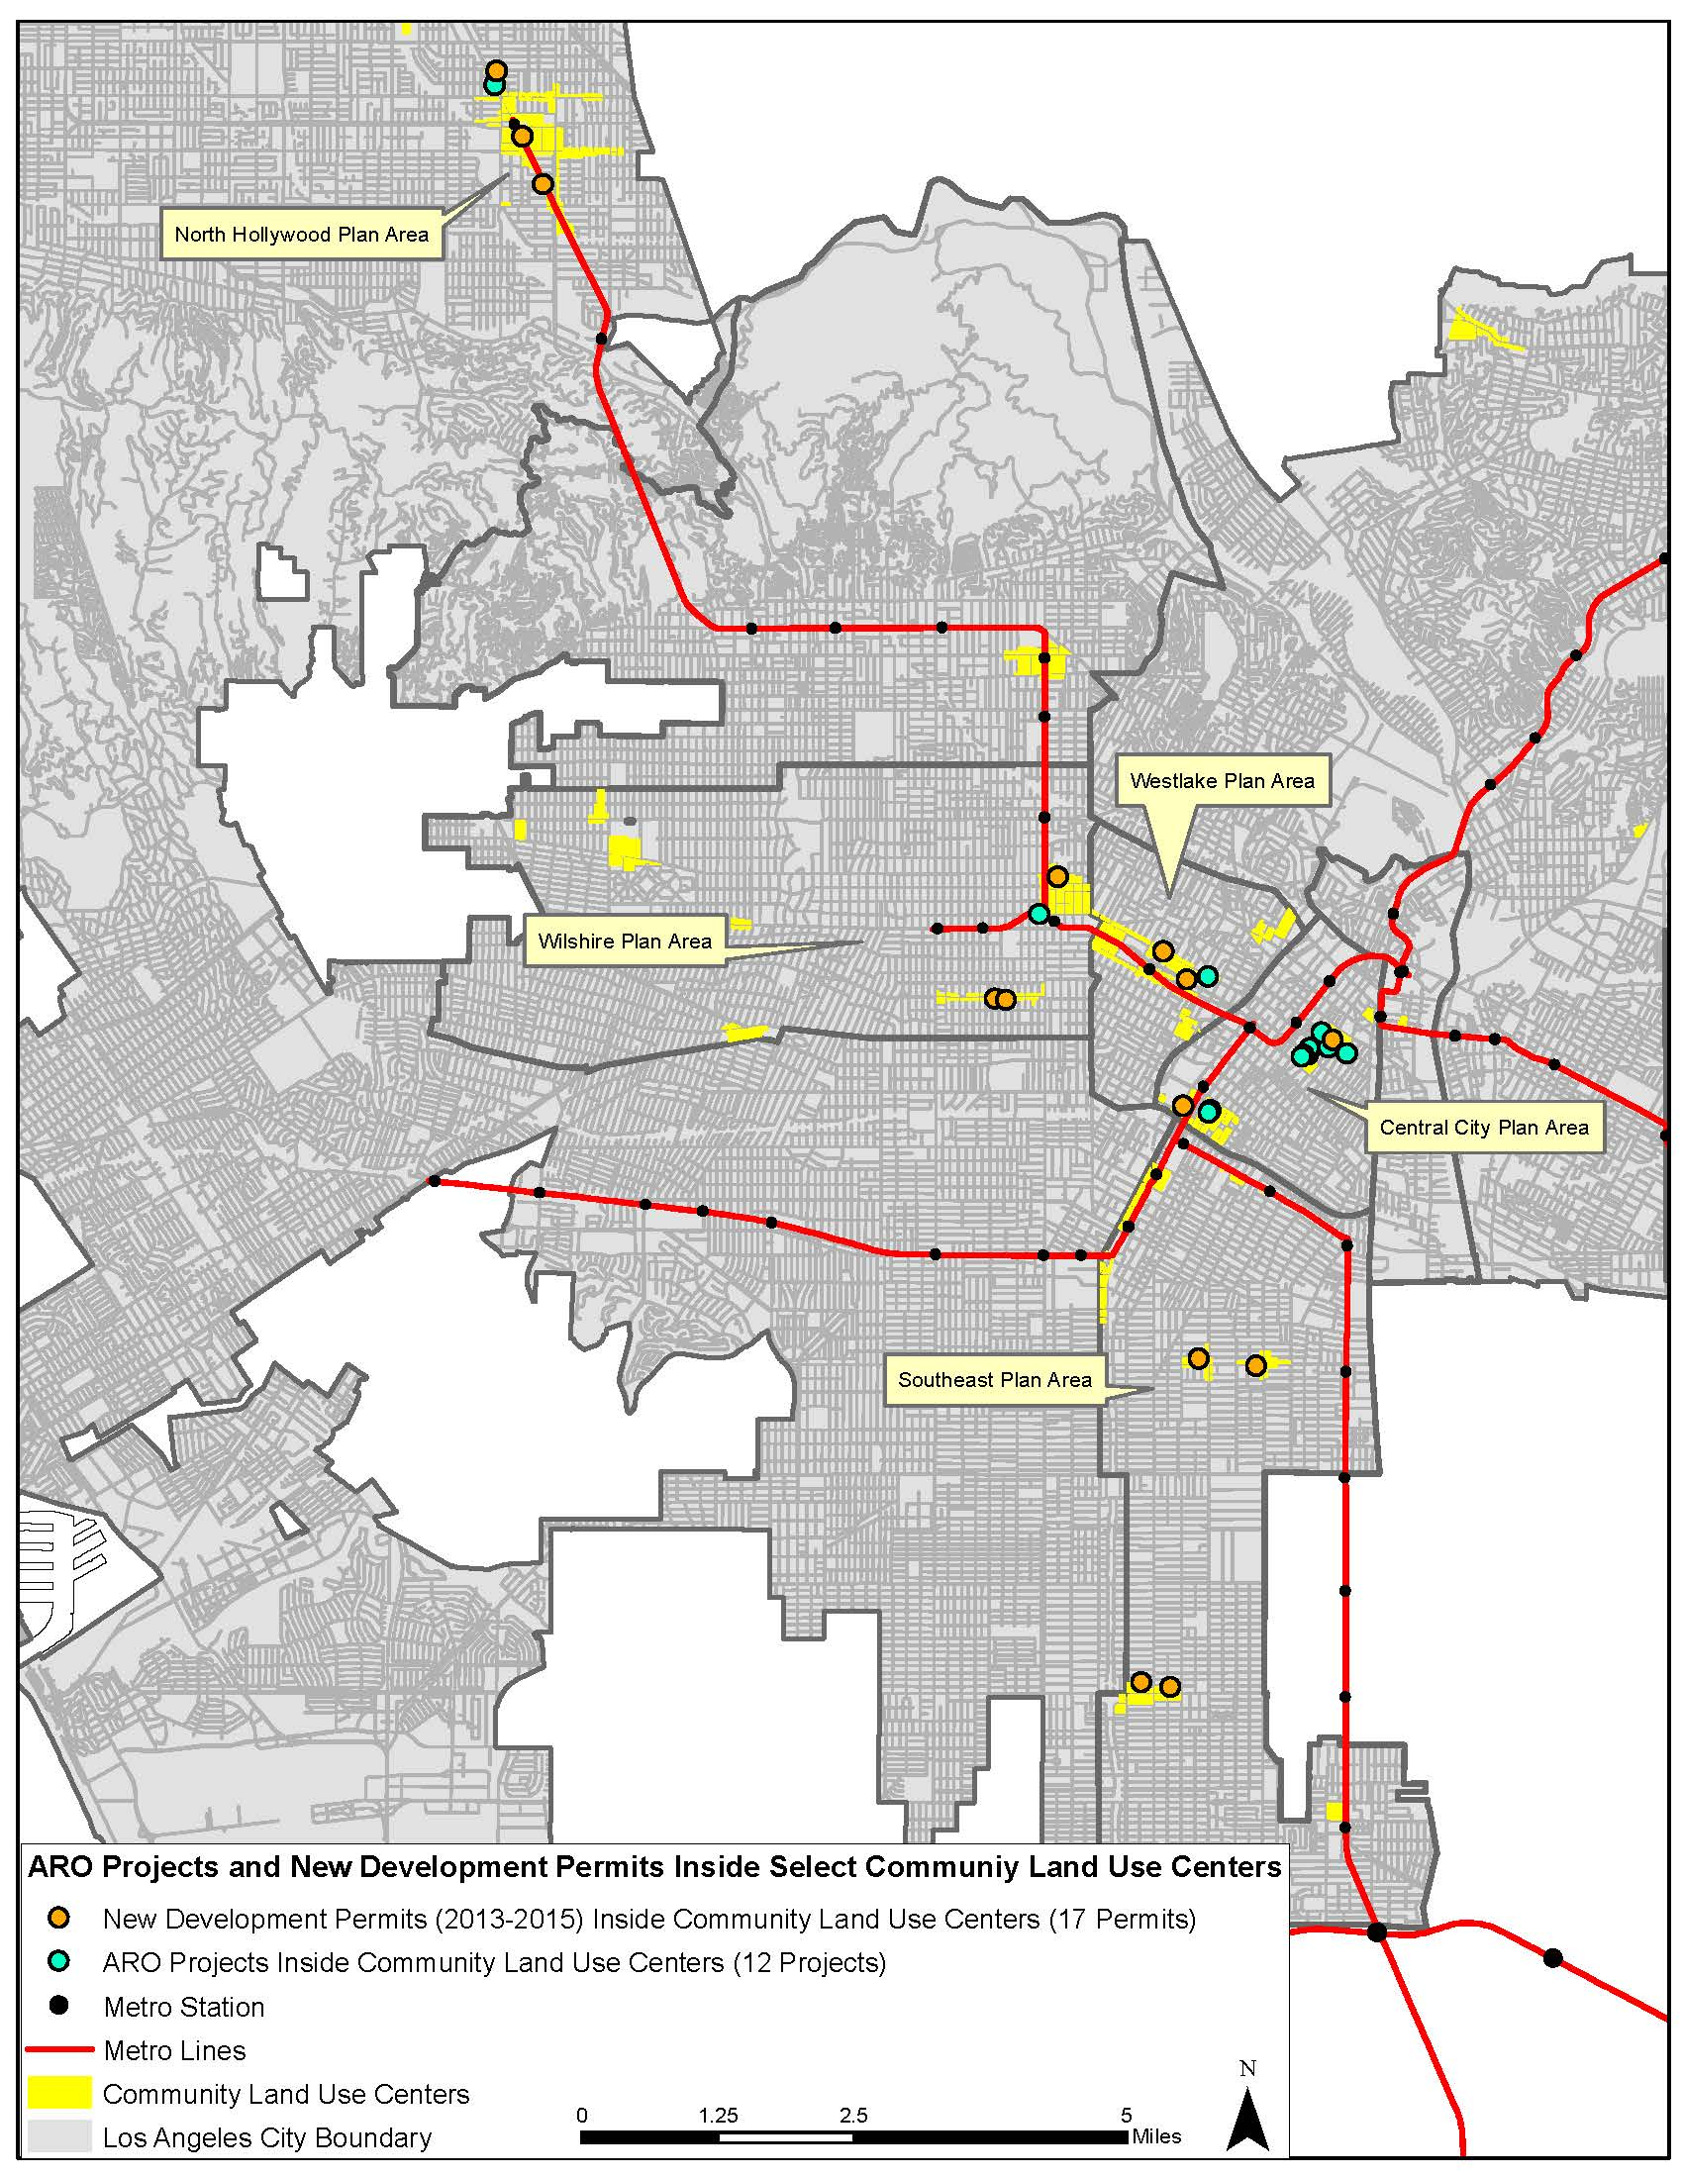**ARO Projects and New Development Inside Community Centers**

ARO Project Data

ARO Project 1-90 (Part One)



ARO Project 1-90 (Part Two)



ARO Project 90-154 (Part One)



ARO Project 90-154 (Part Two)

