**Supporting information to “A New Strontium Bromide MOF composite with Improved Performance for Solar Energy Storage Application”.**

Pierre D’Ans,a,b,\* Emilie Courbon,c Anastasia Permyakova,b Farid Nouar,d Corine Simonnet-Jégat,b Flavien Bourdreux,b Loïc Malet,a Christian Serre,d Marc Frère,c and Nathalie Steunoub

\* Corresponding author, pdans@ulb.ac.be

a Université libre de Bruxelles (ULB), 4MAT Department, 50 Avenue F.D. Roosevelt, CP194/03, 1050 Brussels, Belgium (partly detached at UMONS, see below).

b Institut Lavoisier, UMR CNRS 8180, Université de Versailles St-Quentin en Yvelines, 45 Avenue des Etats-Unis, 78035 Versailles Cedex, Université Paris-Saclay, France

c UMONS, Institut de Recherche en Energie – Laboratoire de Thermodynamique, 31 Boulevard Dolez, 7000 Mons, Belgium.

d Institut des Matériaux Poreux de Paris, UMR 8004 CNRS, Ecole Normale Supérieure, Ecole supérieure de physique et de chimie industrielles de la ville de Paris, PSL Research University, 75005 Paris, France.

# Additional characterization of fresh MIL-101(Cr)-SrBr2

## Elemental analysis via ICP

In addition to the measurement of the Cr/Sr ratio on the composite based on a 30 wt. % salt solution, the ICP measurement was performed on the composite obtained from a 40 wt. % salt solution. The detailed results from ICP measurements are given in S1.

|  |  |  |
| --- | --- | --- |
|  | Based on 40 wt. % solution | Based on 30 wt. % solution |
| Analysed mass (mg) | 4.44 | 4.87 |
| Cr mass in 1 L (µg) | 4582 | 6520 |
| Sr mass in 1 L (µg) | 20128 | 21580 |
| MIL-101 mol. mass (g/mol) | 719 | 719 |
| SrBr2 mol. mass (g/mol) | 248 | 248 |
| MIL-101 mass in 1 L (µg) | 21 119 | 30 050 |
| SrBr2 mass in 1 L (µg) | 56 726 | 60 816 |
| **Salt content (wt. %)** | **72.87** | **66.93** |

S1: salt content evaluated from ICP measurement for the two studied composite materials.

## BET

The detailed BET data are given for the MIL-101(Cr)-SrBr2 composites based on a 30 wt. % salt solution, and on a 40 wt. % solution (S2 and S3). The estimated pore size distribution is also given.

|  |  |
| --- | --- |
|  |  |
| S2: nitrogen adsorption isotherm and pore size distribution of MIL-101(Cr)-SrBr2 composite from a 40 wt. % solution. Note that part of the salt is not incorporated inside the pores. | |

|  |  |
| --- | --- |
|  |  |
| S3: nitrogen adsorption isotherm and pore size distribution of MIL-101(Cr)-SrBr2 composite from a 30 wt. % solution (the left graph is reminded from the paper). | |

Based on BET plots, several features of the composites could be estimated (S4); data for pure MIL-101(Cr) are also given.

|  |  |  |  |
| --- | --- | --- | --- |
|  | Composite from 40 wt. % solution | Composite from 30 wt. % solution | MIL-101(Cr) |
| Specific surface (m²/g) | 447 | 603 | 3721 |
| Pore volume (cm3/g) | 0.37 | 0.44 | 1.51 |

S4: specific surface and pore volume of the studied materials.

Assuming a SrBr2 density of 4.216 g/cm3, and applying the equation used in the paper (§ 3.1) to calculate the salt content from the pore volume, salt contents of **65 wt. % and 61 wt. %** are obtained, respectively. This assumes the absence of closed porosity. In the case of the 40 wt. % composite, the value of 65 wt. % salt is underestimated due to the presence of salt outside the porosity.

## IR

In addition to the data presented in the paper, spectra were acquired at several intermediate temperatures and on SrBr2 impregnated into MIL-101(Cr). S5 gives a general comparison between the composite and MIL-101(Cr) alone. S6 – S8 provide detailed data for the salt and the composite at various temperatures, showing the influence of water desorption.

|  |
| --- |
|  |
| S5: FTIR spectra of MIL-101(Cr) and of the composite. |

|  |
| --- |
|  |
| S6: FTIR spectra of SrBr2 at various temperatures. |

|  |
| --- |
|  |
| S7: FTIR spectra of MIL-101(Cr)-SrBr2 at various temperatures, obtained from a 40 wt. % solution. |

|  |
| --- |
|  |
| S8: FTIR spectra of MIL-101(Cr)-SrBr2 at various temperatures, obtained from a 30 wt. % solution. |

## SEM-EDX

SEM micrographs and typical EDX spectra are given in S9-10 for the studied composite, as well as in the case of the composite obtained from a 40 wt. % solution.

In order to obtain mean compositions, and to get the best sampling, chemical analyses of 2 minutes were performed on large rectangular surfaces, selected directly on the micrographs. 3 measurements were made for the reproducibility.

The three analyses are also given in wt. % in S11, for each material. Gold is excluded from the total. Only Cr, Sr and Br are considered. The salt content in the composite can be deduced from the molar mass of MIL-101 and SrBr2.

|  |  |
| --- | --- |
| NPC81b-27072016x1600-1 | S9: SEM image and EDX spectrum, composite from a 40 wt. % solution. |
|  | |

|  |  |
| --- | --- |
| MIL-101-SrBr2_04072016-x1800-1 | S10: SEM image and EDX spectrum, composite from a 30 wt. % solution. |
|  | |

|  |  |  |  |  |  |  |
| --- | --- | --- | --- | --- | --- | --- |
|  | From 40 wt. % solution | | | From 30 wt. % solution | | |
|  | Meas. 1 | Meas. 2 | Meas. 3 | Meas. 1 | Meas. 2 | Meas. 3 |
| Cr (wt. %) | 10,9 | 3,43 | 14,49 | 11,05 | 12,26 | 10,56 |
| Br (wt. %) | 56,96 | 52,92 | 54,69 | 55,1 | 55,22 | 56,08 |
| Sr (wt. %) | 32,13 | 43,65 | 30,82 | 33,86 | 32,52 | 33,36 |
| wt. % salt  Based on Sr+Br | **64** | **86** | **56** | **64** | **61** | **65** |
| S11: elemental analyses from EDX of composite materials. | | | | | | |

Chemical analyses confim the high salt content, above 60 wt. % in the case of the composite synthesized from 30 wt. % solution. This value is in agreement with BET, but is lower than ICP (66.93 wt. %). Like for CaCl2, the Br/Sr ratio (1.62-1.70) is lower than stoichiometry (1.82). The Sr/Cr ratio (2.65-3.16) is slightly lower than via ICP (3.31).

For the “40 wt. %” composite, a higher variability is observed. It is likely that the highest value was obtained on a sample rich in SrBr2 crystallites, evidenced via XRD. The same discrepancy in the Br/Sr is observed (1.21-1.77).

## TGA

TGA was performed between RT and 600°C at a scan rate of 3°C/min on a Mettler Toledo STARe System device. A TGA of pure MIL-101 (Cr) is given to make comparisons with the composites (S12).

|  |
| --- |
|  |
| S12: TGA measurements on the “40 wt. %” sample (blue), the “30 wt. %” sample (red) and MIL-101(Cr) (green). |

# Water sorption behaviour upon multi-cycles

S13 and S14 provide the kinetic data of the multi-cycles stability test described in the paper. The two first cycles exhibit a similar behavior, after which the kinetics of water sorption/desorption become faster.

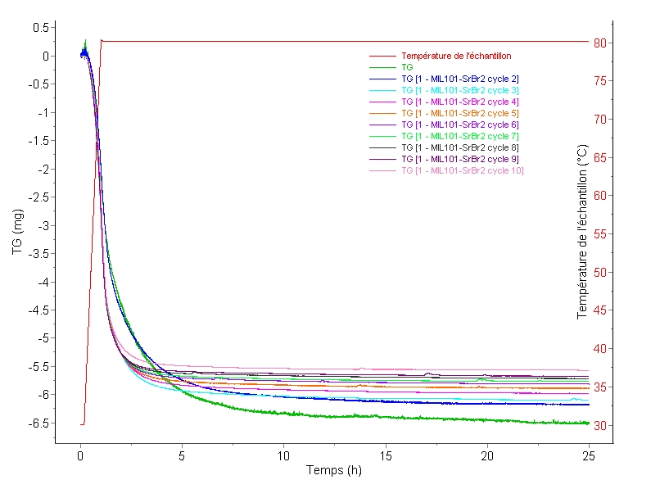

S13: dehydration kinetics: mass evolution during the cycles in the multi-cycles stability test: increase of temperature from 30 to 80°C.

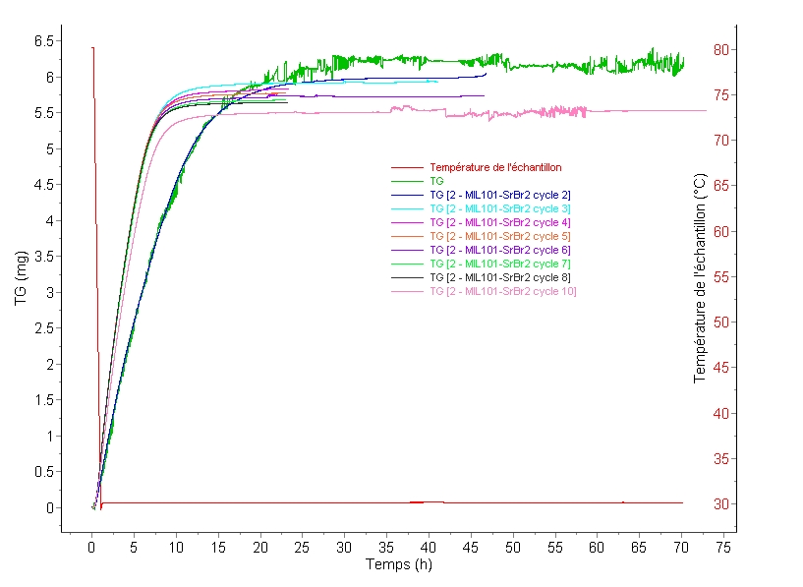

S14: hydration kinetics: mass evolution during the cycles in the multi-cycles stability test: decrease of temperature from 80 to 30°C.

# Detailed thermochemical calculations

In this section, two scenarios are compared with the measured water sorption and heat storage density of the composite material.

## Scenario nr. 1: excess sorption is physisorption

In this scenario, it is assumed that:

1. Chemisorption occurs by the exchange of 5 molecules H2O between SrBr2.H2O and SrBr2.6H2O.
2. All the remaining sorption is assumed to be physisorption.

The used data are given below:

|  |  |
| --- | --- |
| Salt content  (wt. fraction) | 0.63 |
| MIL-101(Cr) content  (wt. fraction) | 0.37 |
| Cycling loading lift of the salt  (g H2O/g dried material)  Value corresponding to the exchange of 5 H2O molecules between SrBr2 and SrBr2.6H2O. | 0.363 |
| Experimental composite cycling loading lift  (g H2O/g dried material) | 0.303 |
| Energy storage capacity of the salt  (Wh/g anhydrous salt)  Source: enthalpy per mol H2O from B.Michel et al. Energy 47 (2012) 553-563. | 0.379 |
| Energy storage capacity of MIL-101(Cr)  (per amount of H2O)  Source: A. Permyakova et al., ChemSusChem 10 (2017) 1419-1426. | 46452 J/molH2O  0.717 Wh/g H2O |
| Packing density of the composite material  (kg/m³) | 621.62 |

For this scenario, the physisorption is adjusted to the measured cycling loading lift  following:

.

The energy storage capacity and energy storage density are then calculated following:



.

Despite the fact that the physisorbed amount was forced to the experimental value, this prediction is far below the experiment.

## Scenario nr. 2: salt solution inside the porosity

In this scenario, it is assumed that both chemisorbed and physisorbed water is transferred to a salt solution that fills the porosity.

This scenario is supported by the water sorption isotherm (fig. 5). At 1.25 kPa, 0.45 g H2O/g dried composite are sorbed, corresponding to ~10 molecules H2O per SrBr2 unit. Assuming that the initial state of the salt is the monohydrate form, and that the final state is dissociated in 10 molecules H2O, the overall transformation writes:



The values of the enthalpies of formation are extracted per mol of species from D. Wagman et al., "The NBS tables of chemical thermodynamic properties." Journal of Physical and Chemical Reference Data 11 (1982) Supplement no. 2.

For dissociated Sr2+ and 2Br-, values are regrouped and specified as aqueous SrBr2, for various concentrations. No value is given for strontium bromide in 10 molecules of water, but it can be seen that the enthalpy of formation ranges from -787.18 kJ/mol in 400 H2O molecules to -788.89 kJ/mol in infinite dissolution, which means very limited variations with respect to present problem. A rounded value of -787 kJ/mol is assumed here for dissociated Sr2+ and 2Br-.

The used enthalpies of formation and stoeichiometric coefficients are given below:

|  |  |  |  |  |
| --- | --- | --- | --- | --- |
| Species |  |  |  |  |
| Formation enthalpy (kJ/mol) | -1031.4 | -241.818 | -285.83 | -787 |
| Coefficient | -1 | -9 | 10 | 1 |

The calculated enthalpy of reaction is -437.538 kJ/mol anhydrous salt or an energy storage capacity of 1764 J/g anhydrous salt or 0.491 Wh/g anhydrous salt. The following values are useful:

|  |  |
| --- | --- |
| Salt content  (wt. fraction) | 0.63 |
| Energy storage capacity of the salt  (Wh/g anhydrous salt)  Source: calculation above. | 0.491(\*) |
| Packing density of the composite material  (kg/m³) | 621.62 |

The energy storage capacity and energy storage density are calculated following:



The energy storage density E is obtained as follows:

.

For the sake of comparison, the energy storage capacity per mol of water taken from (\*) is 52.6 kJ/mol water, i.e. more than in scenario 1.

The energy storage density is still below the measurement, but is still the closest estimate so far.