Supporting Information

2-furyl(phenyl)methanol isolated from *Atractilis gummifera* rhizome exhibits anti-leishmanial activity

*Solene Deiva, Lindsay Ferguson, Mostafa E. Rateb, Roderick Williams and Federico Brucoli\**

\*To whom correspondence should be addressed: Dr F. Brucoli. E-mail:[Federico.brucoli@dmu.ac.uk](mailto:Federico.brucoli@dmu.ac.uk)

1H-NMR spectrum of ATR **1**.

1H-NMR spectrum of genin **2**.

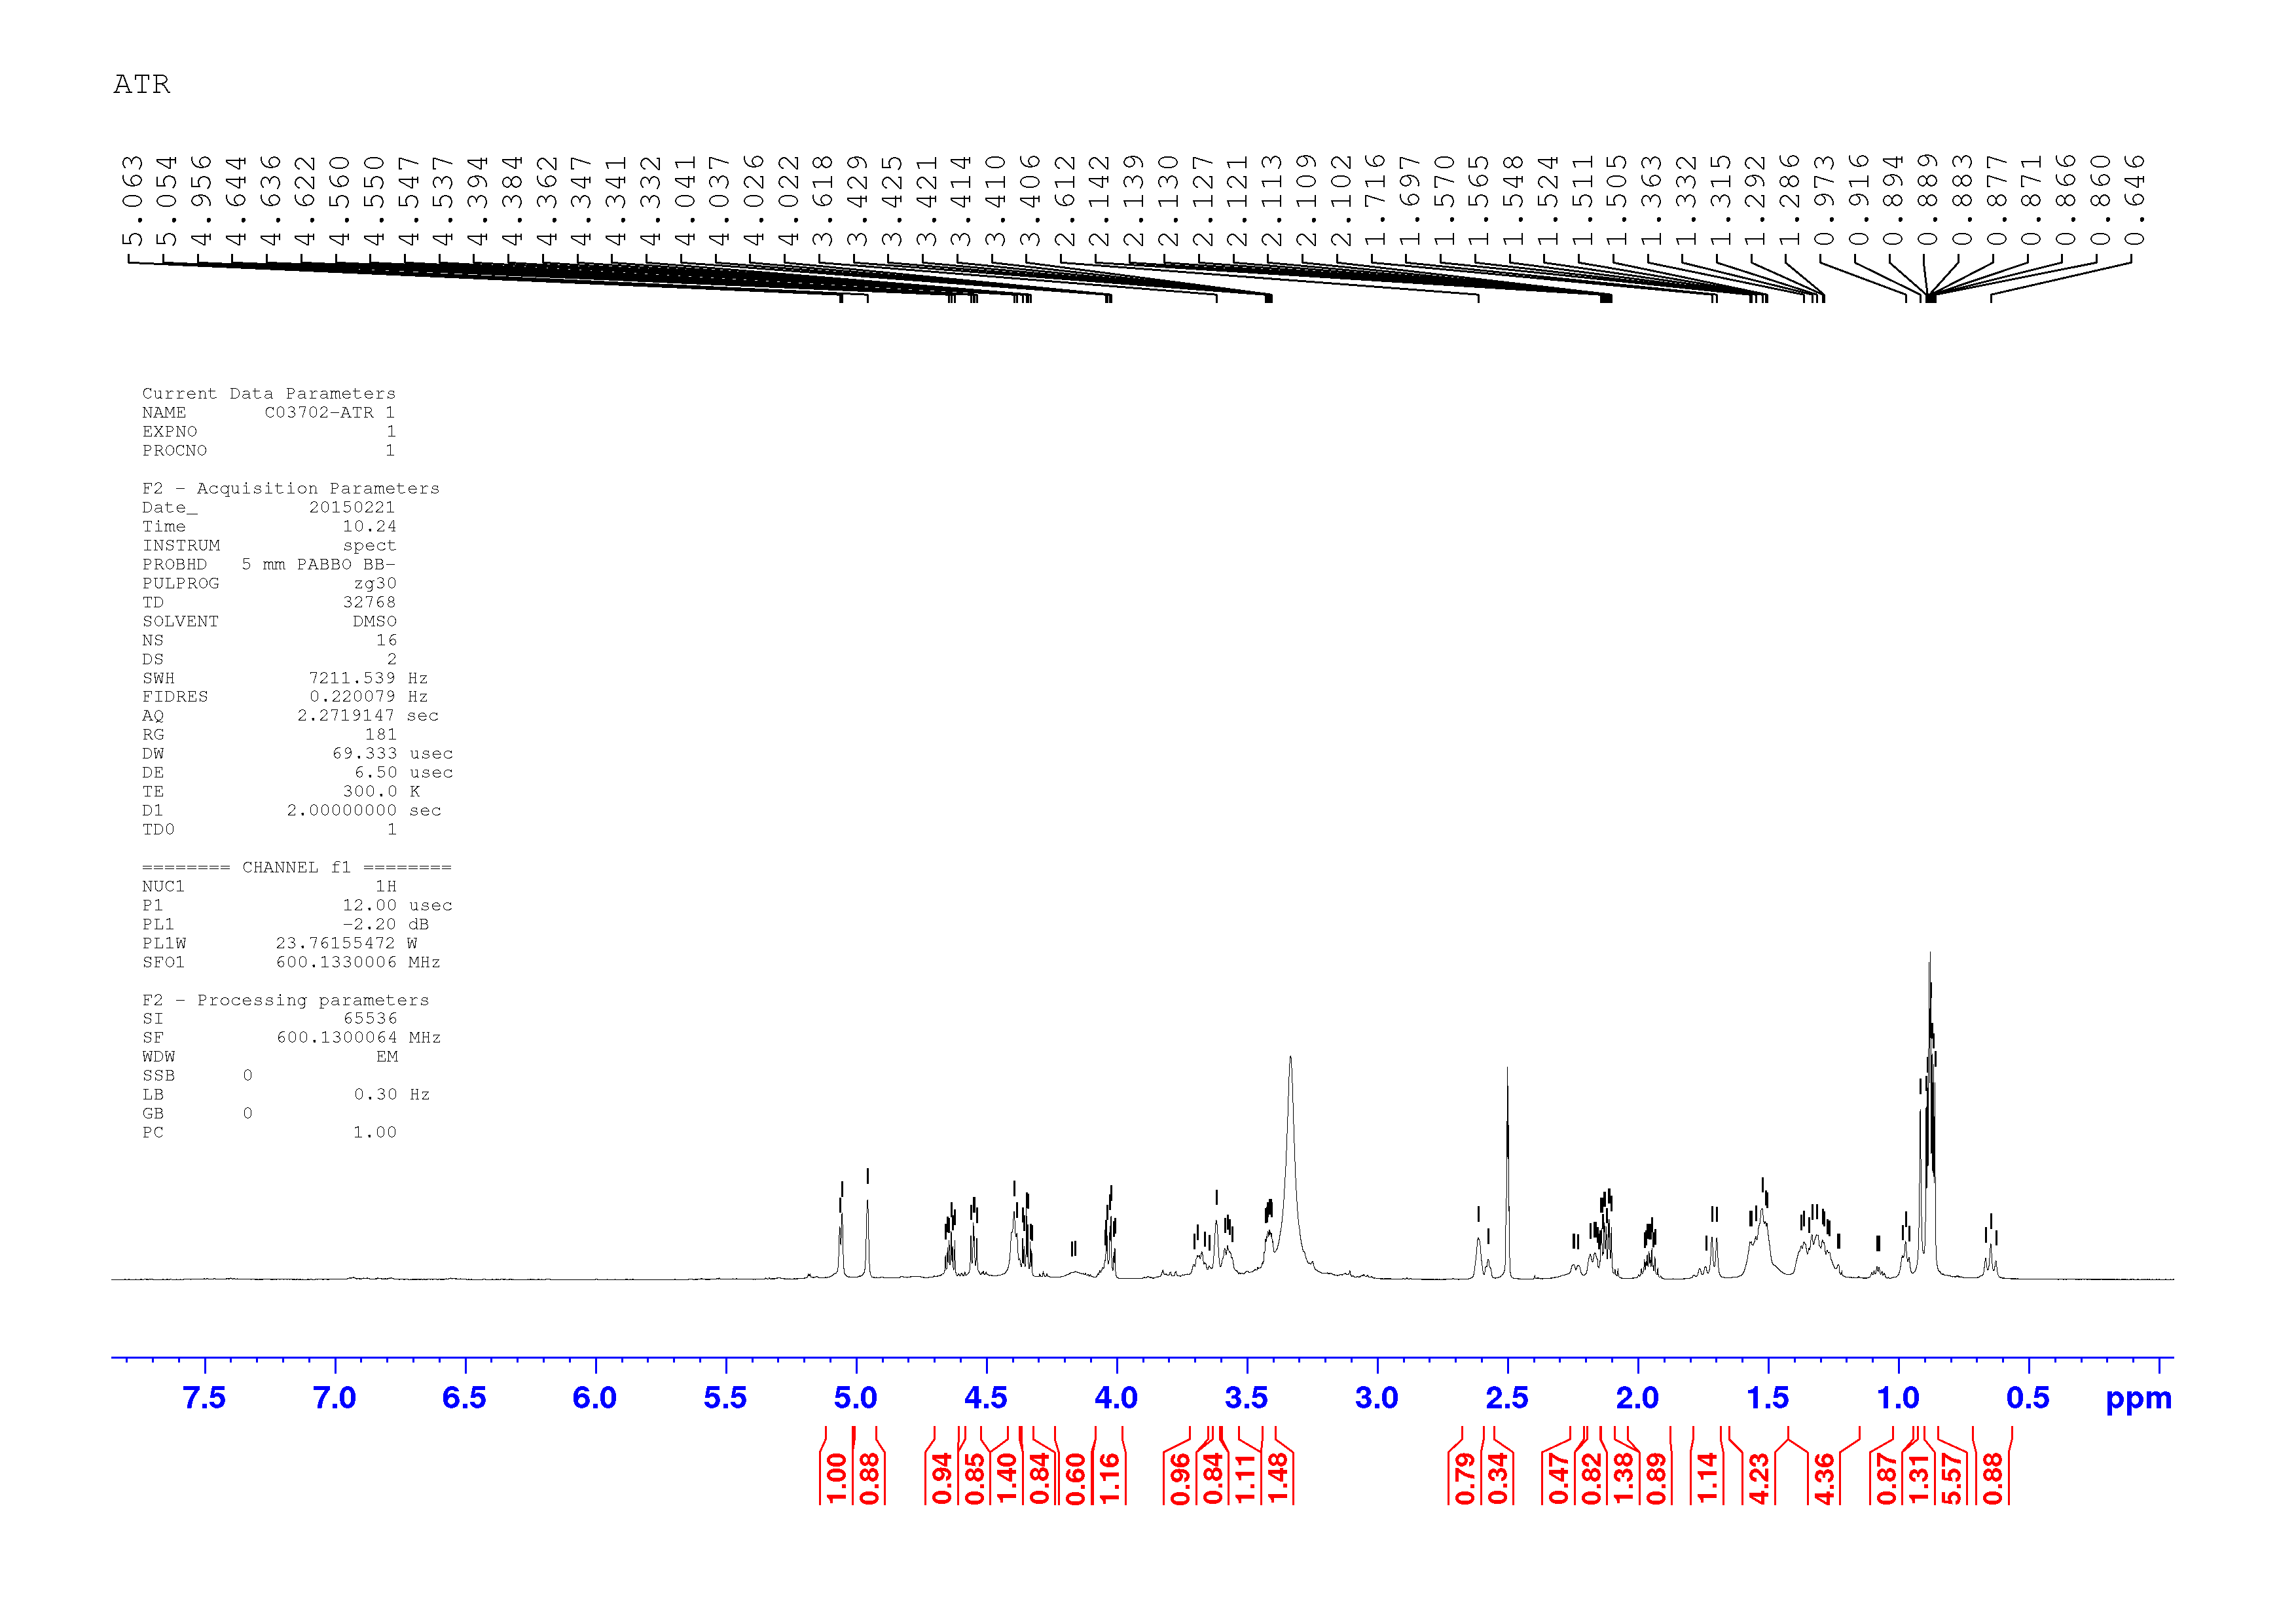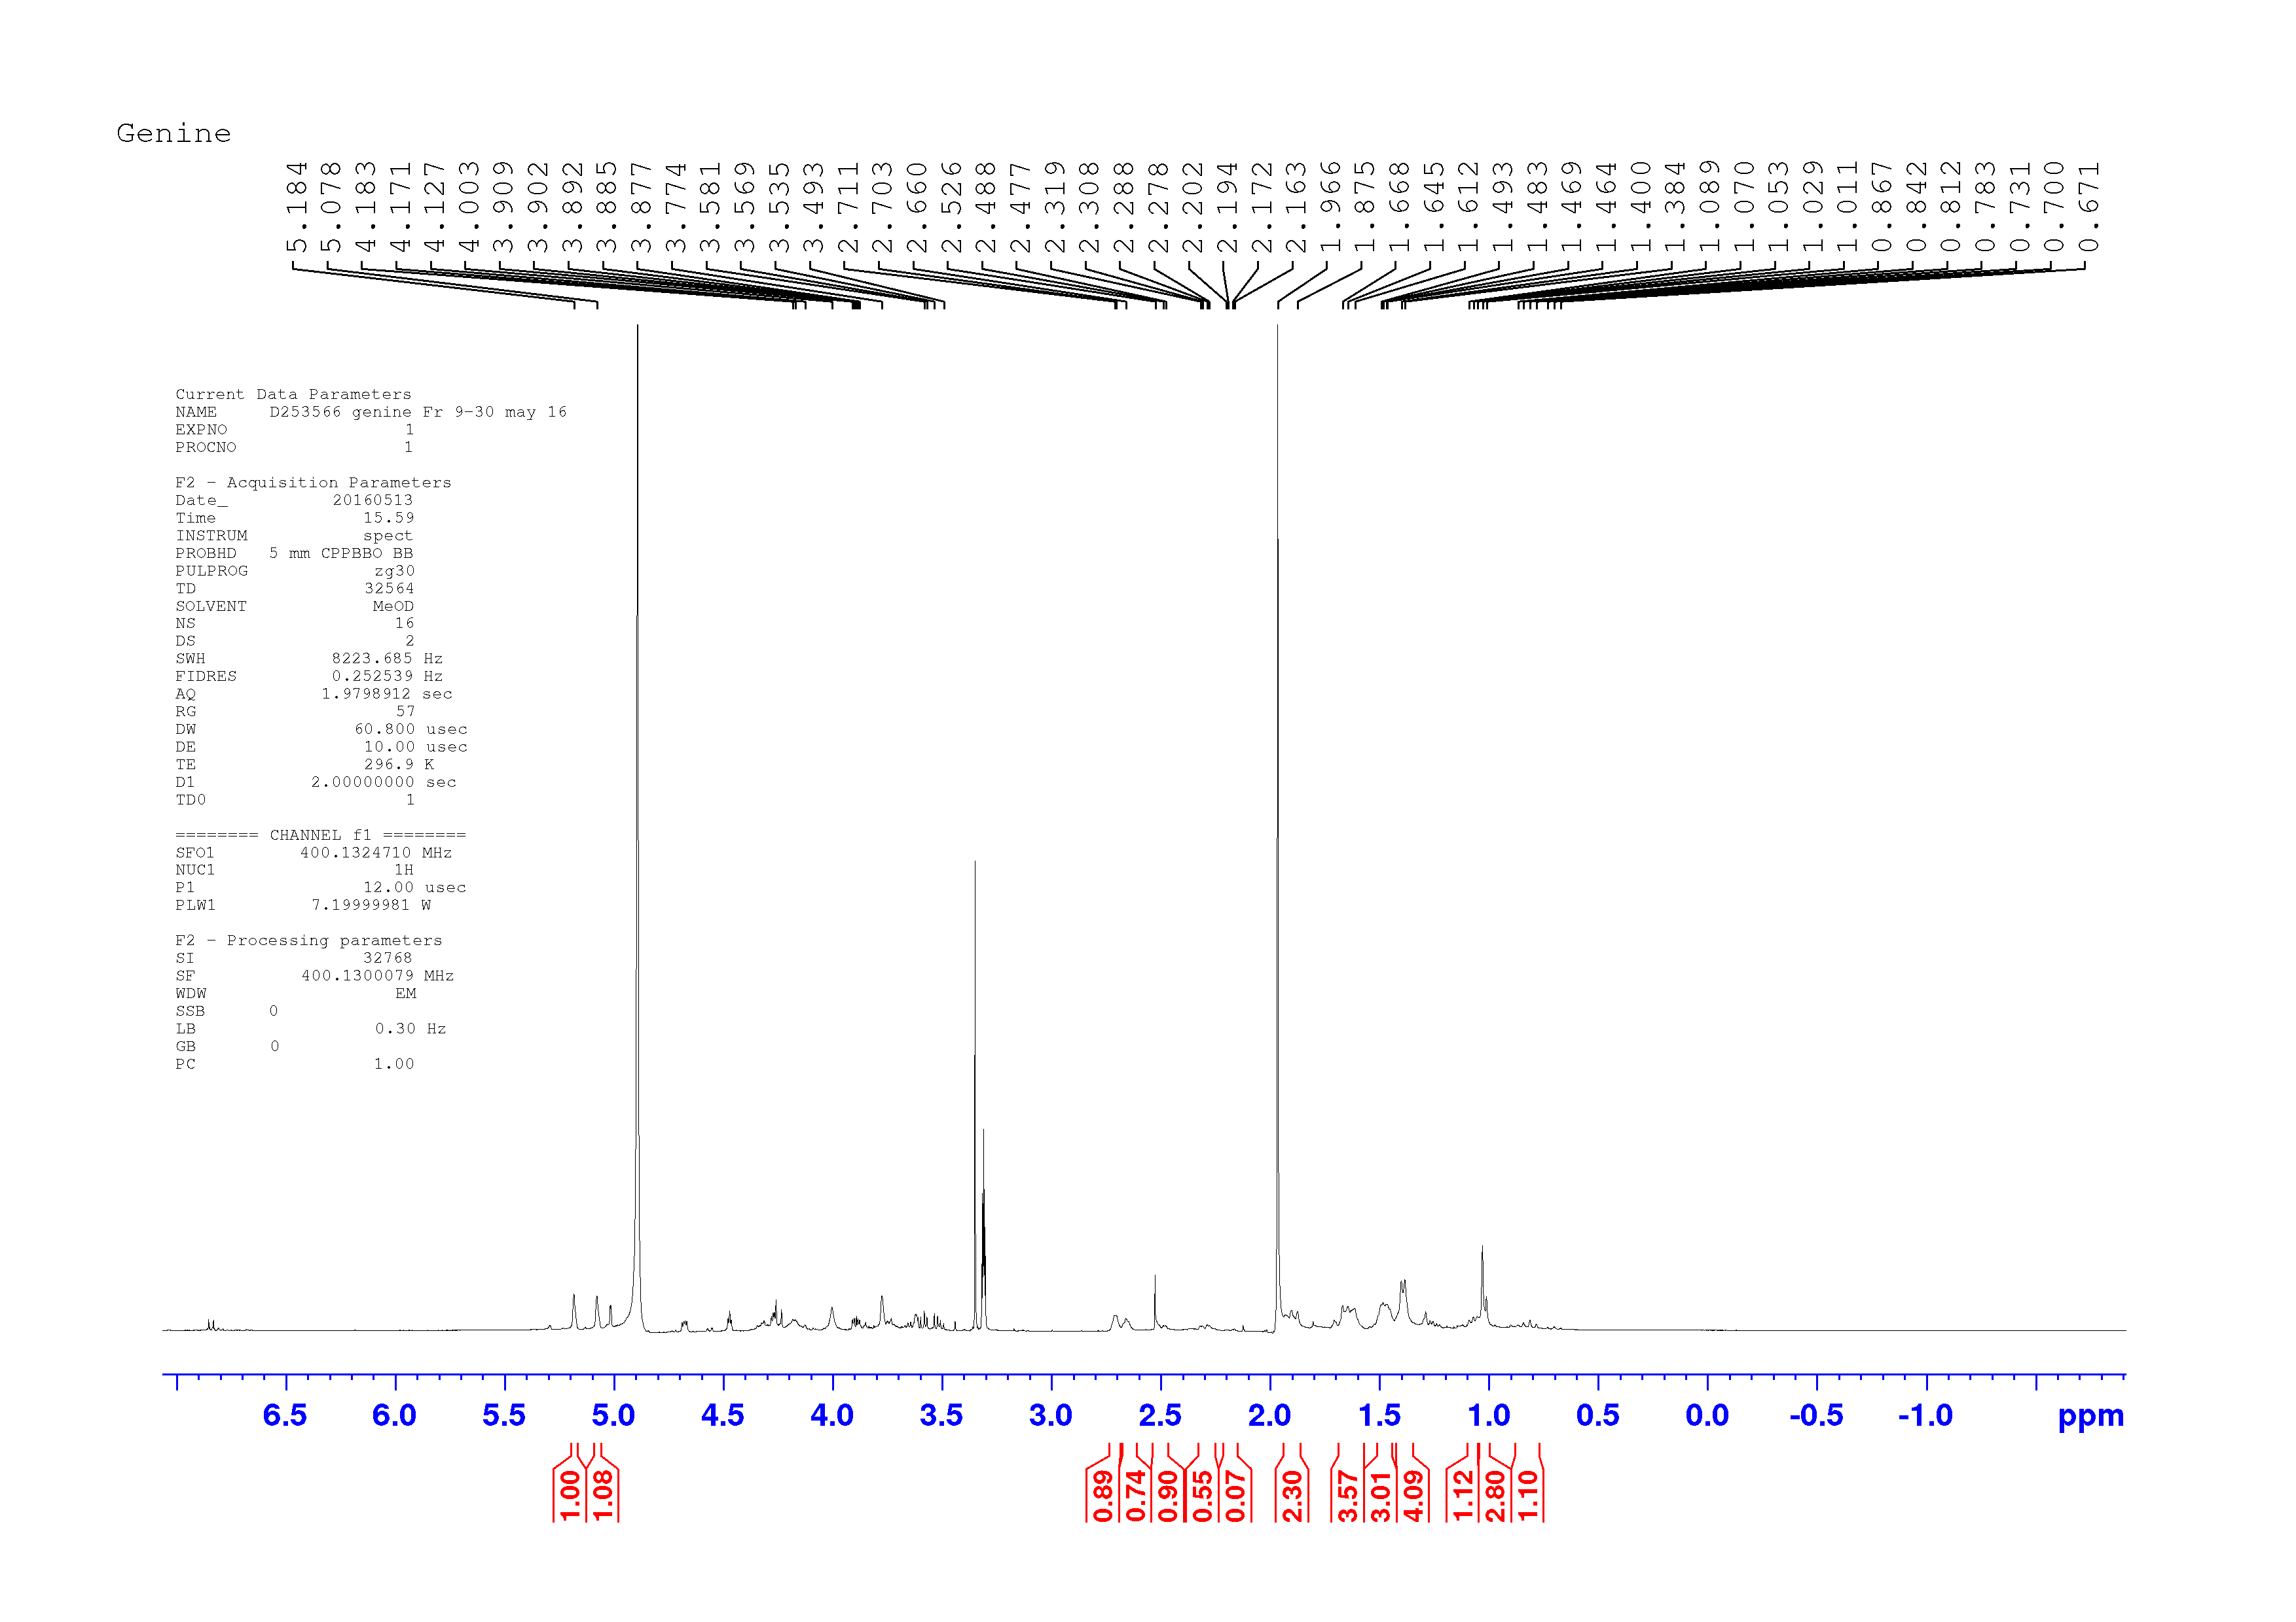

1H-NMR spectrum of ATR-OMe **3**.

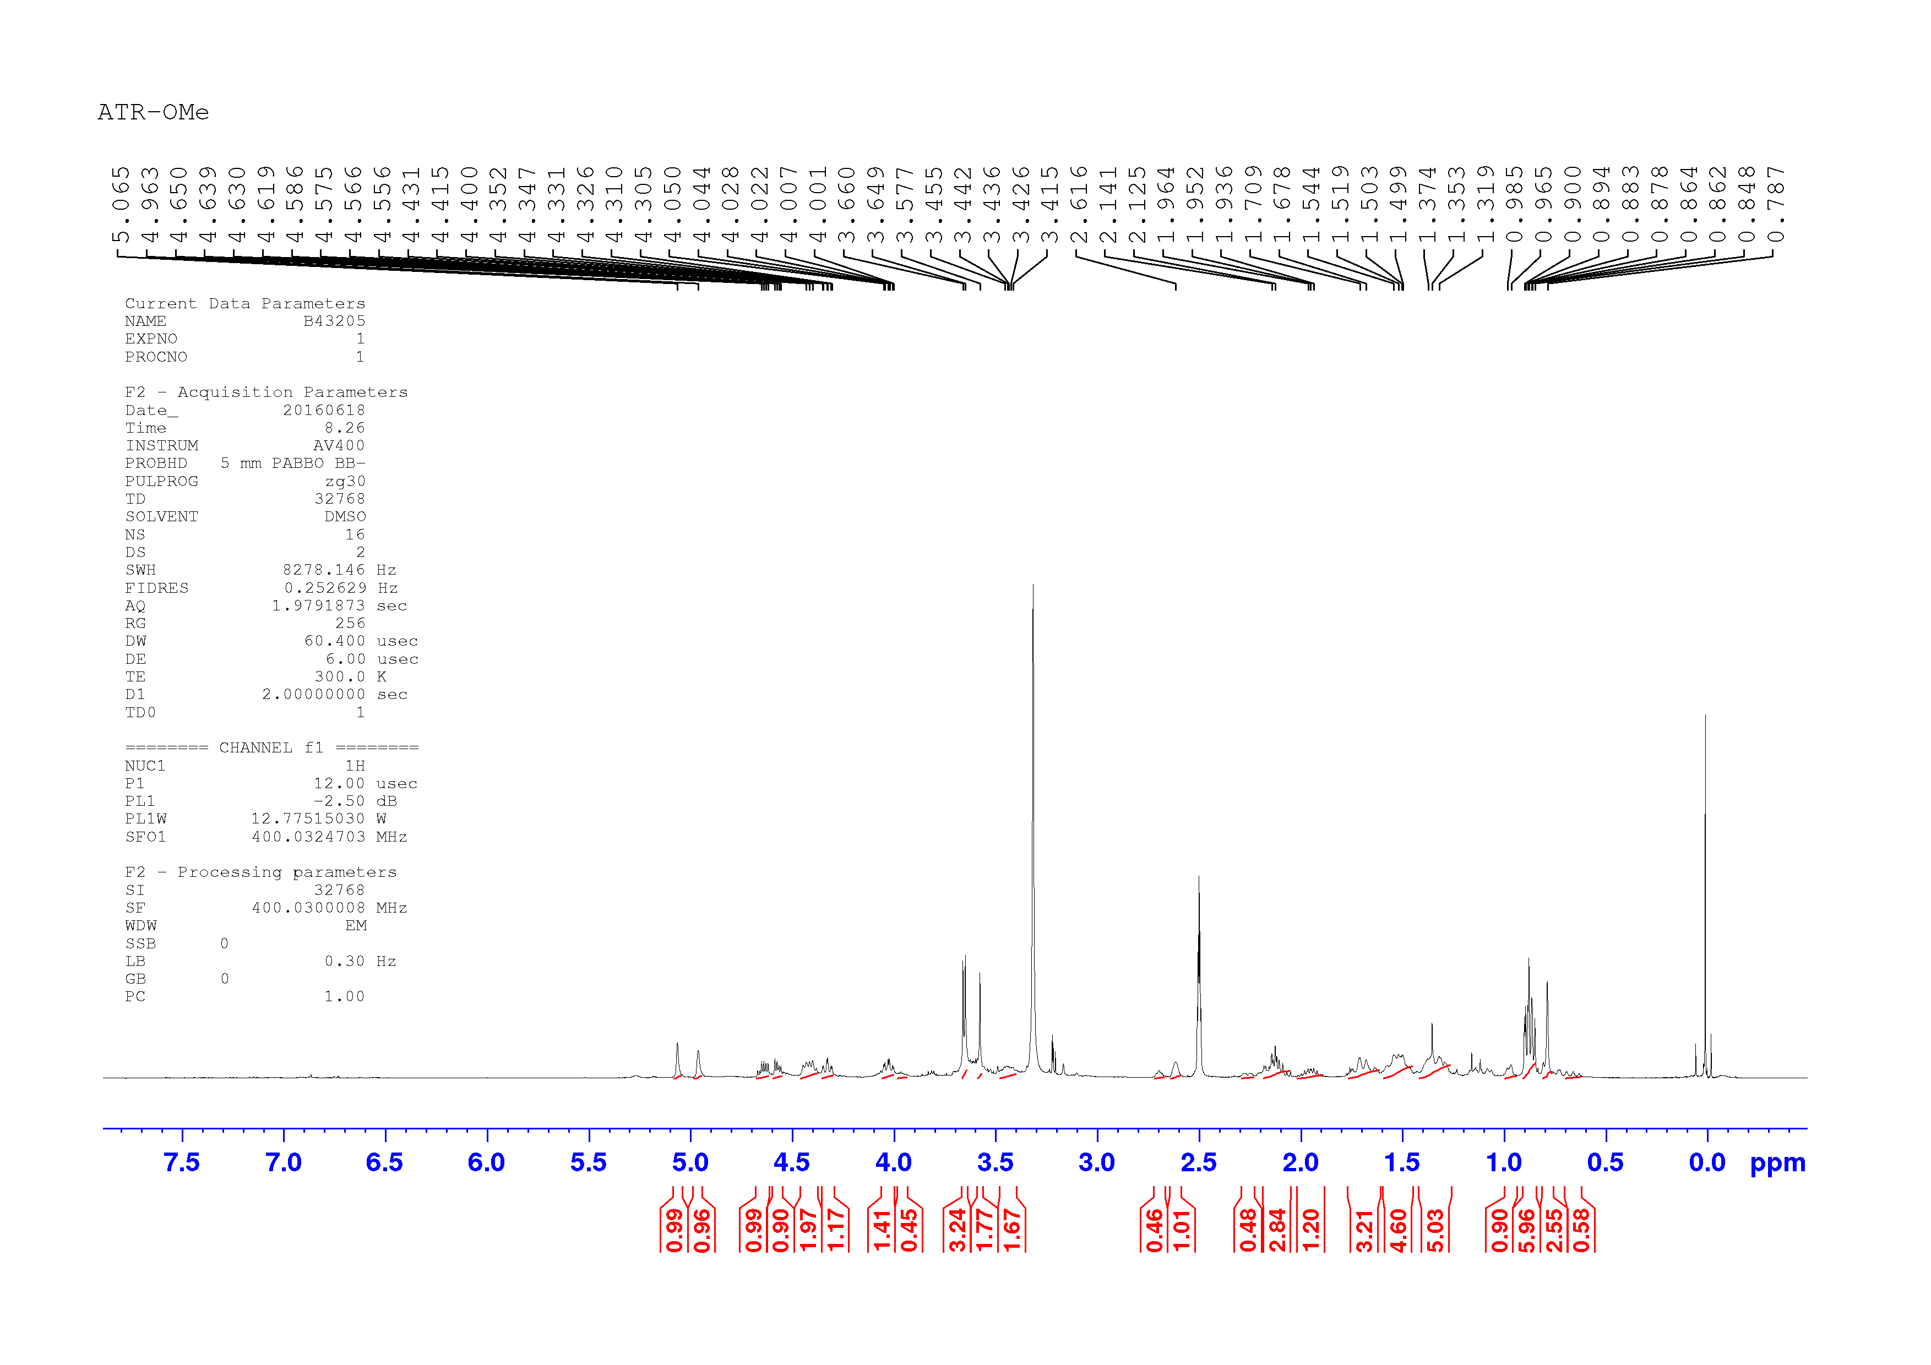

1H-NMR spectrum of genin-OMe **4**.

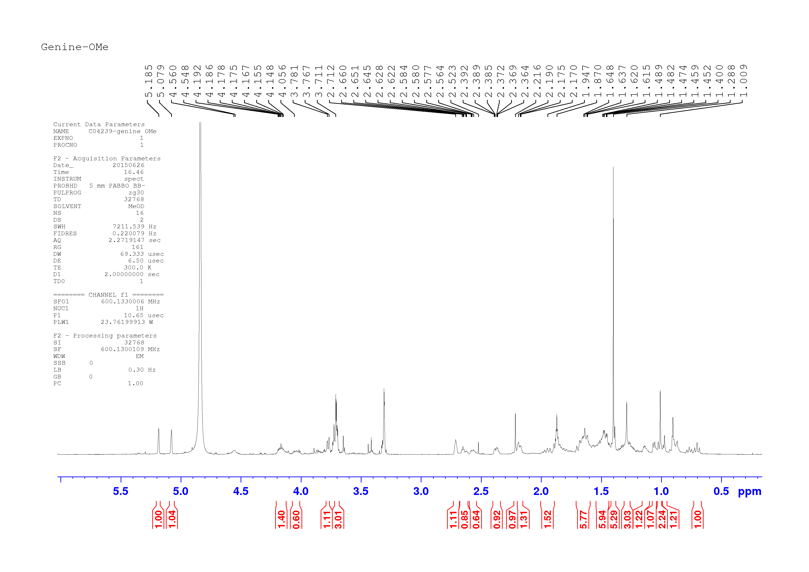

HR-ESI-MS of 2-furyl(phenyl)methanol **5** showing the quasi molecular ion peak [M+H]+ at *m/z* 175.0755 for C11H10O2.

1H NMR spectrum of 2-furyl(phenyl)methanol **5** in DMSO-*d*6.

13C NMR spectrum of 2-furyl(phenyl)methanol **5** in DMSO-*d*6.

Cropped region (8.5-5.0 ppm) of 1H-NMR spectrum of 2-furyl(phenyl)methanol **5** in DMSO-*d*6C:\Users\fbruco00\Documents\J NAt Prod\Supp info\H NMR.tif

1H-13C HSQC spectrum of 2-furyl(phenyl)methanol **5** in DMSO-*d*6C:\Users\fbruco00\Documents\J NAt Prod\Supp info\HSQC.tif.

1H-13C HMBC spectrum of 2-furyl(phenyl)methanol **5** in DMSO-*d*6C:\Users\fbruco00\Documents\J NAt Prod\Supp info\HMQC.tif.

IR spectrum of 2-furyl(phenyl)methanol **5**

C:\Users\fbruco00\Documents\J NAt Prod\Supp info\IR spectrum_ no scrpts.tif