Supporting Information
Novel NIR Absorbing Benzotrithiophene-Based Copolymers for Organic Photovoltaics
Hyokwon Kim^{a, 1}, Mi-Jeong Choi^{b, 1}, Seok-In Na^{b, **}, Kyukwan Zong^{a, *}
ª Department of Chemical Education, Institute of Fusion Science, Chonbuk National University, 567 Baekje-daero, Jeonju 54896, Republic of Korea
^{b} Professional Graduate School of Flexible and Printable Electronics, Polymer Materials Fusion Research Center, Chonbuk National University, 567 Baekje-daero, Jeonju 54896, Republic of Korea

Contents
Molecular structures of seven benzotrithiophene isomers S2
¹H NMR and ¹³C NMR of 6a S3
¹H NMR and ¹³C NMR of 6b S4
Procedure of the device preparation S5
Device optimization:
1. Concentration S5
2. Additive (DIO) S6
3. Film thickness (RPM) S7
4. Solar cell parameters of the devices fabricated from P1~P3 at optimized condition S8
5. Solar cell parameters of the devices fabricated from P1 at DIO optimized condition S9

Figure S1. Molecular structures of seven benzotrithiophene isomers.
(a) benzo[1,2-c:3,4-c’:5,6-c”]trithiophene (ccc-BTT) (b) benzo[1,2-b:3,4-b’:5,6-b”]trithiophene (bbb-BTT-1) (c) benzo[2,1-b:3,4-b’:5,6-b”]trithiophene (bbb-BTT-2) (d) benzo[1,2-b:3,4-c’:5,6-c”]trithiophene (bcc-BTT) (e) benzo[1,2-b:4,3-b’:5,6-c”]trithiophene (bbc-BTT-1) (f) benzo[1,2-b:4,3-b’:5,6-c”]trithiophene (bbc-BTT-2) (g) benzo[2,1-b:3,4-b’:5,6-c”]trithiophene (bbc-BTT-3)

Figure S2. ¹H NMR and ¹³C NMR of 6a

Figure S3. ¹H NMR and ¹³C NMR of 6b

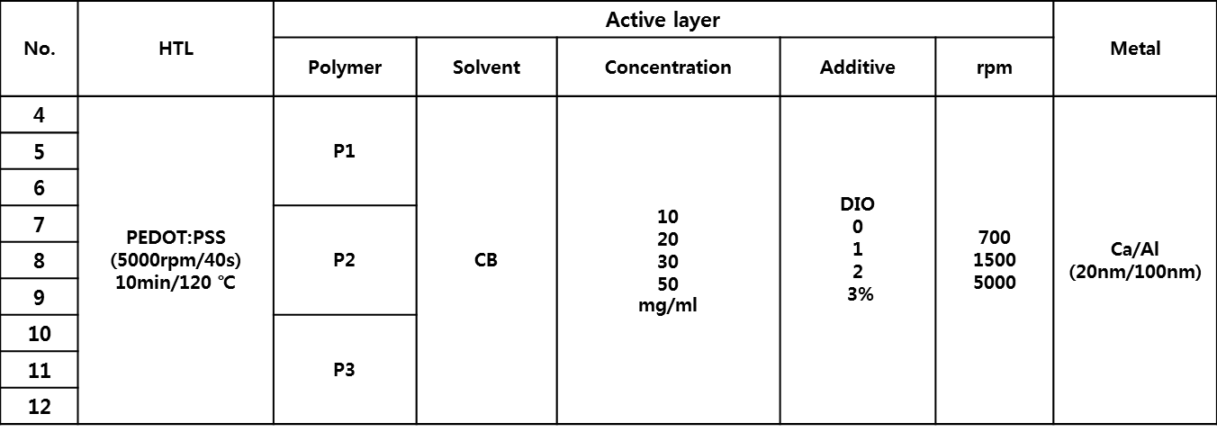
Figure S4. Procedure of device preparation
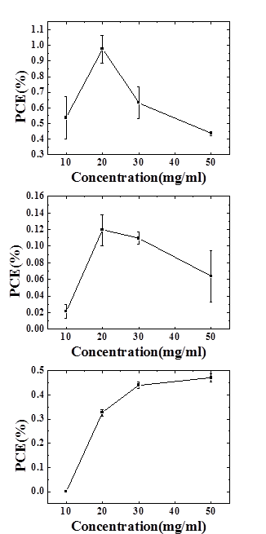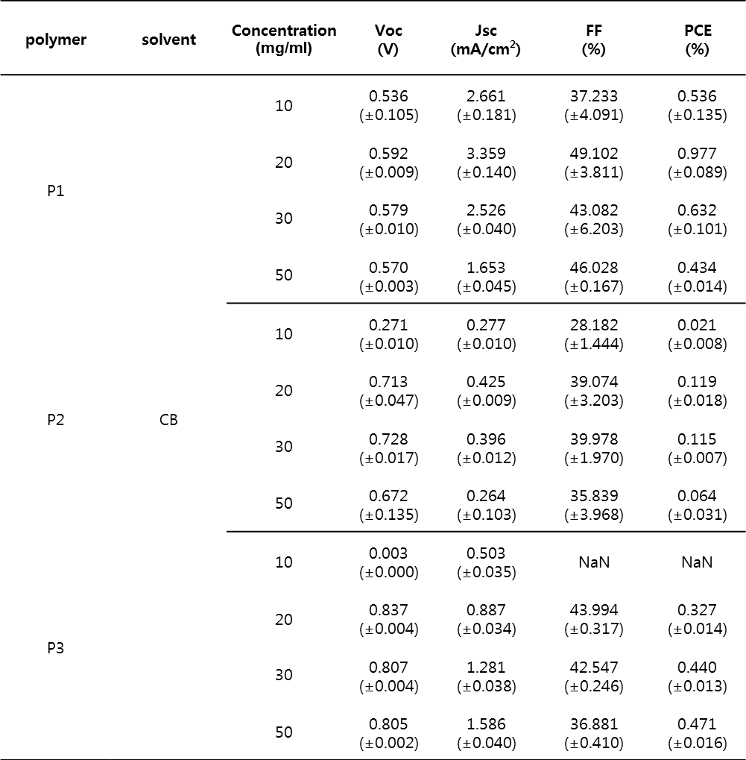
Figure S5. Variation of PCE based on concentration optimization
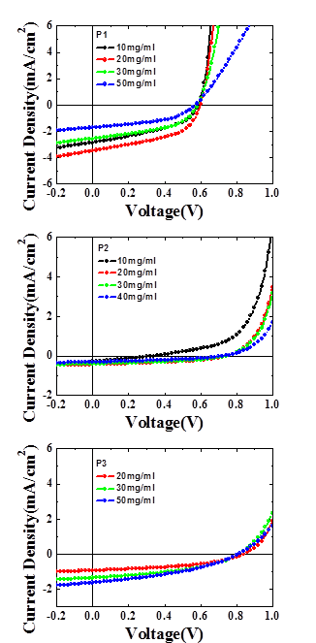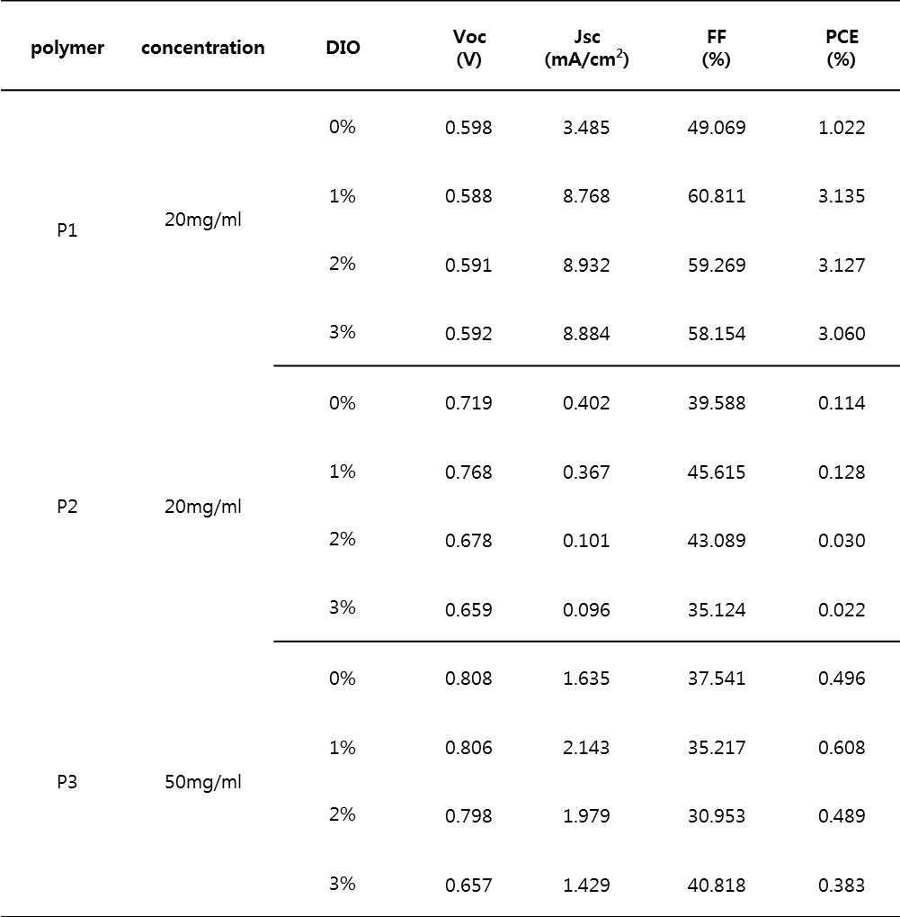
Figure S6. Variation of J-V curves based on concentration optimization.

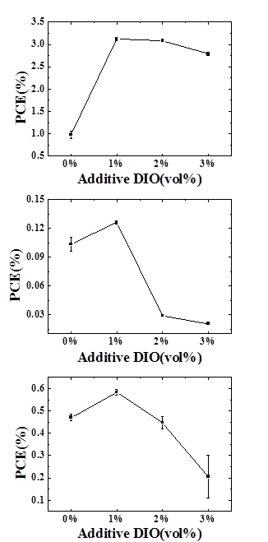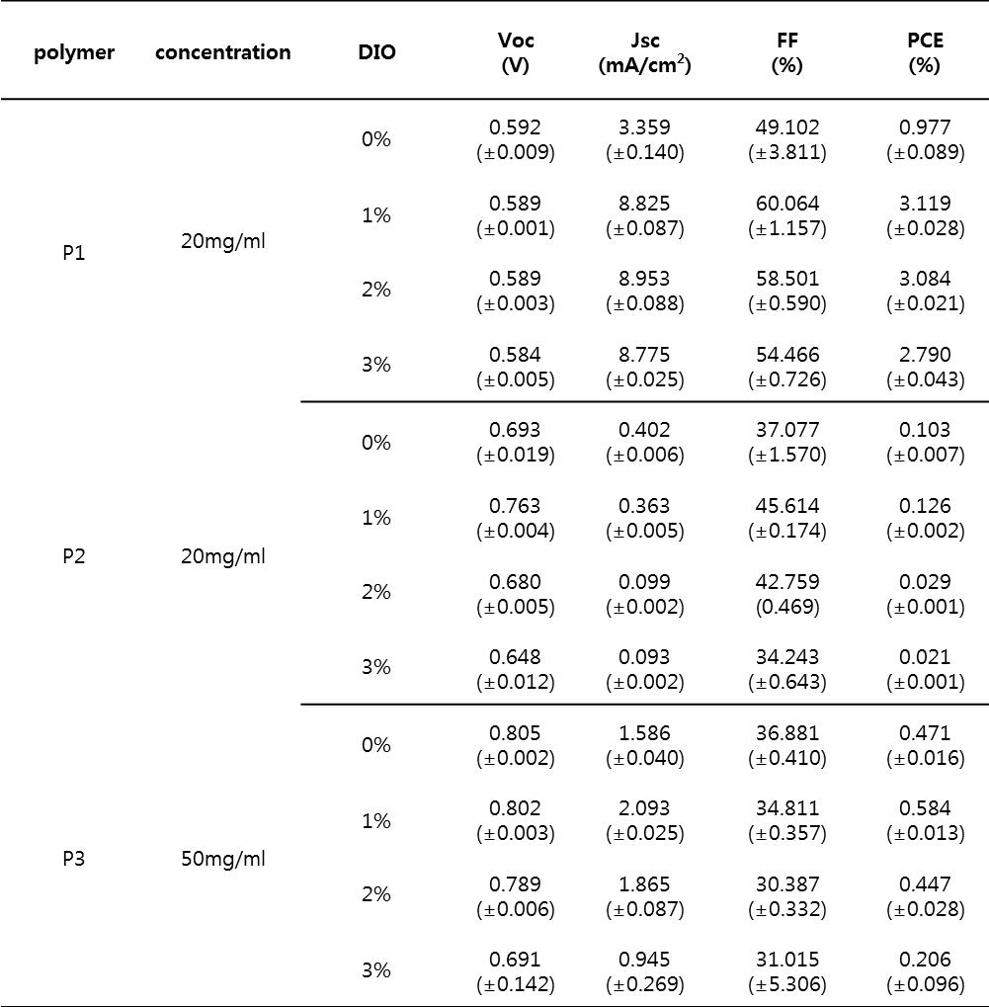
Figure S7. Variation of PCEs based on DIO optimization
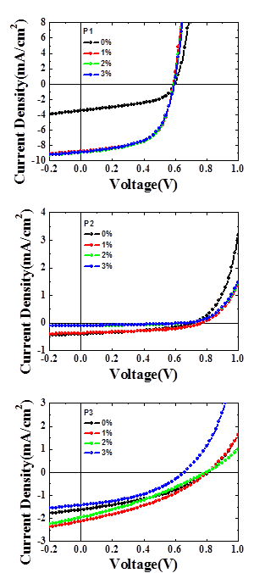
Figure S8. Variation of P-V curves based on DIO optimization
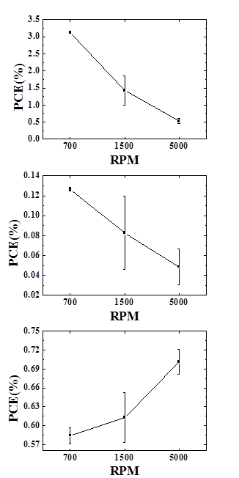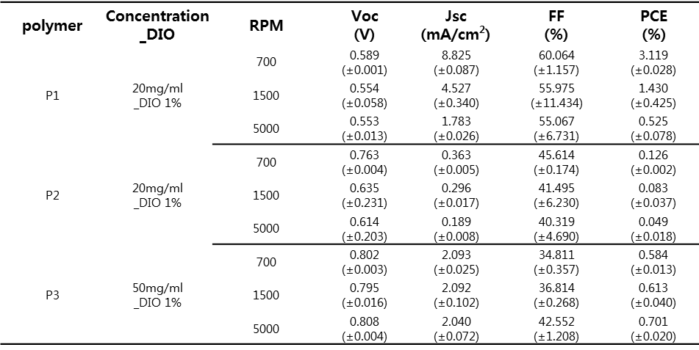
Figure S9. Variation of PCE based on film thickness optimization
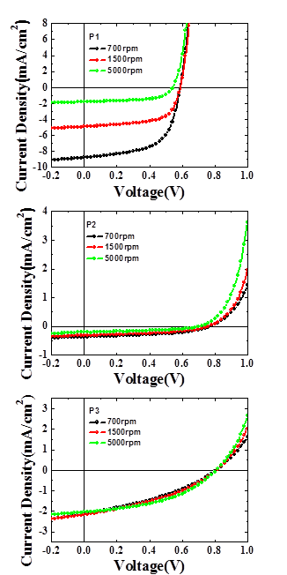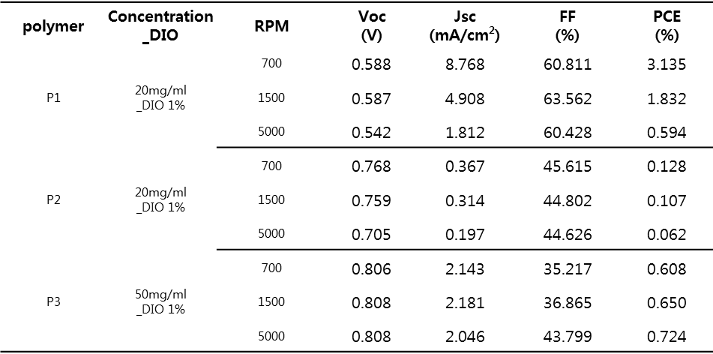
Figure S10. Variation of P-V curves based on film thickness optimization
Table S1. Solar cell parameters of the devices fabricated from P1~P3 at optimized condition
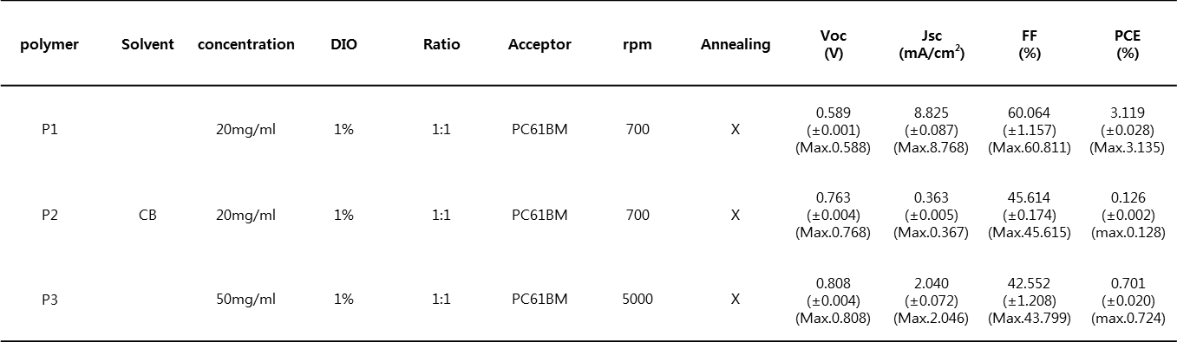

Table S2. Solar cell parameters of the devices fabricated from P1 at DIO optimized condition
