*Supporting information for*

**Methyl 2-naphthoates from a traditional Chinese herb** ***Morinda officinalis* var. *officinalis***

**Jin-Hai Yu,† Hui-Juan** **Zhai,† Zhi-Pu Yu, Qian-Qian Zhang, Yong-Xi Ge, Yu-Ying Zhang, Cheng-Shi Jiang, Hua Zhang\***

*School of Biological Science and Technology, University of Jinan, 336 West Road of Nan Xinzhuang, Jinan 250022, China*

Table of contents

**Table S1.** Crystal data and structure refinement for **1** 1

**Table S2.** Experimental 13C NMR data of **5** and calculated 13C NMR data for **5** and 13-*epi*-**5** 2

**Table S3.** Preliminary cytotoxic screening results (inhibition ratio, %) of **1**‑**15** at 30 *μ*M. 3

**Table S4.** Preliminary anti-cholinesterase screening results (inhibition ratio, %) of **1**‑**15** at 50 *μ*M. 4

**Table S5.** Re-optimized conformers, energies and proportions for **1** (12*R*, 13*S*, 14*R*) 5

**Table S6.** Re-optimized conformers, energies and proportions for **5** (12*R*, 13*S*, 14*R*) 6

**Table S7.** Re-optimized conformers, energies and proportions for*13-epi*-**5** (12*R*, 13*R*, 14*R*) 7

**Table S8.** Re-optimized conformers, energies and proportions for **10** (4*S*, 14*R*) 8

**Table S9.** Re-optimized conformers, energies and proportions for **12** (14*R*) 9

**Figure S1.** 1H NMR spectrum of **1**/**2** in CDCl3 10

**Figure S2.** 13C & DEPT NMR spectra of **1**/**2** in CDCl3 11

**Figure S3.** 1H−1H COSY spectrum of **1**/**2** in CDCl3 12

**Figure S4.** HSQC spectrum of **1**/**2** in CDCl3 13

**Figure S5.** HMBC spectrum of **1**/**2** in CDCl3 14

**Figure S6.** NOESY spectrum of **1**/**2** in CDCl3 15

**Figure S7.** (+)-LR-ESIMS spectrum of **1**/**2** 16

**Figure S8.** (+)-HR-ESIMS spectrum of **1**/**2** 17

**Figure S9.** 1H NMR spectrum of **3**/**4** in CDCl3 18

**Figure S10.** 13C and DEPT NMR spectra of **3**/**4** in CDCl3 19

**Figure S11.** 1H−1H COSY spectrum of **3**/**4** in CDCl3 20

**Figure S12.** HSQC spectrum of **3**/**4** in CDCl3 21

**Figure S13.** HMBC spectrum of **3**/**4** in CDCl3 22

**Figure S14.** NOSEY spectrum of **3**/**4** in CDCl3 23

**Figure S15.** (+)-LR-ESIMS spectrum of **3**/**4** 24

**Figure S16.** (+)-HR-ESIMS spectrum of **3**/**4** 25

**Figure S17.** 1H NMR spectrum of **5**/**6** in methanol-*d*4 26

**Figure S18.** 13C and DEPT NMR spectra of **5**/**6** in methanol-*d*4 27

**Figure S19.** 1H−1H COSY spectrum of **5**/**6** in methanol-*d*4 28

**Figure S20.** HSQC spectrum of **5**/**6** in methanol-*d*4 29

**Figure S21.** HMBC spectrum of **5**/**6** in methanol-*d*4 30

**Figure S22.** NOESY spectrum of **5**/**6** in methanol-*d*4 31

**Figure S23.** (+)-LR-ESIMS spectrum of **5**/**6** 32

**Figure S24.** (+)-HR-ESIMS spectrum of **5**/**6** 33

**Figure S25.** 1H NMR spectrum of **7**/**8** in methanol-*d*4 34

**Figure S26.** 13C and DEPT NMR spectra of **7**/**8** in methanol-*d*4 35

**Figure S27.** 1H−1H COSY spectrum of **7**/**8** in methanol-*d*4 36

**Figure S28.** HSQC spectrum of **7**/**8** in methanol-*d*4 37

**Figure S29.** HMBC spectrum of **7**/**8** in methanol-*d*4 38

**Figure S30.** NOESY spectrum of **7**/**8** in methanol-*d*4 39

**Figure S31.** (+)-LR-ESIMS spectrum of **7**/**8** 40

**Figure S32.** (+)-HR-ESIMS spectrum of **7**/**8** 41

**Figure S33.** 1H NMR spectrum of **9**/**10** in CDCl3 42

**Figure S34.** 13C and DEPT NMR spectra of **9**/**10** in CDCl3 43

**Figure S35.** 1H−1H COSY spectrum of **9**/**10** in CDCl3 44

**Figure S36.** HSQC spectrum of **9**/**10** in CDCl3 45

**Figure S37.** HMBC spectrum of **9**/**10** in CDCl3 46

**Figure S38.** NOESY spectrum of **9**/**10** in CDCl3 47

**Figure S39.** (+)-LR-ESIMS spectrum of **9**/**10** 48

**Figure S40.** (+)-HR-ESIMS spectrum of **9**/**10** 49

**Figure S41.** 1H NMR spectrum of **13** in methanol-*d*4 50

**Figure S42.** 13C and DEPT NMR spectra of **13** in methanol-*d*4 51

**Figure S43.** 1H−1H COSY spectrum of **13** in methanol-*d*4 52

**Figure S44.** HSQC spectrum of **13** in methanol-*d*4 53

**Figure S45.** HMBC spectrum of **13** in methanol-*d*4 54

**Figure S46.** NOESYspectrum of **13** in methanol-*d*4 55

**Figure S47.** (+)-LR-ESIMSspectrum of **13** 56

**Figure S48.** (+)-HR-ESIMSspectrum of **13** 57

**Figure S49** ChiralHPLC analyses for compounds **1**−**12** 58

**Figure S50.** 1H NMR spectra for the enantiomers of **1** and **2** in CDCl3 59

**Figure S51.** 1H NMR spectra for the enantiomers of **3** and **4** in CDCl3 60

**Figure S52.** 1H NMR spectra for the enantiomers of **5** and **6** in methanol-*d*4 61

**Figure S53.** 1H NMR spectra for the enantiomers of **7** and **8** in methanol-*d*4 62

**Figure S54.** 1H NMR spectra for the enantiomers of **9** and **10** in CDCl3 63

**Figure S55.** 1H NMR spectra for the enantiomers of **11** and **12** in CDCl3 64

**Table S1.** Crystal data and structure refinement for **1**

|  |  |  |
| --- | --- | --- |
| Empirical formula | C19H20O6 | |
| Formula weight | 344.35 | |
| Temperature | 296 (2) K | |
| Wavelength | 1.54178 Å | |
| Crystal system | orthorhombic | |
| Space group | P 21 21 21 | |
| Unit cell dimensions | a = 10.2153(4) Å | α= 90° |
| b = 10.6252(4) Å | β= 90° |
| c = 15.7108(6) Å | γ= 90° |
| Volume | 1705.24(11) Å3 | |
| Z | 4 | |
| Density (calculated) | 1.341 g/cm3 | |
| Absorption coefficient | 0.832 mm-1 | |
| F(000) | 728.0 | |
| Theta range for data collection | 5.025 to 74.824° | |
| Index ranges | −12<=h<=12, −13<=k<=13, −19<=l<=19 | |
| Reflections collected | 28651 | |
| Independent reflections | 9911 | |
| Completeness to theta = 67.679° | 96.9 % | |
| Absorption correction | multi-scan | |
| Max. and min. transmission | 0.7538 and 0.3042 | |
| Refinement method | Full-matrix least-squares on F2 | |
| Data / restraints / parameters | 3503 / 0 / 230 | |
| Goodness-of-fit on F2 | 1.092 | |
| Final R indices [I>2sigma(I)] | R1 = 0.0733, wR2 = 0.1697 | |
| R indices (all data) | R1 = 0.0814, wR2 = 0.1764 | |
| Absolute structure parameter | -0.2(2) | |
| Extinction coefficient | n/a | |
| *a* Colorless crystals of **1** were obtained in acetone with a litter methanol | | |

**Table S2.** Experimental 13C NMR data of **5** and calculated 13C NMR data for **5** and 13-*epi*-**5**

|  |  |  |  |
| --- | --- | --- | --- |
| position | expl. dataof **5** | calcd. data for **5** | calcd. data for 13-*epi*-**5** |
| 1 | 153.2 | 151.9 | 151.6 |
| 2 | 108.4 | 101.6 | 101.3 |
| 3 | 112.8 | 113.1 | 112.6 |
| 4 | 143.0 | 137.0 | 137.0 |
| 5 | 123.6 | 119.3 | 119.3 |
| 6 | 129.6 | 126.5 | 126.4 |
| 7 | 127.9 | 123.4 | 123.2 |
| 8 | 124.3 | 121.9 | 121.7 |
| 9 | 127.1 | 121.2 | 120.8 |
| 10 | 129.1 | 124.0 | 124.2 |
| 11 | 172.4 | 166.6 | 166.8 |
| 12 | **77.7** | **77.6** | **72.8** |
| 13 | **78.2** | **78.2** | **69.5** |
| 14 | **81.3** | **81.1** | **81.6** |
| 15 | **66.3** | **67.5** | **68.2** |
| 16 | **15.4** | **15.5** | **21.2** |
| 11-OMe | 53.0 | 53.2 | 53.2 |
| 12-OMe | 56.4 | 56.7 | 56.4 |
| 13-OMe | 60.0 | 58.1 | 55.6 |

**Table S3.** Preliminary cytotoxic screening results (inhibition ratio, %) of **1**‑**15** at 30 *μ*M.

|  |  |  |  |
| --- | --- | --- | --- |
|  | A549 | MDA-MB-231 | MCF-7 |
| **1** | -18.09% | 6.25% | 5.12% |
| **2** | -9.05% | 3.87% | 8.10% |
| **3** | -26.88% | 4.49% | 5.55% |
| **4** | -17.15% | -8.07% | 8.45% |
| **5** | -7.76% | -10.92% | 13.61% |
| **6** | -9.12% | -9.72% | 15.17% |
| **7** | -0.24% | -3.75% | 7.61% |
| **8** | -18.85% | -15.30% | 12.75% |
| **9** | 96.48% | 96.51% | 98.17% |
| **10** | 93.69% | 90.39% | 80.92% |
| **11** | -0.56% | / | / |
| **12** | -16.82% | / | / |
| **13** | 11.91% | 0.95% | 17.13% |
| **14** | 0.15% | -2.92% | 9.77% |
| **15** | 4.79% | 10.43% | 0.72% |

**Table S4.** Preliminary anti-cholinesterase screening results (inhibition ratio, %) of **1**‑**15** at 50 *μ*M.

|  |  |  |
| --- | --- | --- |
|  | AChE | BChE |
| **1** | 4.3% | 18.0% |
| **2** | 5.5% | 57.0% |
| **3** | 14.0% | 18.0% |
| **4** | 2.4% | 20.0% |
| **5** | 13.0% | 11.0% |
| **6** | 19.0% | 6.0% |
| **7** | 19.0% | 9.0% |
| **8** | 11.0% | 37.0% |
| **9** | 14.0% | 18.0% |
| **10** | 2.4% | 20.0% |
| **11** | 13.0% | 9.0% |
| **12** | 19.0% | 9.0% |
| **13** | 7.5% | 41.0% |
| **14** | 8.0% | 4.0% |
| **15** | 4.0% | 0.0% |

**Table S5.** Re-optimized conformers, energies and proportions for **1** (12*R*,13*S*,14*R*)

|  |  |  |  |  |
| --- | --- | --- | --- | --- |
| Number | Conformer | Energy (hartree) | Energy (kcal/mol) | Proportion (%) |
| 1 | C:\Users\Administrator\Desktop\ZHJ\74\opt\conf1.tif | -1187.1649282 | -744957.864094782 | 49.53 |
| 2 | C:\Users\Administrator\Desktop\ZHJ\74\opt\conf2.tif | -1187.1646778 | -744957.706966278 | 37.99 |
| 3 | C:\Users\Administrator\Desktop\ZHJ\74\opt\conf3.tif | -1187.162283 | -744956.20420533 | 3.00 |
| 4 | C:\Users\Administrator\Desktop\ZHJ\74\opt\conf4.tif | -1187.16244 | -744956.3027244 | 3.54 |
| 5 | C:\Users\Administrator\Desktop\ZHJ\74\opt\conf5.tif | -1187.1621373 | -744956.112777123 | 2.57 |
| 6 | C:\Users\Administrator\Desktop\ZHJ\74\opt\conf6.tif | -1187.1610341 | -744955.420508091 | 0.80 |
| 7 | C:\Users\Administrator\Desktop\ZHJ\74\opt\conf7.tif | -1187.162137 | -744956.11258887 | 2.57 |

**Table S6.** Re-optimized conformers, energies and proportions for **5** (12*R*,13*S*,14*R*)

|  |  |  |  |  |
| --- | --- | --- | --- | --- |
| Number | Conformer | Energy (hartree) | Energy (kcal/mol) | Proportion (%) |
| 1 | C:\Users\Administrator\Desktop\ZHJ\3\opt\conf1.png | -1264.1573677 | -793271.389805427 | 37.23 |
| 2 | C:\Users\Administrator\Desktop\ZHJ\3\opt\conf2.png | -1264.1539411 | -793269.239579661 | 0.98 |
| 3 | C:\Users\Administrator\Desktop\ZHJ\3\opt\conf3.png | -1264.1556481 | -793270.310739231 | 6.01 |
| 4 | C:\Users\Administrator\Desktop\ZHJ\3\opt\conf4.png | -1264.1566855 | -793270.961718105 | 18.07 |
| 5 | C:\Users\Administrator\Desktop\ZHJ\3\opt\conf5.png | -1264.1573736 | -793271.393507736 | 37.47 |
| 6 | C:\Users\Administrator\Desktop\ZHJ\3\opt\conf6.png | -1264.1525925 | -793268.393319675 | 0.24 |

**Table S7.** Re-optimized conformers, energies and proportions for*13-epi*-**5** (12*R*,13*R*,14*R*)

|  |  |  |  |  |
| --- | --- | --- | --- | --- |
| Number | Conformer | Energy (hartree) | Energy (kcal/mol) | Proportion (%) |
| 1 | C:\Users\Administrator\Desktop\ZHJ\3\trans-3\opt\conf1.png | -1264.149628 | -793266.53306628 | 9.51 |
| 2 | C:\Users\Administrator\Desktop\ZHJ\3\trans-3\opt\conf2.png | -1264.1500892 | -793266.822473892 | 15.5 |
| 3 | C:\Users\Administrator\Desktop\ZHJ\3\trans-3\opt\conf3.png | -1264.1486867 | -793265.942391117 | 3.50 |
| 4 | C:\Users\Administrator\Desktop\ZHJ\3\trans-3\opt\conf4.png | -1264.1515312 | -793267.727343312 | 71.49 |

**Table S8.** Re-optimized conformers, energies and proportions for **10** (4*S*,14*R*)

|  |  |  |  |  |
| --- | --- | --- | --- | --- |
| Number | Conformer | Energy (hartree) | Energy (kcal/mol) | Proportion (%) |
| 1 | C:\Users\Administrator\Desktop\ZHJ\16\opt\conf1.tif | -1032.1085422 | -647658.431315922 | 93.54 |
| 2 | C:\Users\Administrator\Desktop\ZHJ\16\opt\conf2.tif | -1032.0969837 | -647651.178241587 | 0.00 |
| 3 | C:\Users\Administrator\Desktop\ZHJ\16\opt\conf3.tif | -1032.1060214 | -647656.849488714 | 6.46 |

**Table S9.** Re-optimized conformers, energies and proportions for **12** (14*R*)

|  |  |  |  |  |
| --- | --- | --- | --- | --- |
| Number | Conformer | Energy (hartree) | Energy (Kcal/mol) | Proportion (%) |
| 1 | C:\Users\Administrator\Desktop\ZHJ\43\opt\conf1.tif | -1033.3519061 | -648438.654596811 | 31.81 |
| 2 | C:\Users\Administrator\Desktop\ZHJ\43\opt\conf2.tif | -1033.3518919 | -648438.645686169 | 31.34 |
| 3 | C:\Users\Administrator\Desktop\ZHJ\43\opt\conf4.tif | -1033.3511138 | -648438.157420638 | 13.73 |
| 4 | C:\Users\Administrator\Desktop\ZHJ\43\opt\conf5.tif | -1033.3514372 | -648438.360357372 | 19.35 |
| 5 | C:\Users\Administrator\Desktop\ZHJ\43\opt\conf8.tif | -1033.3492318 | -648436.976446818 | 1.87 |
| 6 | C:\Users\Administrator\Desktop\ZHJ\43\opt\conf12.tif | -1033.3492482 | -648436.986737982 | 1.90 |

**Figure S1.** 1H NMR spectrum of **1**/**2** in CDCl3

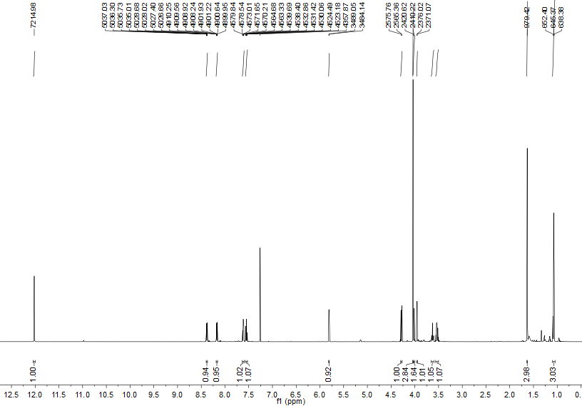



**Figure S2.** 13C & DEPT NMR spectra of **1**/**2** in CDCl3

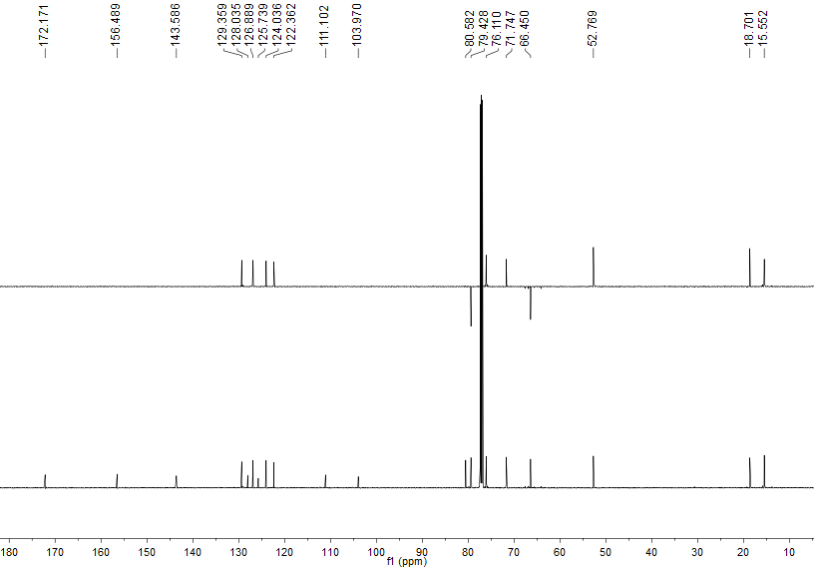



**Figure S3.** 1H−1H COSY spectrum of **1**/**2** in CDCl3

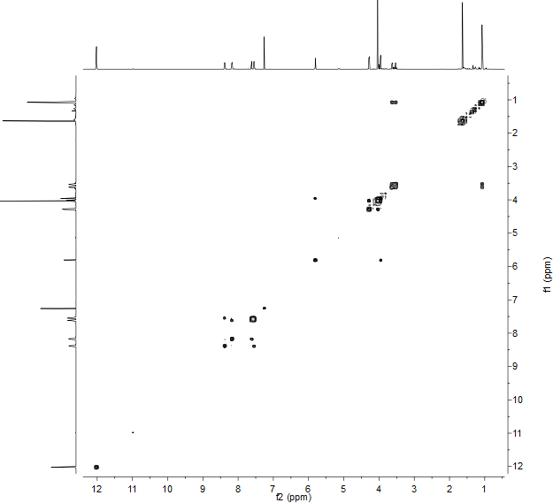

**Figure S4.** HSQC spectrum of **1**/**2** in CDCl3

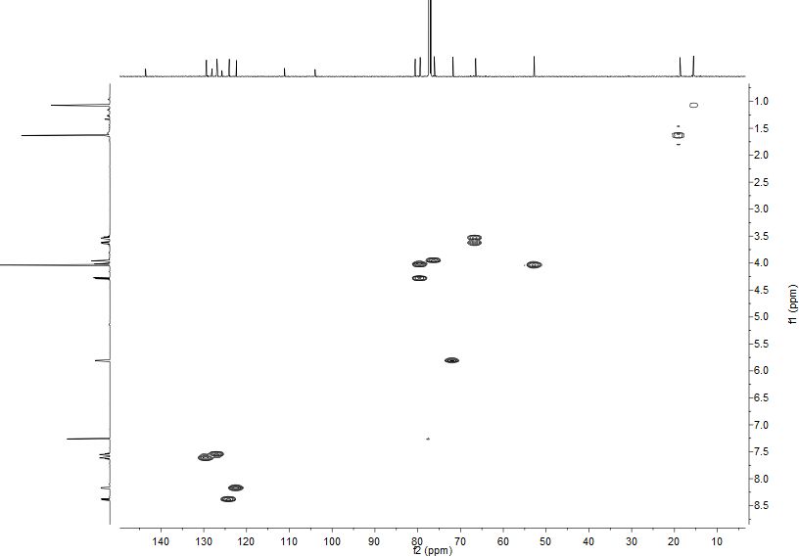

**Figure S5.** HMBC spectrum of **1**/**2** in CDCl3

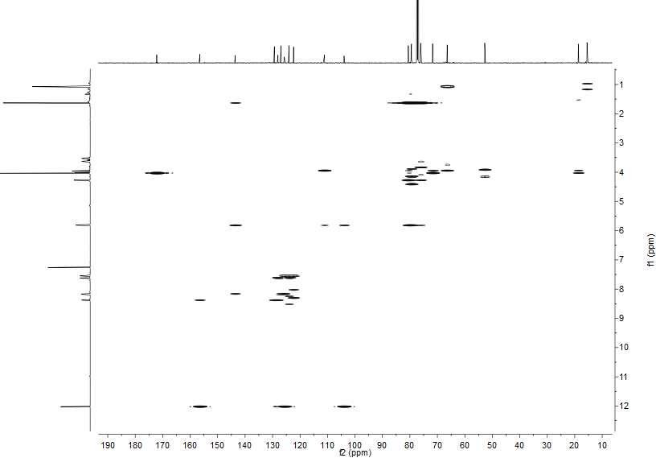

**Figure S6.** NOESY spectrum of **1**/**2** in CDCl3

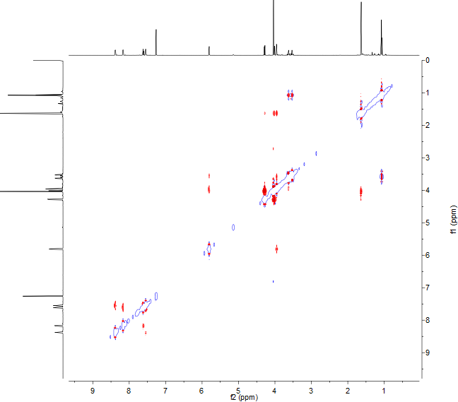

**Figure S7.** (+)-LR-ESIMS spectrum of **1**/**2**

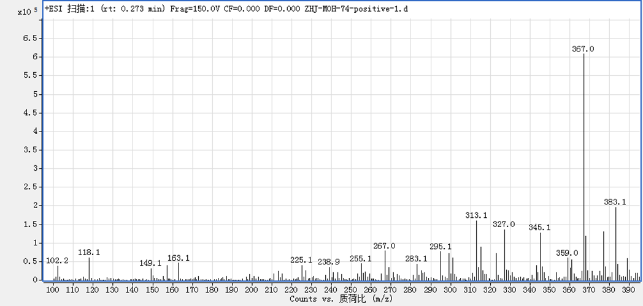

**Figure S8.** (+)-HR-ESIMS spectrum of **1**/**2**

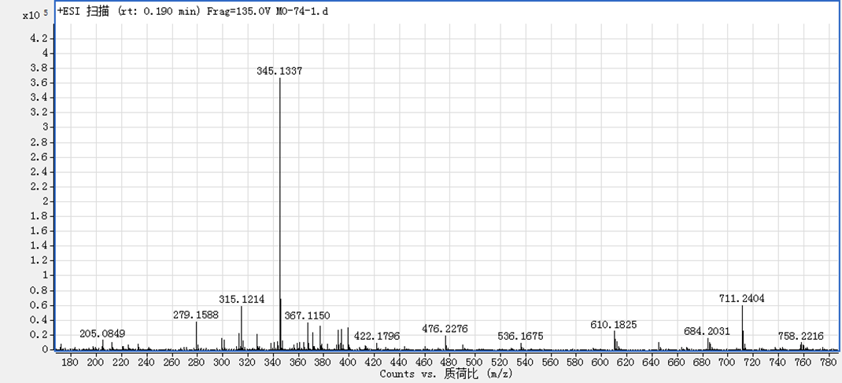

**Figure S9.** 1H NMR spectrum of **3**/**4** in CDCl3

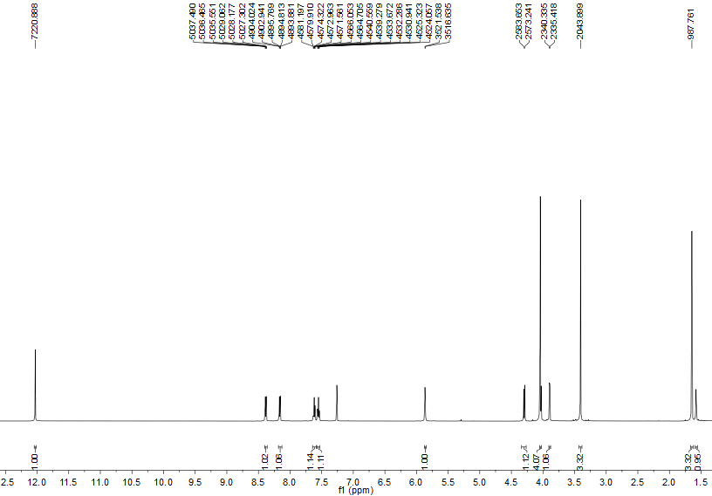



**Figure S10.** 13C and DEPT NMR spectra of **3**/**4** in CDCl3

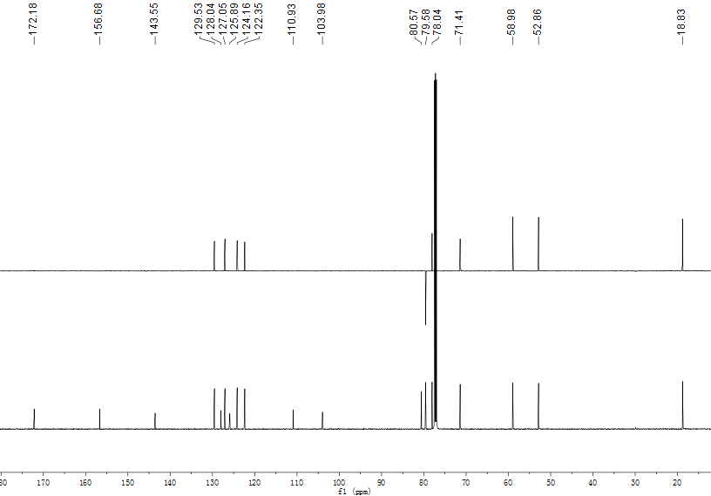



**Figure S11.** 1H−1H COSY spectrum of **3**/**4** in CDCl3

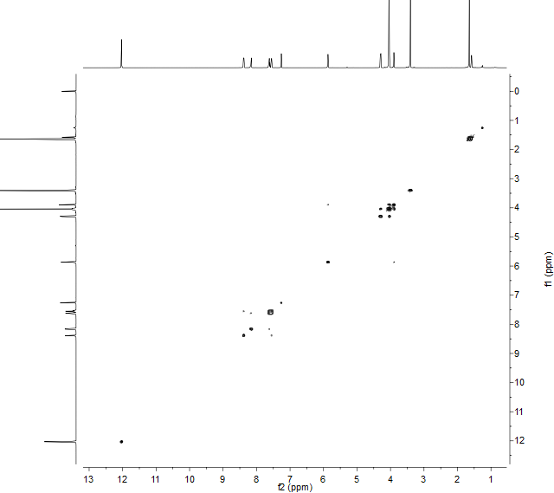

**Figure S12.** HSQC spectrum of **3**/**4** in CDCl3

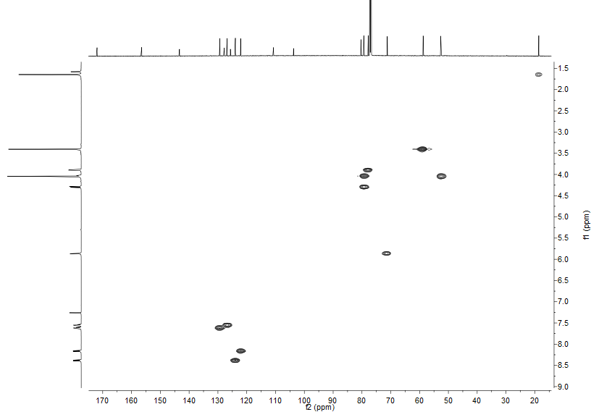

**Figure S13.** HMBC spectrum of **3**/**4** in CDCl3

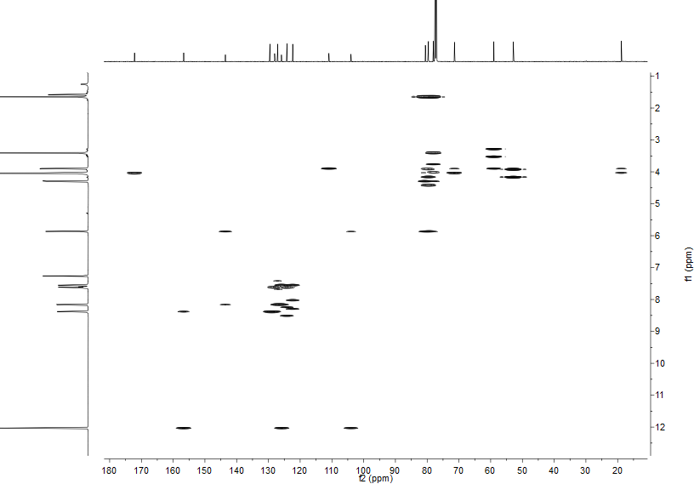

**Figure S14.** NOSEY spectrum of **3**/**4** in CDCl3

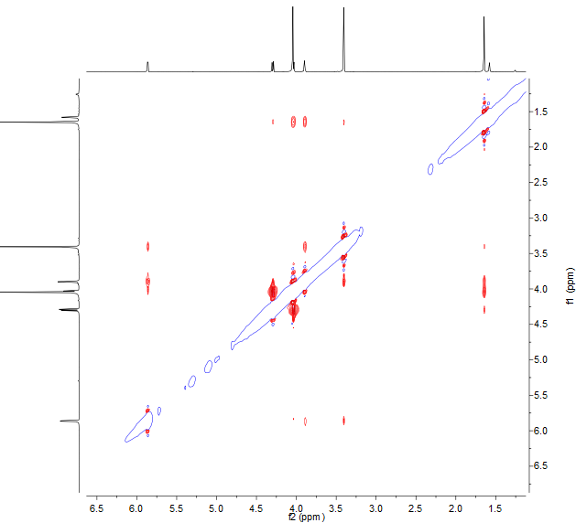

**Figure S15.** (+)-LR-ESIMS spectrum of **3**/**4**

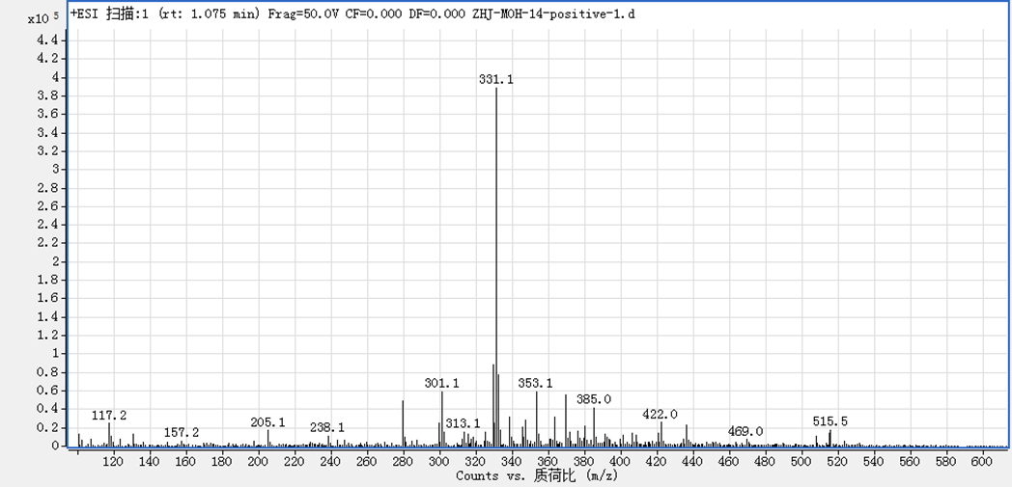

**Figure S16.** (+)-HR-ESIMS spectrum of **3**/**4**

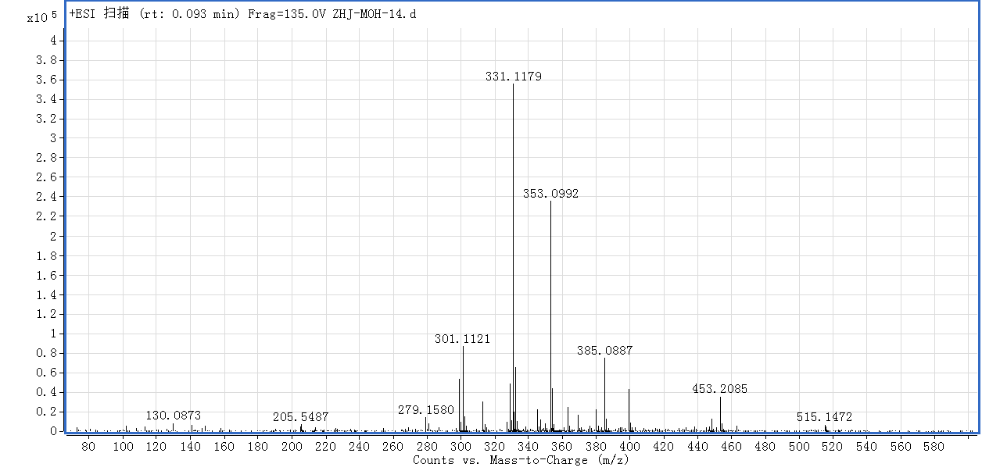

**Figure S17.** 1H NMR spectrum of **5**/**6** in methanol-*d*4

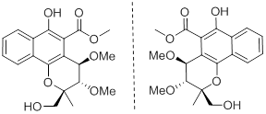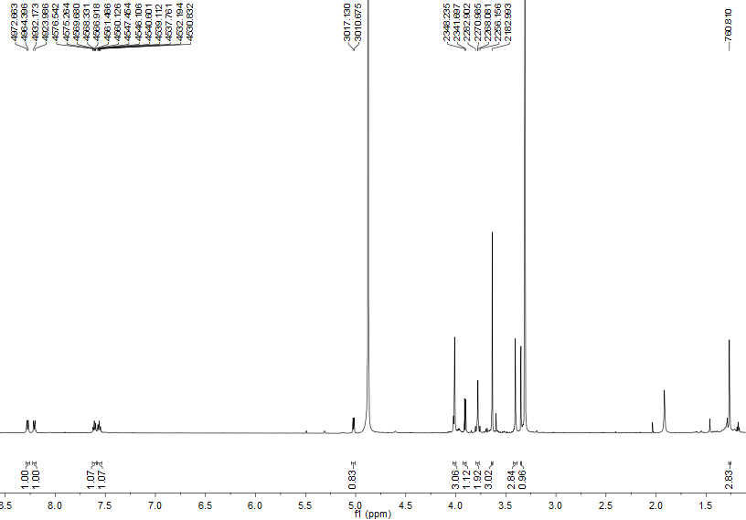

**Figure S18.** 13C and DEPT NMR spectra of **5**/**6** in methanol-*d*4

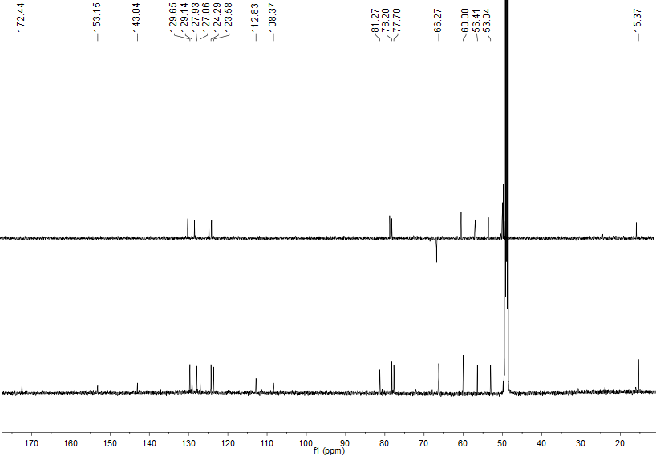

**Figure S19.** 1H−1H COSY spectrum of **5**/**6** in methanol-*d*4

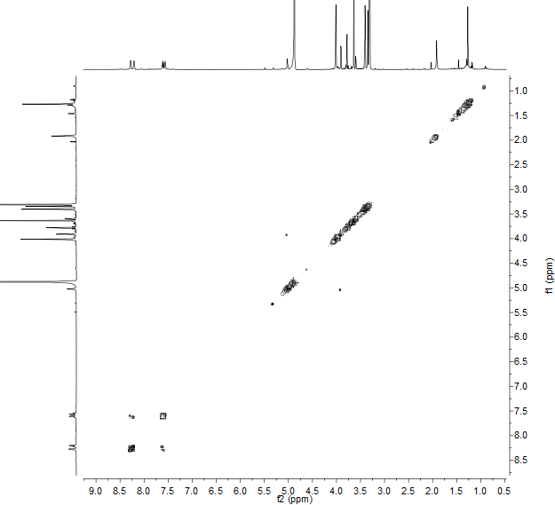

**Figure S20.** HSQC spectrum of **5**/**6** in methanol-*d*4

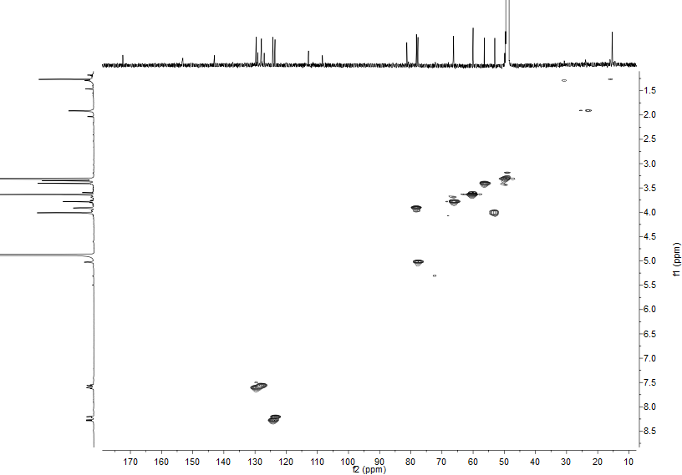

**Figure S21.** HMBC spectrum of **5**/**6** in methanol-*d*4

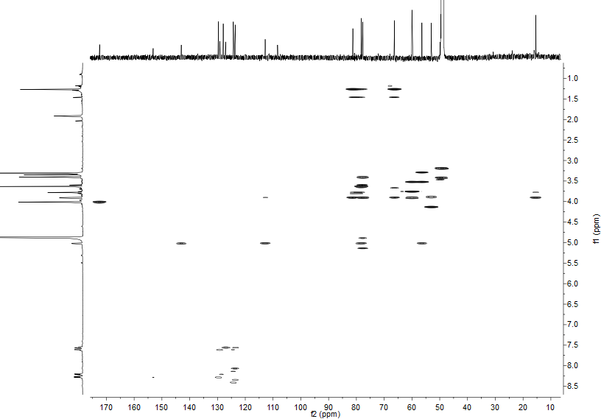

**Figure S22.** NOESY spectrum of **5**/**6** in methanol-*d*4

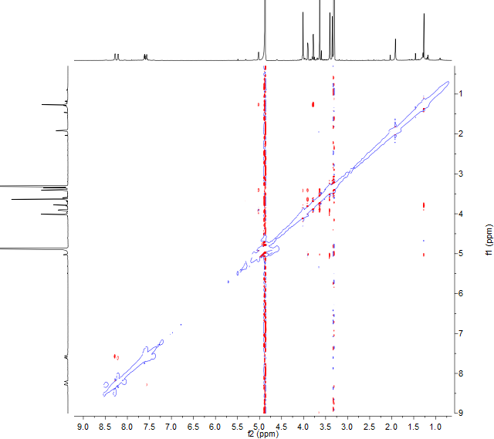

**Figure S23.** (+)-LR-ESIMS spectrum of **5**/**6**

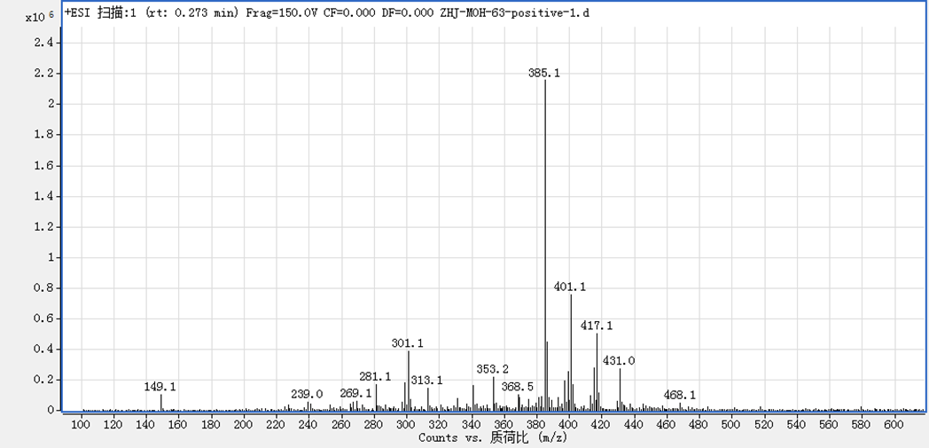

**Figure S24.** (+)-HR-ESIMS spectrum of **5**/**6**

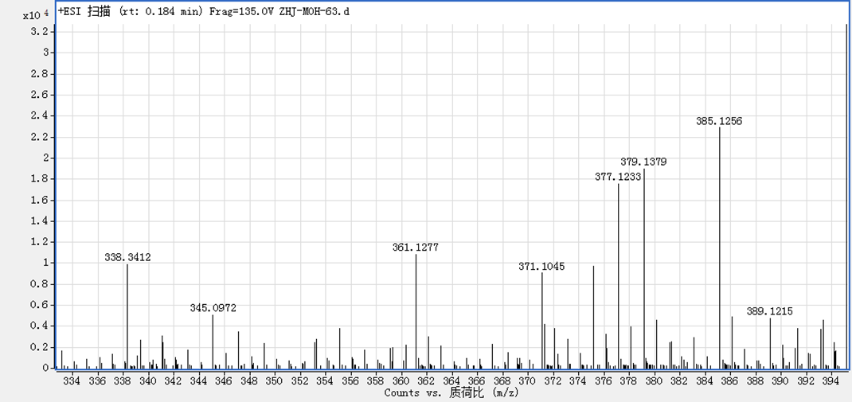

**Figure S25.** 1H NMR spectrum of **7**/**8** in methanol-*d*4

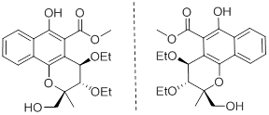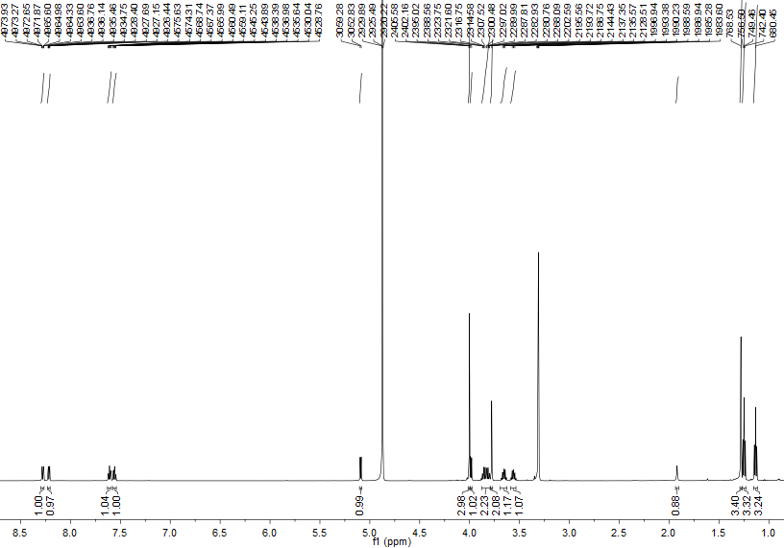

**Figure S26.** 13C and DEPT NMR spectra of **7**/**8** in methanol-*d*4

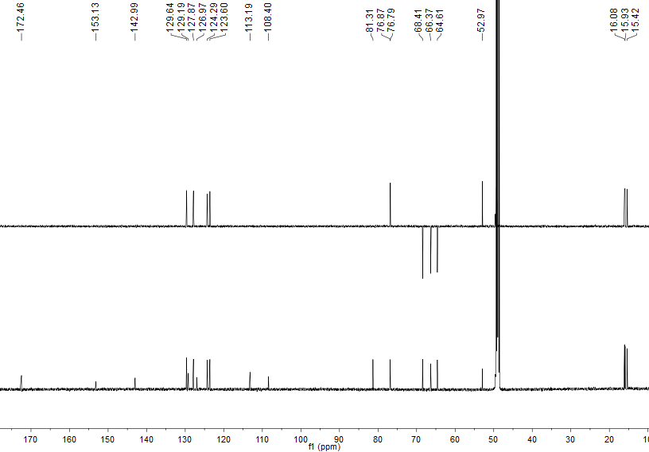

**Figure S27.** 1H−1H COSY spectrum of **7**/**8** in methanol-*d*4

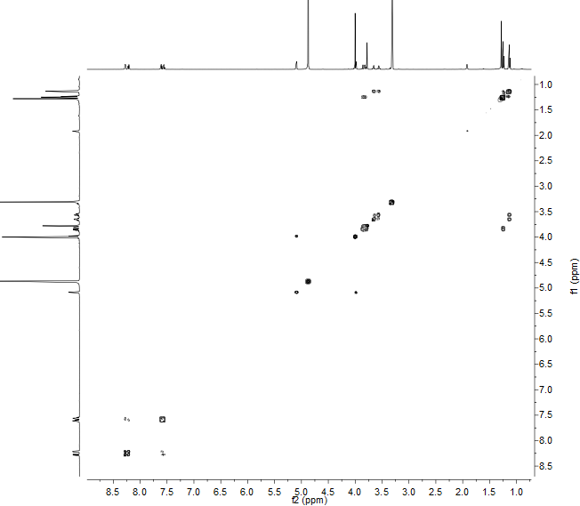

**Figure S28.** HSQC spectrum of **7**/**8** in methanol-*d*4

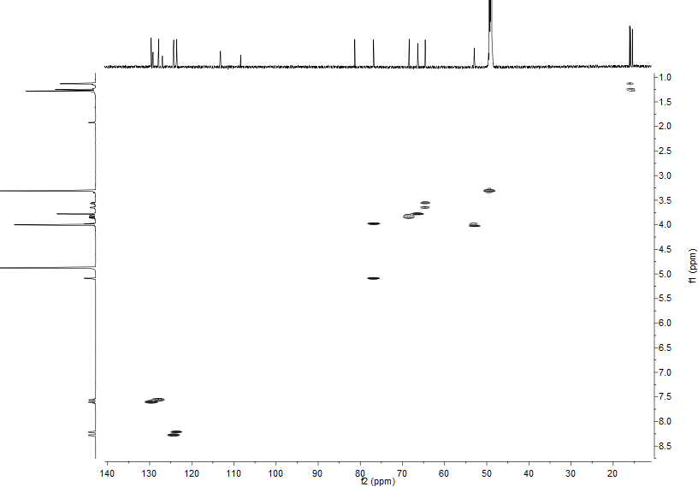

**Figure S29.** HMBC spectrum of **7**/**8** in methanol-*d*4

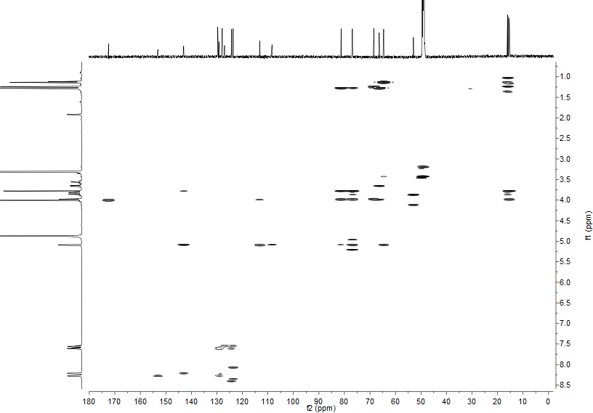

**Figure S30.** NOESY spectrum of **7**/**8** in methanol-*d*4

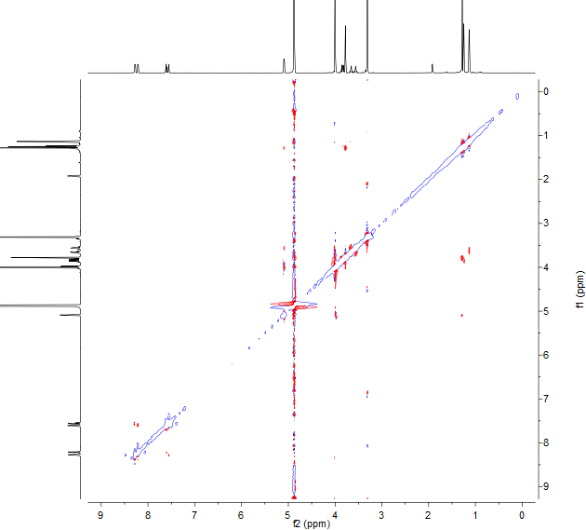

**Figure S31.** (+)-LR-ESIMS spectrum of **7**/**8**

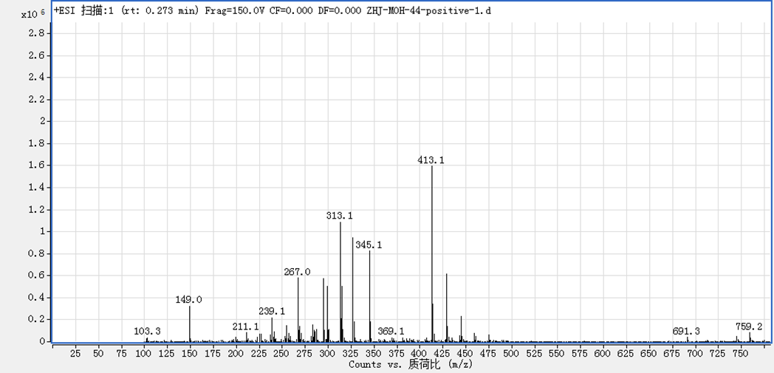

**Figure S32.** (+)-HR-ESIMS spectrum of **7**/**8**

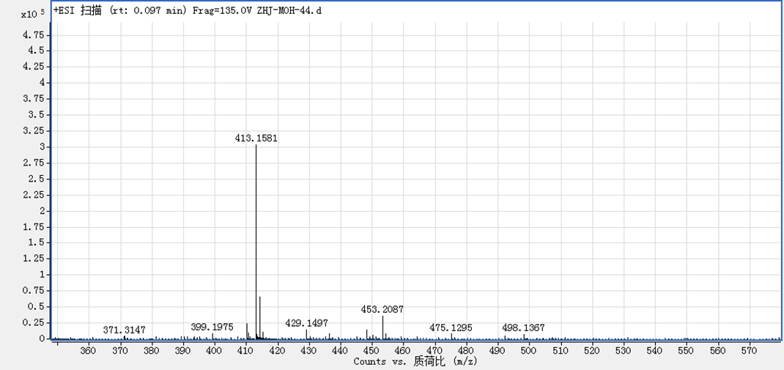

**Figure S33.** 1H NMR spectrum of **9**/**10** in CDCl3

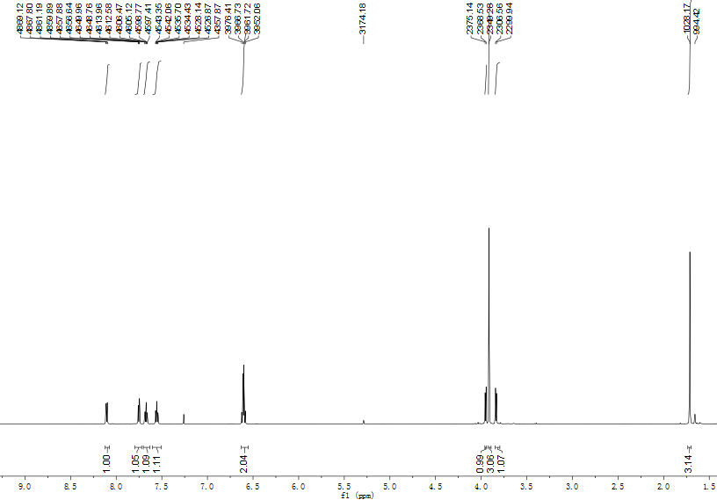



**Figure S34.** 13C and DEPT NMR spectra of **9**/**10** in CDCl3

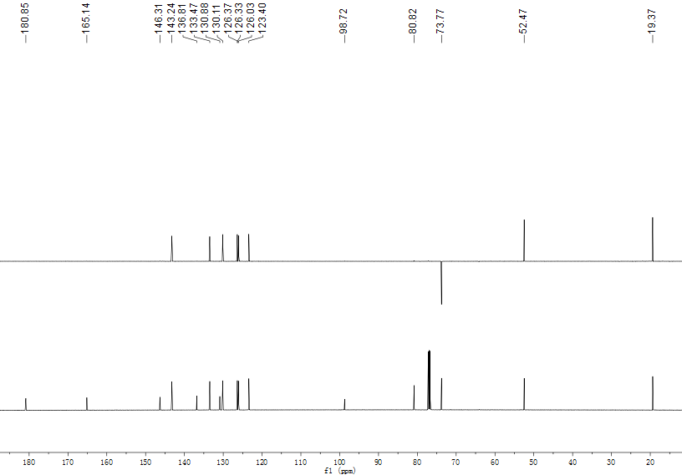



**Figure S35.** 1H−1H COSY spectrum of **9**/**10** in CDCl3

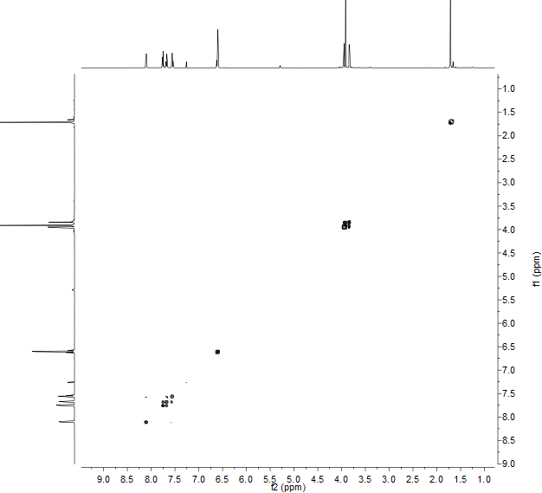

**Figure S36.** HSQC spectrum of **9**/**10** in CDCl3

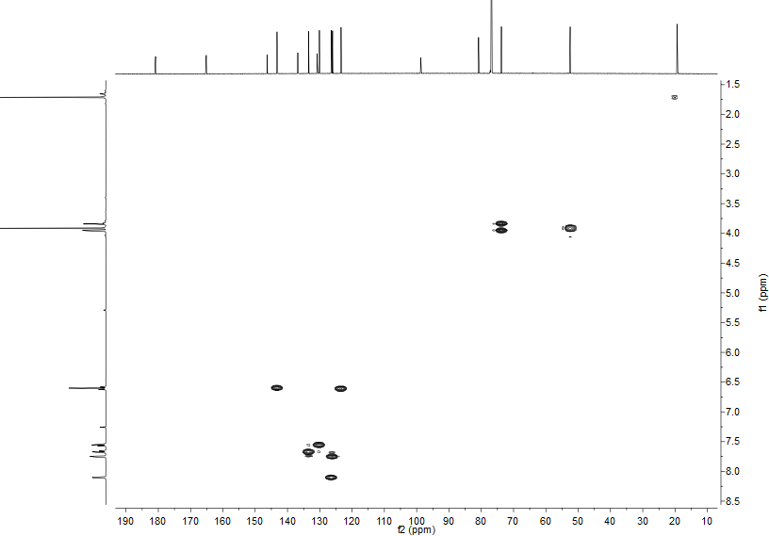

**Figure S37.** HMBC spectrum of **9**/**10** in CDCl3

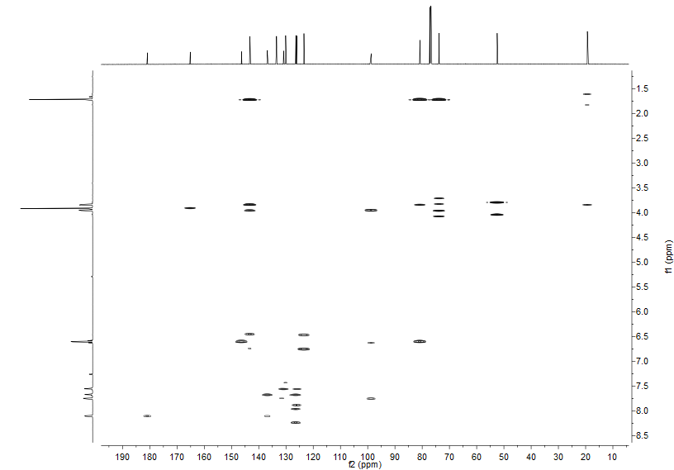

**Figure S38.** NOESY spectrum of **9**/**10** in CDCl3

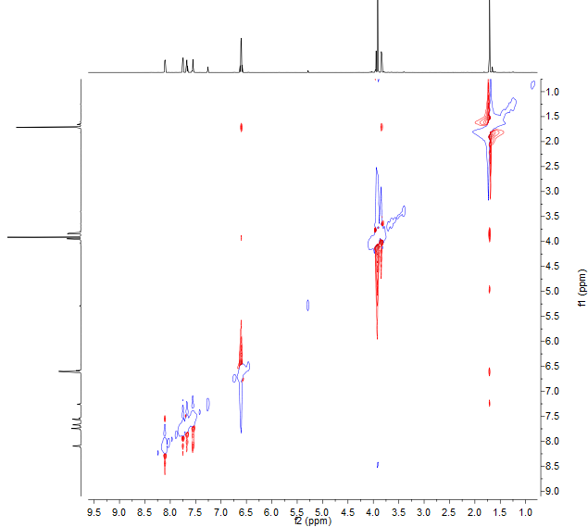

**Figure S39.** (+)-LR-ESIMS spectrum of **9**/**10**

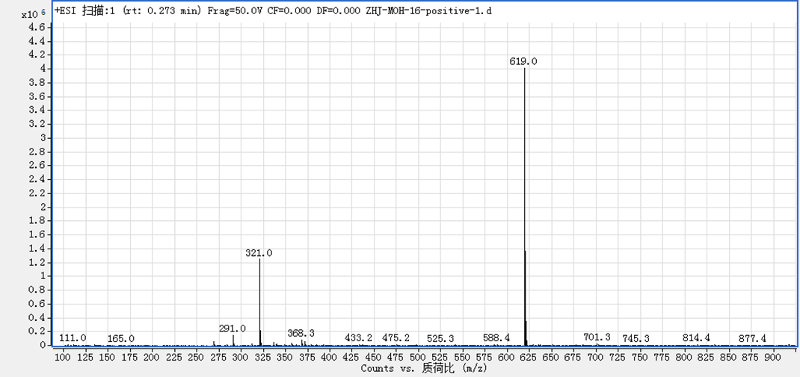

**Figure S40.** (+)-HR-ESIMS spectrum of **9**/**10**

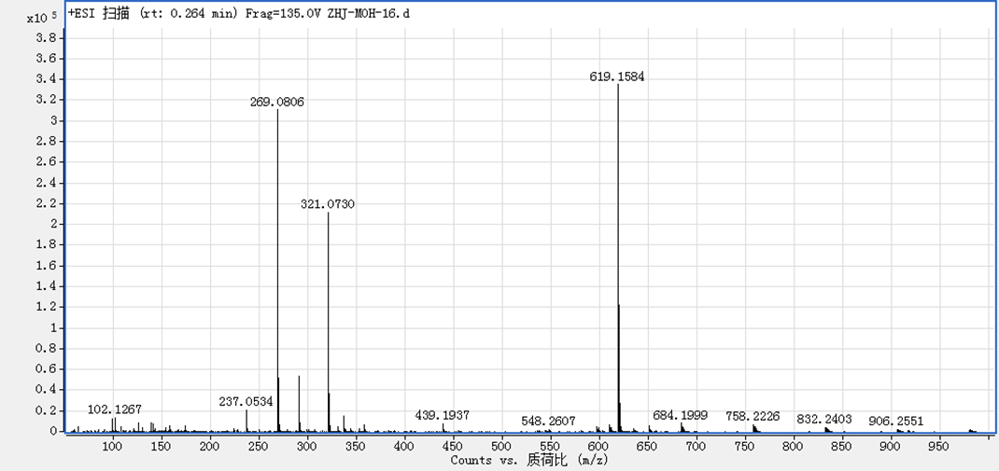

**Figure S41.** 1H NMR spectrum of **13** in methanol-*d*4

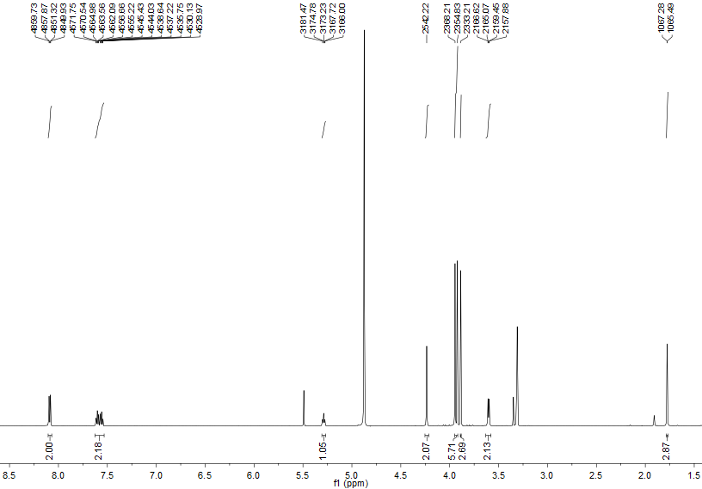



**Figure S42.** 13C and DEPT NMR spectra of **13** in methanol-*d*4

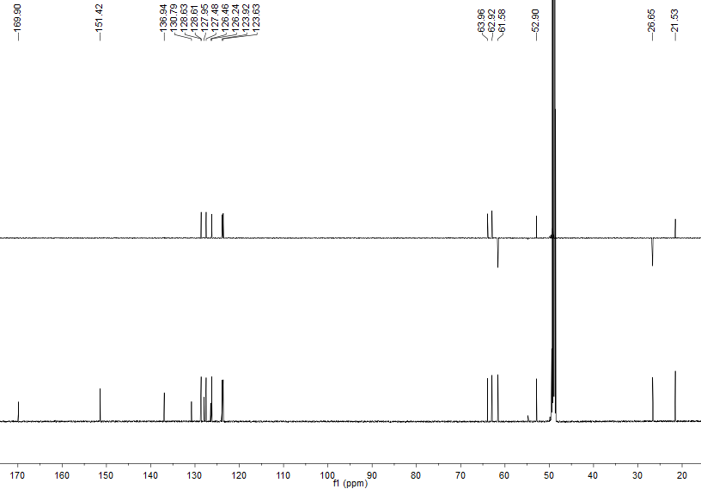



**Figure S43.** 1H−1H COSY spectrum of **13** in methanol-*d*4

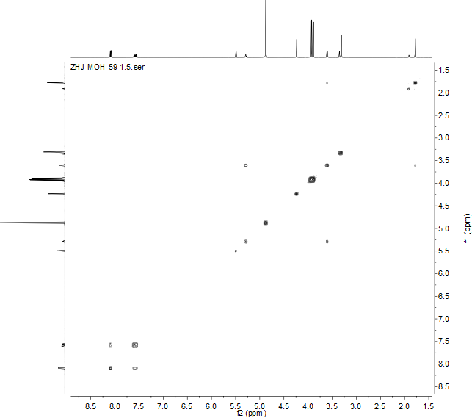

**Figure S44.** HSQC spectrum of **13** in methanol-*d*4

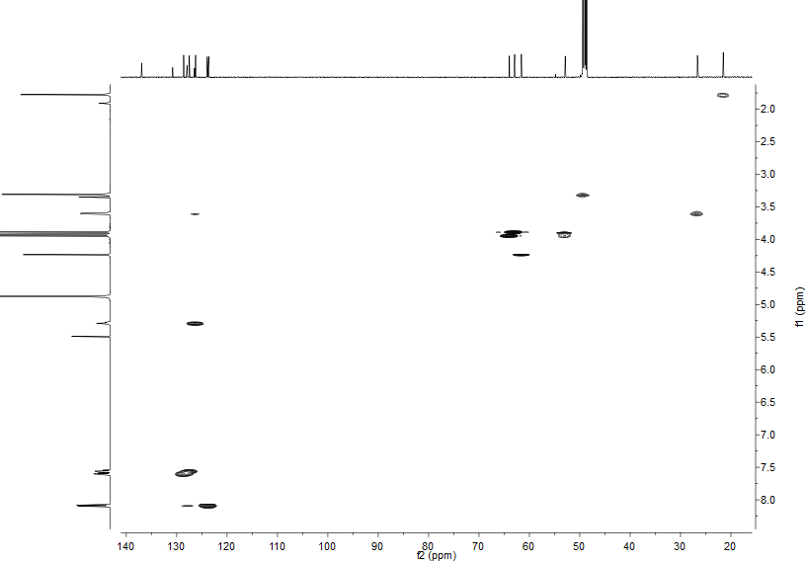

**Figure S45.** HMBC spectrum of **13** in methanol-*d*4

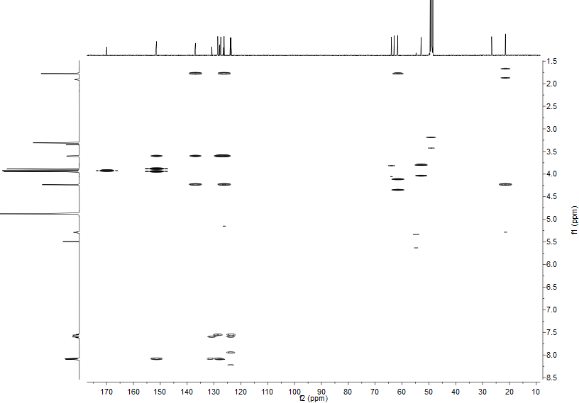

**Figure S46.** NOESYspectrum of **13** in methanol-*d*4

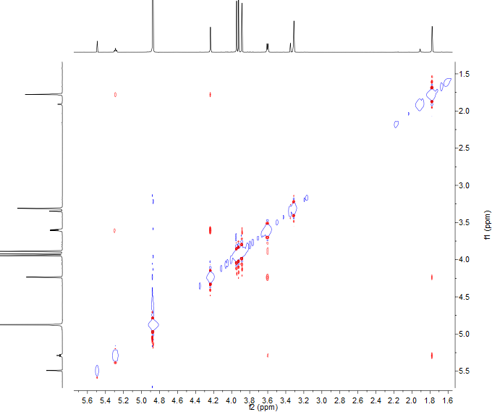

**Figure S47.** (+)-LR-ESIMSspectrum of **13**

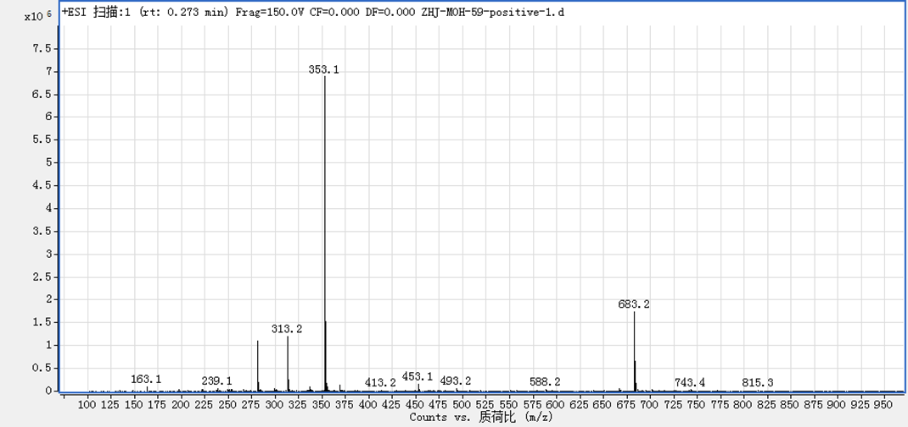

**Figure S48.** (+)-HR-ESIMSspectrum of **13**

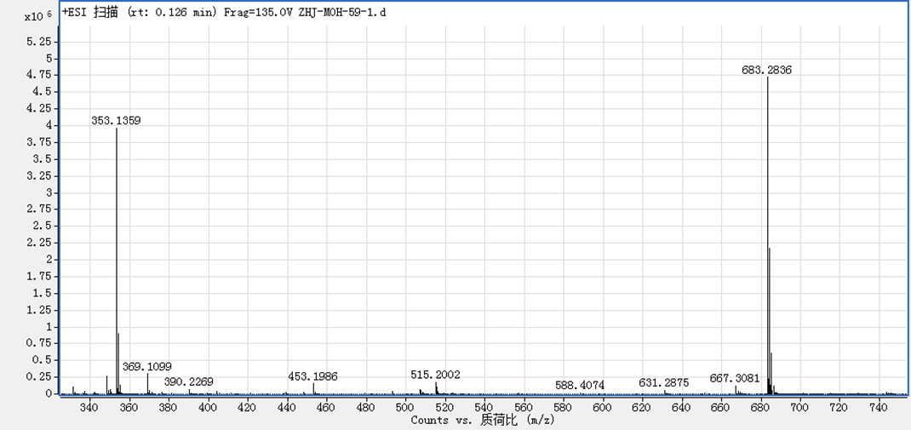

**Figure S49** ChiralHPLC analyses for compounds **1**−**12**

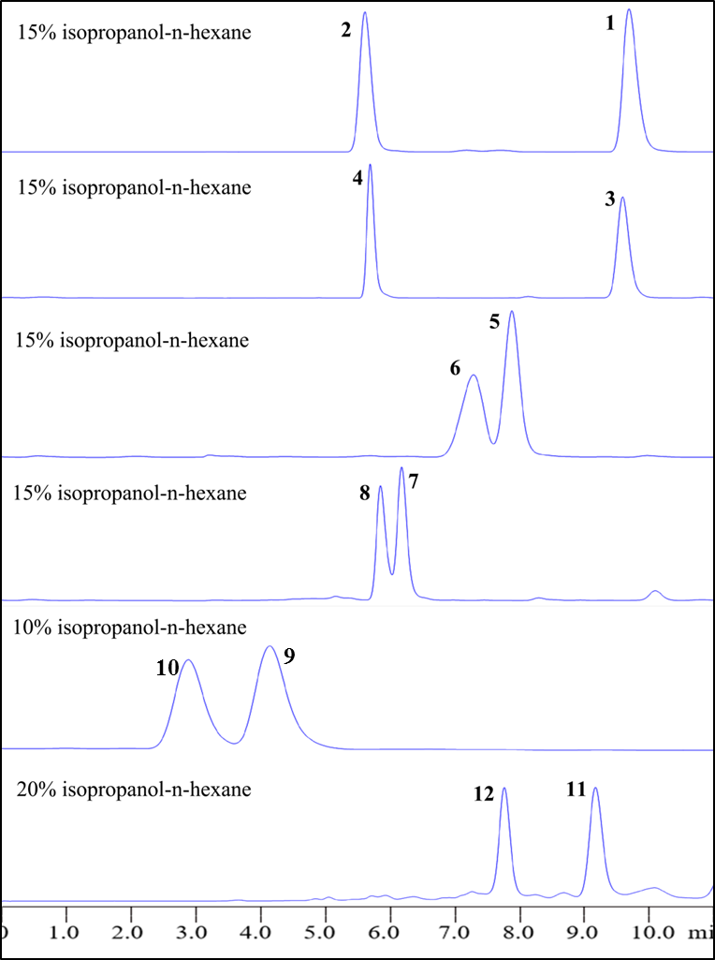

**Figure S50.** 1H NMR spectra for the enantiomers of **1** and **2** in CDCl3

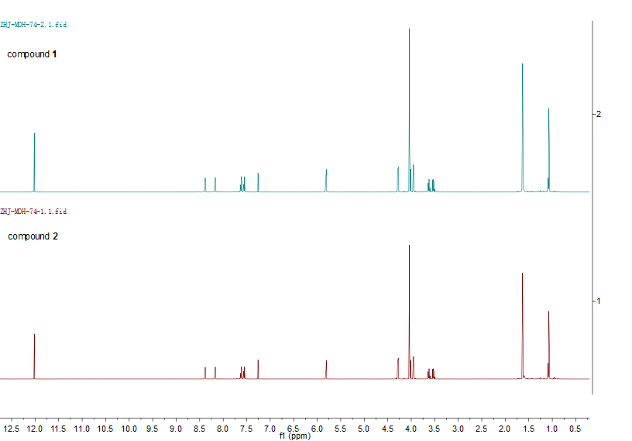



**Figure S51.** 1H NMR spectra for the enantiomers of **3** and **4** in CDCl3

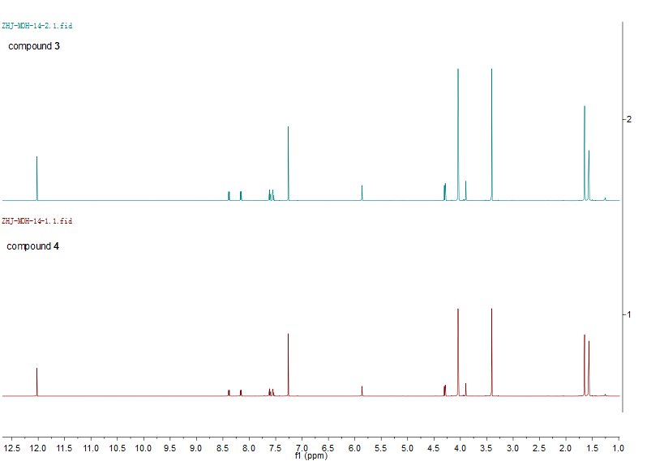



**Figure S52.** 1H NMR spectra for the enantiomers of **5** and **6** in methanol-*d*4

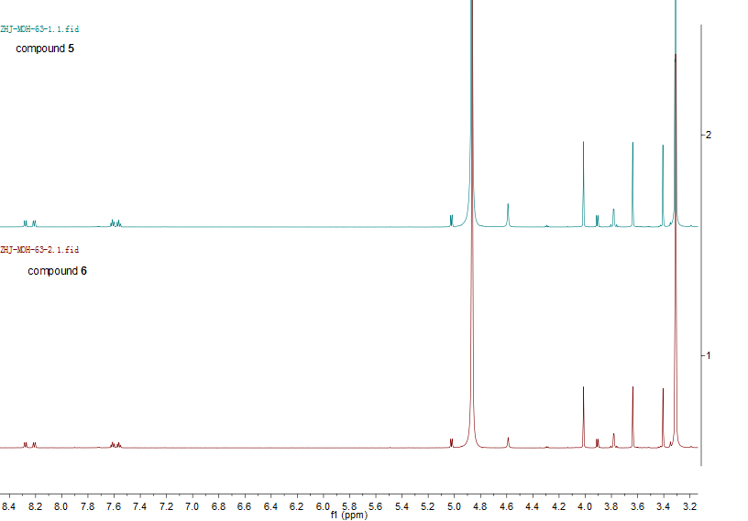



**Figure S53.** 1H NMR spectra for the enantiomers of **7** and **8** in methanol-*d*4

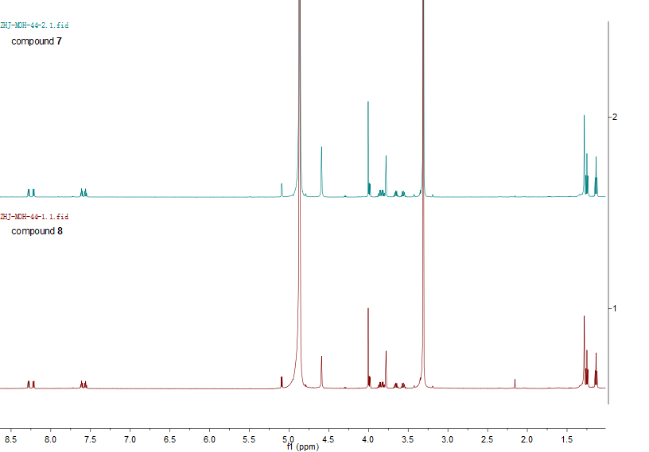



**Figure S54.** 1H NMR spectra for the enantiomers of **9** and **10** in CDCl3

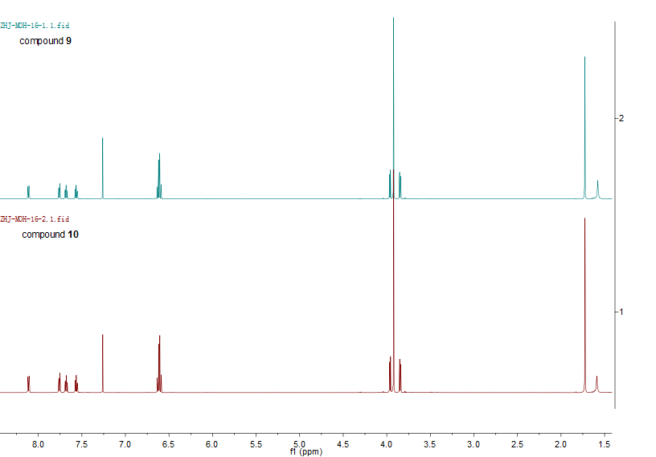



**Figure S55.** 1H NMR spectra for the enantiomers of **11** and **12** in CDCl3

