Tables and Figures – solvent paper

Table 1: Partition coefficient (log P) and solubility (log S) calculated with ChemDraw software for all monomers and solvents used in this study.
Monomer or solvent | logP | logS
Water | - | 0.158
Ethanol | 0.07 | 0.3046
Ethyl acetate | 0.29 | -0.5017
BisGMA | 5.09 | -5.571
HEMAM-BDI | 2.37 | -4.312
DMAM | 0.2 | -0.3436

Table 2. Modulus of elasticity (GPa) and yield strength (MPa) tested dry and after 7 days storage in water (wet) for all tested experimental groups. HEMAM-BDI specimens could not tested after water storeage. Values followed by the same superscript within the same column are statistically similar (two-way ANOVA within column). The asterisk symbol * indicates statistical difference between dry and wet results for the same group (t-test). For all tests, α=5%.
Solvent |  | BisGMA |  |  |  |  |  | HEMAM-BDI
Type | Concentration (wt%) | Yield strength (MPa) |  |  | Flexural modulus (GPa) |  |  | Yield strength (MPa) | Flexural modulus (GPa)
 |  | dry | wet | Reduction (%) | dry | wet | Reduction (%) | dry | dry
Control | 0 | 78.1±14.4 b | 48.2±2.1 b* | 38 | 3.55±0.10 b | 2.31±0.20 b* | 35 | 51.5±14.0 b | 5.40±0.59 a
EtOAc | 2 | 85.8±12.9 ab | 42.3±3.3 b* | 51 | 3.42±0.34 b | 2.13±0.23 b* | 38 | 70.1±6.3 a | 4.89±0.31 ab
 | 5 | 71.4±3.8 bc | 45.8±5.0 b* | 36 | 3.17±0.22 bc | 2.19±0.18 b* | 31 | 70.1±14.8 a | 4.94±0.44 a
 | 15 | 76.0±3.0 b | 53.7±7.6 b* | 29 | 3.18±0.07 bc | 2.82±0.43 b | 11 | 86.5±21.0 a | 5.10±0.17 a
 | 20 | 63.0±5.8 c | 53.5±5.7 b | 15 | 2.77±0.41 c | 2.90±0.48 b | -5 | 70.1±8.7 a | 4.57±0.81 bc
EtOH/H₂O | 2 | 101.3±6.6 a | 87.2±13.8 a | 14 | 4.64±0.47 a | 4.23±0.47 a | 9 | 68.1±7.0 ab | 5.01±0.65 a
 | 5 | 89.7±3.7 ab | 88.1±5.4 a | 2 | 4.25±0.44 a | 4.10±0.27 a | 4 | 53.9±17.5 | 5.16±0.36 a
 | 15 | 64.3±9.2 c | 55.2±10.3 b | 14 | 3.31±0.61 b | 2.59±0.36 b | 22 | 62.2±15.3 ab | 3.97±0.34 c
 | 20 | 54.0±5.4 c | 52.6±3.4 b | 3 | 3.00±0.35 bc | 2.89±0.11b | 4 | 47.9±13.4 b | 3.20±0.12 c

Figure 1. Chemical structure of the newly synthesized secondary dimethacrylamide – HEMAM-BDI (MW = 502.61g/mol).

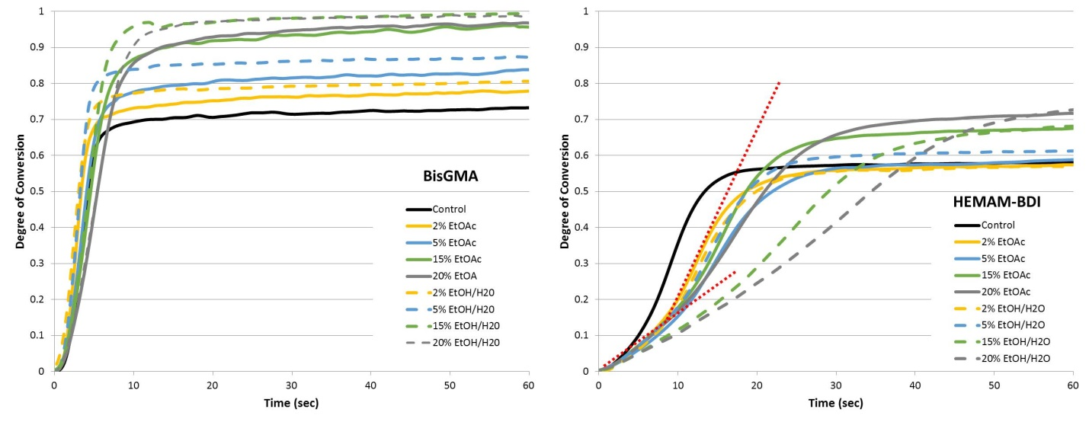
Figure 2. Degree of conversion (%) as a function of time (up to 60 s) for BisGMA- and HEMAM-BDI-based materials, containing different concentrations of ethyl acetate (EtOAc, solid lines) or Ethanol/H₂O (EtOH/H₂O, dashed lines). Dashed red lines on the HEMAM-BDI graph are highlighting the two-stage kinetic profile for the groups with highest solvent concentrations. Vinyl conversion was followed in real time as the materials were photocured with 250 mW/cm² for 300 seconds.

Figure 3. Averages of maximum rates of polymerization (Rp_{max}, %.s⁻¹), degree of conversion at Rp_{max} (DC at RP, %) and degree of conversion at 5 min (DC at 50 min, %), for all groups tested. BisGMA-based materials were statistically different from HEMAM-BDI-based materials for every variable, so comparisons were made only within each monomer system, using two-way ANOVA/Tukey’s test (solvent type and concentration as factors, α=5%). Values followed by the same superscript or connected by a horizontal bar are statistically similar. Vinyl conversion was followed in real time as the materials were photocured with 250 mW/cm² for 300 seconds.

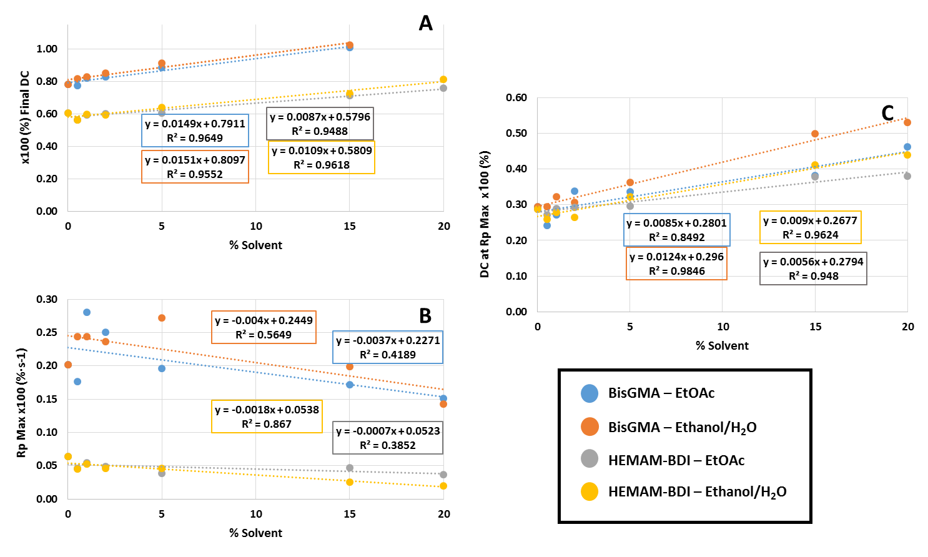
Figure 4. Linear regression curves for: (A) the final degree of conversion (DC) (%), (B) maximum rate of polymerization (Rp_{max}) (%.s⁻¹), and (C) degree of conversion at maximum rate of polymerization (DC at Rp_{max}) (%) as a function of solvent percentage incorporated in the mixtures for BisGMA and HEMAM-BDI resins.

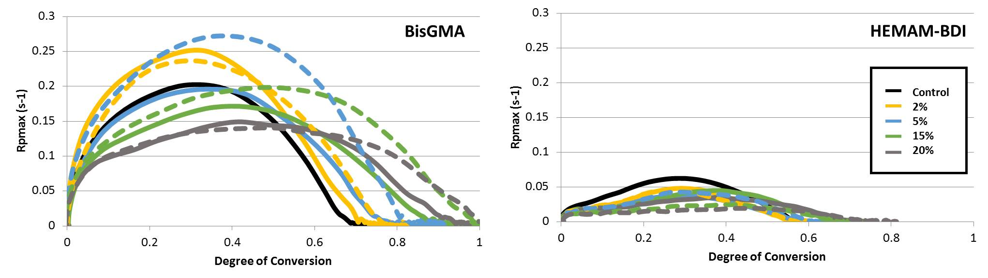
Figure 5. Polymerization rate (%.s⁻¹) as a function of conversion (%) for BisGMA- and HEMAM-BDI-based materials, containing different concentrations of ethyl acetate (EtOAc, solid lines) or Ethanol/H₂O (EtOH/H₂O, dashed lines). Vinyl conversion was followed in real time as the materials were photocured with 250 mW/cm² for 300 seconds.

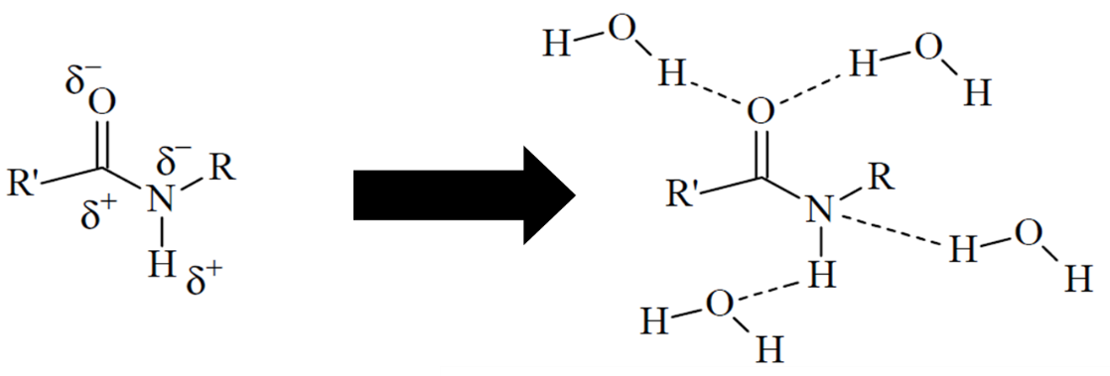
Figure 6. Schematic representation of a secondary methacrylamide with the two dipoles: carbonyl (C=O) and amine (N-H) and the potential hydrogen bonds. (Adapted from De Ruiter2005).

